1. **Grammatical gender**: watch the tutorial, study also from: Textbook, p. 18

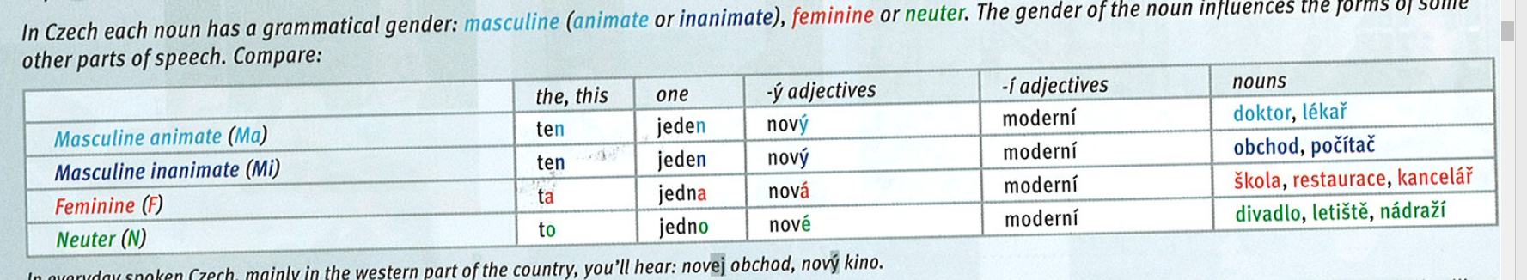



* + Textbook, p. 17/ex. 5: Listen and fill in the gaps (link for audio: [here](https://www.czechstepbystep.cz/coLm4dEPxQE9/uploads/2018/06/CD1_track_15.mp3))
    - make sure you understand the dialogues, use the dictionnary

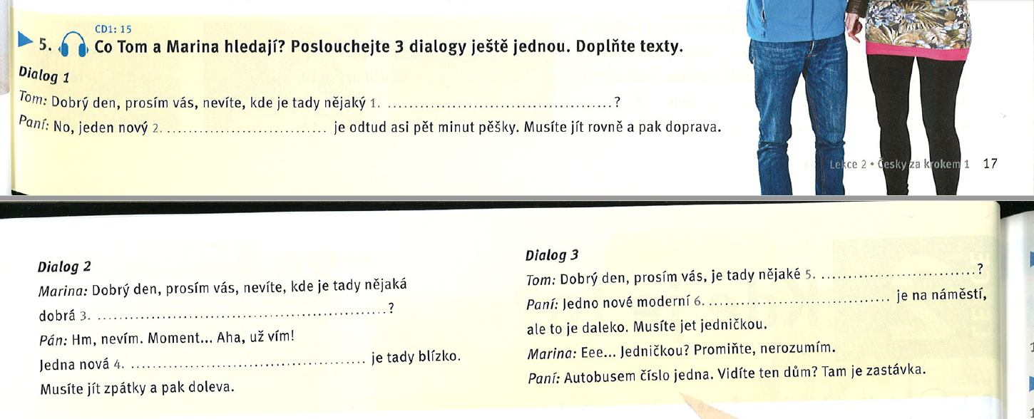



1. hotel
2. hotel
3. restaurace
4. restaurace
5. kino nebo divadlo
6. kino

## Important phrases & info

* 1 = jedna = *one (numeral)*; jednička = *number one* = tramvaj *číslo jedna*
  + *trolejbus číslo 25*
* nevíte, kde je = *do you know, where*…? (*polite: asking in negative way*)
  + vím, víš, ví, víme, víte, ví
  + nevím = I do not know
  + nestudujete medicínu?
* kde je tady nějaký/á/é [place]? *Is there any [place] around?* (lit. Where is any [place] here?)
* *[place] je na náměstí* = there is a [place] on the square (lit. [place] is on the square) = no *there is* in czech language
  + V Brně je univerzita = In Brno is university = There is an university in Brno.
* *Musíte jít / jet* = you have to go
* už = already
  + Textbook, p. 18/ex. 6: read the dialogues again and decide whether the statements are true (ANO) or false (NE)

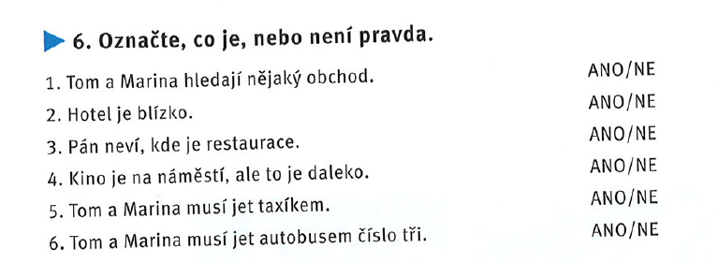



* + sort the words out according to their gender, observe the pronunciation: [link](https://learningapps.org/watch?v=pja5qon8n20)

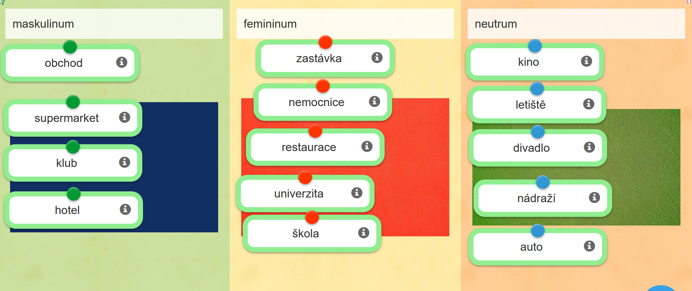

* + Textbook, p. 18/ex. 7: fill in *nový* and *moderní* in correct forms (according to the gender of given nouns)

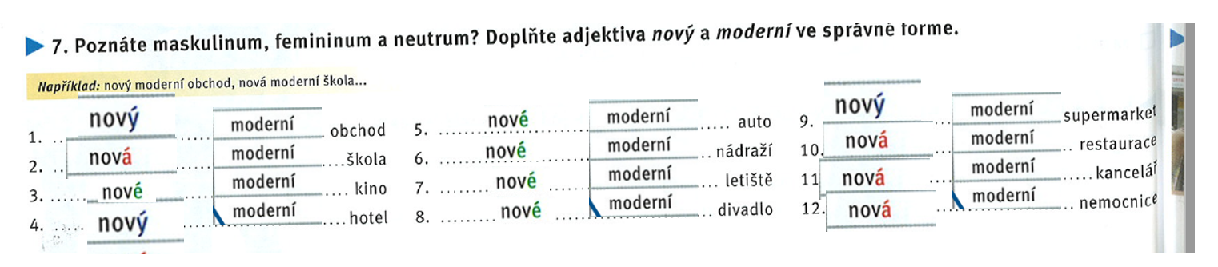

* + choose the correct forms of adjectives: [link](https://learningapps.org/watch?v=pn3mhob6a20)

# BREAK UNTIL 12:03

1. **Likes and dislikes**: observe the grey box in Texbook, p. 22

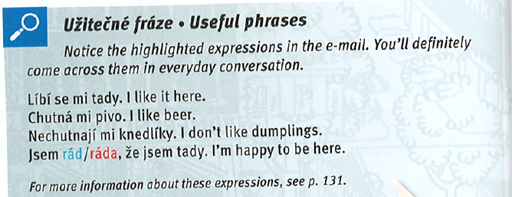

* ***Líbí*** se mi **tady** = lit. Here *seems* nice to me…
* ***Líbí se*** *vám Brno? Do you like Brno?*
* ~~Líbím se ti = you like me~~
* ~~Líbíš se mi = I like you~~
* **Chutná** mi pivo = lit. Beer seems tasty to me…
  + Co vám chutná?
  + Textbook, p. 22/ex. 5: decide what is positive and what is negative statement

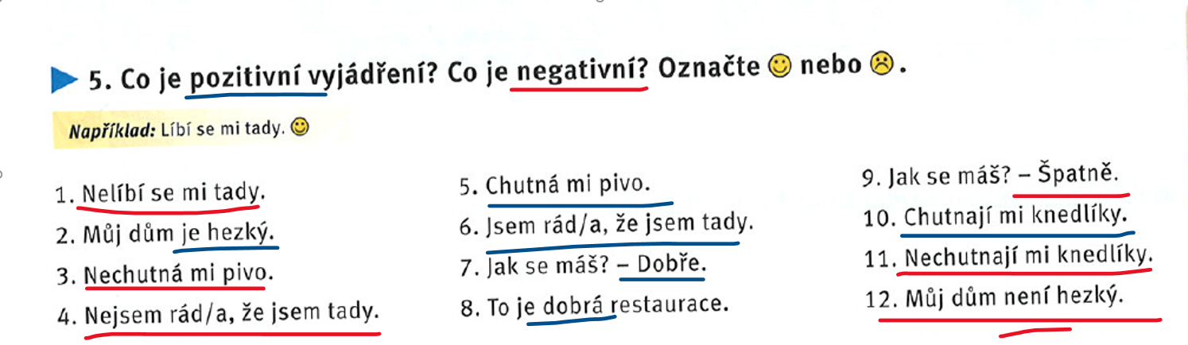

1. **Writing an email**
   * read the email (Textbook, p. 21/ex. 2)

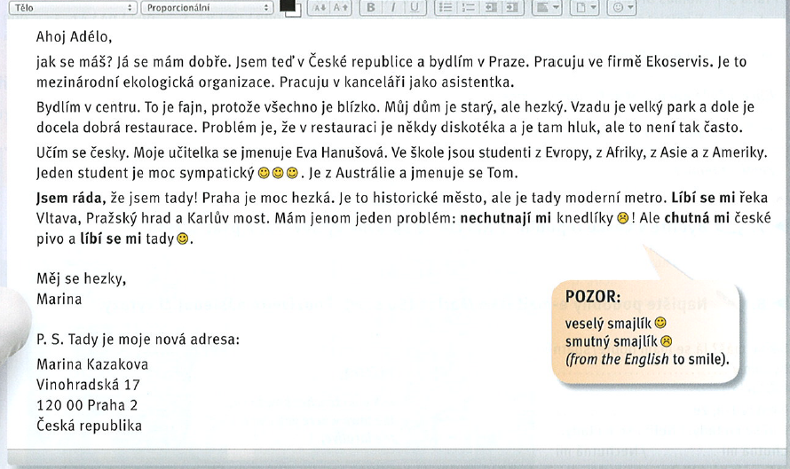

* + learn the vocabulary from this email, use the dictionnary

1. „international vocabulary“:
   * diskotéka, asistentka, firma, ekologická organizace,
   * **fajn** = fine; **džus** = juice
   * „false friends“: sympatický (nice, likeable)
2. hluk: noise
3. pracuju jako… = I work as…
4. **dům** = house → doma = home
5. často = often
   * Textbook, p. 22/ex. 3: read the email again and decide whether the statements are true (ANO) or false (NE)

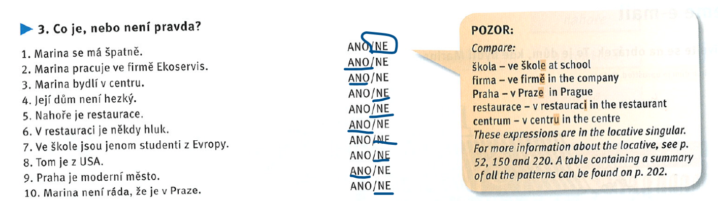



* + Textbook, p. 22/ex. 4:match the left and right parts

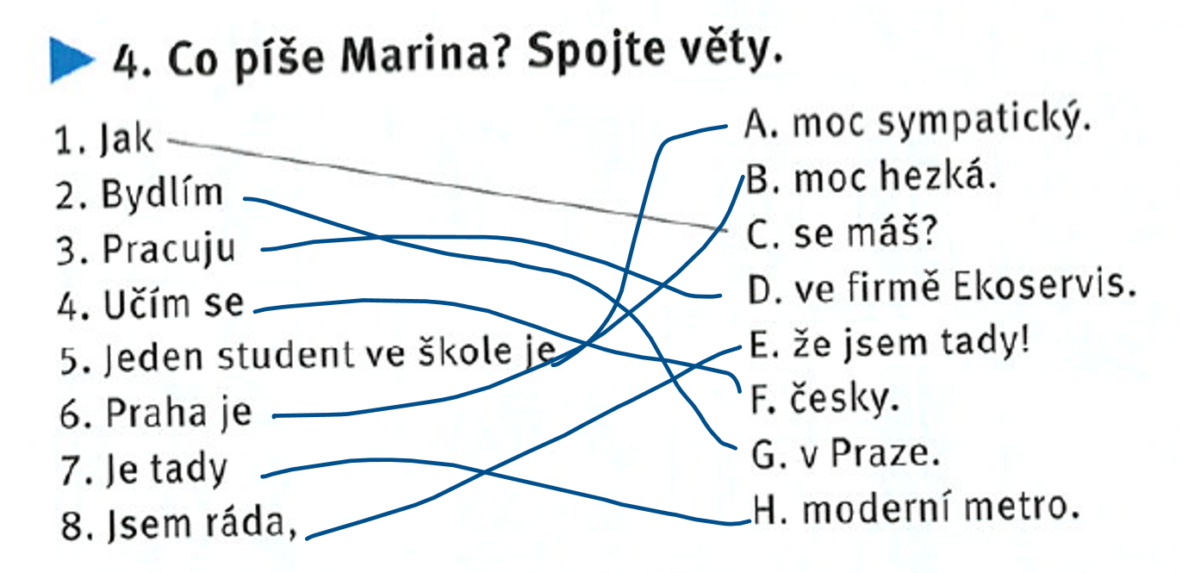

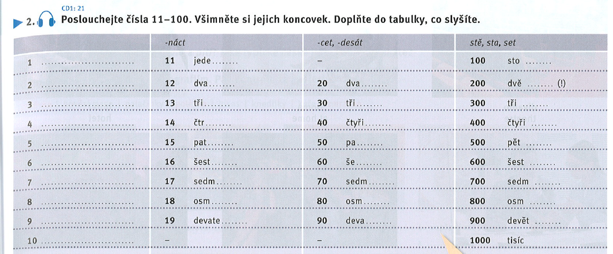



1. **Revision**
   * lesson 2 test: [link](https://learningapps.org/watch?v=p7w3kzgi220)
2. **Project**
   * write an email to your friend (50 words)
   * follow the structure from: Textbook, p. 22/ex. 8
   * tell him/her where you are, what you do, where you live, what you like
   * upload it on IS (onto your homework vaults)