What to study

Jídlo = food
maso (meat)
- vepřové maso = pork (meat)
- hovězí maso = beef (meat)
- kuřecí maso = chicken (meat)

Pití = drinks

- Vocabulary:
  - study food: Textbook, p. 25/ex. 2: listen and repeat (link for audio: here), fill in the gaps related to photos
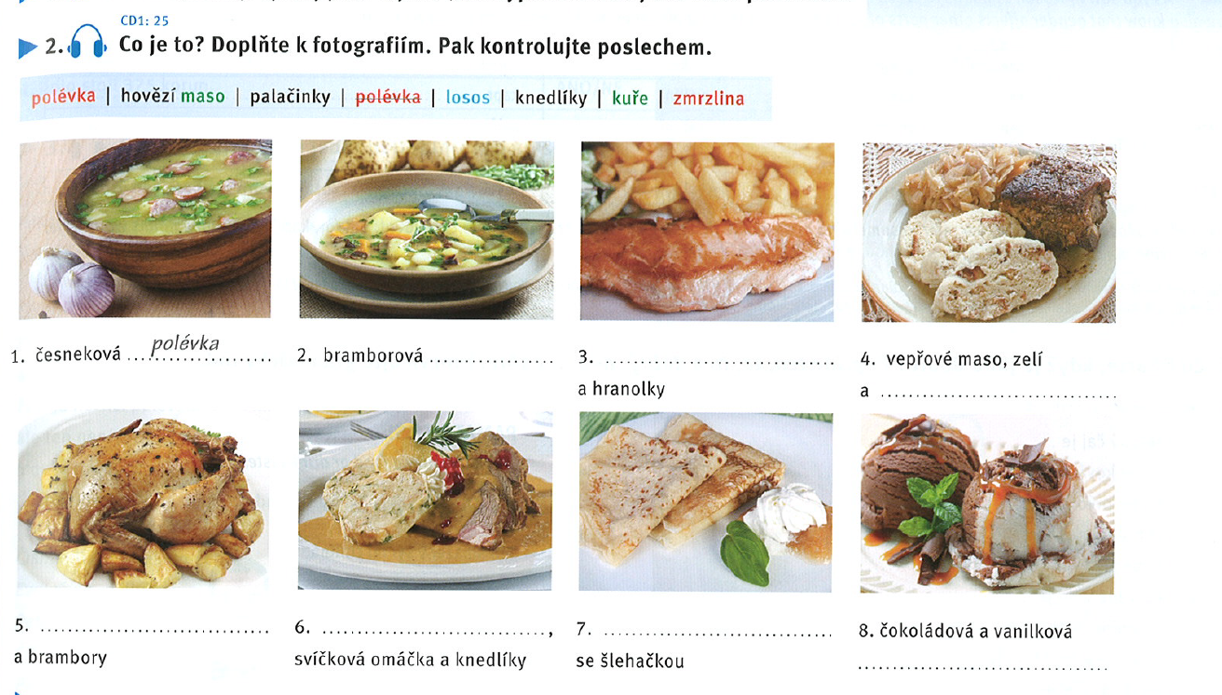
- česneková polévka: garlic soup
- bramborová polévka: potato soup
- losos a hranolky: salmon and fries
- vepřové maso, zelí a knedlíky: pork, cabbage, dumplings
- kuře a brambory: chicken (a bird) and potatoes
- hovězí maso, svíčková omáčka, knedlíky: beef (roast tenderloin), cream („candle“) sauce
- palačinky
- čokoládová a vanilková zmrzlina: ice cream

  - study other words in Textbook, p. 32
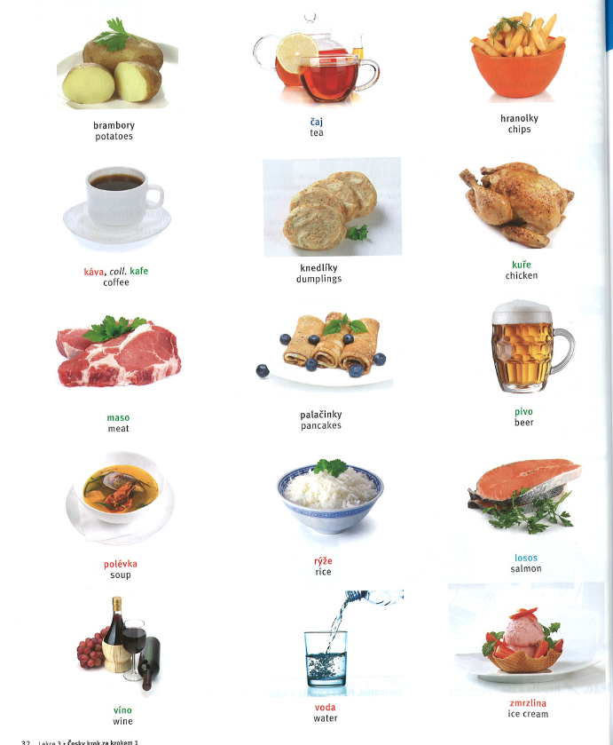
  - practice new vocabulary - match a Czech word with a picture - link
  - work with the menu on page 25: read the menu and fill in the missing words from the blue headline.
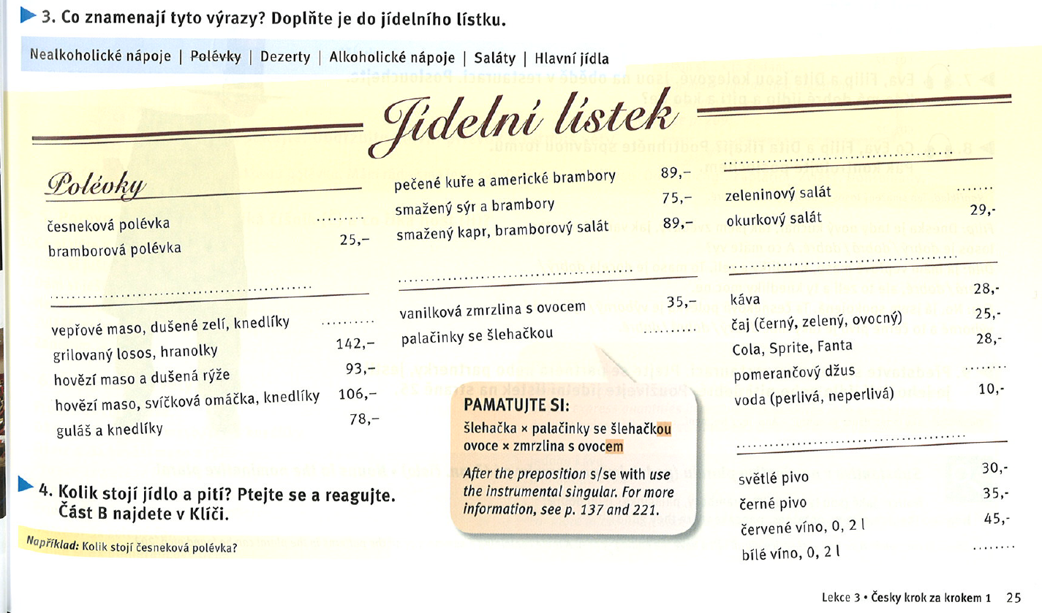
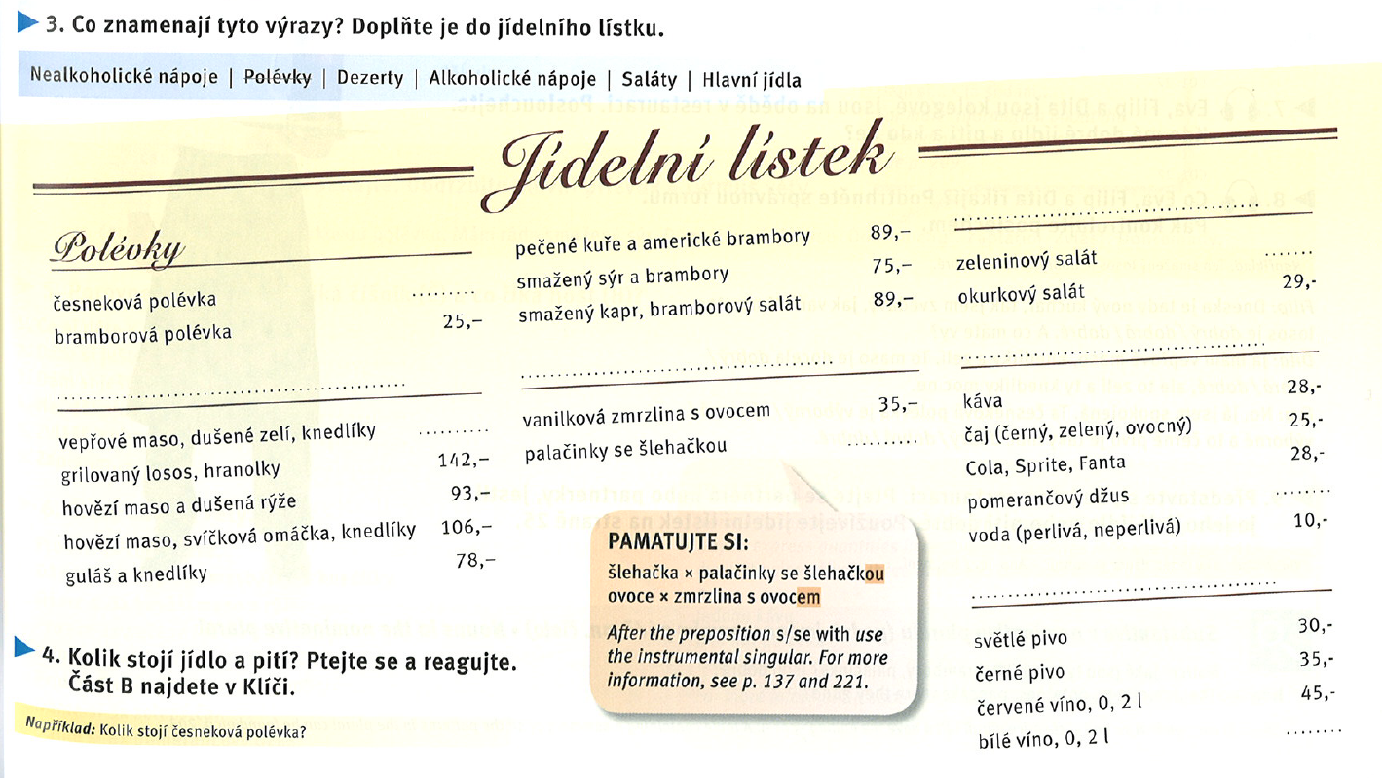
1 euro = 27 czk
1 USD = +/- 23 czk
pivo in a restaurant/bar/pub = 30–45 korun (1,5 euro) / 0,5 l
pivo v supermarketu: 0,5 l = 4 korun; 10–20 korun
voda (water) = 330 ml / 30–45 korun
27 000 korun = 1000 euro

KOLIK (how much/how many) stojí [something]?
[something] stojí 25 korun. Pivo stojí 30 korun.
  - practice new vocabulary - sort the words into the suitable section of the menu - link
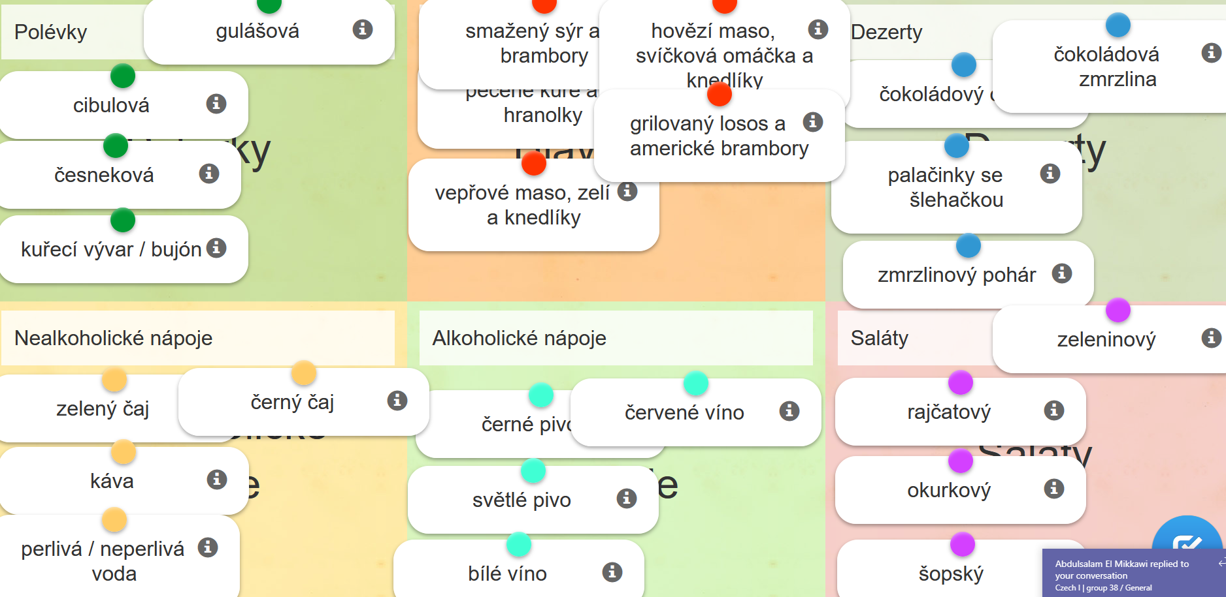
vývar: clear soup (hovězí, kuřecí)
šopský salát: salat with white cheese
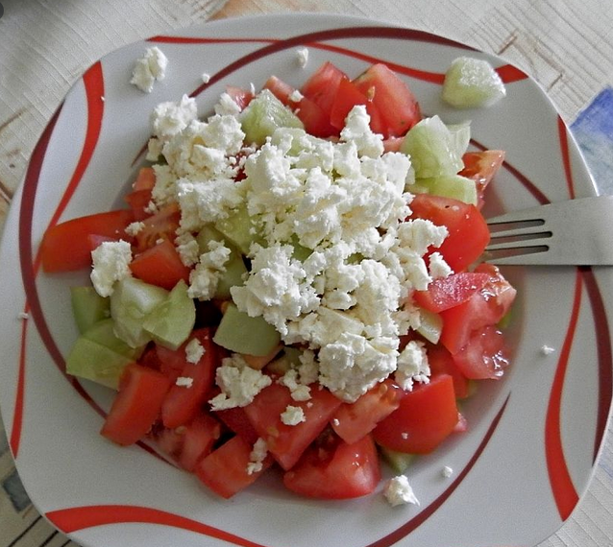

- Grammatical gender: revise the topic, work with Textbook, p. 26
  - Textbook, p. 26/ex. 6: Fill in the suitable fom of an adjective and pronoun.


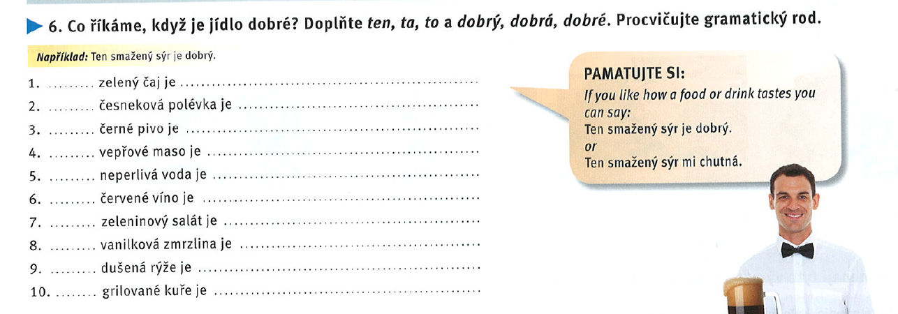
ten dobrý
ta dobrá
to … dobré

  - Textbook, p. 26/ex. 8: Listen to a recording (link) and choose the suitable form of an adjective.
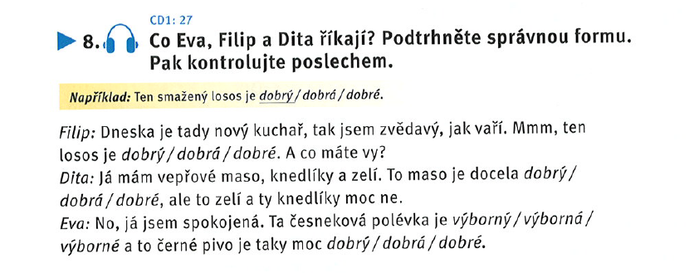
docela dobrý = quite good
moc = much/very (děkuju moc), moc ne = not that much, Mám se moc dobře.
moč = urine
výborný = excellent
  - Fill in a noun into a sentence. Notice the gender of the adjective.: link
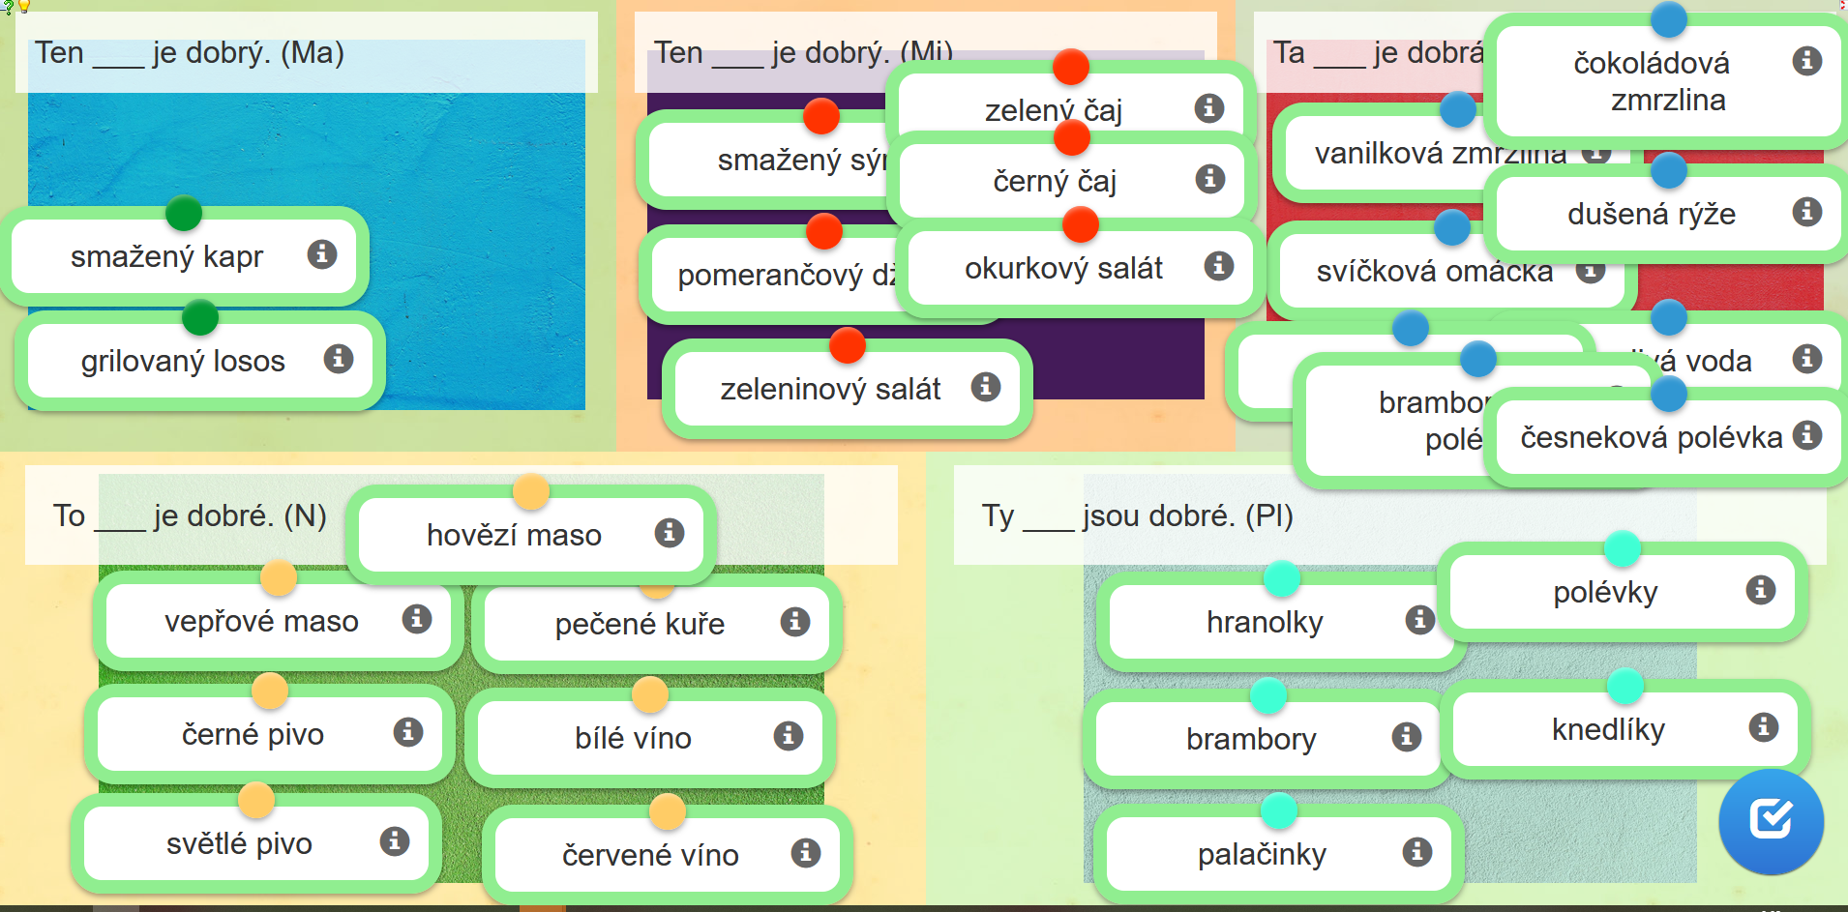
moře = sea, n.
restaurace = f.
kuře, n.: kohout (rooster) + slepice (hen) = kuře (chicken)
muž + žena = dítě (child, n.)

- Dialogue - listening and reading:
  - Textbook p. 27/ ex. 2 - Listen to a dialogue (link) and answer the questions in the exercise.
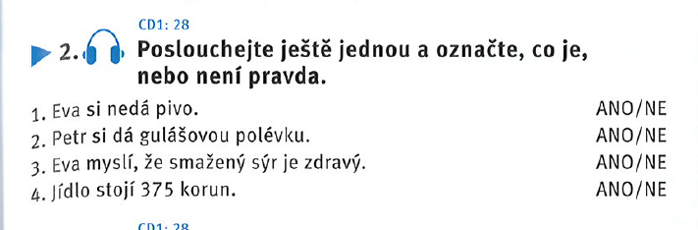
dát si, dám si = I will have/order (in restaurant, lit. I give something to myself)
smažený sýr je zdravý = fried cheese is healthy
stát, stojím = to cost
  - Textbook p. 27/ ex. 3 - Listen to the dialogue once again, fill in the missing words.
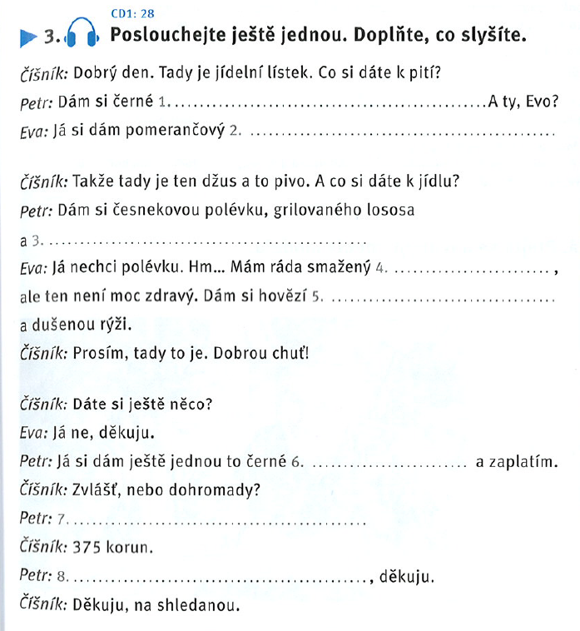
- černé pivo
- pomerančový džus
- lososa a brambory
- smažený sýr
- hovězí maso
- černé pivo
- dohromady (together) × zvlášť (separately)
- 375 → 400
spropitné, dýško, tringelt = tip: +5 Kč; 10 %

  - Textbook p. 27/ ex. 5 - Read the phrases, decide who says it - waiter or guest?
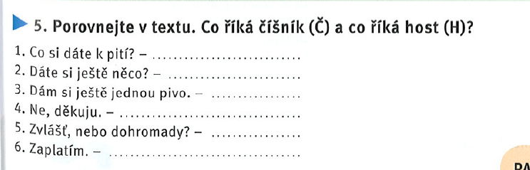
  - Practice the phrases from the dialogue - sort the parts of the dialogue (link)

try to buy something you have never had, taste it, remember its name and share your experience next week
some tips:
- termix
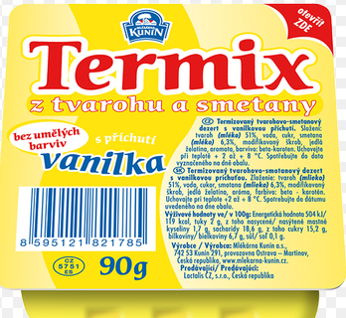
- Míša
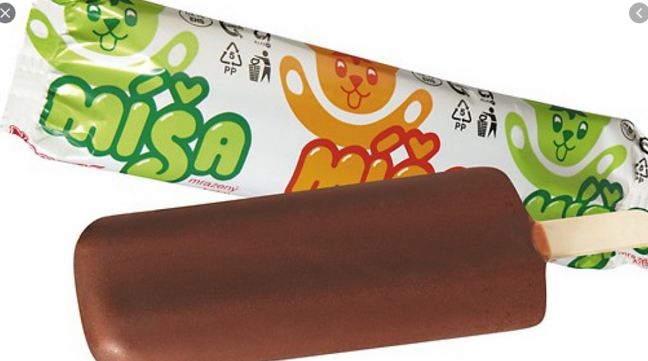
- Mila
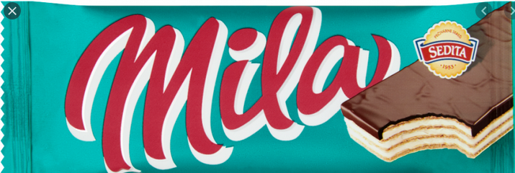
- tvaroh
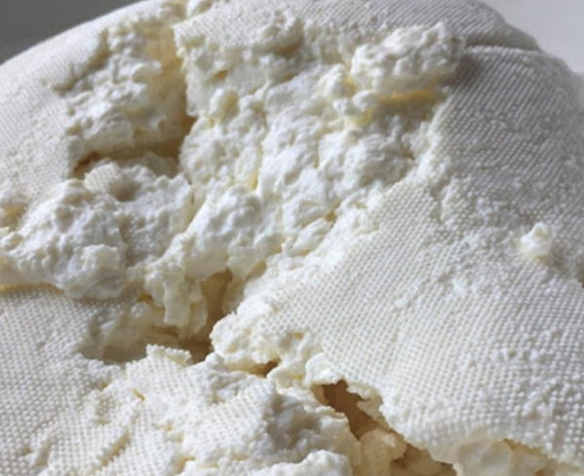
- věneček
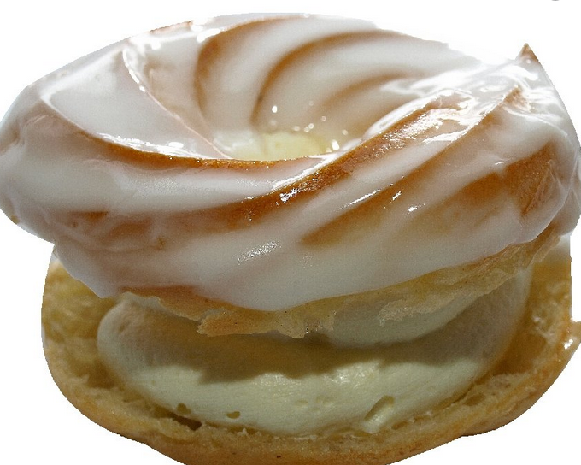
- kysané zelí (tuřanské)
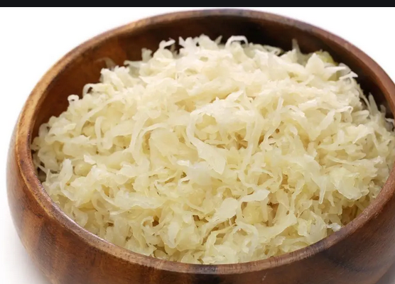
- olomoucké tvarůžky
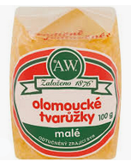
- točený salám
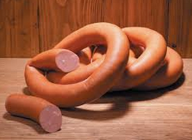
- rohlík
