**1st week: Revision. Conversation: What did you do during summer? Grammar: Revision of accusative forms in sg and plural, prepositions, verbs. The locative sg. The question KDE. Medical Czech: Revision: Parts of body. At the doctor.**

Information about the semester and online learning **(5 minutes)**

* Kde jste?
  + Doma.
  + Jsem doma.
* Co studujete tento semestr?
  + Studuju češtinu.
  + … mikrobiologii
  + fyziologii.
* Máte hlad?
  + Ano, mám hlad.
  + **Proč** jste nejedl/a?
    - **Protože** nemám čas.
    - … mám lekci.

**Classroom activites/topics**

* warm up: answer teacher's questions **(5 minutes)**
* accusative singular and plural **(10 minutes)** 
  + work in groups, describe the picture you will be given, present it

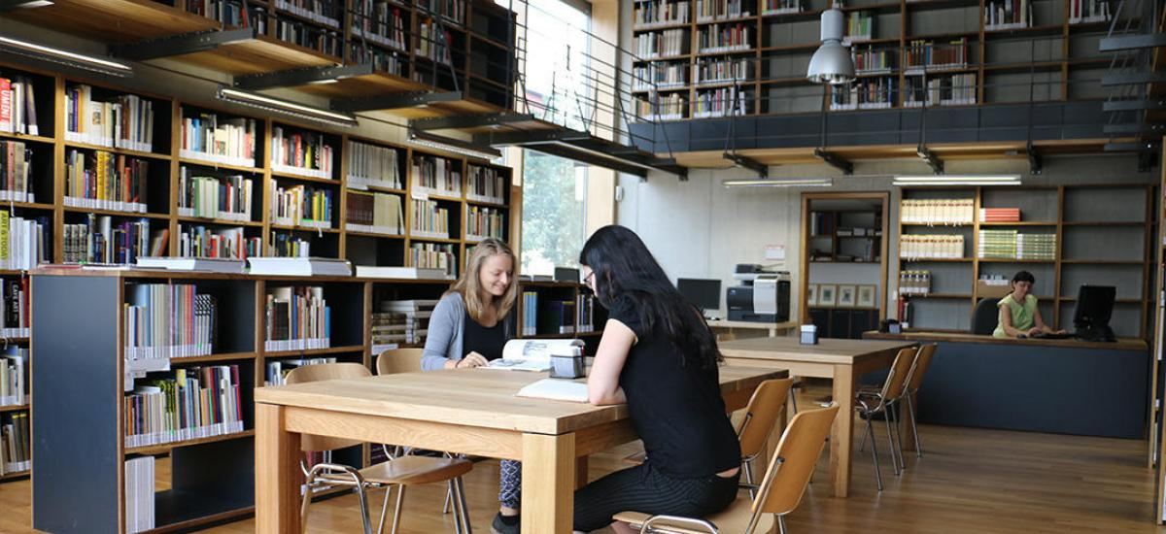

Student studuje v knihovně. Studentka má černé tričko (t-shirt).

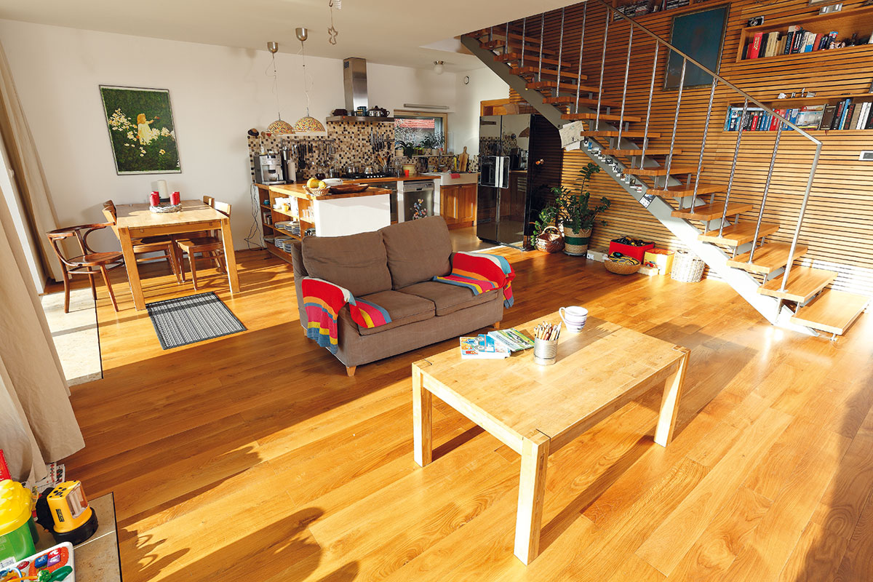

To je doma. Vidím stůl, židle, sedačka. Kuchyňská linka a lednička,.

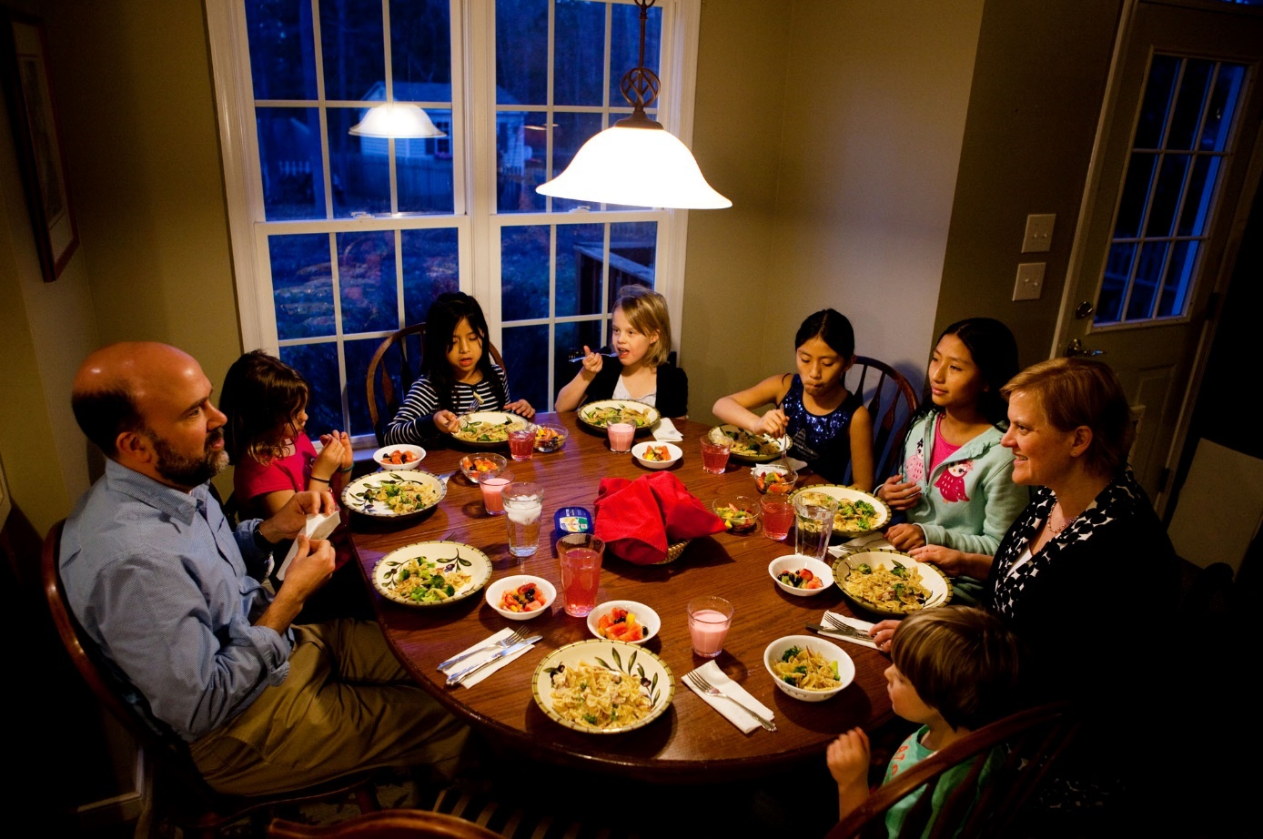

To je rodina. Jsou na večeři. = Oni večeří. Co večeří? Večeří jídlo.-

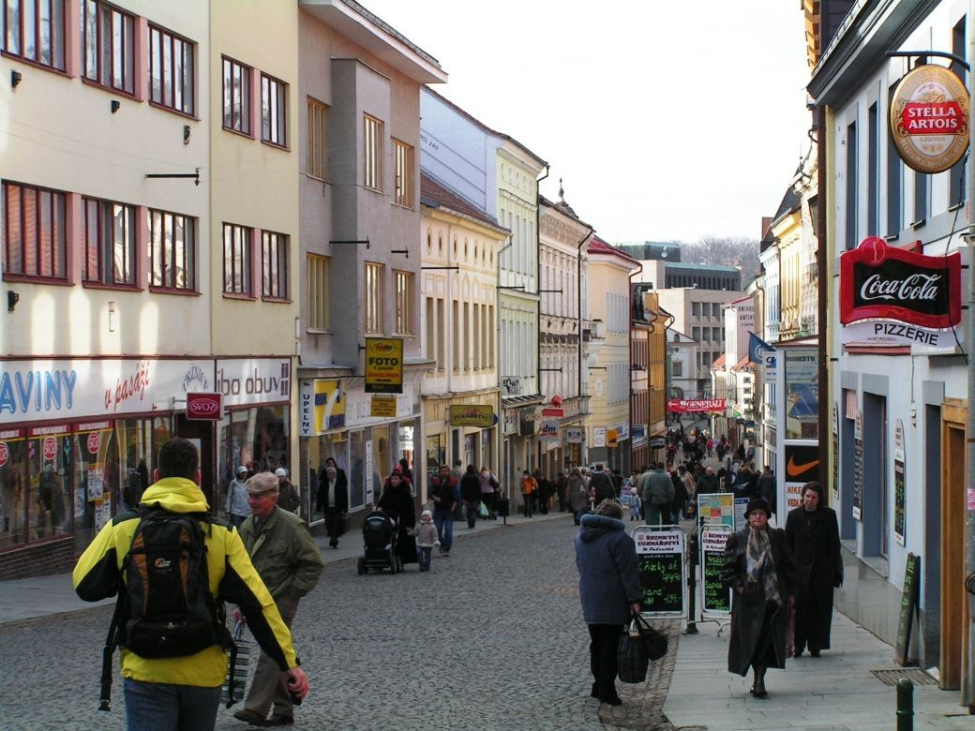

To je ulice. Tam jsou obchody a lidi.

* verbs (vocabulary) and present tense **(10 minutes)**
  + match the picture with the appropriate verb (5 minutes): [link](https://learningapps.org/watch?v=pkpigx35j20)
  + sort the verbs out into four groups according to their type (5 minutes): [link](https://learningapps.org/watch?v=po6pz7rf320)

vstávám, dělám, dívám se…

vstáváš..

spím, jím

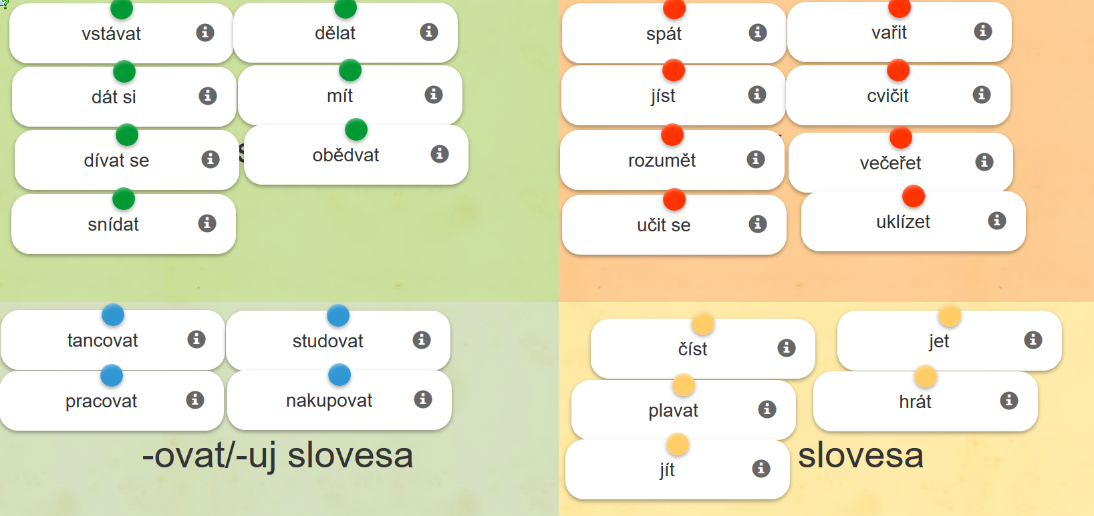

tancuju, pracuju čtu, čteš, čte; plavu; jdu; jedu, hraju

* locative singular and verbs in present tense **(15 minutes)**
  + sort the words out according to the ending they take in the locative case (5 minutes): [link](https://learningapps.org/watch?v=pkwwy9xhn20)
* 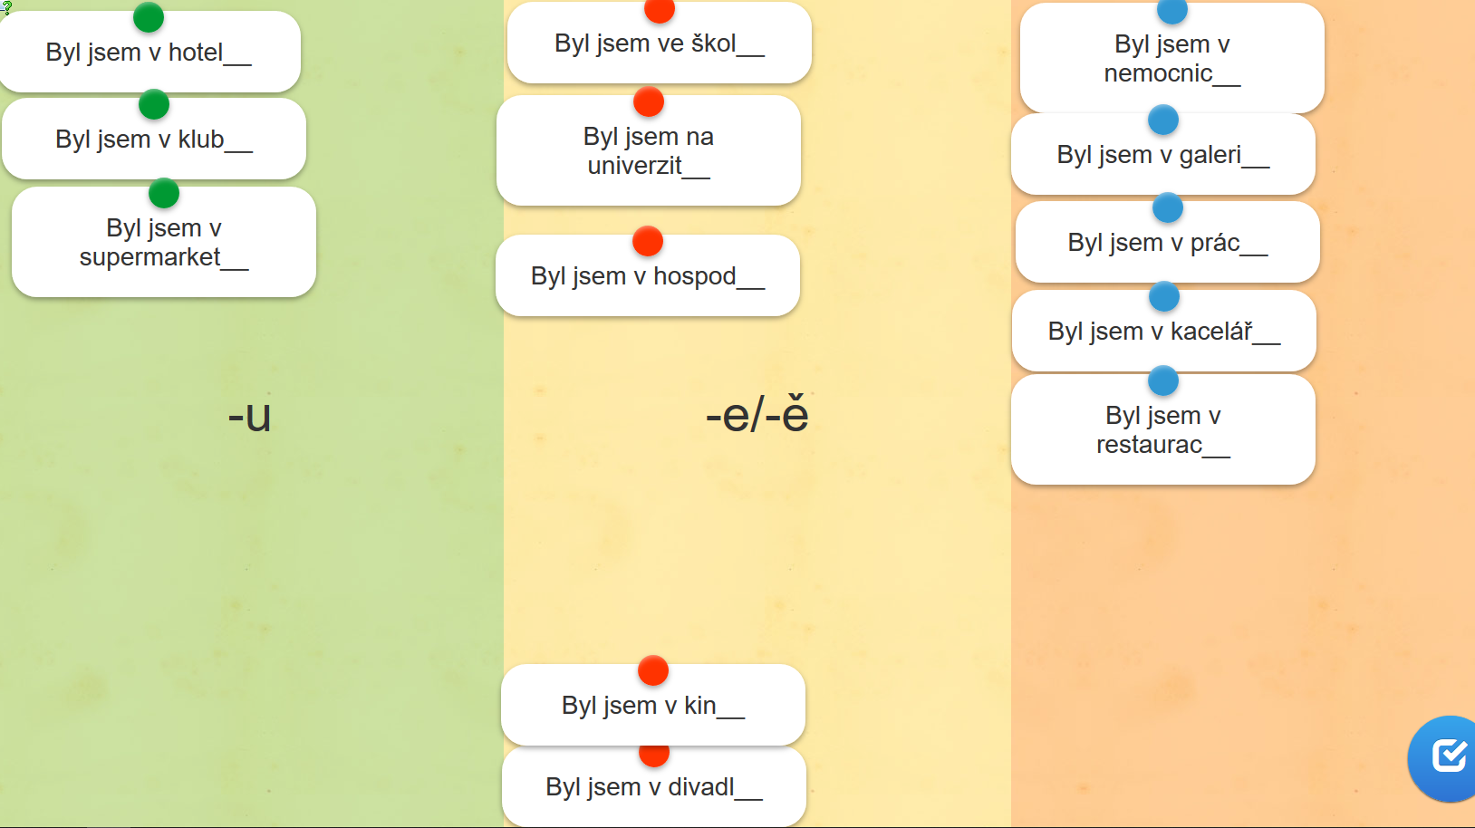
  + work in groups: ask questions according to the model (10 minutes)

*A: Snídáš* ***v kuchyni****?*

*B: Ano, snídám* ***v kuchyni****. A co ty? Obědváš* ***doma****?*

*C: Ne, obědvám* ***v restauraci****. A co ty? Sportuješ* ***v klubu****?*

* verbs in paste and future tense **(10 minutes)** 
  + work in groups: Say what you were doing during summer and ask your colleagues about the activity. Practise past tense forms. Use the correct word order. Use the verbs from the wordbank. Ask about negative answers in future tense.
  + wordbank: [link](https://is.muni.cz/auth/el/med/podzim2020/aVLCJ0383/105649142/w01-wordbank.png)
* prepositions **(10 minutes)**
  + ROPOT: Sort the words out with given prepositions (NA/DO/K) (5 minutes)
  + Sort the words out with given prepositions: [link](https://learningapps.org/watch?v=pzzh9ki8a20) (A/V/U) (5 minutes)

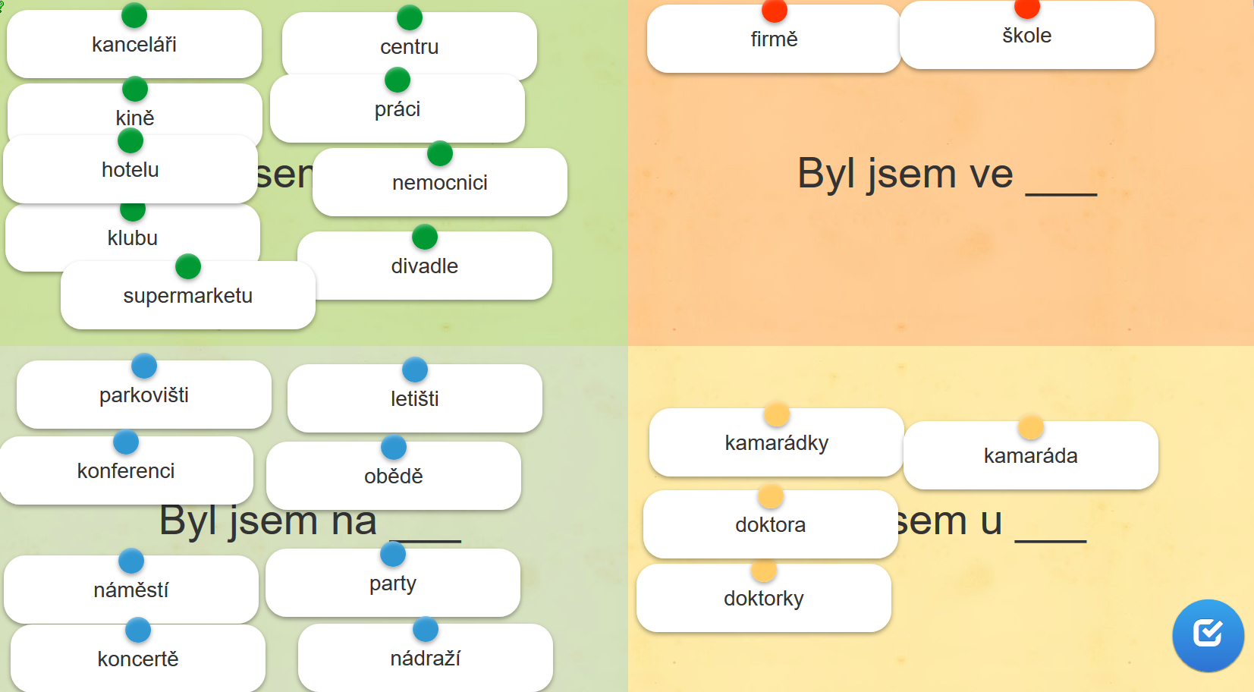

**VE ŠK**OLE

VE FIRMĚ

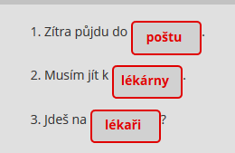

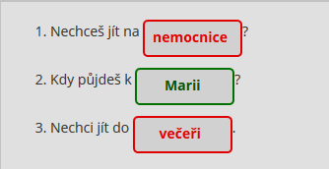

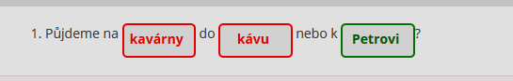

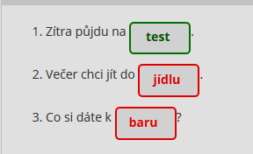

* at the doctor: what does the doctor say? and what the patient? [link](https://learningapps.org/watch?v=puurjf98520) **(5 minutes)**
* human body vocabulary **(10 minutes):** 
  + what is it?  (3 minutes) [link](https://learningapps.org/watch?v=pho61z0ua20)
  + quiz ([link](https://b.socrative.com/login/student/?feature=embed), enter the room number your teacher tells you) (7 minutes)

**Homework (ROPOTs)**

* verbs in present tense: what do they like doing? Choose the suitable answer. Revise the vocabulary: [link](https://learningapps.org/watch?v=pvjpv2ms320)
* verbs in present tense: sort the verbs out into four groups according their person: [link](https://learningapps.org/watch?v=p8dgsqa0j20)