**1st week: Revision. Conversation: What did you do during summer? Grammar: Revision of accusative forms in sg and plural, prepositions, verbs. The locative sg. The question KDE. Medical Czech: Revision: Parts of body. At the doctor.**

Information about the semester and online learning **(5 minutes)**

**Classroom activites/topics**

* warm up: answer teacher's questions **(5 minutes)**
* accusative singular and plural **(10 minutes)** 
  + work in groups, describe the picture you will be given, present it

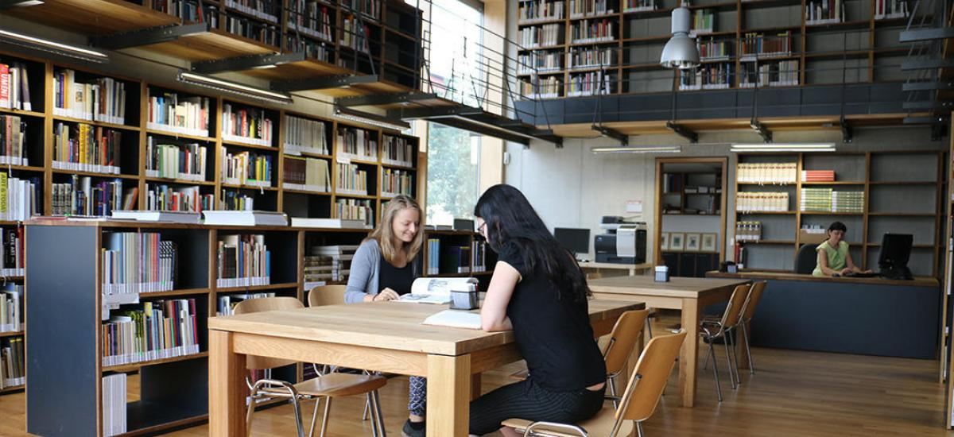

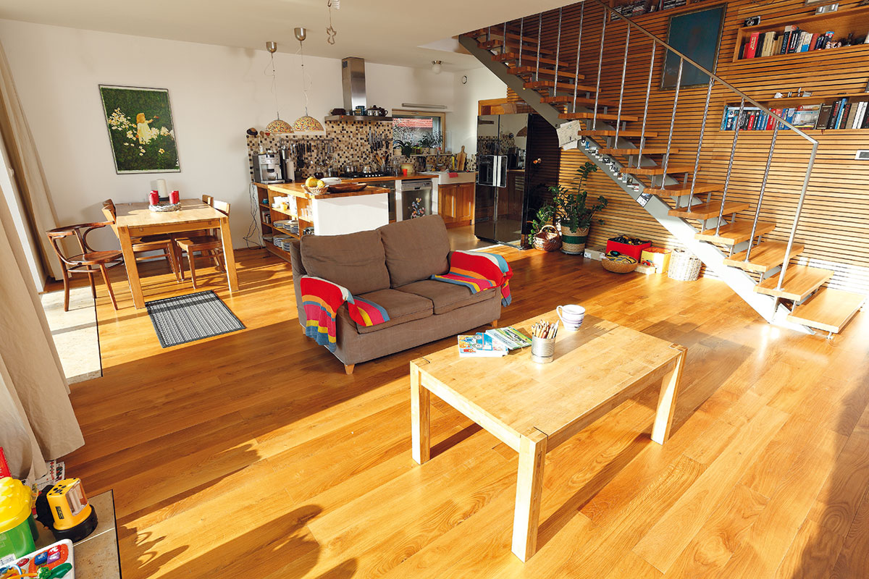

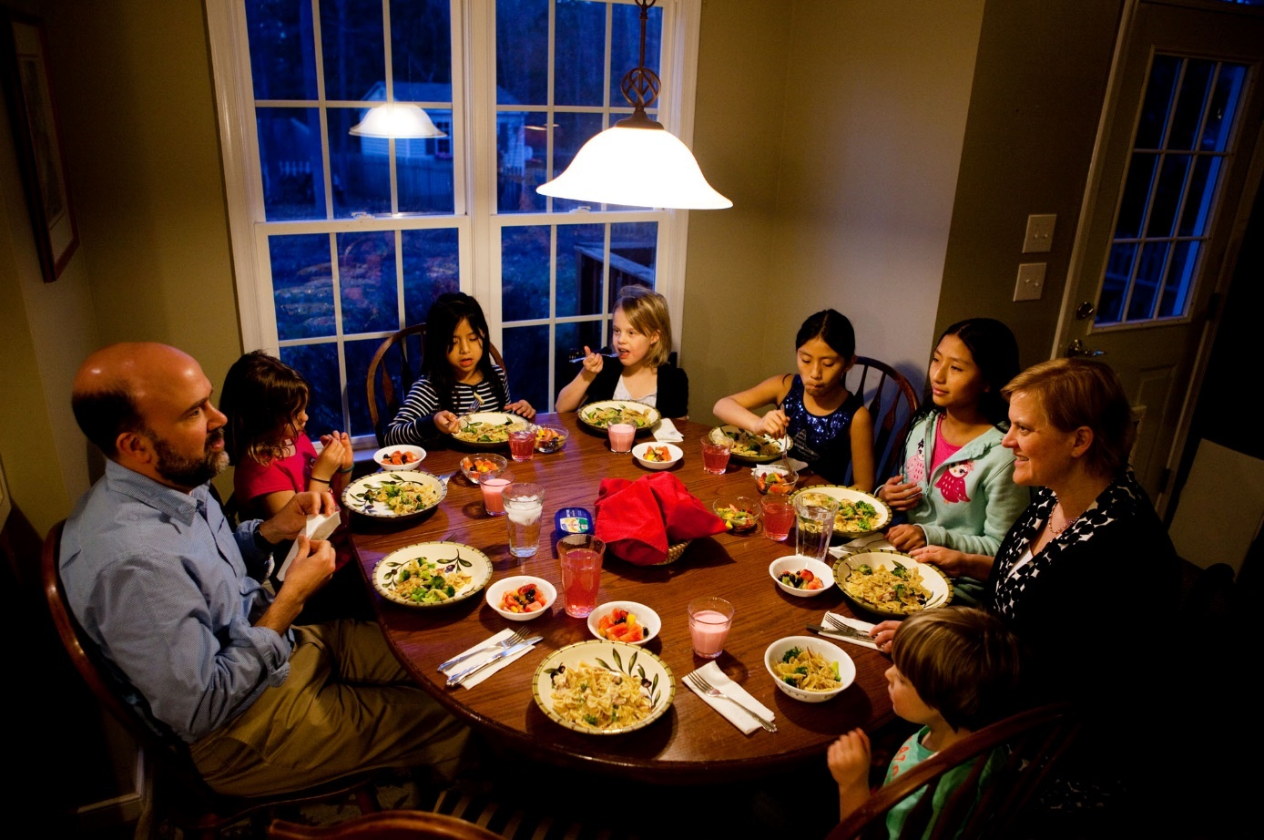

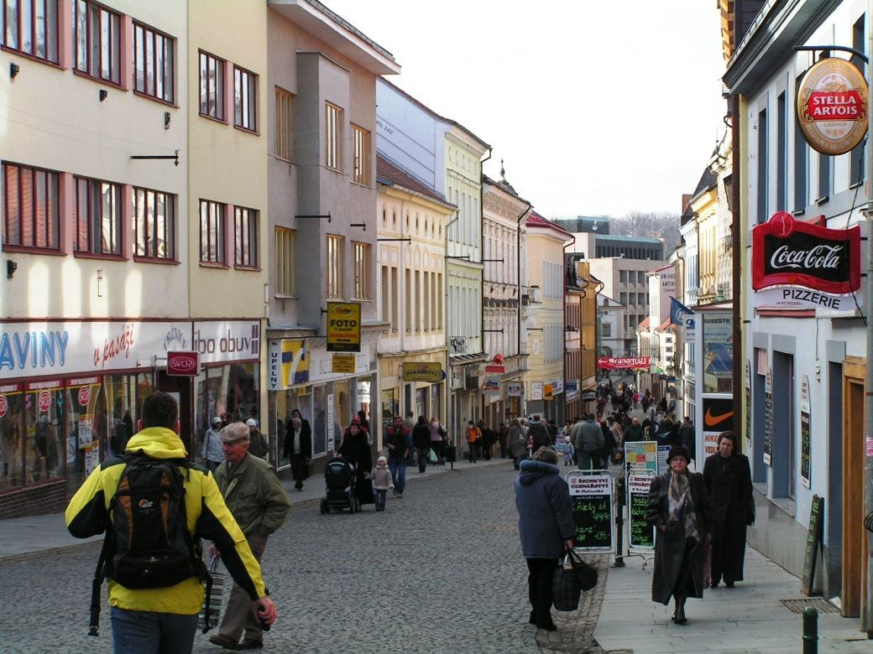

* verbs (vocabulary) and present tense **(10 minutes)**
  + match the picture with the appropriate verb (5 minutes): [link](https://learningapps.org/watch?v=pkpigx35j20)
  + sort the verbs out into four groups according to their type (5 minutes): [link](https://learningapps.org/watch?v=po6pz7rf320)

we get up: vstáváme

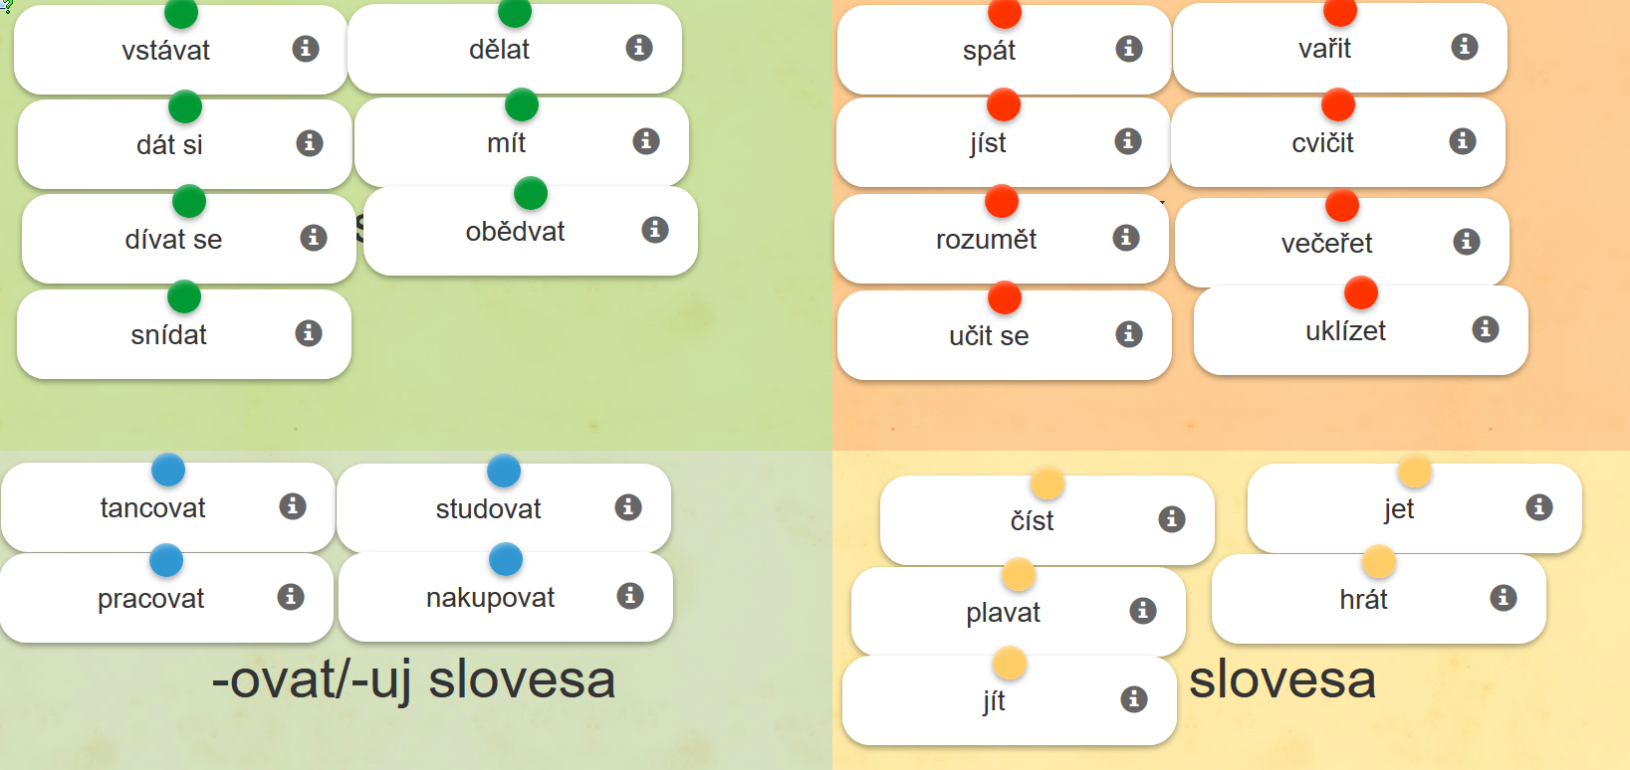

* locative singular and verbs in present tense **(15 minutes)**
  + sort the words out according to the ending they take in the locative case (5 minutes): [link](https://learningapps.org/watch?v=pkwwy9xhn20)
* 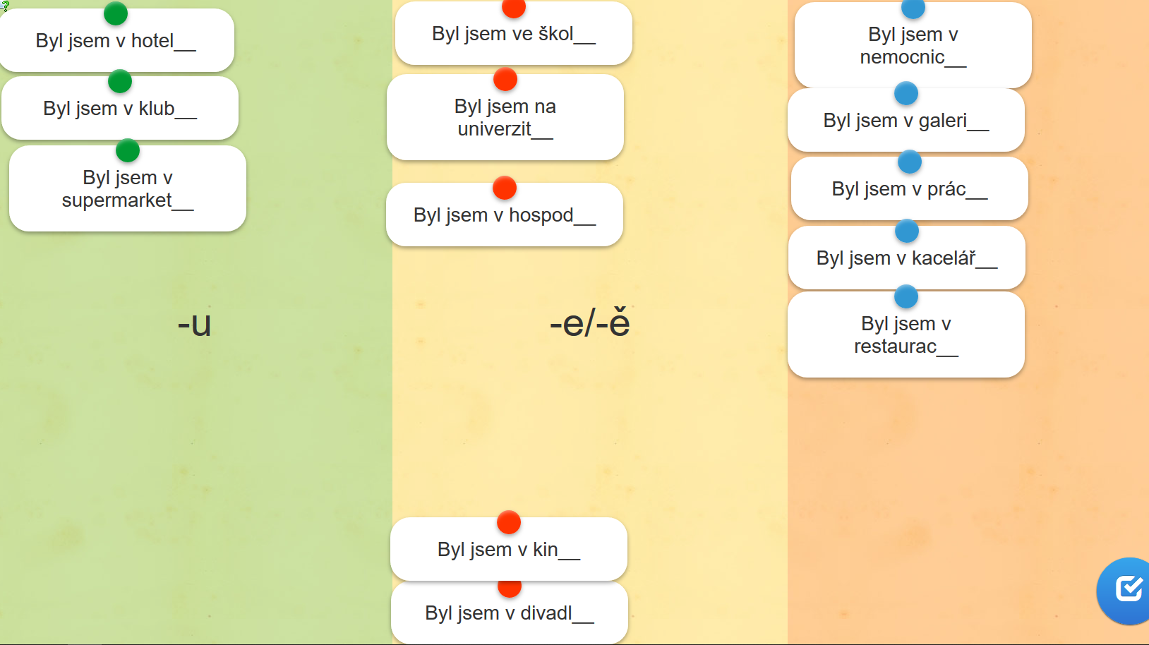
  + **work in groups: ask questions according to the model (10 minutes)**

rounds: A → B → C → …

**Q: you-verb + location; A: me-verb + location** → next round

*A: Snídáš* ***v kuchyni****?*

*B: Ano, snídám* ***v kuchyni****. A co ty? Obědváš* ***doma****?*

*C: Ne, obědvám* ***v restauraci****. A co ty? Sportuješ* ***v klubu****?*

**DOMA** = (at) home, adverb + no preposition ever, no grammar ever

**domov**: a home (noun); „**Kde domov můj**“: czech national anthem

* verbs in paste and future tense **(10 minutes)** 
  + work in groups: Say what you were doing during summer and ask your colleagues about the activity. Practise past tense forms. Use the correct word order. Use the verbs from the wordbank. Ask about negative answers in future tense.

Studoval JSEM…

Studoval J**SI**..

Díval jsem se na TV… / Dal jsem SI pivo…

Díval jsi se…

**Co** jste **dělala** v létě?

**Hrála** jsi **volejbal**?

**Studoval** jste v létě?

Ano, **studoval** jsem v létě.

**Byl jsi ve škole?**

Ano, **byl** jsem ve škole. = Ve škole jsem byl.

Ne, ne**byl** jsem ve škole.

Ne, byl jsem doma.

**Včera** jsem studoval anatomii v kavárně na náměstí Svobody.

studoval jsem **Včera** anatomii v kavárně na náměstí Svobody.

anatomii jsem studoval v kavárně na náměstí Svobody včera.

* + wordbank: [link](https://is.muni.cz/auth/el/med/podzim2020/aVLCJ0383/105649142/w01-wordbank.png)
* prepositions **(10 minutes)**
  + ROPOT: Sort the words out with given prepositions (NA/DO/K) (5 minutes)
  + Sort the words out with given prepositions: [link](https://learningapps.org/watch?v=pzzh9ki8a20) (A/V/U) (5 minutes)

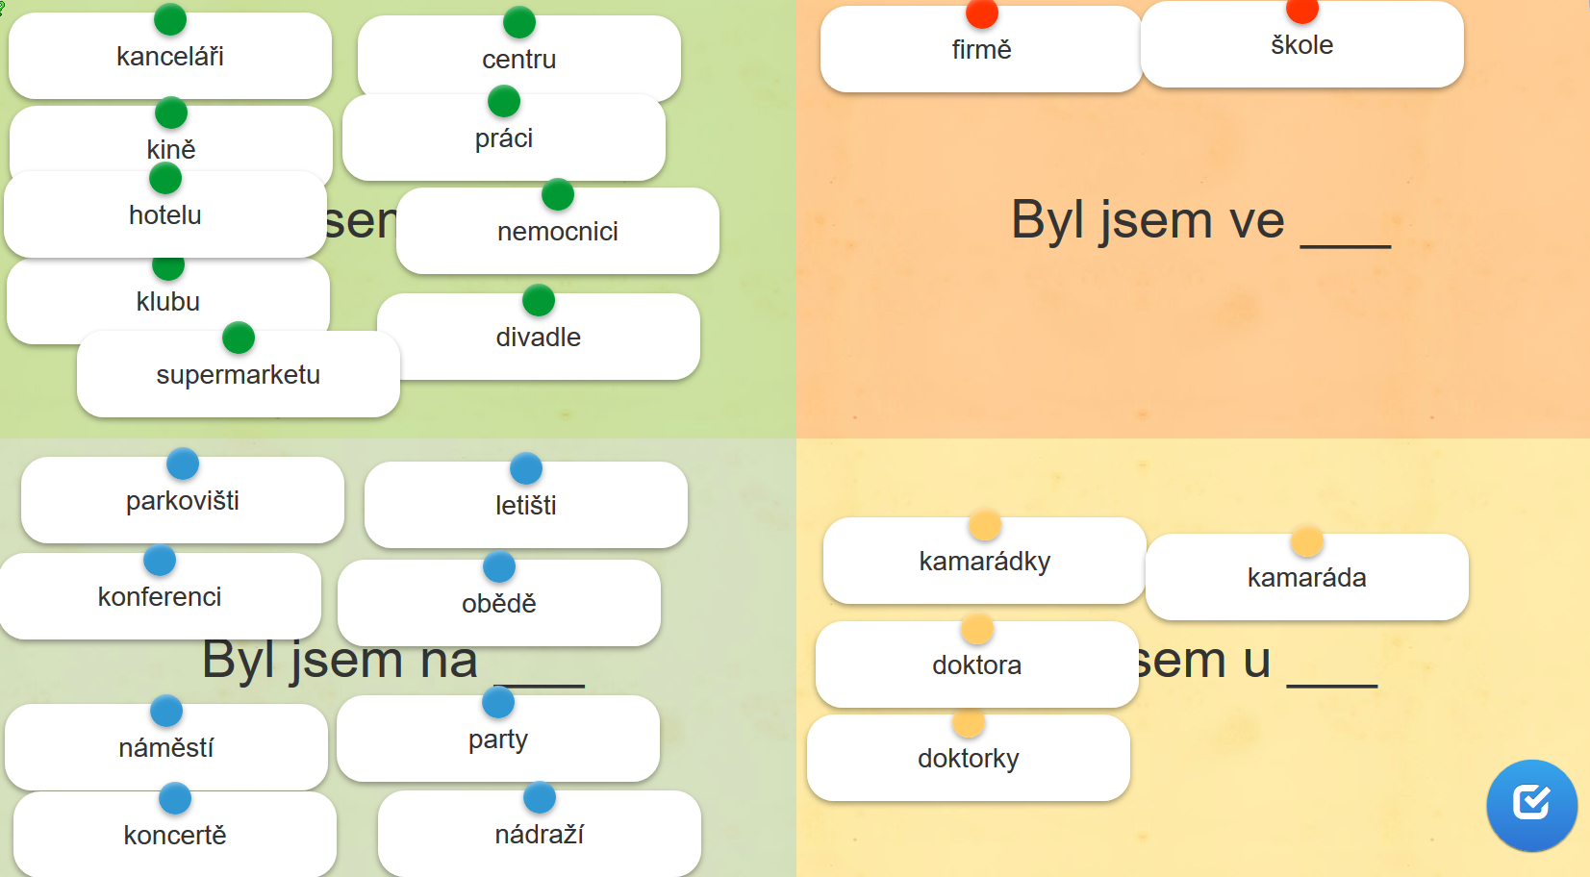

**V = VE:** IN, AT, ON, …

**ve su**permarketu

v**e** středu

v**e** čtvrtek

**Being:** V – NA – U

**Going: DO** –**NA** – K

Jdu **do** doktora.

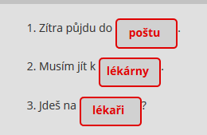

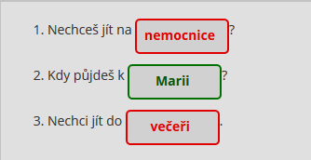

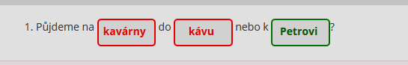

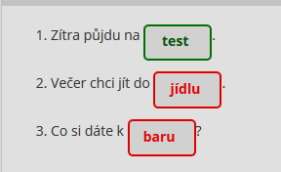

* at the doctor: what does the doctor say? and what the patient? [link](https://learningapps.org/watch?v=puurjf98520) **(5 minutes)**
* human body vocabulary **(10 minutes):** 
  + what is it?  (3 minutes) [link](https://learningapps.org/watch?v=pho61z0ua20)
  + quiz ([link](https://b.socrative.com/login/student/?feature=embed), enter the room number your teacher tells you) (7 minutes)

**Homework (ROPOTs)**

* verbs in present tense: what do they like doing? Choose the suitable answer. Revise the vocabulary: [link](https://learningapps.org/watch?v=pvjpv2ms320)
* verbs in present tense: sort the verbs out into four groups according their person: [link](https://learningapps.org/watch?v=p8dgsqa0j20)