**Sensory organs**

1) Draw a diagram of the individual layers of the eyeball and name the layers and their specific parts.

2) How does the *cornea* differs from the *sclera*? List at least 3 different characteristics.

3) Define the refractive power of the eye in dioptres? What percentage of this number belongs to the eye lens? Name the remaining refractive structures of the eye.

4) Describe what does *pars caeca retinae* look like on the iris and ciliary body. What embryonic structure does this part develop from?

5) Schematically draw *pars optica retinae* (with 10 layers).

6) What is *macula lutea*? Why is there a pit in this region - *fovea centralis?*

7) How does an eye cup develop? What are the further steps of development? How does the lens develop?

8) Which embryonic structure do the sensory cells of the inner ear develop from? Briefly describe how.

9) Describe the structures that delimit the *ductus cochlearis* of the inner ear.

10) What is the function of the hair of hair cells of the inner ear?

11) Label as many structures in the image as possible:

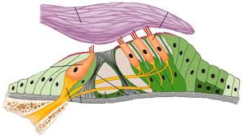

Slides:

88. Anterior segment of the eye

89. Posterior segment of the eye

90. Fasciculus opticus

91. Palpebra

92. Gl. lacrimalis

93. Ductus cochlearis

94. Auricula

Atlas EM:

Development of the eye (97)

Development of the ear (98)