Task VI. Monitoring 1

Required knowledge: The effects of acoustic factors; Audiometry; Blood pressure measuring; Electric properties of tissues.

1. Conductometry
Do not hesitate to ask the teacher to explain the experiment.

2. Audiometry

Main task:
Determination of the zero isophone for air conduction of sound.

Do not start measuring alone, your teacher will show you the right manipulation with audiometer!

Measurement aids and implemnts:
Audiometer AD226, headphones.

Procedure:

- Set “right ear”.
- Set frequency of 125 Hz. Set the lowest intensity level of the tone (-10 dB). Activate the tone approximately for 1s for the right ear; wait for response from the tested subject. If you have no response (the subject did not hear the tone) increase repeatedly intensity by 5 dB and activate tone again till to obtain response. Write down the intensity.
- Repeat this procedure (point 2) for all frequencies enabled by the audiometer (125, 250, 750, 1000, 1500, 2000, 3000, 4000, 6000, 8000 Hz).
- Test the left ear in the same way.

Record:
Create the table of measurements and plot a graph of the dependence of threshold intensity (Y axis) on frequency (X axis) - i.e. the zero isophones – for the right and left ear . So you will have two curves in one graph.
Discuss differences and the application of audiometry in medicine.
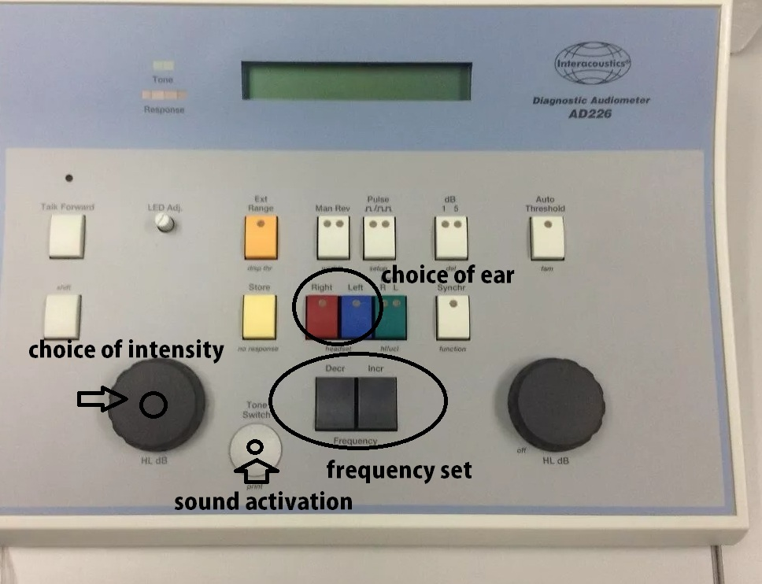

3. Blood flow measurement by the doppler

It will be explained by the teacher.

