**ANATOMICAL DISSECTION –PROTOCOLS**

*L. Kubíčková, K. Vymazalová, and col.*

*Department of Anatomy*

*Faculty of Medicine*

*Masaryk Univerzity*

**Authors:** Karolína Bretová, Veronika Dzetkuličová, Vojtěch Karvay, Erik Kročka, Lucie Kubíčková, Klaudia Lakatosová, Zuzana Musilová, Ivana Pračková, Kateřina Vymazalová

**Reviewers:**

doc. RNDr. Ladislava Horáčková, Ph.D.

doc. MUDr. Ondřej Naňka, Ph.D.

**Introduction**

Dear students,

we are presenting the scripts that should help you to better orientation during the dissection course and to improve your preparation for the final examination. At the same time, we aim to point out clinically significant or frequently occurring anatomical variations.

The scripts are divided into individual chapters and subchapters corresponding to the dissection procedures at the Department of Anatomy, Faculty of Medicine, MUNI.

You can find a list of anatomical variations that you may encounter during the dissection course at the beginning of each chapter. This list can motivate you to find out more information about the variation in order to deepen your knowledge. Moreover, you can use the cited literature, which is at the end of each chapter.

Each subchapter contains the tables with the anatomical structures you should identify, and note the relevant information, such as the course of the nerves or vessels, etc.

The NOTE box is for any variation, or the reason for the absence of the structure (e.g., it was cut out during dissection). This part should be completed during the work in the dissection room.

In the second part of the subchapter, you have the opportunity to draw the schematic drawings of important topographical regions and note the relationships of important anatomical structures. These schemes are also an important part of the final examination. You can work on this part during your self-study time in the red floor or at home.

The final part of each subchapter is devoted to selected clinically significant variations whose presence on the specimens you should observe. You can note any others that you have encountered during dissection.

We wish you all that the scripts will serve the purpose and help you in improving your study of Anatomy.

Lucie Kubíčková and colleagues

**Used abbreviations:**

a. – arteria

aa. – arteriae

ant-. – anterior

cap. – capitis

dx. – dexter

ggl. – ganglion

ggll. – ganglia

inf. – inferior

int. – interna

lat. – lateralis

lig. – ligamentum

med. – medialis

m. – musculus

n. – nervus

nn. – nervi

pl. – plexus

post. – posterior

proc. – processus

r. – ramus

rr. – rami

sin. – sinister

sup. – superior

tr. – truncus

v. – vena

vv. – venae

**Contents:**

1. **DISSECTION OF THE BACK REGION…………………………………8**
   1. **OVERVIEW OF THE MOST COMMON VARIATIONS OF THIS REGION……………………………………………………………………………8**
   2. **POSTERIOR CERVICAL REGION/NUCHAL REGION (*REGIO COLLI POSTERIOR/REGIO NUCHAE*)………………………………………………….9**
   3. **DORSAL REGIONES – SCAPULAR, SUPRASCAPULAR, VERTEBRAL, SACRAL, LUMBAR REGION (*REGIO SCAPULARIS, SUPRASCAPULARIS, VERTEBRALIS, SACRALIS, LUMBALIS*) *……………………………….….…*12**
2. **DISSECTION OF THE UPPER EXTREMITY………………………....17**
   1. **OVERVIEW OF THE MOST COMMON VARIATIONS OF THIS REGION……………………………………………………………………….….17**
   2. **SCAPULAR AND DELTOID REGION (*REGIO SCAPULARIS ET DELTOIDEA*)……………………………………………………….…………….18**
   3. **ANTERIOR BRACHIAL REGION (*REGIO BRACHII ANTERIOR*) ……….22**
   4. **POSTERIOR BRACHIAL REGION (*REGIO BRACHII POSTERIOR*) …….25**
   5. **CUBITAL REGION (*REGIO CUBITI*) ……………………………………...…28**
   6. **ANTERIOR ANTEBRACHIAL REGION (*REGIO ANTEBRACHII ANTERIOR*) + ANTERIOR CARPAL REGION (*REGIO CARPI PALMARE*)………………………………………………………………….…….31**
   7. **POSTERIOR ANTEBRACHIAL REGION (*REGIO ANTEBRACHII POSTERIOR*) + POSTERIOR CARPAL REGION (*REGIO CARPI DORSALE*)………………………………………………………………………..34**
   8. **PALM OF THE HAND (*PALMA MANUS*) + FINGERS (*DIGITOS*)………....37**
   9. **DORSUM OF THE HAND (*DORSUM MANUS*) + FINGERS (*DIGITOS*)…...42**
3. **DISSECTION OF THE LOWER EXTREMITY……………………..…46**
   1. **OVERVIEW OF THE MOST COMMON VARIATIONS OF THIS REGION…………………………………………………………………………..46**
   2. **GLUTEAL REGION (*REGIO GLUTAE*)*…………………………………….…*47**
   3. **ANTERIOR THIGH REGION (*REGIO FEMORIS ANTERIOR*)*………….…*51**
   4. **POSTERIOR THIGH REGION (*REGIO FEMORIS POSTERIOR*)*…….……*55**
   5. **ANTERIOR AND POSTERIOR KNEE REGIONS (*REGIO GENUS ANTERIOR ET POSTERIOR*)*……………………………………………...……*58**
   6. **ANTERIOR LEG REGION (*REGIO CRURIS ANTERIOR*)*………….……….*62**
   7. **POSTERIOR LEG REGION (*REGIO CRURIS POSTERIOR*)*………..………*65**
   8. **MEDIAL MALLEOLAR AND RETROMALLEOLAR REGION (*REGIO MALLEOLARIS ET RETROMALLEOLARIS MEDIALIS*)*……………………*68**
   9. **LATERAL MALLEOLAR AND RETROMALLEOLAR REGION (*REGIO MALLEOLARIS ET RETROMALLEOLARIS LATERALIS*)*………………..…*71**
   10. **SOLE OF THE FOOT (*PLANTA PEDIS*)*………………………………………*74**
   11. **DORSUM OF THE FOOT (*REGIO DORSALIS PEDIS*)*…………..…………..*77**
4. **DISSECTION OF THE NECK ……………………………………...……83**
   1. **OVERVIEW OF THE MOST COMMON VARIATIONS OF THIS REGION……………………………………………………………………….….83**
   2. **LATERAL CERVICAL REGION (*REGIO CERVICALIS LATERALIS*)*……*84**
   3. **SCALENE FISSURE (*FISSURA SCALENORUM*)……………………….……87**
   4. **SCALENOVERTEBRAL TRIANGLE (*TRIGONUM SCALENOVERTEBRALE*)………………………………………………………89**
   5. **OMOTRACHEAL TRIANGLE (*TRIGONUM OMOTRACHEALE*)………...91**
   6. **CAROTID TRIANGLE (*TRIGONUM CAROTICUM*)………………….…….94**
   7. **SUBMANDIBULAR TRIANGLE (*TRIGONUM SUBMANDIBULARE*)…....97**
5. **DISSECTION OF THE THORAX………………………………...……101**
   1. **OVERVIEW OF THE MOST COMMON VARIATIONS OF THIS REGION…………………………………………………………………………101**
   2. **SKIN, SUBCUTANEOUS TISSUE AND MUSCLES OF THE THORACIC WALL……………………………………………………………………………103**
   3. **CLAVIPECTORAL (DELTOPECTORAL) TRIANGLE (*TRIGONUM CLAVIPECTORALE* (*DELTOIDEOPECTORALE*))………………………….107**
   4. **AXILLA…………………………………………………………...…………….110**
   5. **OPENING OF THE THORAX + PHRENIC NERVE + ANTERIOR MEDIASTINUM + LUNG REMOVAL (THE ROOT OF THE LUNG)…….113**
   6. **HEART REMOVAL AND PREPARATION…………………………….……116**
   7. **POSTERIOR MEDIASTINUM…………..……………………………………121**
6. **DISSECTION OF THE ABDOMEN……………………………………127**
   1. **OVERVIEW OF THE MOST COMMON VARIATIONS OF THIS REGION……………………………………………………………………...….127**
   2. **SKIN + SUBCUTANEOUS TISSUE + ABDOMINAL MUSCLE LAYER………………………………………………………………………......130**
   3. **RECTUS SHEAT (*VAGINA MUSCULI RECTI ABDOMINIS*) + LATERAL ABDOMINAL MUSCLES…………………………………..…………………133**
   4. **INGUINAL CANAL (*CANALIS INGUINALIS*)………………..……………..136**
   5. **OPENING OF THE ABDOMINAL CAVITY…………………………….…..139**
   6. **SUPRAMESOCOLIC PART OF THE PERITONEAL CAVITY………..….141**
   7. **INFRAMESOCOLIC PART OF THE PERITONEAL CAVITY……………148**
   8. **RETROPERITONEUM………………………………………………………..152**
7. **PELVIS DISSECTION……………………………………...…………...159**
   1. **OVERVIEW OF THE MOST COMMON VARIATIONS OF THIS REGION…………………………………………………………………..……..159**
   2. **DISSECTION OF THE PENIS AND SCROTUM……….……………………160**
   3. **DISSECTION OF THE MALE PELVIC ORGANS AND INTERNAL ILIAC ARTERY……………………….………………………………………………..162**
   4. **DISSECTION OF THE FEMALE PELVIC ORGANS AND INTERNAL ILIAC ARTERY………………………...………………………………………166**
8. **DISSECTION OF THE HEAD……………………………………….....171**
   1. **OVERVIEW OF THE MOST COMMON VARIATIONS OF THIS REGION………………………………………………………………………....171**
   2. **PAROTIDEOMASSETERIC REGION (*REGIO PAROTIDEOMASSETERICA*)……………………………………………….…..172**
   3. **FACIAL REGIONS (*REGIONES FACIALES*)………………………………….175**
   4. **TEMPORAL REGION (*REGIO TEMPORALIS*)……………………………….178**
   5. **INFRATEMPORAL FOSSA (*FOSSA INFRATEMPORALIS*)*……………..….*180**
   6. **FRONTOPARIETOOCCIPITAL REGION, OPENING OF THE SKULL AND DISSECTION OF DURA MATER……………………………………………....183**
   7. **BRAIN DISSECTION, CIRCLE OF WILLIS (*CIRCULUS ARTERIOSUS CEREBRI*)……………………………………………………………………….…187**
   8. **PHARYNX – SECTIONING PHARYNX……………………………………..…199**
   9. **ORBIT (*ORBITA*)…………………………………………………………………204**
   10. **SUBLINGUAL REGION (*REGIO SUBLINGUALIS*)*……...…………...……*208**
   11. **LARYNX………………………………………………………………............….211**
9. **DISSECTION OF THE BACK REGION (***Klaudia Lakatosová***)**
   1. **OVERVIEW OF THE MOST COMMON VARIATIONS OF THIS REGION**

|  |
| --- |
| **VARIATIONS OF MUSCLES** |
| partial or full absence of trapezius muscle |
| bifurcation of semispinalis capitis muscle |
| rectus capitis posterior major muscle divided into 2/3 parts |
| rectus capitis posterior minor muscle divided into 2/3/4 parts |
| occipitalis minor muscle (of Santorini) |
| spinalis capitis muscle with 2 bellies |
| rhomboideus capitis muscle |
| serratus posterior superior muscle replaced by fibrous tissue |
| serratus posterior inferior muscle replaced by fibrous tissue |
| thoracodorsal artery running on the surface of latissimus dorsi muscle |
| rhomboideus capitis muscle |
| **VARIATIONS OF ARTERIES** |
| duplication of occipital artery |
| thoracodorsal artery running on the surface of latissimus dorsi muscle |
| **VARIATIONS OF NERVES** |
| duplication of greater occipital nerve |
| lesser occipital nerve passing through the sternocleidomastoideus muscle |

**1.2. POSTERIOR CERVICAL REGION/NUCHAL REGION (*REGIO COLLI POSTERIOR/REGIO NUCHAE*)**

|  |  |
| --- | --- |
| SPECIMEN IDENTIFICATION | |
| Specimen number: | side: right/left (*dx/sin*) |

1) SKIN

Inspect the skin in the gluteal region. Note any scars or other damage.

2) SUBCUTANEOUS TISSUE

Indicate which structures you have dissected in the subcutaneous tissue. Mark their presence/absence. Note whether the structure has a standard course. Write down any variations or the reason for their absence:

|  |  |  |  |
| --- | --- | --- | --- |
|  | ✓/x | COURSE | NOTE |
| dorsal branches of the spinal nerves (*rr. dorsales nervorum spinalium*) |  |  |  |
| greater occipital nerve  (*n. occipitalis major*) |  |  |  |
| third occipital nerve  (*n. occipitalis tertius*) |  |  |  |
| lesser occipital nerve  (*n. occipitalis minor*) |  |  |  |
| occipital artery(*a. occipitalis*) |  |  |  |
| occipital vein(*v. occipitalis*) |  |  |  |

3) DEEP LAYER

A) MUSCLES

Identify the muscles, mark their presence/absence, include their innervation, origin, and insertion. Note any variations found in the appropriate muscles or the reason for the absence of the muscle:

|  |  |  |  |  |  |
| --- | --- | --- | --- | --- | --- |
|  | ✓/x | INNERVATION | ORIGIN | INSERTION | NOTE |
| trapezius muscle |  |  |  |  |  |
| splenius capitis muscle |  |  |  |  |  |
| splenius cervicis muscle |  |  |  |  |  |
| levator scapulae muscle |  |  |  |  |  |
| longissimus capitis muscle |  |  |  |  |  |
| longissimus cervicis muscle |  |  |  |  |  |
| semispinalis capitis muscle |  |  |  |  |  |
| semispinalis cervicis muscle |  |  |  |  |  |
| rectus capitis post. major muscle |  |  |  |  |  |
| rectus capitis post. minor muscle |  |  |  |  |  |
| obliquus capitis sup. muscle |  |  |  |  |  |
| obliquus capitis inf. muscle |  |  |  |  |  |

B) VESSELS

Identify the arteries (veins), mark their presence/absence, course, and include their area of supply (where does it drain). Note any variations found in the appropriate arteries (veins) (e.g., unusual branching) or the reason for the absence of the artery (vein):

|  |  |  |  |  |
| --- | --- | --- | --- | --- |
|  | ✓/x | COURSE | AREA OF SUPPLY | NOTE |
| occipital artery (*a. occipitalis*) |  |  |  |  |
| vertebral artery (*a. vertebralis*) |  |  |  |  |
| deep cervical artery  (*a. cervicalis profunda*) |  |  |  |  |
| transverse cervical artery  (*a. transversa colli*) |  |  |  |  |
|  | ✓/x | COURSE | IS A TRIBUTARY OF | NOTE |
| suboccipital venous plexus  (*plexus venosus suboccipitalis*) |  |  |  |  |

C) NERVES:

Identify the nerves, mark their presence/absence, course, and include their area of innervation. Note any variations found in the appropriate nerves or the reason for the absence of the nerve:

|  |  |  |  |  |
| --- | --- | --- | --- | --- |
|  | ✓/x | COURSE | AREA OF INNERVATION | NOTE |
| accessory nerve  (*n. accessorius*) |  |  |  |  |
| suboccipital nerve(*n. suboccipitalis*) |  |  |  |  |

4) DRAW AND LABEL THE SCHEMATIC DRAWING OF THE SUBOCCIPITAL TRIANGLE – BORDERS AND CONTENT:

5) VARIATIONS MOST COMMONLY FOUND IN THIS AREA:

Mark the presence/absence of each of the appropriate variations:

|  |  |
| --- | --- |
|  | ✓/x |
| partial or full absence of trapezius m. |  |
| bifurcation of semispinalis capitis m. |  |
| rectus capitis posterior major m. divided into 2/3 parts |  |
| rectus capitis posterior minor m. divided into 2/3/4 parts |  |
| occipitalis minor m. (of Santorini) |  |
| spinalis capitis muscle with 2 bellies |  |
| duplication of occipital artery |  |
| lesser occipital n. passing through sternocleidomastoideus m. |  |
| duplication of greater occipital n. |  |

6) DESCRIBE AND DRAW ANY OTHER VARIATIONS IDENTIFIED IN THIS AREA:

**1.3. DORSAL REGIONES – SCAPULAR, SUPRASCAPULAR, VERTEBRAL, SACRAL, LUMBAR REGION (*REGIO SCAPULARIS, SUPRASCAPULARIS, VERTEBRALIS, SACRALIS, LUMBALIS*)**

|  |  |
| --- | --- |
| SPECIMEN IDENTIFICATION | |
| Specimen number: | side: right/left (*dx/sin*) |

1) SKIN

Inspect the skin in the gluteal region. Note any scars or other damage.

2) SUBCUTANEOUS TISSUE

Indicate which structures you have dissected in the subcutaneous tissue. Mark their presence/absence. Note whether the structure has a standard course. Write down any variations or the reason for their absence:

|  |  |  |  |
| --- | --- | --- | --- |
|  | ✓/x | COURSE | NOTE |
| dorsal branches of the spinal nerves(*rr. dorsales nervorum spinalium*) |  |  |  |
| posterior intercostal arteries  (*aa. intercostales posteriores*) |  |  |  |
| posterior intercostal veins  (*vv. intercostales posteriores*) |  |  |  |
| thoracodorsal fascia  (*fascia thoracodorsalis*) |  |  |  |
| thoracolumbar fascia  (*fascia thoracolumbalis*) |  |  |  |

3) DEEP LAYER

A) EXTRINSIC BACK MUSCLES

Identify the muscles, mark their presence/absence, include their innervation, origin, and insertion. Note any variations found in the appropriate muscles or the reason for the absence of the muscle:

|  |  |  |  |  |  |
| --- | --- | --- | --- | --- | --- |
|  | ✓/x | INNERVATION | ORIGIN | INSERTION | NOTE |
| trapezius muscle |  |  |  |  |  |
| latissimus dorsi muscle |  |  |  |  |  |
| levator scapulae muscle |  |  |  |  |  |
| rhomboideus minor muscle |  |  |  |  |  |
| rhomboideus major muscle |  |  |  |  |  |
| serratus posterior superior muscle |  |  |  |  |  |
| serratus posterior inferior muscle |  |  |  |  |  |

B) INTRINSIC BACK MUSCLES

|  |  |  |  |  |  |
| --- | --- | --- | --- | --- | --- |
|  | ✓/x | INNERVATION | ORIGIN | INSERTION | NOTE |
| splenius capitis muscle |  |  |  |  |  |
| splenius cervicis muscle |  |  |  |  |  |
| longissimus cervicis muscle |  |  |  |  |  |
| longissimus dorsi muscle |  |  |  |  |  |
| iliocostalis muscle |  |  |  |  |  |
| spinalis cervicis muscle |  |  |  |  |  |
| spinalis thoracis muscle |  |  |  |  |  |
| interspinales cervicis muscles |  |  |  |  |  |
| interspinales lumborum mm. |  |  |  |  |  |
| semispinalis cervicis muscle |  |  |  |  |  |
| semispinalis thoracis muscle |  |  |  |  |  |
| multifidi muscles |  |  |  |  |  |
| rotatores muscles |  |  |  |  |  |

C) VESSELS

Identify the arteries (veins), mark their presence/absence, course, and include their area of supply (where does it drain). Note any variations found in the appropriate arteries (veins) (e.g., unusual branching) or the reason for the absence of the artery (vein):

|  |  |  |  |  |
| --- | --- | --- | --- | --- |
|  | ✓/x | COURSE | AREA OF SUPPLY | NOTE |
| transverse cervical artery  (*a. transversa colli*) |  |  |  |  |
| thoracodorsal artery  (*a. thoracodorsalis****)*** |  |  |  |  |
| lumbar arteries(*aa. lumbales*) |  |  |  |  |
| deep cervical artery  (*a. cervisalis profunda*) |  |  |  |  |
|  | ✓/x | COURSE | IS A TRIBUTARY OF | NOTE |
| deep cervical vein  (*v. cervicalis profunda*) |  |  |  |  |
| thoracodorsal vein  *(v. thoracodorsalis)* |  |  |  |  |

D) NERVES:

Identify the nerves, mark their presence/absence, course, and include their area of innervation. Note any variations found in the appropriate nerves or the reason for the absence of the nerve:

|  |  |  |  |  |
| --- | --- | --- | --- | --- |
|  | ✓/x | COURSE | AREA OF INNERVATION | NOTE |
| accessory nerve  (*n. accesorius*) |  |  |  |  |
| thoracodorsal nerve  (*n. thoracodorsalis*) |  |  |  |  |
| dorsal scapular nerve(*n. dorsalis scapulae*) |  |  |  |  |
| intercostal nerves  (*nn. intercostales*) |  |  |  |  |

4) DRAW AND LABEL THE SCHEMATIC DRAWING OF THE INFERIOR LUMBAR TRIANGLE (PETITI), DESCRIBE THE BORDERS:

5) DRAW AND LABEL THE SCHEMATIC DRAWING OF THE SUPERIOR LUMBAR TRIANGLE (GRINFELTTI), DESCRIBE THE BORDERS. EXPLAIN THE DIFFERENCE BETWEEN THE GRINFELTTI TRIANGLE AND KRAUSEI TETRAGON:

6) VARIATIONS MOST COMMONLY FOUND IN THIS AREA:

Mark the presence/absence of each of the appropriate variations:

|  |  |
| --- | --- |
|  | ✓/x |
| rhomboideus capitis m. |  |
| serratus posterior superior muscle replaced by fibrous tissue |  |
| serratus posterior inferior muscle replaced by fibrous tissue |  |
| thoracodorsal a. running on the surface of latissimus dorsi m. |  |

7) DESCRIBE AND DRAW ANY OTHER VARIATIONS IDENTIFIED IN THIS AREA:

**BIBLIOGRAPHY:**

CELIK, H. H. et al. Bilateral anomaly of the semispinalis capitis muscle. *Morphologie: Bulletin De l’Association Des Anatomistes* 1997, **81**, s. 15.

*Duplicated axillary arch muscles arising from the latissimus dorsi* (no date). Available at: https://www.ncbi.nlm.nih.gov/pmc/articles/PMC3531594/ (Accessed: 7 July 2021).

EMSLEY, J. G. a DAVIS, M. D. Partial unilateral absence of the trapezius muscle in a human cadaver. *Clinical Anatomy* 2001, **14**, s. 383-386. doi: 10.1002/ca.1068.

HUMPHRY, G. M. Lectures on the Varieties in the Muscles of Man. *British Medical Journal* 1873, **2**, s. 33-37.

KAMIBAYASHI, L. K. a RICHMOND, F. J. Morphometry of human neck muscles’, *Spine* 1998, **23**, s. 1314-1323. doi: 10.1097/00007632-199806150-00005.

TUBBS, S. R., MOHAMMADALI, S. M. a LOUKAS, M. *Bergman´s Comprehensive Encyclopedia of Human Anatomic Variation* [online]. Hoboken, N. J: Wiley-Blackwell, 2016, 1432 s. [cit. 2021-05-26]. ISBN 9781118430354. Available at: <https://eds.a.ebscohost.com/eds/ebookviewer/ebook/bmxlYmtfXzEyMjc5ODFfX0FO0?sid=83fc6545-baf5-4b5c-bcb7-f51051acac65@sessionmgr4006&vid=1&format=EB&rid=1>

**2. DISSECTION OF THE UPPER EXTREMITY (***Kateřina Vymazalová***)**

**2.1. OVERVIEW OF THE MOST COMMON VARIATIONS OF THIS REGION**

|  |
| --- |
| **VARIATIONS OF MUSCLES** |
| subscapularis minor muscle |
| third head of the biceps brachii muscle |
| Epitrochleoanconeus muscle |
| absent palmaris longus muscle |
| Gantzer muscle: accessory portion of flexor pollicis longus or flexor digitoum profundus |
| arcade of Frohse (thicker fibrous margin of the superficial part of the supinator) |
| tendinous ulnar head of the pronator teres muscle |
| absent flexor pollicis brevis muscle |
| 4th palmar interosseous muscle |
| **VARIATIONS OF ARTERIES** |
| suprascapular artery (*a. suprascapularis*) passes beneath the superior transverse scapular ligament (*lig. transversum scapulae superius*) |
| brachioradial artery (*a. brachioradialis*) |
| superficial brachial artery (*a. brachialis superficialis*) |
| median artery (*a. mediana*) |
| incomplete superficial palmar arch (*arcus palmaris superficialis*) |
| **VARIATIONS OF VEINS** |
| median cubital vein (*v. mediana cubiti*) - its shape: M/Y/N/W |
| **VARIATIONS OF NERVES** |
| medial head of the triceps brachii is innervated by ulnar nerve |
| absent musculocutaneous nerve (*n. musculocutaneus*) |
| musculocutaneous nerve (*n. musculocutaneus*) doesn’t pierce through coracobrachialis m. |
| Martin-Gruber anastomosis:connection between ulnar nerve and median nerve |
| superficial branch of the radial nerve (*r. superficialis n. radialis*) passes through split tendon of brachioradialis m. |
| **OTHER VARIATIONS** |
| supracondylar spur (*proc. supracondylaris humeri*) |
| Struthers’ ligament: Arcade of Struthers: thickening of the brachial fascia |
| Osborne´s ligament: cubital tunnel retinaculum |

**2.2. SCAPULAR AND DELTOID REGION (*REGIO SCAPULARIS ET DELTOIDEA*)**

|  |  |
| --- | --- |
| SPECIMEN IDENTIFICATION | |
| Specimen number: | side: right/left (*dx/sin*) |

1) SKIN

Inspect the skin in the scapular and deltoid regions. Note any scars or other damage.

2) SUBCUTANEOUS TISSUE

Indicate which structures you have dissected in the subcutaneous tissue. Mark their presence/absence. Note whether the structure has a standard course. Write down any variations or the reason for their absence:

|  |  |  |  |
| --- | --- | --- | --- |
|  | ✓/x | COURSE | NOTE |
| superior lateral brachial cutaneous nerve  (*n. cutaneus brachii lateralis superior*) |  |  |  |
| inferior lateral brachial cutaneous nerve  (*n. cutaneus brachii lateralis inferior*) |  |  |  |
| supraclavicular nerves (*nn. supraclaviculares*) |  |  |  |
| cephalic vein (*v. cephalica*) |  |  |  |

3) DEEP LAYER

A) MUSCLES

Identify the muscles, mark their presence/absence, include their innervation, origin, and insertion. Note any variations found in the appropriate muscles or the reason for the absence of the muscle:

|  |  |  |  |  |  |
| --- | --- | --- | --- | --- | --- |
|  | ✓/x | INNERVATION | ORIGIN | INSERTION | NOTE |
| deltoid muscle |  |  |  |  |  |
| supraspinatus muscle |  |  |  |  |  |
| infraspinatus muscle |  |  |  |  |  |
| teres minor muscle |  |  |  |  |  |
| teres major muscle |  |  |  |  |  |
| subscapularis muscle |  |  |  |  |  |

B) ARTERIES

Identify the arteries, mark their presence/absence, course, and include their area of supply. Note any variations found in the appropriate arteries (e.g., unusual branching) or the reason for the absence of the artery:

|  |  |  |  |  |
| --- | --- | --- | --- | --- |
|  | ✓/x | COURSE | AREA OF SUPPLY | NOTE |
| suprascapular artery  (*a. suprascapularis*) |  |  |  |  |
| posterior circumflex humeral artery (*a. circumflexa humeri posterior*) |  |  |  |  |
| circumflex scapular artery  (*a. circumflexa scapulae*) |  |  |  |  |
| anterior circumflex humeral artery (*a. circumflexa humeri anterior*) |  |  |  |  |
| subscapular artery  (*a. subscapularis*) |  |  |  |  |
| thoracodorsal artery  (*a. thoracodorsalis*) |  |  |  |  |

C) NERVES

Identify the nerves, mark their presence/absence, course, and include their area of innervation. Note any variations found in the appropriate nerves or the reason for the absence of the nerve:

|  |  |  |  |  |
| --- | --- | --- | --- | --- |
|  | ✓/x | COURSE | AREA OF INNERVATION | NOTE |
| medial cord  (*fasciculus medialis*) |  |  |  |  |
| posterior cord  (*fasciculus posterior*) |  |  |  |  |
| lateral cord  (*fasciculus lateralis*) |  |  |  |  |
| axillary nerve (*n. axillaris*) |  |  |  |  |
| suprascapular nerve  (*n. suprascapularis*) |  |  |  |  |
| subscapular nerve  (*n. subscapularis*) |  |  |  |  |
| thoracodorsal nerve  (*n. thoracodorsalis*) |  |  |  |  |

4) DRAW AND LABEL THE SCHEMATIC DRAWING OF THE *FORAMEN OMOTRICIPITALE* AND *FORAMEN HUMEROTRICIPITALE* – BORDERS AND CONTENT:

5) WRITE OTHER ADJACENT MUSCLES (12), WHOSE ORIGINS OR INSERTIONS ARE PART OF THESE TWO REGIONS. MARK THEIR PRESENCE/ABSENCE, INCLUDE THEIR INNERVATION, ORIGIN, OR INSERTION. NOTE ANY VARIATIONS FOUND IN THE APPROPRIATE MUSCLES OR THE REASON FOR THE ABSENCE OF THE MUSCLE:

|  |  |  |  |  |
| --- | --- | --- | --- | --- |
| MUSCLE | ✓/x | INNERVATION | ORIGION/INSERTION | NOTE |
|  |  |  |  |  |
|  |  |  |  |  |
|  |  |  |  |  |
|  |  |  |  |  |
|  |  |  |  |  |
|  |  |  |  |  |
|  |  |  |  |  |
|  |  |  |  |  |
|  |  |  |  |  |
|  |  |  |  |  |
|  |  |  |  |  |
|  |  |  |  |  |

6) WRITE THE ROTATOR CUFF MUSCLES AND THEIR FUNCTIONS:

7) LABEL THE SUPERIOR TRANSVERSE SCAPULAR LIGAMENT (*LIG. TRANSVERSUM SCAPULAE SUPERIUS*) AND ADJACENT STRUCTURES INTO THE SCHEMATIC DRAWING:

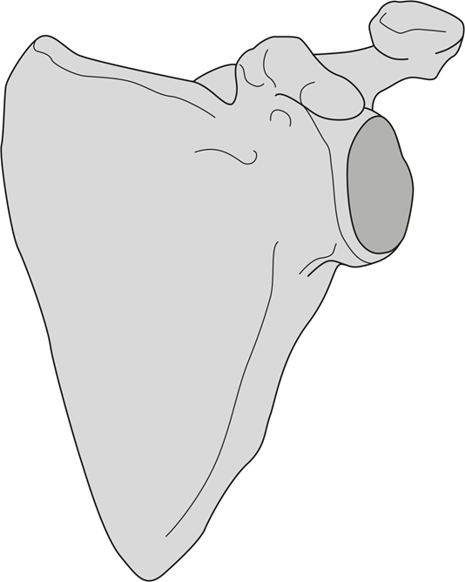

8) VARIATIONS MOST COMMONLY FOUND IN THIS AREA:

Mark the presence/absence of each of the appropriate variations:

|  |  |
| --- | --- |
|  | ✓/x |
| suprascapular artery (*a. suprascapularis*) passes beneath the superior transverse scapular ligament (*lig. transversum scapulae superius*) |  |
| subscapularis minor muscle (*m. subscapularis minor*) |  |

9) DESCRIBE AND DRAW ANY OTHER VARIATIONS IDENTIFIED IN THIS AREA:

**2.3. ANTERIOR BRACHIAL REGION (*REGIO BRACHII ANTERIOR*)**

|  |  |
| --- | --- |
| SPECIMEN IDENTIFICATION | |
| Specimen number: | side: right/left (*dx/sin*) |

1) SKIN

Inspect the skin in the anterior brachial region. Note any scars or other damage.

2) SUBCUTANEOUS TISSUE

Indicate which structures you have dissected in the subcutaneous tissue. Mark their presence/absence. Note whether the structure has a standard course. Write down any variations or the reason for their absence:

|  |  |  |  |
| --- | --- | --- | --- |
|  | ✓/x | COURSE | NOTE |
| intercostobrachial nerves (*nn. intercostobrachiales*) |  |  |  |
| medial brachial cutaneous nerve  (*n. cutaneus brachii medialis*) |  |  |  |
| medial antebrachial cutaneous nerve  (*n. cutaneus antebrachii medialis*) |  |  |  |
| basilic vein (*v. basilica*) |  |  |  |
| cephalic vein (*v. cephalica*) |  |  |  |

3) DEEP LAYER

A) MUSCLES

Identify the muscles, mark their presence/absence, include their innervation, origin, and insertion. Note any variations found in the appropriate muscles or the reason for the absence of the muscle:

|  |  |  |  |  |  |
| --- | --- | --- | --- | --- | --- |
|  | ✓/x | INNERVATION | ORIGIN | INSERTION | NOTE |
| biceps brachii muscle |  |  |  |  |  |
| coracobrachialis m. |  |  |  |  |  |
| brachialis muscle |  |  |  |  |  |

B) ARTERIES

Identify the arteries, mark their presence/absence, course, and include their area of supply. Note any variations found in the appropriate arteries (e.g., unusual branching) or the reason for the absence of the artery:

|  |  |  |  |  |
| --- | --- | --- | --- | --- |
|  | ✓/x | COURSE | AREA OF SUPPLY | NOTE |
| brachial artery (*a. brachialis*) |  |  |  |  |
| superior ulnar collateral artery (*a. collateralis ulnaris superior*) |  |  |  |  |
| inferior ulnar collateral artery (*a. collateralis ulnaris inferior*) |  |  |  |  |

C) NERVES

Identify the nerves, mark their presence/absence, course, and include their area of innervation. Note any variations found in the appropriate nerves or the reason for the absence of the nerve:

|  |  |  |  |  |
| --- | --- | --- | --- | --- |
|  | ✓/x | COURSE | AREA OF INNERVATION | NOTE |
| musculocutaneous nerve  (*n. musculocutaneus*) |  |  |  |  |
| median nerve (*n. medianus*) |  |  |  |  |
| ulnar nerve (*n. ulnaris*) |  |  |  |  |

4) DRAW AND LABEL THE STRUCTURES PASSING THROUGH THE MEDIAL AND LATERAL BICIPITAL GROOVES (*SULCUS BICIPITALIS MEDIALIS ET LATERALIS*):

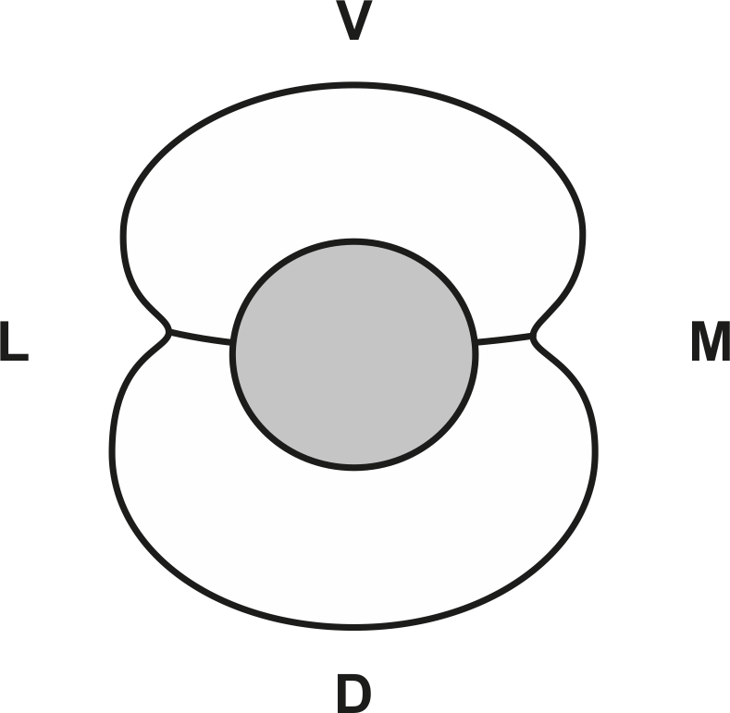

5) DRAW AND LABEL THE SCHEMATIC DRAWING OF THE RELATIONSHIP BETWEEN THE CORACOBRACHIALIS MUSCLE (*MUSCULUS CORACOBRACHIALIS*) AND MUSCULOCUTANEOUS NERVE (*NERVUS MUSCULOCUTANEUS*):

6) VARIATIONS MOST COMMONLY FOUND IN THIS AREA:

Mark the presence/absence of each of the appropriate variations:

|  |  |
| --- | --- |
|  | ✓/x |
| absent musculocutaneous nerve (*n. musculocutaneus*) |  |
| brachioradial artery (*a. brachioradialis*) |  |
| superficial brachial artery (*a. brachialis superficialis*) |  |
| third head of the biceps brachii muscle (*m. biceps brachii*) |  |
| supracondylar spur (*proc. supracondylaris humeri*) |  |
| Struthers’ ligament – Arcade of Struters |  |

7) DESCRIBE AND DRAW ANY OTHER VARIATIONS IDENTIFIED IN THIS AREA:

**2.4. POSTERIOR BRACHIAL REGION (*REGIO BRACHII POSTERIOR*)**

|  |  |
| --- | --- |
| SPECIMEN IDENTIFICATION | |
| Specimen number: | side: right/left (*dx/sin*) |

1) SKIN

Inspect the skin in the posterior brachial region. Note any scars or other damage.

2) SUBCUTANEOUS TISSUE

Indicate which structures you have dissected in the subcutaneous tissue. Mark their presence/absence. Note whether the structure has a standard course. Write down any variations or the reason for their absence:

|  |  |  |  |
| --- | --- | --- | --- |
|  | ✓/x | COURSE | NOTE |
| superior lateral brachial cutaneous nerve  (*n. cutaneus brachii lateralis superior*) |  |  |  |
| inferior lateral brachial cutaneous nerve  (*n. cutaneus brachii lateralis inferior*) |  |  |  |
| posterior brachial cutaneous nerve  (*n. cutaneus brachii posterior*) |  |  |  |
| posterior antebrachial cutaneous nerve  (*n. cutaneus antebrachii posterior*) |  |  |  |

3) DEEP LAYER

A) MUSCLES

Identify the muscles, mark their presence/absence, include their innervation, origin, and insertion. Note any variations found in the appropriate muscles or the reason for the absence of the muscle:

|  |  |  |  |  |  |
| --- | --- | --- | --- | --- | --- |
|  | ✓/x | INNERVATION | ORIGIN | INSERTION | NOTE |
| triceps brachii muscle |  |  |  |  |  |
| anconeus muscle |  |  |  |  |  |

B) ARTERIES

Identify the arteries, mark their presence/absence, course, and include their area of supply. Note any variations found in the appropriate arteries (e.g., unusual branching) or the reason for the absence of the artery:

|  |  |  |  |  |
| --- | --- | --- | --- | --- |
|  | ✓/x | COURSE | AREA OF SUPPLY | NOTE |
| deep brachial artery  (*a. profunda brachii*) |  |  |  |  |
| middle collateral artery  (*a. collateralis media*) |  |  |  |  |
| radial collateral artery  (*a. collateralis radialis*) |  |  |  |  |
| humeral nutrient artery  (*a. nutricia humeri*) |  |  |  |  |

C) NERVES

Identify the nerves, mark their presence/absence, course, and include their area of innervation. Note any variations found in the appropriate nerves or the reason for the absence of the nerve:

|  |  |  |  |  |
| --- | --- | --- | --- | --- |
|  | ✓/x | COURSE | AREA OF INNERVATION | NOTE |
| radial nerve (*n. radialis*) |  |  |  |  |

4) DRAW AND LABEL THE RADIAL NERVE (*NERVUS RADIALIS*) AND THE DEEP BRACHIAL ARTERY (*ARTERIA PROFUNDA BRACHII*) INTO THE SCHEMATIC DRAWING:

5) VARIATIONS MOST COMMONLY FOUND IN THIS AREA:

Mark the presence/absence of each of the appropriate variations:

|  |  |
| --- | --- |
|  | ✓/x |
| epitrochleoanconeus muscle (*m. epitrochleoanconaeus*) |  |
| medial head of the triceps brachii muscle (*caput mediale musculi tricipitis brachii*) innervated from the ulnar nerve (*n. ulnaris*) |  |

6) DESCRIBE AND DRAW ANY OTHER VARIATIONS IDENTIFIED IN THIS AREA:

**2.5. CUBITAL REGION (*REGIO CUBITI*)**

|  |  |
| --- | --- |
| SPECIMEN IDENTIFICATION | |
| Specimen number: | side: right/left (*dx/sin*) |

1) SKIN

Inspect the skin in the cubital region. Note any scars or other damage.

2) SUBCUTANEOUS TISSUE

Indicate which structures you have dissected in the subcutaneous tissue. Mark their presence/absence. Note whether the structure has a standard course. Write down any variations or the reason for their absence:

|  |  |  |  |
| --- | --- | --- | --- |
|  | ✓/x | COURSE | NOTE |
| lateral antebrachial cutaneous nerve  (*n. cutaneus antebrachii lateralis*) |  |  |  |
| medial antebrachial cutaneous nerve  (*n. cutaneus antebrachii medialis*) |  |  |  |
| posterior antebrachial cutaneous nerve  (*n. cutaneus antebrachii posterior*) |  |  |  |
| superficial branch of the radial nerve  (*r. superficialis n. radialis*) |  |  |  |
| basilic vein (*v. basilica*) |  |  |  |
| cephalic vein (*v. cephalica*) |  |  |  |
| median cubital vein (*v. mediana cubiti*) |  |  |  |

3) DEEP LAYER

A) ARTERIES

Identify the arteries, mark their presence/absence, course, and include their area of supply. Note any variations found in the appropriate arteries (e.g., unusual branching) or the reason for the absence of the artery:

|  |  |  |  |  |
| --- | --- | --- | --- | --- |
|  | ✓/x | COURSE | AREA OF SUPPLY | NOTE |
| brachial artery (*a. brachialis*) |  |  |  |  |
| recurrent radial artery  (*a. recurrens radialis*) |  |  |  |  |
| radial collateral artery  (*a. collateralis radialis*) |  |  |  |  |

B) NERVES

Identify the nerves, mark their presence/absence, course, and include their area of innervation. Note any variations found in the appropriate nerves or the reason for the absence of the nerve:

|  |  |  |  |  |
| --- | --- | --- | --- | --- |
|  | ✓/x | COURSE | AREA OF INNERVATION | NOTE |
| deep branch of the radial nerve (*r. profundus n. radialis*) |  |  |  |  |
| ulnar nerve (*n. ulnaris*) |  |  |  |  |
| median nerve (*n. medianus*) |  |  |  |  |

4) DRAW AND LABEL SCHEMATIC DRAWING OF THE CUBITAL FOSSA (*FOSSA CUBITI*):

5) WRITE THE MUSCLES WHOSE ORIGIN OR INSERTION IS PRESENT IN THIS REGION:

6) VARIATIONS MOST COMMONLY FOUND IN THIS AREA:

Mark the presence/absence of each of the appropriate variations:

|  |  |  |
| --- | --- | --- |
|  | ✓/x | |
| median cubital vein (*v. mediana cubiti*) |  | SHAPE (M/Y/N/W) |
| Osborne´s ligament: cubital tunnel retinaculum |  |  |

7) DESCRIBE AND DRAW ANY OTHER VARIATIONS IDENTIFIED IN THIS AREA:

**2.6.** **ANTERIOR ANTEBRACHIAL REGION (*REGIO ANTEBRACHII ANTERIOR*) + ANTERIOR CARPAL REGION (*REGIO CARPI PALMARE*)**

|  |  |
| --- | --- |
| SPECIMEN IDENTIFICATION | |
| Specimen number: | side: right/left (*dx/sin*) |

1) SKIN

Inspect the skin in the anterior antebrachial and anterior carpal regions. Note any scars or other damage.

2) SUBCUTANEOUS TISSUE

Indicate which structures you have dissected in the subcutaneous tissue. Mark their presence/absence. Note whether the structure has a standard course. Write down any variations or the reason for their absence:

|  |  |  |  |
| --- | --- | --- | --- |
|  | ✓/x | COURSE | NOTE |
| lateral antebrachial cutaneous nerve  (*n. cutaneus antebrachii lateralis*) |  |  |  |
| medial antebrachial cutaneous nerve  (*n. cutaneus antebrachii medialis*) |  |  |  |
| superficial branch of the radial nerve  (*r. superficialis nervi radialis*) |  |  |  |
| basilic vein (*v. basilica*) |  |  |  |
| cephalic vein (*v. cephalica*) |  |  |  |

3) DEEP LAYER

A) MUSCLES

Identify the muscles, mark their presence/absence, include their innervation, origin, and insertion. Note any variations found in the appropriate muscles or the reason for the absence of the muscle:

|  |  |  |  |  |  |
| --- | --- | --- | --- | --- | --- |
|  | ✓/x | INNERVATION | ORIGIN | INSERTION | NOTE |
| pronator teres m. |  |  |  |  |  |
| palmaris longus m. |  |  |  |  |  |
| flexor carpi radialis m. |  |  |  |  |  |
| flexor carpi ulnaris m. |  |  |  |  |  |
| flexor digitorum superficialis m. |  |  |  |  |  |
| flexor digitorum profundus m. |  |  |  |  |  |
| flexor pollicis longus m. |  |  |  |  |  |
| pronator quadratus m. |  |  |  |  |  |
| supinator m. |  |  |  |  |  |

B) ARTERIES

Identify the arteries, mark their presence/absence, course, and include their area of supply. Note any variations found in the appropriate arteries (e.g., unusual branching) or the reason for the absence of the artery:

|  |  |  |  |  |
| --- | --- | --- | --- | --- |
|  | ✓/x | COURSE | AREA OF SUPPLY | NOTE |
| radial artery (*a. radialis*) |  |  |  |  |
| ulnar artery (*a. ulnaris*) |  |  |  |  |
| recurrent radial artery  (*a. recurrens radialis*) |  |  |  |  |
| recurrent ulnar artery  (*a. recurrens ulnaris*) |  |  |  |  |
| anterior interosseous artery  (*a. interossea antebrachii ant.*) |  |  |  |  |

C) NERVES

Identify the nerves, mark their presence/absence, course, and include their area of innervation. Note any variations found in the appropriate nerves or the reason for the absence of the nerve:

|  |  |  |  |  |
| --- | --- | --- | --- | --- |
|  | ✓/x | COURSE | AREA OF INNERVATION | NOTE |
| superficial branch of the radial nerve (*r. superficialis n. radialis*) |  |  |  |  |
| median nerve (*n. medianus*) |  |  |  |  |
| anterior interosseous nerve (*n. interosseus antebrachii anterior*) |  |  |  |  |
| ulnar nerve (*n. ulnaris*) |  |  |  |  |
| dorsal branch of the ulnar nerve  (*r. dorsalis n. ulnaris*) |  |  |  |  |

4) DRAW AND LABEL THE SCHEMATIC DRAWING (CROSS SECTION) OF THE CARPAL CANAL (*CANALIS CARPI*) (INCLUDING CONTENTS):

5) VARIATIONS MOST COMMONLY FOUND IN THIS AREA:

Mark the presence/absence of each of the appropriate variations:

|  |  |
| --- | --- |
|  | ✓/x |
| absent palmaris longus muscle |  |
| Gantzer muscle |  |
| arcade of Frohse |  |
| tendinous ulnar head of the pronator teres muscle |  |
| median artery (*a. mediana*) |  |
| Martin-Gruber anastomosis |  |

6) DESCRIBE AND DRAW ANY OTHER VARIATIONS IDENTIFIED IN THIS AREA:

**2.7.** **POSTERIOR ANTEBRACHIAL REGION (*REGIO ANTEBRACHII POSTERIOR*) + POSTERIOR CARPAL REGION (*REGIO CARPI DORSALE*)**

|  |  |
| --- | --- |
| SPECIMEN IDENTIFICATION | |
| Specimen number: | side: right/left (*dx/sin*) |

1) SKIN

Inspect the skin in the posterior antebrachial and posterior carpal regions. Note any scars or other damage.

2) SUBCUTANEOUS TISSUE

Indicate which structures you have dissected in the subcutaneous tissue. Mark their presence/absence. Note whether the structure has a standard course. Write down any variations or the reason for their absence:

|  |  |  |  |
| --- | --- | --- | --- |
|  | ✓/x | COURSE | NOTE |
| posterior antebrachial cutaneous nerve  (*n. cutaneus antebrachii posterior*) |  |  |  |
| dorsal branch of the ulnar nerve  (*r. dorsalis n. ulnaris*) |  |  |  |
| superficial branch of the radial nerve  (*r. superficialis n. radialis*) |  |  |  |

3) DEEP LAYER

A) MUSCLES

Identify the muscles, mark their presence/absence, include their innervation, origin, and insertion. Note any variations found in the appropriate muscles or the reason for the absence of the muscle:

|  |  |  |  |  |  |
| --- | --- | --- | --- | --- | --- |
|  | ✓/x | INNERVATION | ORIGIN | INSERTION | NOTE |
| extensor digitorum m. |  |  |  |  |  |
| extensor digiti minimi m. |  |  |  |  |  |
| extensor carpi ulnaris m. |  |  |  |  |  |
| abductor pollicis longus m. |  |  |  |  |  |
| extensor pollicis brevis m. |  |  |  |  |  |
| extensor pollicis longus m. |  |  |  |  |  |
| extensor indicis m. |  |  |  |  |  |
| brachioradialis m. |  |  |  |  |  |
| extensor carpi radialis longus m. |  |  |  |  |  |
| extensor carpi radialis brevis m. |  |  |  |  |  |

B) ARTERIES

Identify the arteries, mark their presence/absence, course, and include their area of supply. Note any variations found in the appropriate arteries (e.g., unusual branching) or the reason for the absence of the artery:

|  |  |  |  |  |
| --- | --- | --- | --- | --- |
|  | ✓/x | COURSE | AREA OF SUPPLY | NOTE |
| posterior interosseous artery (*a. interossea posterior*) |  |  |  |  |
| anterior interosseous artery (*a. interossea anterior*) |  |  |  |  |

C) NERVES

Identify the nerves, mark their presence/absence, course, and include their area of innervation. Note any variations found in the appropriate nerves or the reason for the absence of the nerve:

|  |  |  |  |  |
| --- | --- | --- | --- | --- |
|  | ✓/x | COURSE | AREA OF INNERVATION | NOTE |
| superficial branch of the radial nerve (*r. superficialis n. radialis*) |  |  |  |  |

4) DRAW AND LABEL THE SCHEMATIC DRAWING OF THE ANATOMICAL SNUFF BOX (*FOVEOLA RADIALIS*):

5) VARIATIONS MOST COMMONLY FOUND IN THIS AREA:

Mark the presence/absence of each of the appropriate variations:

|  |  |
| --- | --- |
|  | ✓/x |
| split tendon of the brachioradialis muscle |  |
| superficial branch of the radial nerve (*r. superficialis n. radialis*) passes through split tendon of the brachioradialis muscle |  |
| accessory head of pollicis longus |  |

6) DESCRIBE AND DRAW ANY OTHER VARIATIONS IDENTIFIED IN THIS AREA:

**2.8.** **PALM OF THE HAND (*PALMA MANUS*) + FINGERS (*DIGITOS*)**

|  |  |
| --- | --- |
| SPECIMEN IDENTIFICATION | |
| Specimen number: | side: right/left (*dx/sin*) |

1) SKIN

Inspect the skin in the hand and palmar side of the fingers. Note any scars or other damage.

2) SUBCUTANEOUS TISSUE

Indicate which structures you have dissected in the subcutaneous tissue. Mark their presence/absence. Note whether the structure has a standard course. Write down any variations or the reason for their absence. Inspect the palmar aponeurosis (*aponeurosis palmaris*):

|  |  |  |  |
| --- | --- | --- | --- |
|  | ✓/x | COURSE | NOTE |
| palmar branch of the median nerve  (*r. palmaris n. mediani*) |  |  |  |
| palmar cutaneous branch of the ulnar nerve (*r. cutaneus palmaris n. ulnaris*) |  |  |  |
| proper palmar digital nerves  (*nn. digitales palmares proprii*) |  |  |  |
| proper palmar digital vessels  (*vasa digitalia palmaria propria*) |  |  |  |

3) DEEP LAYER

A) MUSCLES

Identify the muscles, mark their presence/absence, include their innervation, origin, and insertion. Note any variations found in the appropriate muscles or the reason for the absence of the muscle:

|  |  |  |  |  |  |
| --- | --- | --- | --- | --- | --- |
|  | ✓/x | INNERVATION | ORIGIN | INSERTION | NOTE |
| abductor pollicis brevis m. |  |  |  |  |  |
| flexor pollicis brevis m. |  |  |  |  |  |
| opponens pollicis m. |  |  |  |  |  |
| adductor pollicis m. |  |  |  |  |  |
| palmaris brevis m. |  |  |  |  |  |
| abductor digiti minimi m. |  |  |  |  |  |
| flexor digiti minimi m. |  |  |  |  |  |
| opponens digiti minimi m. |  |  |  |  |  |
| lumbrical m. |  |  |  |  |  |
| palmar interosseous m. |  |  |  |  |  |

B) ARTERIES

Identify the arteries, mark their presence/absence, course, and include their area of supply. Note any variations found in the appropriate arteries (e.g., unusual branching) or the reason for the absence of the artery:

|  |  |  |  |  |
| --- | --- | --- | --- | --- |
|  | ✓/x | COURSE | AREA OF SUPPLY | NOTE |
| superficial palmar arch  (*arcus palmaris superficialis*) |  |  |  |  |
| common and proper palmar digital arteries (*aa. digitales palmares communes et propriae*) |  |  |  |  |
| deep palmar arch  (*arcus palmaris profundus*) |  |  |  |  |
| palmar metacarpal arteries  *(aa. metacarpae palmares*) |  |  |  |  |
| princeps pollicis artery  (*a. princeps pollicis*) |  |  |  |  |
| radialis indicis artery (*a. radialis indicis*) |  |  |  |  |

C) NERVES

Identify the nerves, mark their presence/absence, course, and include their area of innervation. Note any variations found in the appropriate nerves or the reason for the absence of the nerve:

|  |  |  |  |  |
| --- | --- | --- | --- | --- |
|  | ✓/x | COURSE | AREA OF INNERVATION | NOTE |
| thenar branch of the median nerve (*r. thenaris n. mediani*) |  |  |  |  |
| common palmar digital nerves (*nn. digitales palmares communes*) |  |  |  |  |
| proper palmar digital nerves (*nn. digitales palmares propriae*) |  |  |  |  |

4) DRAW AND LABEL THE SKIN INNERVATION OF THE PALM OF THE HAND AND PALMAR SIDE OF THE FINGERS INTO THE SCHEMATIC DRAWING:

5) WRITE THE FOREARM MUSCLES WHICH ARE ATTACHED IN THESE REGIONS:

6) DRAW THE INTEROSSEAL PALMAR MUSCLES (*MM. INTEROSSEI PALMARES*) INTO THE SCHEMATIC DRAWING:

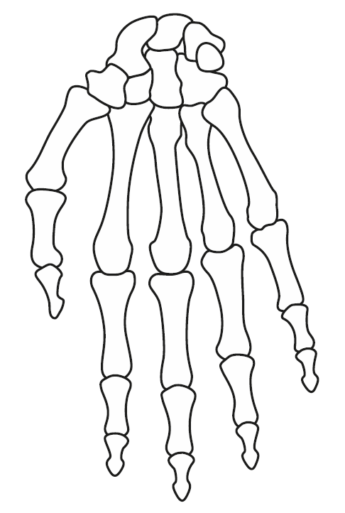

7) DRAW THE SUPERFICIAL AND DEEP PALMAR ARCHES (*ARCUS PLAMARIS SUPERFICIALIS ET PROFUNDUS)* INTO THE SCHEMATIC DRAWING:

8) VARIATIONS MOST COMMONLY FOUND IN THIS AREA:

Mark the presence/absence of each of the appropriate variations:

|  |  |
| --- | --- |
|  | ✓/x |
| absent flexor pollicis brevis muscle |  |
| 4th palmar interosseous muscle |  |
| incomplete superficial palmar arch (*arcus palmaris superficialis*) |  |

9) DESCRIBE AND DRAW ANY OTHER VARIATIONS IDENTIFIED IN THIS AREA:

**2.9. DORSUM OF THE HAND (*DORSUM MANUS*) + FINGERS (*DIGITOS*)**

|  |  |
| --- | --- |
| SPECIMEN IDENTIFICATION | |
| Specimen number: | side: right/left (*dx/sin*) |

1) SKIN

Inspect the skin in the dorsum of the hand and dorsal side of the fingers. Note any scars or other damage.

2) SUBCUTANEOUS TISSUE

Indicate which structures you have dissected in the subcutaneous tissue. Mark their presence/absence. Note whether the structure has a standard course. Write down any varieties or the reason for their absence:

|  |  |  |  |
| --- | --- | --- | --- |
|  | ✓/x | COURSE | NOTE |
| dorsal branch of the ulnar nerve  (*r. dorsalis n. ulnaris*) |  |  |  |
| superficial branch of the radial nerve  *(r. superficialis nervi radialis*) |  |  |  |

3) DEEP LAYER

A) MUSCLES

Identify the muscles, mark their presence/absence, include their innervation, origin, and insertion. Note any variations found in the appropriate muscles or the reason for the absence of the muscle:

|  |  |  |  |  |  |
| --- | --- | --- | --- | --- | --- |
|  | ✓/x | INNERVATION | ORIGIN | INSERTION | NOTE |
| dorsal interosseous muscles |  |  |  |  |  |

B) ARTERIES

Identify the arteries, mark their presence/absence, course, and include their area of supply. Note any variations found in the appropriate arteries (e.g., unusual branching) or the reason for the absence of the artery:

|  |  |  |  |  |
| --- | --- | --- | --- | --- |
|  | ✓/x | COURSE | AREA OF SUPPLY | NOTE |
| radial artery (*a. radialis*) |  |  |  |  |
| dorsal arterial network (*rete carpi dorsale*) |  |  |  |  |

C) NERVES

|  |  |  |  |  |
| --- | --- | --- | --- | --- |
|  | ✓/x | COURSE | AREA OF INNERVATION | NOTE |
| dorsal digital nerves  (*nn. digitales dorsales*) |  |  |  |  |

4) DRAW AND LABEL THE SKIN INNERVATION OF THE DORSAL SIDE OF THE HAND AND FINGERS (*DORSUM MANUS)* INTO THE SCHEMATIC DRAWING:

5) DRAW THE INTEROSSEAL DORSAL MUSCLES (*MM. INTEROSSEI DORSALES*) INTO THE SCHEMATIC DRAWING:

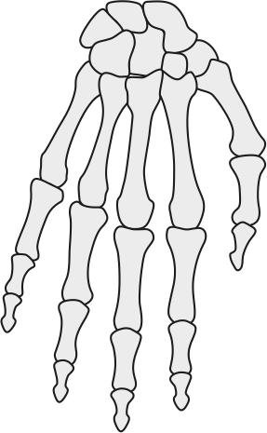

6) WRITE THE FOREARM MUSCLES WHICH ARE ATTACHED IN THESE REGIONS:

7) DESCRIBE AND DRAW ANY OTHER VARIATIONS IDENTIFIED IN THIS AREA:

**BIBLIOGRAPHY:**

BENEŠ, M. et al. The arcade of Frohse: a systematic review and meta-analysis. *Surgical and Radiologic Anatomy* 2021, **43**, s.703-711. ISSN 0930-1038.

CAETANO, E. B. et al. Gantzer muscle. An anatomical study. *Acta Ortopedica Brasileira* 2015, **23**(2), s. 72-75. *ISSN* 1413-7852.

MACALISTER, A. Additional observations on muscular anomalies in human anatomy (third series), with a catalogue of the principal muscular variations hitherto published. *The* *Transactions of the Royal Irish Academy* 1875, **25**, s. 1-134. ISSN 0790-8113.

TUBBS, S. R. et al. Anomalous traversement of the suprascapular artery through the suprascapular notch: A possible mechanism for undiagnosed shoulder pain? *Medical Science Monitor*2003, **9**(3), s. 116-119. ISSN 1643-3750.

TUBBS, S. R., MOHAMMADALI, S. M. a LOUKAS, M. *Bergman´s Comprehensive Encyclopedia of Human Anatomic Variation* [online]. Hoboken, N. J: Wiley-Blackwell, 2016, 1432 s. [cit. 2021-05-26]. ISBN 9781118430354. Available at: <https://eds.a.ebscohost.com/eds/ebookviewer/ebook/bmxlYmtfXzEyMjc5ODFfX0FO0?sid=83fc6545-baf5-4b5c-bcb7-f51051acac65@sessionmgr4006&vid=1&format=EB&rid=1>

VYMAZALOVÁ, K, VARGOVÁ, L. a JOUKAL, M. Variability of the pronator teres muscle and its clinical significance. *Romanian journal of morphology and embryology* 2015, **56**(3), s. 1127-1135. ISSN 1220-0522.

**3. DISSECTION OF THE LOWER EXTREMITY (***Lucie Kubíčková***)**

**3.1. OVERVIEW OF THE MOST COMMON VARIATIONS OF THIS REGION**

|  |
| --- |
| **VARIATION OF MUSCLES** |
| two heads of the piriform muscle |
| fusion of the lateral and intermedius vastus muscles |
| separate insertions of both heads of the biceps femoris muscle to the head of the fibula |
| origin of the long head of the biceps femoris – sacrotuberal ligament |
| origin of the semitendinosus muscle – sacrotuberal ligament |
| *musculus tensor fasciae dorsalis pedis* (Woodi) |
| accessory soleus muscle |
| plantar muscle |
| accessory plantar muscle |
| missing soleus muscle or it’s tibial head |
| fibularis quadratus muscle |
| fibularis tertius muscle |
| *m. tibioastragalus anticus* (Gruber muscle) |
| **VARIATION OF ARTERIES** |
| sciatic artery (*a. comitans n. ischiadici*) |
| variations in the branching of the deep femoral artery from the femoral artery |
| branching of the lateral circumflex femoral artery from the femoral artery |
| variations in the branching of the popliteal artery |
| branching of the popliteal artery above popliteal muscle |
| hypoplastic, aplastic anterior/posterior tibial artery |
| **VARIATION OF VEINS** |
| small saphenous vein – tributary of the femoral vein or great saphenous vein |
| anterior/posterior accessory saphenous vein |
| small saphenous vein – tributary of the inferior gluteal vein |
| persistent sciatic vein |
| **VARIATION OF NERVES** |
| pudendal nerve pierces the sacrotuberal ligament |
| high branching of the sciatic nerve (absent sciatic nerve) |
| communicating fibular branch-from the common fibular nerve, from the lateral sural cutaneous nerve, missing |
| deep accessory fibular nerve of the superficial fibular nerve |
| medial sural cutaneous nerve substituting the sural nerve |
| lateral sural cutaneous nerve substituting the sural nerve |

**3.2. GLUTEAL REGION *(REGIO GLUTAE)***

|  |  |
| --- | --- |
| SPECIMEN IDENTIFICATION | |
| Specimen number: | side: right/left (*dx/sin*) |

1) SKIN

Inspect the skin in the gluteal region. Note any scars or other damage.

2) SUBCUTANEOUS TISSUE

Indicate which structures you have dissected in the subcutaneous tissue. Mark their presence/absence. Note whether the structure has a standard course. Write down any variations or the reason for their absence:

|  |  |  |  |
| --- | --- | --- | --- |
|  | ✓/x | COURSE | NOTE |
| superior cluneal nerves (*n. clunium superiores*) |  |  |  |
| medial cluneal nerves (*n. clunium medii*) |  |  |  |
| inferior cluneal nerves (*n. clunium inferiores*) |  |  |  |

3) DEEP LAYER

A) MUSCLES

Identify the muscles, mark their presence/absence, include their innervation, origin, and insertion. Note any variations found in the appropriate muscles or the reason for the absence of the muscle:

|  |  |  |  |  |  |
| --- | --- | --- | --- | --- | --- |
|  | ✓/x | INNERVATION | ORIGIN | INSERTION | NOTE |
| gluteus maximus m. |  |  |  |  |  |
| gluteus medius m. |  |  |  |  |  |
| gluteus minimus m. |  |  |  |  |  |
| piriformis m. |  |  |  |  |  |
| tensor fasciae latae m. |  |  |  |  |  |
| superior gemellus m. |  |  |  |  |  |
| inferior gemellus m. |  |  |  |  |  |
| obturator internus m. |  |  |  |  |  |
| quadratus femoris m. |  |  |  |  |  |

B) VESSELS

Identify the arteries (veins), mark their presence/absence, course, and include their area of supply (where does it drain). Note any variations found in the appropriate arteries (veins) (e.g., unusual branching) or the reason for the absence of the artery (vein):

|  |  |  |  |  |  |
| --- | --- | --- | --- | --- | --- |
|  | ✓/x | COURSE | AREA OF SUPPLY | | NOTE |
| superior gluteal artery  (*a. glutea superior*) |  |  |  | |  |
| inferior gluteal artery  (*a. glutea inferior*) |  |  |  | |  |
| internal pudendal artery (*a. pudenda interna*) |  |  |  | |  |
|  | ✓/x | COURSE | | IS A TRIBUTARY OF | NOTE |
| superior gluteal vein  (*v. glutea superior*) |  |  | |  |  |
| inferior gluteal vein  (*v. glutea inferior*) |  |  | |  |  |
| internal pudendal vein  (*v. pudenda interna*) |  |  | |  |  |

C) NERVES:

Identify the nerves, mark their presence/absence, course, and include their area of innervation. Note any variations found in the appropriate nerves or the reason for the absence of the nerve:

|  |  |  |  |  |
| --- | --- | --- | --- | --- |
|  | ✓/x | COURSE | AREA OF INNERVATION | NOTE |
| superior gluteal nerve  (*n. gluteus superior*) |  |  |  |  |
| inferior gluteal nerve  (*n. gluteus inferior*) |  |  |  |  |
| posterior cutaneous femoral nerve (*n. cutaneus femoris posterior*) |  |  |  |  |
| pudendal nerve  (*n. pudendus*) |  |  |  |  |
| sciatic nerve  (*n. ischiadicus*) |  |  |  |  |

4) DRAW AND LABEL THE SACROSPINAL AND SACROTUBERAL LIGAMENTS (*LIGAMENTUM SACROSPINALE* *ET* *SACROTUBERALE*) INTO THE SCHEMATIC DRAWING. WHICH SPACES ARE CREATED?

5) DRAW AND LABEL THE COURSE OF THE PIRIFORM MUSCLE (*MUSCULUS PIRIFORMIS*)INTO THE SCHEMATIC DRAWING:

6) LABEL THE SCHEMATIC DRAWING OF THE SUPRAPIRIFORM AND INFRAPIRIFORM OPENINGS (*FORAMEN SUPRAPIRIFIRME* ET *INFRAPIRIFORME*) AND THE STRUCTURES PASSING THROUGH THEM:

7) VARIATIONS MOST COMMONLY FOUND IN THIS AREA:

Mark the presence/absence of each of the appropriate variations:

|  |  |
| --- | --- |
|  | ✓/x |
| Two heads of the piriform muscle |  |
| high branching of the sciatic nerve (absent sciatic nerve) |  |

8) DESCRIBE AND DRAW ANY OTHER VARIATIONS IDENTIFIED IN THIS AREA:

**3.3. ANTERIOR THIGH REGION (*REGIO FEMORIS ANTERIOR*)**

|  |  |
| --- | --- |
| SPECIMEN IDENTIFICATION | |
| Specimen number: | side: right/left (*dx/sin*) |

1) SKIN

Inspect the skin in the anterior thigh region. Note any scars or other damage.

2) SUBCUTANEOUS TISSUE

Indicate which structures you have dissected in the subcutaneous tissue. Mark their presence/absence. Note whether the structure has a standard course. Write down any variations or the reason for their absence:

|  |  |  |  |
| --- | --- | --- | --- |
|  | ✓/x | COURSE | NOTE |
| anterior cutaneous branches of the femoral nerve (*rr. cutanei anteriores n. femoralis*) |  |  |  |
| lateral femoral cutaneous nerve  (*n. cutaneus femoris lateralis*) |  |  |  |
| great saphenous vein (*v. saphena magna*) |  |  |  |
| accessory saphenous vein (*v. saphena accessoria*) |  |  |  |
| saphenous nerve (*n. saphenus*) |  |  |  |
| femoral branch of the genitofemoral nerve  (*r. femoralis n. genitofemoralis*) |  |  |  |
| obturator nerve (*n. obturatorius*) |  |  |  |
| superficial circumflex femoral vein  (*v. circumflexa femoris superficialis*) |  |  |  |
| superficial epigastric vein  (*v. epigastrica superficialis*) |  |  |  |
| external pudendal veins (*vv. pudendae externae*) |  |  |  |

3) DEEP LAYER

A) MUSCLES:

Identify the muscles, mark their presence/absence, include their innervation, origin, and insertion. Note any variations found in the appropriate muscles or the reason for the absence of the muscle:

|  |  |  |  |  |  |
| --- | --- | --- | --- | --- | --- |
|  | ✓/x | INNERVATION | ORIGIN | INSERTION | NOTE |
| quadriceps femoris m. |  |  |  |  |  |
| sartorius m. |  |  |  |  |  |
| pectineus m. |  |  |  |  |  |
| gracilis m. |  |  |  |  |  |
| adductor longus m. |  |  |  |  |  |
| adductor brevis m. |  |  |  |  |  |
| adductor magnus m. |  |  |  |  |  |
| obturator externus m. |  |  |  |  |  |

B) VESSELS

Identify the arteries (veins), mark their presence/absence, course, and include their area of supply (where does it drain). Note any variations found in the appropriate arteries (veins) (e.g., unusual branching) or the reason for the absence of the artery (vein):

|  |  |  |  |  |  |
| --- | --- | --- | --- | --- | --- |
|  | ✓/x | | COURSE | AREA OF SUPPLY | NOTE |
| femoral artery  (*a. femoralis*) |  | |  |  |  |
| deep femoral artery  (*a. profunda femoris*) |  | |  |  |  |
| lateral circumflex femoral artery (*a. circumflexa femoris lateralis*) |  | |  |  |  |
| medial circumflex femoral artery (*a. circumflexa femoris medial*) |  | |  |  |  |
| perforating arteries  (*aa. perforantes*) |  | |  |  |  |
| obturator artery  (*a. obturatoria*) |  | |  |  |  |
|  | | ✓/x | COURSE | IS A TRIBUTARY OF | NOTE |
| femoral vein  (*v. femoralis*) | |  |  |  |  |
| deep femoral vein  (*v. profunda femoris*) | |  |  |  |  |

C) NERVES

Identify the nerves, mark their presence/absence, course, and include their area of innervation. Note any variations found in the appropriate nerves or the reason for the absence of the nerve:

|  |  |  |  |  |
| --- | --- | --- | --- | --- |
|  | ✓/x | COURSE | AREA OF INNERVATION | NOTE |
| femoral nerve  (*n. femoralis*) |  |  |  |  |
| muscular branches of the femoral nerve (*rr. musculares n. femoralis*) |  |  |  |  |
| anterior branch of the obturator nerve (*r. anterior n. obturatorii)* |  |  |  |  |
| posterior branch of the obturator nerve *(r. posterior n. obturatorii)* |  |  |  |  |

4) DRAW AND LABEL THE SCHEMATIC DRAWING OF THE *LACUNA VASORUM* AND *MUSCULORUM* – BORDERS AND CONTENTS:

5) DRAW AND LABEL THE SCHEMATIC DRAWING OF THE FEMORAL TRIANGLE AND THE ILIOPECTINEAL FOSSA (*TRIGONUM FEMORALE* *ET FOSSA ILIOPECTINEA*)– BORDERS AND CONTENTS:

6) DRAW AND LABEL THE SCHEMATIC DRAWING OF THE ADDUCTOR CANAL (*CANALIS ADDUCTORIUS*)– BORDERS, CONTENT, AND COURSE:

7) VARIATIONS MOST COMMONLY FOUND IN THIS AREA:

Mark the presence/absence of each of the appropriate variations:

|  |  |
| --- | --- |
|  | ✓/x |
| variations in the branching of the deep femoral artery (*a. femoralis profunda*) from the femoral artery (*a. femoralis*) |  |
| small saphenous vein (*v. saphena parva*) – a tributary of the great saphenous vein (*v. saphena magna*) or femoral vein (*v. femoralis*) |  |
| superficial epigastric artery (*a.epigastrica superficialis*) – common origin with the superficial circumflex iliac artery (*a. circumflexa ilium superficialis*) |  |

8) DESCRIBE AND DRAW ANY OTHER VARIATIONS IDENTIFIED IN THIS AREA:

**3.4. POSTERIOR THIGH REGION (*REGIO FEMORIS POSTERIOR*)**

|  |  |
| --- | --- |
| SPECIMEN IDENTIFICATION | |
| Specimen number: | side: right/left (*dx/sin*) |

1) SKIN

Inspect the skin in the posterior thigh region. Note any scars or other damage:

2) SUBCUTANEOUS TISSUE

Indicate which structures you have dissected in the subcutaneous tissue. Mark their presence/absence. Note whether the structure has a standard course. Write down any variations or the reason for their absence:

|  |  |  |  |
| --- | --- | --- | --- |
|  | ✓/x | COURSE | NOTE |
| posterior femoral cutaneous nerve (*n. cutaneus femoris posterior*) |  |  |  |
| femoropopliteal vein (*v. femoropoplitea*) |  |  |  |

3) DEEP LAYER

A) MUSCLES

Identify the muscles, mark their presence/absence, include their innervation, origin, and insertion. Note any variations found in the appropriate muscles or the reason for the absence of the muscle:

|  |  |  |  |  |  |
| --- | --- | --- | --- | --- | --- |
|  | ✓/x | INNERVATION | ORIGIN | INSERTION | NOTE |
| semitendinosus m. |  |  |  |  |  |
| semimembranosus m. |  |  |  |  |  |
| biceps femoris m. |  |  |  |  |  |

B) ARTERIES

Identify the arteries, mark their presence/absence, course, and include their area of supply. Note any variations found in the appropriate arteries (e.g., unusual branching) or the reason for the absence of the artery:

|  |  |  |  |  |
| --- | --- | --- | --- | --- |
|  | ✓/x | COURSE | AREA OF SUPPLY | NOTE |
| muscular branches of the perforating arteries (*rr. musculares aa. perforantes*) |  |  |  |  |

C) NERVES

Identify the nerves, mark their presence/absence, course, and include their area of innervation. Note any variations found in the appropriate nerves or the reason for the absence of the nerve:

|  |  |  |  |  |
| --- | --- | --- | --- | --- |
|  | ✓/x | COURSE | AREA OF INNERVATION | NOTE |
| sciatic nerve  (*n. ischiadicus*) |  |  |  |  |
| tibial nerve (*n. tibialis*) |  |  |  |  |
| common fibular nerve (*n. fibularis communis*) |  |  |  |  |

4) DRAW AND LABEL THE COURSE OF THE HAMSTRINGS (*M. SEMITENDINOSUS, M. SEMIMEMBRANOSUS ET M. BICEPS FEMORIS*) INTO THE SCHEMATIC DRAWING:

5) DRAW AND LABEL THE BORDERS OF THE SKIN INNERVATION OF THE POSTERIOR THIGH REGION (*REGIO FEMORIS POSTERIOR*)INTO THE SCHEMATIC DRAWING:

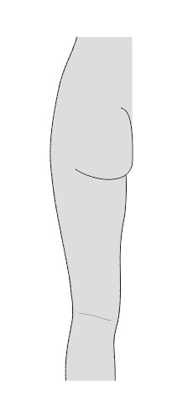

6) VARIATIONS MOST COMMONLY FOUND IN THIS AREA:

Mark the presence/absence of each of the appropriate variations:

|  |  |
| --- | --- |
|  | ✓/x |
| Long head of the biceps femoris muscle – origin – sacrotuberal ligament |  |
| Small saphenous vein is the tributary to the inferior gluteal vein |  |
| Communicating fibular branch of the common fibular nerve |  |

7) DESCRIBE AND DRAW ANY OTHER VARIATIONS IDENTIFIED IN THIS AREA:

**3.5. ANTERIOR AND POSTERIOR KNEE REGIONS (*REGIO GENUS ANTERIOR ET POSTERIOR*)**

|  |  |
| --- | --- |
| SPECIMEN IDENTIFICATION | |
| Specimen number: | side: right/left (*dx/sin*) |

1) SKIN

Inspect the skin in the anterior and posterior knee regions. Note any scars or other damage.

2) SUBCUTANEOUS TISSUE

Indicate which structures you have dissected in the subcutaneous tissue. Mark their presence/absence. Note whether the structure has a standard course. Write down any variations or the reason for their absence:

|  |  |  |  |
| --- | --- | --- | --- |
|  | ✓/x | COURSE | NOTE |
| small saphenous vein (*v. saphena parva*) |  |  |  |
| great saphenous vein (*v. saphena magna*) |  |  |  |
| femoropopliteal vein (*v. femoropoplitea*) |  |  |  |
| lateral femoral cutaneous nerve  (*n. cutaneus femoris lateralis*) |  |  |  |
| lateral sural cutaneous nerve  (*n. cutaneus surae lateralis*) |  |  |  |
| medial sural cutaneous nerve  (*n. cutaneus surae medialis*) |  |  |  |
| saphenous nerve (*n. saphenus*) |  |  |  |

3) DEEP LAYER

A) MUSCLES

Write the muscles (tendons) which are attached in this region, mark their presence/absence, include their innervation, origin, and insertion. Note any variations found in the appropriate muscles or the reason for the absence of the muscle:

|  |  |  |  |  |  |
| --- | --- | --- | --- | --- | --- |
| MUSCLE | ✓/x | INNERVATION | ORIGIN | INSERTION | NOTE |
|  |  |  |  |  |  |
|  |  |  |  |  |  |
|  |  |  |  |  |  |
|  |  |  |  |  |  |
|  |  |  |  |  |  |
|  |  |  |  |  |  |
|  |  |  |  |  |  |
|  |  |  |  |  |  |
|  |  |  |  |  |  |
|  |  |  |  |  |  |

Write the muscles which make up the ***pes anserinus*,** note their innervation and any variations found in the appropriate muscles or the reason for the absence of the muscle:

|  |  |  |  |
| --- | --- | --- | --- |
| MUSCLE | ✓/x | INNERVATION | NOTE |
|  |  |  |  |
|  |  |  |  |
|  |  |  |  |
|  |  |  |  |

B) VESSELS

Identify the arteries (veins), mark their presence/absence, course, and include their area of supply (where does it drain). Note any variations found in the appropriate arteries (veins) (e.g., unusual branching) or the reason for the absence of the artery (vein):

|  |  |  |  |  |
| --- | --- | --- | --- | --- |
|  | ✓/x | COURSE | AREA OF SUPPLY | NOTE |
| popliteal artery  (*a. poplitea*) |  |  |  |  |
| lateral superior collateral (genicular) artery (*a.genus collateralis superior lateralis*) |  |  |  |  |
| medial superior collateral (genicular) artery (*a. genus collateralis superior medialis*) |  |  |  |  |
| lateral inferior collateral (genicular) artery (*a. genus collateralis inferior lateralis*) |  |  |  |  |
| medial inferior collateral (genicular) artery (*a. genus collateralis inferior medialis*) |  |  |  |  |
| descending genicular artery (*a. genus descendens*) |  |  |  |  |
| saphenous branch of the descending genicular artery (*r. saphenus* of*a. genus descendens*) |  |  |  |  |
|  | ✓/x | COURSE | IS A TRIBUTARY OF | NOTE |
| popliteal vein  (*v. poplitea*) |  |  |  |  |

C) NERVES

Identify the nerves, mark their presence/absence, course, and include their area of innervation. Note any variations found in the appropriate nerves or the reason for the absence of the nerve:

|  |  |  |  |  |
| --- | --- | --- | --- | --- |
|  | ✓/x | COURSE | AREA OF INNERVATION | NOTE |
| saphenous nerve  (*n. saphenus*) |  |  |  |  |
| tibial nerve  (*n. tibialis*) |  |  |  |  |
| common fibular nerve (*n. fibularis comm.*) |  |  |  |  |

4) DRAW AND LABEL THE SCHEMATIC DRAWING OF THE POPLITEAL FOSSA (*FOSSA POPLITEA*) - BORDERS, CONTENS:

5) DRAW AND LABEL THE INTRAARTICULAR STRUCTURES IN THE KNEE JOINT (*ART. GENUS)* AND THEIR RELATIONSHIP TO THE FIBROUS AND SYNOVIAL LAYER OF THE ARTICULAR CAPSULE INTO THE SCHEMATIC DRAWING:

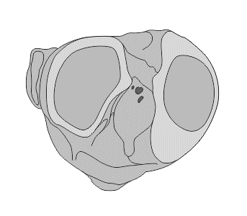

6) VARIATIONS MOST COMMONLY FOUND IN THIS AREA:

Mark the presence/absence of each of the appropriate variations:

|  |  |
| --- | --- |
|  | ✓/x |
| variations in branching of the popliteal artery |  |
| branching of popliteal artery above the superior margin of the popliteal muscle |  |

7) DESCRIBE AND DRAW ANY OTHER VARIATIONS IDENTIFIED IN THIS AREA:

**3.6. ANTERIOR LEG REGION (*REGIO CRURIS ANTERIOR*)**

|  |  |
| --- | --- |
| SPECIMEN IDENTIFICATION | |
| Specimen number: | side: right/left (*dx/sin*) |

1) SKIN

Inspect the skin in the anterior leg region. Note any scars or other damage.

2) SUBCUTANEOUS TISSUE

Indicate which structures you have dissected in the subcutaneous tissue. Mark their presence/absence. Note whether the structure has a standard course. Write down any variations or the reason for their absence:

|  |  |  |  |
| --- | --- | --- | --- |
|  | ✓/x | COURSE | NOTE |
| great saphenous vein (*v. saphena magna*) |  |  |  |
| saphenous nerve (*n. saphenus*) |  |  |  |
| superficial fibular nerve (*n. fibulais superficialis*) |  |  |  |

3) DEEP LAYER

A) MUSCLES

Identify the muscles, mark their presence/absence, include their innervation, origin, and insertion. Note any variations found in the appropriate muscles or the reason for the absence of the muscle:

|  |  |  |  |  |  |
| --- | --- | --- | --- | --- | --- |
|  | ✓/x | INNERVATION | ORIGIN | INSERTION | NOTE |
| tibialis anterior m. |  |  |  |  |  |
| extensor digitorum longus m. |  |  |  |  |  |
| extensor hallucis longus m. |  |  |  |  |  |
| fibularis longus m. |  |  |  |  |  |
| fibularis brevis m. |  |  |  |  |  |

B) VESSELS

Identify the arteries (veins), mark their presence/absence, course, and include their area of supply (where does it drain). Note any variations found in the appropriate arteries (veins) (e.g., unusual branching) or the reason for the absence of the artery (vein):

|  |  |  |  |  |
| --- | --- | --- | --- | --- |
|  | ✓/x | COURSE | AREA OF SUPPLY | NOTE |
| anterior tibial artery  (*a. tibialis anterior*) |  |  |  |  |
|  | ✓/x | COURSE | IS A TRIBUTARY OF | NOTE |
| anterior tibial vein  (*v. tibialis anterior*) |  |  |  |  |

C) NERVES

Identify the nerves, mark their presence/absence, course, and include their area of innervation. Note any variations found in the appropriate nerves or the reason for the absence of the nerve:

|  |  |  |  |  |
| --- | --- | --- | --- | --- |
|  | ✓/x | COURSE | AREA OF INNERVATION | NOTE |
| deep fibular nerve  (*n. fibularis profundus*) |  |  |  |  |
| superficial fibular nerve (*n. fibularis superficialis*) |  |  |  |  |

4) DRAW AND LABEL THE COURSE OF THE CRURAL MUSCLES (*MM. CRURIS ANTERIOR*) INTO THE SCHEMATIC DRAWING:

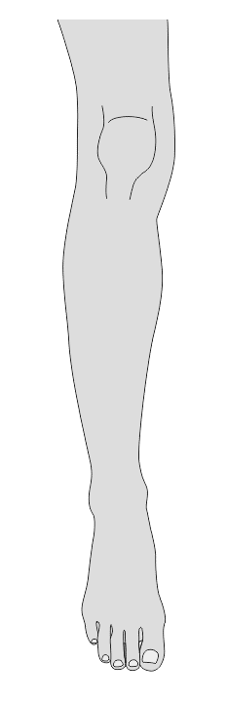

5) VARIATIONS MOST COMMONLY FOUND IN THIS AREA:

Mark the presence/absence of each of the appropriate variations:

|  |  |
| --- | --- |
|  | ✓/x |
| hypoplastic or aplastic anterior tibial artery |  |
| deep accessory fibular nerve of the superficial fibular nerve |  |

6) DESCRIBE AND DRAW ANY OTHER VARIATIONS IDENTIFIED IN THIS AREA:

**3.7. POSTERIOR LEG REGION (*REGIO CRURIS POSTERIOR*)**

|  |  |
| --- | --- |
| SPECIMEN IDENTIFICATION | |
| Specimen number: | side: right/left (*dx/sin*) |

1) SKIN

Inspect the skin in the posterior leg region. Note any scars or other damage.

2) SUBCUTANEOUS TISSUE

Indicate which structures you have dissected in the subcutaneous tissue. Mark their presence/absence. Note whether the structure has a standard course. Write down any variations or the reason for their absence:

|  |  |  |  |
| --- | --- | --- | --- |
|  | ✓/x | COURSE | NOTE |
| small saphenous vein  (*v. saphena parva*) |  |  |  |
| sural nerve (*n. suralis*) |  |  |  |
| lateral sural cutaneous nerve  (*n. cutaneus surae lateralis*) |  |  |  |
| medial sural cutaneous nerve  (*n. cutaneus surae medialis*) |  |  |  |

3) DEEP LAYER

A) MUSCLES

Identify the muscles, mark their presence/absence, include their innervation, origin, and insertion. Note any variations found in the appropriate muscles or the reason for the absence of the muscle:

|  |  |  |  |  |  |
| --- | --- | --- | --- | --- | --- |
|  | ✓/x | INNERVATION | ORIGIN | INSERTION | NOTE |
| posterior tibial m. |  |  |  |  |  |
| flexor digitorum longus m. |  |  |  |  |  |
| flexor hallucis longus m. |  |  |  |  |  |
| gastrocnemius m. |  |  |  |  |  |
| soleus m. |  |  |  |  |  |
| plantaris m. |  |  |  |  |  |

B) VESSELS

Identify the arteries (veins), mark their presence/absence, course, and include their area of supply (where does it drain). Note any variations found in the appropriate arteries (veins) (e.g., unusual branching) or the reason for the absence of the artery (vein):

|  |  |  |  |  |
| --- | --- | --- | --- | --- |
|  | ✓/x | COURSE | AREA OF SUPPLY | NOTE |
| posterior tibial artery  (*a. tibialis posterior*) |  |  |  |  |
| circumflex fibular branch of the posterior tibial artery (*r. circumflexus fibularis a. tibialis posterior*) |  |  |  |  |
| muscular branches of the posterior tibial artery *(rr. musculares a. tibialis posterior*) |  |  |  |  |
| fibular artery (*a. fibularis*) |  |  |  |  |
| muscular branches of fibular artery (*rr. musculares a. fibularis*) |  |  |  |  |
|  | ✓/x | COURSE | IS A TRIBUTARY OF | NOTE |
| posterior tibial vein  (*v. tibialis posterior*) |  |  |  |  |
| fibular vein (*v. fibularis*) |  |  |  |  |

C) NERVES

Identify the nerves, mark their presence/absence, course, and include their area of innervation. Note any variations found in the appropriate nerves or the reason for the absence of the nerve:

|  |  |  |  |  |
| --- | --- | --- | --- | --- |
|  | ✓/x | COURSE | AREA OF INNERVATION | NOTE |
| tibial nerve (*n. tibialis*) |  |  |  |  |
| muscular branches of the tibial nerve (*rr. musculares n. tibialis*) |  |  |  |  |

4) DRAW AND LABEL THE BORDERS OF THE SKIN INNERVATION OF THE POSTERIOR LEG REGION (*REGIO CRURIS POSTERIOR*):

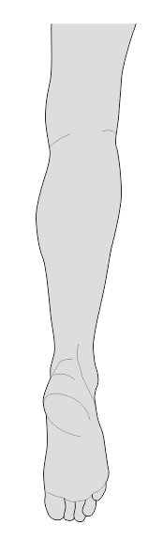

5) VARIATIONS MOST COMMONLY FOUND IN THIS AREA:

Mark the presence/absence of each of the appropriate variations:

|  |  |
| --- | --- |
|  | ✓/x |
| soleus accessory muscle |  |
| plantaris muscle |  |
| variations of constitution of the sural nerve – different position, different branches |  |

6) DESCRIBE AND DRAW ANY OTHER VARIATIONS IDENTIFIED IN THIS AREA:

**3.8. MEDIAL MALLEOLAR AND RETROMALLEOLAR REGION (*REGIO MALLEOLARIS ET RETROMALLEOLARIS MEDIALIS*)**

|  |  |
| --- | --- |
| SPECIMEN IDENTIFICATION | |
| Specimen number: | side: right/left (*dx/sin*) |

1) SKIN

Inspect the skin in the medial malleolar and retromalleolar region. Note any scars or other damage.

2) SUBCUTANEOUS TISSUE

Indicate which structures you have dissected in the subcutaneous tissue. Mark their presence/absence. Note whether the structure has a standard course. Write down any variations or the reason for their absence:

|  |  |  |  |
| --- | --- | --- | --- |
|  | ✓/x | COURSE | NOTE |
| saphenous nerve (*n. saphenus*) |  |  |  |
| great saphenous vein (*v. saphena magna*) |  |  |  |
| medial calcaneal branches of the saphenous nerve  (*rr. calcanei cruris mediales* of *n. saphenus*) |  |  |  |

3) DEEP LAYER

A) MUSCLES

Identify the muscles, mark their presence/absence, include their innervation, origin, and insertion. Note any variations found in the appropriate muscles or the reason for the absence of the muscle:

|  |  |  |  |  |  |
| --- | --- | --- | --- | --- | --- |
|  | ✓/x | INNERVATION | ORIGIN | INSERTION | NOTE |
| posterior tibial m. |  |  |  |  |  |
| flexor digitorum longus m. |  |  |  |  |  |
| flexor hallucis longus m. |  |  |  |  |  |

B) VESSELS

Identify the arteries (veins), mark their presence/absence, course, and include their area of supply (where does it drain). Note any variations found in the appropriate arteries (veins) (e.g., unusual branching) or the reason for the absence of the artery (vein):

|  |  |  |  |  |  |
| --- | --- | --- | --- | --- | --- |
|  | ✓/x | COURSE | AREA OF SUPPLY | | NOTE |
| posterior tibial artery  (*a. tibialis posterior*) |  |  |  | |  |
| medial posterior malleolar artery of the posterior tibial artery  (*a. malleolaris posterior medialis* of*a. tibialis posterior*) |  |  |  | |  |
| medial anterior malleolar artery of dorsalis pedis artery (*a. malleolaris anterior medialis* of*a. dorsalis pedis*) |  |  |  | |  |
|  | ✓/x | COURSE | IS A TRIBUTARY OF | NOTE | |
| posterior tibial vein  (*v. tibialis posterior*) |  |  |  |  | |

C) NERVES

Identify the nerves, mark their presence/absence, course, and include their area of innervation. Note any variations found in the appropriate nerves or the reason for the absence of the nerve:

|  |  |  |  |  |
| --- | --- | --- | --- | --- |
|  | ✓/x | COURSE | AREA OF INNERVATION | NOTE |
| tibial nerve  (*n. tibialis*) |  |  |  |  |
| medial calcaneal branches of the tibial nerve (*rr. calcanei mediales* of *n. tibialis*) |  |  |  |  |

4) DRAW AND LABEL THE SCHEMATIC DRAWING OF THE PLACEMENT OF THE STRUCTURES BEHIND THE MEDIAL MALLEOLUS:

5) VARIATIONS MOST COMMONLY FOUND IN THIS AREA:

Mark the presence/absence of each of the appropriate variations:

|  |  |
| --- | --- |
|  | ✓/x |
| flexor digitorum accessorius longus muscle |  |

6) DESCRIBE AND DRAW ANY OTHER VARIATIONS IDENTIFIED IN THIS AREA:

**3.9.** **LATERAL MALLEOLAR AND RETROMALLEOLAR REGION (*REGIO MALLEOLARIS ET RETROMALLEOLARIS LATERALIS*)**

|  |  |
| --- | --- |
| SPECIMEN IDENTIFICATION | |
| Specimen number: | side: right/left (*dx/sin*) |

1) SKIN

Inspect the skin in the lateral malleolar and retromalleolar region. Note any scars or other damage.

2) SUBCUTANEOUS TISSUE

Indicate which structures you have dissected in the subcutaneous tissue. Mark their presence/absence. Note whether the structure has a standard course. Write down any variations or the reason for their absence:

|  |  |  |  |
| --- | --- | --- | --- |
|  | ✓/x | COURSE | NOTE |
| sural nerve (*n. suralis*) |  |  |  |
| small saphenous vein (*v. saphena parva*) |  |  |  |
| lateral calcaneal branches of the sural nerve  (*rr. calcanei laterales* of *n. suralis*) |  |  |  |
| lateral dorsal cutaneous nerve of the sural nerve  (*n. cutaneus dorsalis lateralis* of *n. suralis*) |  |  |  |

3) DEEP LAYER

A) MUSCLES

Identify the muscles, mark their presence/absence, include their innervation, origin, and insertion. Note any variations found in the appropriate muscles or the reason for the absence of the muscle:

|  |  |  |  |  |  |
| --- | --- | --- | --- | --- | --- |
|  | ✓/x | INNERVATION | ORIGIN | INSERTION | NOTE |
| fibularis longus m. |  |  |  |  |  |
| fibularis brevis m. |  |  |  |  |  |

B) VESSELS

Identify the arteries (veins), mark their presence/absence, course, and include their area of supply (where does it drain). Note any variations found in the appropriate arteries (veins) (e.g., unusual branching) or the reason for the absence of the artery (vein):

|  |  |  |  |  |
| --- | --- | --- | --- | --- |
|  | ✓/x | COURSE | AREA OF SUPPLY | NOTE |
| muscular branches of the fibular artery (*rr. musculares a. fibularis*) |  |  |  |  |
| posterior lateral malleolar artery (*a. malleolaris posterior lateralis* of *a. fibularis*) |  |  |  |  |
| anterior lateral malleolar artery (*a. malleolaris anterior lateralis* of *a. dorsalis pedis)* |  |  |  |  |
| communicating branch  (*r. communicans*) |  |  |  |  |
| lateral malleolar network (*rete malleolare laterale*) |  |  |  |  |
|  | ✓/x | COURSE | IS A TRIBUTARY OF | NOTE |
| fibular vein  (*v. fibularis*) |  |  |  |  |

C) NERVES

Identify the nerves, mark their presence/absence, course, and include their area of innervation. Note any variations found in the appropriate nerves or the reason for the absence of the nerve:

|  |  |  |  |  |
| --- | --- | --- | --- | --- |
|  | ✓/x | COURSE | AREA OF INNERVATION | NOTE |
| muscular branches of the superficial fibular nerve (*rr. musculares* of*n. fibularis superficialis*) |  |  |  |  |

4) DRAW AND LABEL THE PLACEMENT OF THE STRUCTURES BEHIND THE LATERAL ANKLE:

5) VARIATIONS MOST COMMONLY FOUND IN THIS AREA:

Mark the presence/absence of each of the appropriate variations:

|  |  |
| --- | --- |
|  | ✓/x |
| fibularis quadratus muscle |  |
| insertion of the fibularis longus muscle on the sesamoid bone of the cuboid bone |  |

6) DESCRIBE AND DRAW ANY OTHER VARIATIONS IDENTIFIED IN THIS AREA:

**3.10. SOLE OF THE FOOT *(PLANTA PEDIS)***

|  |  |
| --- | --- |
| SPECIMEN IDENTIFICATION | |
| Specimen number: | side: right/left (*dx/sin*) |

1) SKIN

Inspect the skin in the sole of the foot. Note any scars or other damage.

2) SUBCUTANEOUS TISSUE

Indicate which structures you have dissected in the subcutaneous tissue. Mark their presence/absence. Note whether the structure has a standard course. Write down any variations or the reason for their absence:

|  |  |  |  |
| --- | --- | --- | --- |
|  | ✓/x | COURSE | NOTE |
| plantar aponeurosis (*aponeurosis plantae*) |  |  |  |

3) DEEP LAYER

A) MUSCLES

Identify the muscles, mark their presence/absence, include their innervation, origin, and insertion. Note any variations found in the appropriate muscles or the reason for the absence of the muscle:

|  |  |  |  |  |  |
| --- | --- | --- | --- | --- | --- |
|  | ✓/x | INNERVATION | ORIGIN | INSERTION | NOTE |
| flexor digitorum brevis m. |  |  |  |  |  |
| flexor hallucis brevis m. |  |  |  |  |  |
| quadratus plantae m. |  |  |  |  |  |
| abductor hallucis m. |  |  |  |  |  |
| abductor digiti minimi m. |  |  |  |  |  |
| flexor hallucis brevis m. |  |  |  |  |  |
| flexor digiti minimi brevis m. |  |  |  |  |  |
| adductor hallucis m. |  |  |  |  |  |
| lumbrical mm. |  |  |  |  |  |
| opponens digiti minimi m. |  |  |  |  |  |

B) VESSELS

Identify the arteries (veins), mark their presence/absence, course, and include their area of supply (where does it drain). Note any variations found in the appropriate arteries (veins) (e.g., unusual branching) or the reason for the absence of the artery (vein):

|  |  |  |  |  |
| --- | --- | --- | --- | --- |
|  | ✓/x | COURSE | AREA OF SUPPLY | NOTE |
| medial plantar artery  (*a. plantaris medialis*) |  |  |  |  |
| lateral plantar artery  (*a. plantaris lateralis*) |  |  |  |  |
| metatarsal plantar arteries (*aa. metatarsae plantares pedis*) |  |  |  |  |
| deep branch of the medial plantar artery (*r. profundus a. plantaris medialis*) |  |  |  |  |
| superficial branch of the medial plantar artery (*r. superficialis a. plantaris medialis*) |  |  |  |  |
| plantar arch  (*arcus plantaris*) |  |  |  |  |
| plantar digital arteries  (*aa. digitales plantares*) |  |  |  |  |
|  | ✓/x | COURSE | IS A TRIBUTARY OF | NOTE |
| medial plantar vein  (*v. plantaris medialis*) |  |  |  |  |
| lateral plantar vein  (*v. plantaris lateralis*) |  |  |  |  |

C) NERVES

Identify the nerves, mark their presence/absence, course, and include their area of innervation. Note any variations found in the appropriate nerves or the reason for the absence of the nerve:

|  |  |  |  |  |
| --- | --- | --- | --- | --- |
|  | ✓/x | COURSE | AREA OF INNERVATION | NOTE |
| medial plantar nerve (*n. plantaris medialis*) |  |  |  |  |
| lateral plantar nerve (*n. plantaris lateralis*) |  |  |  |  |
| muscular branches of the medial plantar nerve (*rr. musculares* of*n. plantaris medialis*) |  |  |  |  |
| muscular branches of the lateral plantar nerve (*rr. musculares* of*n. plantaris lateralis*) |  |  |  |  |
| common and proper plantar digital nerves (*nn. digital. plantares comm. et prop.*) |  |  |  |  |

4) DRAW AND LABEL THE BORDERS OF THE BLOOD SUPPLY AND OF THE SKIN INNERVATION IN THE FOOT SOLE REGION (*PLANTA PEDIS*) INTO THE SCHEMATIC DRAWINGS:

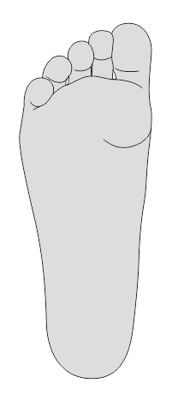 

5) VARIATIONS MOST COMMONLY FOUND IN THIS AREA:

Mark the presence/absence of each of the appropriate variations:

|  |  |
| --- | --- |
|  | ✓/x |
| plantar arch (*arcus plantae*) – location, shape, blood supply |  |

6) DESCRIBE AND DRAW ANY OTHER VARIATIONS IDENTIFIED IN THIS AREA:

**3.11. DORSUM OF THE FOOT (*REGIO DORSALIS PEDIS*)**

|  |  |
| --- | --- |
| SPECIMEN IDENTIFICATION | |
| Specimen number: | side: right/left (*dx/sin*) |

1) SKIN

Inspect the skin in the dorsum of the foot. Note any scars or other damage.

2) SUBCUTANEOUS TISSUE

Indicate which structures you have dissected in the subcutaneous tissue. Mark their presence/absence. Note whether the structure has a standard course. Write down any variations or the reason for their absence:

|  |  |  |  |
| --- | --- | --- | --- |
|  | ✓/x | COURSE | NOTE |
| great saphenous vein (*v. saphena magna*) |  |  |  |
| saphenous nerve (*n. saphenus*) |  |  |  |
| medial dorsal cutaneous nerve of the superficial fibular nerve (*n. cutaneus dorsalis medialis* of *n. fibularis superficialis*) |  |  |  |
| intermediate dorsal cutaneous nerve of the superficial fibular nerve (*n. cutaneus dorsalis intermedius* of *n. fibularis superficialis*) |  |  |  |
| dorsal digital nerves of the foot (*nn. digitales dorsales pedis*) |  |  |  |
| lateral dorsal digital nerve of the hallux from the deep fibular nerve (*n. digitalis dorsalis hallucis lat.* of *n. fibularis profundus*) |  |  |  |
| medial dorsal digital nerve of the second digit from the deep fibular nerve (*n. digitalis dorsalis digiti secundi med.* of *n. fibularis profundus*) |  |  |  |

3) DEEP LAYER

A) MUSCLES

Identify the muscles, mark their presence/absence, include their innervation, origin, and insertion. Note any variations found in the appropriate muscles or the reason for the absence of the muscle:

|  |  |  |  |  |  |
| --- | --- | --- | --- | --- | --- |
|  | ✓/x | INNERVATION | ORIGIN | INSERTION | NOTE |
| extensor digitorum brevis m. |  |  |  |  |  |
| extensor hallucis brevis m. |  |  |  |  |  |
| fibularis tertius m. |  |  |  |  |  |

B) VESSELS

Identify the arteries (veins), mark their presence/absence, course, and include their area of supply (where does it drain). Note any variations found in the appropriate arteries (veins) (e.g., unusual branching) or the reason for the absence of the artery (vein):

|  |  |  |  |  |
| --- | --- | --- | --- | --- |
|  | ✓/x | COURSE | AREA OF SUPPLY | NOTE |
| dorsalis pedis artery  (*a. dorsalis pedis*) |  |  |  |  |
| arcuate artery (*a. arcuata*) |  |  |  |  |
| dorsal metatarsal arteries  (*aa. metatarsae dorsales pedis*) |  |  |  |  |
| deep plantar branch  (*r. pantaris profundus*) |  |  |  |  |
| dorsal digital arteries of the foot  (*aa. digitales dorsales pedis*) |  |  |  |  |
| dorsal artery I. (*a. dorsalis I.*) |  |  |  |  |
|  | ✓/x | COURSE | IS A TRIBUTARY OF | NOTE |
| dorsalis pedis vein  (*v. dorsalis pedis*) |  |  |  |  |

C) NERVES

Identify the nerves, mark their presence/absence, course, and include their area of innervation. Note any variations found in the appropriate nerves or the reason for the absence of the nerve:

|  |  |  |  |  |
| --- | --- | --- | --- | --- |
|  | ✓/x | COURSE | AREA OF INNERVATION | NOTE |
| muscular branches of the deep fibular nerve (*rr. musculares* of *n. fibularis profundus*) |  |  |  |  |

4) DRAW AND LABEL THE BRANCHING OF THE DORSALIS PEDIS ARTERY (*A. DORSALIS PEDIS*) INTO THE SCHEMATIC DRAWING:

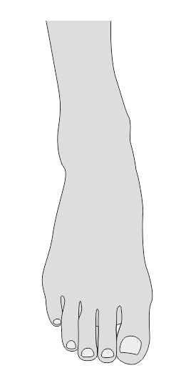

5) DRAW AND LABEL THE BORDERS OF THE SKIN INNERVATION IN THE DORSUM OF THE FOOT REGION (*DORSUM PEDIS*)INTO THE SCHEMATIC DRAWING:



6) VARIATIONS MOST COMMONLY FOUND IN THIS AREA:

Mark the presence/absence of each of the appropriate variations:

|  |  |
| --- | --- |
|  | ✓/x |
| fibularis tertius muscle |  |
| absence of the dorsalis pedis artery |  |
| absence of the arcuate artery |  |

7) DESCRIBE AND DRAW ANY OTHER VARIATIONS IDENTIFIED IN THIS AREA:

**BIBLIOGRAPHY:**  
ARAGONÉS, P. et al. Popliteal artery: Anatomical study and review of the literature. *Annals of Anatomy - Anatomischer Anzeiger* [online]. 2021, **234**, s. 151-654. [Accessed 28 May 2021]. DOI 10.1016/j.aanat.2020.151654. Retrieved from: https://www.sciencedirect.com/science/article/pii/S0940960220301989

ATHAVALE, S. A. et al. The peroneus quartus muscle: Clinical correlation with evolutionary importance. *Anatomical science international*. 2012, **87**, s. 106-110. DOI 10.1007/s12565-011-0129-3.  
   
BILGILI, M. et al. Peroneus quartus: Prevalance and clinical importance. *Archives of orthopaedic and trauma surgery* 2014, **134**, s. 481-487 DOI 10.1007/s00402-014-1937-4.  
   
DEMIRTAŞ, H. et al. Anatomic variations of popliteal artery: Evaluation with 128-section CT-angiography in 1261 lower limbs. *Diagnostic and Interventional Imaging* [online]. 2016, **97**(6), s. 635-642. [Accessed 28 May 2021]. DOI 10.1016/j.diii.2016.02.014. Retrieved from: https://www.sciencedirect.com/science/article/pii/S2211568416300018  
  
KALICHARAN, A. et al. The Anatomy of the Plantar Arterial Arch. *International Journal of Morphology* [online]. 2015, **33**(1), s. 36-42. [Accessed 28 May 2021]. DOI 10.4067/S0717-95022015000100005. Retrieved from: http://www.scielo.cl/scielo.php?script=sci_arttext&pid=S0717-95022015000100005&lng=en&nrm=iso&tlng=en  
  
QAZI, E. et al. Arteries of the Lower Limb—Embryology, Variations, and Clinical Significance. *Canadian Association of Radiologists Journal* [online]. 2021. P. 08465371211003860. [Accessed 28 May 2021]. DOI 10.1177/08465371211003860. Retrieved from: https://doi.org/10.1177/08465371211003860  
  
QUINLAN, D. et al. Variations in Lower Limb Venous Anatomy: Implications for US Diagnosis of Deep Vein Thrombosis1. *Radiology* 2003,  **228**, s. 443-448. DOI 10.1148/radiol.2282020411.  
   
RICE, Shauna Mary, SCHIPANI, Elke Sarah, SANTOS, Ana Maleesa Rae, SADANIANTZ, ROYCHOWDHURY, K. A. et al. Varicosities affecting the lower limb veins consequent to a unique variant drainage pattern of the small saphenous vein. *International Journal of Anatomical Variations* [online]. 2018, **11**(2) [Accessed 28 May 2021]. Retrieved from: https://www.pulsus.com/abstract/varicosities-affecting-the-lower-limb-veins-consequent-to-a-unique-variant-drainage-pattern-of-the-small-saphenous-vein-4594.html

TZOUMA, G. et al. Anatomic Variations of the Deep Femoral Artery and Its Branches: Clinical Implications on Anterolateral Thigh Harvesting. *Cureus* [online]. 2020, **12**(4) [Accessed 28 May 2021]. DOI 10.7759/cureus.7867. Retrieved from: https://www.cureus.com/articles/28805-anatomic-variations-of-the-deep-femoral-artery-and-its-branches-clinical-implications-on-anterolateral-thigh-harvesting

TUBBS, S. R., MOHAMMADALI, S. M. a LOUKAS, M. *Bergman´s Comprehensive Encyclopedia of Human Anatomic Variation* [online]. Hoboken, N. J: Wiley-Blackwell, 2016, 1432 s. [cit. 2021-05-26]. ISBN 9781118430354. Retreived from: <https://eds.a.ebscohost.com/eds/ebookviewer/ebook/bmxlYmtfXzEyMjc5ODFfX0FO0?sid=83fc6545-baf5-4b5c-bcb7-f51051acac65@sessionmgr4006&vid=1&format=EB&rid=1>

UHL, J-F., GILLOT, C. a CHAHIM, M. Anatomical variations of the femoral vein. *Journal of Vascular Surgery* [online]. 2010, **52**(3), s. 714-719. [Accessed 28 May 2021]. DOI 10.1016/j.jvs.2010.04.014. Retrieved from: https://linkinghub.elsevier.com/retrieve/pii/S0741521410009080

WANG, X-T. et al. Normal Variants and Diseases of the Peroneal Tendons and Superior Peroneal Retinaculum: MR Imaging Features. *RadioGraphics* [online]. 2005, **25**(3), s. 587-602. [Accessed 28 May 2021]. DOI 10.1148/rg.253045123. Retrieved from: http://pubs.rsna.org/doi/10.1148/rg.253045123

**4. DISSECTION OF THE NECK** (*Vojtěch Karvay*)

**4.1. OVERVIEW OF THE MOST COMMON VARIATIONS OF THIS REGION**

|  |
| --- |
| **VARIATONS OF MUSCLES** |
| fusion of posterior belly of the digastric muscle with the stylohyoid muscle |
| indistinct mylohyoid raphe |
| anterior scalene muscle– variable origin |
| doubled omohyoid muscle |
| **VARIATIONS OF ARTERIES** |
| superior thyroid artery (*a. thyroidea sup.*) is branch of the common carotid artery (*a. carotis comm.*) |
| rudimental facial artery (*a. facialis*) |
| double internal thoracic artery (*a. thoracica interna*) |
| internal thoracic artery (*a. thoracica interna*) originates from the thyrocervical trunk (*truncus thyrocervicalis*) |
| inferior thyroid artery (*a. thyroidea inferior*) originates from the subclavian artery (*a. subclavia*) |
| subclavian artery (*a. subclavia*) originates from the bicarotic trunk |
| thyroidea ima artery (*a. thyroidea ima*) |
| Vertebral artery (*a. vertebralis*) originates from aortic arch (*arcus aortae*) |
| **VARIATIONS OF VEINS** |
| double internal jugular vein (*v. jugularis interna*) |
| internal jugular vein (*v. jugularis interna*) is posterior to the common carotid artery (*a. carotis comm.*) |
| facial vein (v*. facialis*) is a tributary of the external jugular vein (*v. jugularis externa*) or anterior jugular vein (*v. jugularis anterior*) |
| external jugular vein (*v. jugularis externa*) is a tributary of the right subclavian vein (*v. subclavia dx.*) |
| absence of the external jugular vein (*v. jugularis externa*) |
| hypoplastic external jugular vein (*v. jugularis externa*) |
| **VARIATIONS OF NERVES** |
| non-recurrent laryngeal nerve (*n. laryngeus ​non recurrens*) |
| hypoglossal nerve (*n. hypoglossus*) innervates the mylohyoid muscle |
| vagus nerve (*n. vagus*) anastomoses with the glossopharyngeal nerve (*n. glossopharyngeus*) |
| vagus nerve (*n. vagus*) anastomoses with the accessory nerve (*n. accessorius*) |

**4.2. LATERAL CERVICAL REGION (*REGIO CERVICALIS LATERALIS*)**

|  |  |
| --- | --- |
| SPECIMEN IDENTIFICATION | |
| Specimen number: | side: right/left (*dx/sin*) |

1) SKIN

Inspect the skin in the lateral cervical region (*regio cervicalis lateralis).* Note any scars or other damage.

2) SUBCUTANEOUS TISSUE

Indicate which structures you have dissected in the subcutaneous tissue. Mark their presence/absence. Note whether the structure has a standard course. Write down any variations or the reason for their absence:

|  |  |  |  |
| --- | --- | --- | --- |
|  | ✓/x | COURSE | NOTE |
| external jugular vein  (*v. jugularis externa*) |  |  |  |
| lesser occipital nerve  (*n. occipitalis minor*) |  |  |  |
| great auricular nerve  (*n. auricularis magnus*) |  |  |  |
| transverse cervical vein(*v. transversa colli*) |  |  |  |
| supraclavicular nerves (*nn. supraclaviculares*) |  |  |  |

3) MUSCLES

Identify the muscles, mark their presence/absence, include their innervation, origin, and insertion. Note any variations found in the appropriate muscles or the reason for the absence of the muscle:

|  |  |  |  |  |  |
| --- | --- | --- | --- | --- | --- |
|  | ✓/x | INNERVATION | ORIGIN | INSERTION | NOTE |
| sternocleidomastoid muscle |  |  |  |  |  |

4) DRAW AND LABEL THE SCHEMATIC DRAWING OF THE NECK TRIANGLES (NECK REGIONS):

5) DRAW AND LABEL THE SIMPLE SCHEMATIC DRAWING OF THE CERVICAL FASCIAE:

6) DRAW AND LABEL THE SCHEMATIC DRAWING OF THE DIVISIONS OF THE LATERAL CERVICAL REGION (*REGIO CERVICALIS LATERALIS*) INTO THE OMOCLAVICULAR TRIANGLE (*TRIGONUM OMOCLAVICULARE*) AND OMOTRAPEZIAL TRIANGLE (*TRIGONUM OMOTRAPEZIUM*):

7) DRAW AND LABEL THE ERB’S POINT (*PUNCTUM NERVOSUM*):

8) VARIATIONS MOST COMMONLY FOUND IN THIS AREA:

Mark the presence/absence of each of the appropriate variations:

|  |  |
| --- | --- |
|  | ✓/x |
| missing external jugular vein (*v. jugularis ext*.) |  |
| internal jugular vein(*v. jugularis interna*) is a tributary of the right subclavian vein (*v. subclavia dx.*) |  |

9) DESCRIBE AND DRAW ANY OTHER VARIATIONS IDENTIFIED IN THIS AREA:

**4.3. SCALENE FISSURE (*FISSURA SCALENORUM*)**

|  |  |
| --- | --- |
| SPECIMEN IDENTIFICATION | |
| Specimen number: | side: right/left (*dx/sin*) |

1) MUSCLES

Identify the muscles, mark their presence/absence, include their innervation, origin, and insertion. Note any variations found in the appropriate muscles or the reason for the absence of the muscle:

|  |  |  |  |  |  |
| --- | --- | --- | --- | --- | --- |
|  | ✓/x | INNERVATION | ORIGIN | INSERTION | NOTE |
| anterior scalene muscle |  |  |  |  |  |
| middle scalene muscle |  |  |  |  |  |
| posterior scalene muscle |  |  |  |  |  |

2) VESSELS

Identify the arteries (veins), mark their presence/absence, course, and include their area of supply (where does it drain). Note any variations found in the appropriate arteries (veins) (e.g., unusual branching) or the reason for the absence of the artery (vein):

|  |  |  |  |  |
| --- | --- | --- | --- | --- |
|  | ✓/x | COURSE | AREA OF SUPPLY | NOTE |
| subclavian artery  (*a. subclavia*) |  |  |  |  |
| costocervical trunk  (*truncus costocervicalis*) |  |  |  |  |
| deep cervical artery  (*a. cervicalis profunda*) |  |  |  |  |
| supreme intercostal artery  (*a. intercostalis suprema*) |  |  |  |  |
| transverse cervical artery  (*a. transversa colli*) |  |  |  |  |

3) NERVES:

Identify the nerves, mark their presence/absence, course, and include their area of innervation. Note any variations found in the appropriate nerves or the reason for the absence of the nerve:

|  |  |  |  |  |
| --- | --- | --- | --- | --- |
|  | ✓/x | COURSE | AREA OF INNERVATION | NOTE |
| brachial plexus (*plexus brachialis*) |  |  |  |  |

4) DRAW AND LABEL THE SCHEMATIC DRAWING OF THE *FISSURA SCALENORUM*, ITS BORDERS AND CONTENTS:

5) VARIATIONS MOST COMMONLY FOUND IN THIS AREA:

Mark the presence/absence of each of the appropriate variations:

|  |  |
| --- | --- |
|  | ✓/x |
| subclavian artery (*a. subclavia*) originates from the bicarotic trunk |  |

6) DESCRIBE AND DRAW ANY OTHER VARIATIONS IDENTIFIED IN THIS AREA:

**4.4.** **SCALENOVERTEBRAL TRIANGLE (*TRIGONUM SCALENOVERTEBRALE*)**

|  |  |
| --- | --- |
| SPECIMEN IDENTIFICATION | |
| Specimen number: | side: right/left (*dx/sin*) |

1) LYMPH NODES

Identify the lymphatic ducts, mark their presence/absence, course, and include where do they drain. Note any variations found in the appropriate lymph ducts (e.g., unusual branching/drainage) or the reason for the absence of the duct:

|  |  |  |  |  |
| --- | --- | --- | --- | --- |
|  | ✓/x | COURSE | IT DRAINS INTO | NOTE |
| thoracic duct (*ductus thoracicus*) |  |  |  |  |
| right lymphatic duct(*d. lymphaticus dx*.) |  |  |  |  |

2) ARTERIES

Identify the arteries, mark their presence/absence, course, and include their area of supply. Note any variations found in the appropriate arteries (e.g., unusual branching) or the reason for the absence of the artery:

|  |  |  |  |  |
| --- | --- | --- | --- | --- |
|  | ✓/x | COURSE | AREA OF SUPPLY | NOTE |
| vertebral artery  (*a. vertebralis*) |  |  |  |  |
| internal thoracic artery  (*a. thoracica interna*) |  |  |  |  |
| thyreocervical trunk(*truncus thyreocervicalis*) |  |  |  |  |
| inferior thyroid artery  (*a. thyroidea inferior*) |  |  |  |  |
| superficial cervical artery(*a. cervicalis superficialis*) |  |  |  |  |
| ascending cervical artery  (*a. cervicalis ascendens*) |  |  |  |  |
| suprascapular artery  (*a. suprascapularis*) |  |  |  |  |

3) NERVES:

Identify the nerves, mark their presence/absence, course, and include their area of innervation. Note any variations found in the appropriate nerves or the reason for the absence of the nerve:

|  |  |  |  |  |
| --- | --- | --- | --- | --- |
|  | ✓/x | COURSE | AREA OF INNERVATION | NOTE |
| phrenic nerve  (*n. phrenicus*) |  |  |  |  |
| vagus nerve(*n. vagus*) |  |  |  |  |
| sympathetic trunk(*truncus sympathicus*) |  |  |  |  |
| stellate ganglion (*ganglion stellatum*) |  |  |  |  |
| *ansa subclavia* |  |  |  |  |

4) DRAW AND LABEL THE SCHEMATIC DRAWING OF THE BORDERS OF THE *TRIGONUM SCALENOVERTEBRALE*:

5) VARIATIONS MOST COMMONLY FOUND IN THIS AREA:

Mark the presence/absence of each of the appropriate variations:

|  |  |
| --- | --- |
|  | ✓/x |
| double internal thoracic artery (*a. thoracica interna*) |  |
| Internal thoracic artery (*a. thoracica interna*) is a branch of the thyrocervical trunk (*truncus thyrocervicalis*) |  |

6) DESCRIBE AND DRAW ANY OTHER VARIATIONS IDENTIFIED IN THIS AREA:

**4.5.** **OMOTRACHEAL TRIANGLE (*TRIGONUM OMOTRACHEALE*)**

|  |  |
| --- | --- |
| SPECIMEN IDENTIFICATION | |
| Specimen number: | side: right/left (*dx/sin*) |

1) SKIN

Inspect the skin in the omotracheal triangle (*trigonum omotracheale*). Note any scars or other damage.

2) SUBCUTANEOUS TISSUE

Indicate which structures you have dissected in the subcutaneous tissue. Mark their presence/absence. Note whether the structure has a standard course. Write down any variations or the reason for their absence:

|  |  |  |  |  |  |
| --- | --- | --- | --- | --- | --- |
|  | ✓/x | INNERVATION | ORIGIN | INSERTION | NOTE |
| platysma |  |  |  |  |  |

3) Identify the mentioned fascia, mark its presence/absence:

|  |  |
| --- | --- |
| superficial cervical fascia(*lamina superficialis fasciae cervicalis*) | ✓/x |

4) DEEP LAYER

A) VEINS

Identify the veins, mark their presence/absence, course, and include where does the vein drain. Note any variations found in the appropriate veins or the reason for the absence of the vein:

|  |  |  |  |  |
| --- | --- | --- | --- | --- |
|  | ✓/x | COURSE | IS A TRIBUTARY OF | NOTE |
| anterior jugular vein(*v. jugularis anterior*) |  |  |  |  |
| jugular venous arch(*arcus venosus juguli*) |  |  |  |  |

B) Identify the mentioned fascia, mark its presence/absence:

|  |  |
| --- | --- |
| pretracheal cervical fascia (*lamina praetrachealis fasciae cervicalis*) | ✓/x |

C) MUSCLES

Identify the muscles, mark their presence/absence, include their innervation, origin, and insertion. Note any variations found in the appropriate muscles or the reason for the absence of the muscle:

|  |  |  |  |  |  |
| --- | --- | --- | --- | --- | --- |
|  | ✓/x | INNERVATION | ORIGIN | INSERTION | NOTE |
| sternohyoid muscle |  |  |  |  |  |
| sternothyroid muscle |  |  |  |  |  |
| thyrohyoid muscle |  |  |  |  |  |
| omohyoid muscle |  |  |  |  |  |

5) DISSECTION OF THE LARYNX

Identify the nerves, mark their presence/absence, course, and include their area of innervation. Note any variations found in the appropriate nerves or the reason for the absence of the nerve:

|  |  |  |  |  |
| --- | --- | --- | --- | --- |
|  | ✓/x | COURSE | AREA OF INNERVATION | NOTE |
| superior laryngeal nerve (*n. laryngeus superior*) |  |  |  |  |
| recurrent laryngeal nerve (*n. laryngeus reccurrens*) |  |  |  |  |

6) DRAW AND LABEL THE SCHEMATIC DRAWING OF THE OMOTRACHEAL TRIANGLE (*TRIGONUM OMOTRACHEALE*):

7) DRAW AND LABEL THE SCHEMATIC DRAWING OF THE THYROID GLAND INCLUDING ITS BLOOD SUPPLY:

8) DRAW AND LABEL THE SCHEMATIC DRAWING OF THE *CAVUM LARYNGIS* INCLUDING THE IDENTIFICATION OF THE GALEN’S ANASTOMOSIS:

9) VARIATIONS MOST COMMONLY FOUND IN THIS AREA:

Mark the presence/absence of each of the appropriate variations:

|  |  |
| --- | --- |
|  | ✓/x |
| double omohyoid muscle |  |
| inferior thyroid artery (*a. thyroidea inferior*)is a branch ofthe subclavian artery (*a. subclavia*) |  |

10) DESCRIBE AND DRAW ANY OTHER VARIATIONS IDENTIFIED IN THIS AREA:

**4.6. CAROTID TRIANGLE (*TRIGONUM CAROTICUM*)**

|  |  |
| --- | --- |
| SPECIMEN IDENTIFICATION | |
| Specimen number: | side: right/left (*dx/sin*) |

1) SKIN

Inspect the skin in the carotid triangle (*trigonum caroticum*). Note any scars or other damage.

2) SUBCUTANEOUS TISSUE

Indicate which structures you have dissected in the subcutaneous tissue. Mark their presence/absence. Note whether the structure has a standard course. Write down any variations or the reason for their absence:

|  |  |  |
| --- | --- | --- |
|  | ✓/x | COURSE |
| platysma |  |  |
| transverse cervical nerve (*n. transversus colli*) |  |  |
| facial vein(*v. facialis*) |  |  |
| retromandibular vein(*v. retromandibularis*) |  |  |
| external jugular vein(*v. jugularis externa*) |  |  |

3) DEEP LAYER

A) MUSCLES

Identify the muscles, mark their presence/absence, include their innervation, origin, and insertion. Note any variations found in the appropriate muscles or the reason for the absence of the muscle:

|  |  |  |  |  |  |
| --- | --- | --- | --- | --- | --- |
|  | ✓/x | INNERVATION | ORIGIN | INSERTION | NOTE |
| digastric muscle |  |  |  |  |  |
| sternocleidomastoid muscle |  |  |  |  |  |
| omohyoid muscle |  |  |  |  |  |

B) VESSELS

Identify the arteries (veins), mark their presence/absence, course, and include their area of supply (where does it drain). Note any variations found in the appropriate arteries (veins) (e.g., unusual branching) or the reason for the absence of the artery (vein):

|  |  |  |  |  |
| --- | --- | --- | --- | --- |
|  | ✓/x | COURSE | AREA OF SUPPLY | NOTE |
| common carotid artery  (*a. carotis communis*) |  |  |  |  |
| external carotid artery  (*a. carotis externa*) |  |  |  |  |
| internal carotid artery  (*a. carotis interna*) |  |  |  |  |
| superior thyroid artery  (*a. thyroidea superior*) |  |  |  |  |
| lingual artery  (*a. lingualis*) |  |  |  |  |
| facial artery  (*a. facialis*) |  |  |  |  |
| ascending pharyngeal artery  (*a. pharyngea ascendens*) |  |  |  |  |
| occipital artery  (*a. occipitalis*) |  |  |  |  |
|  | ✓/x | COURSE | IS A TRIBUTARY OF | NOTE |
| internal jugular vein  (*v. jugularis interna*) |  |  |  |  |

C) NERVES:

Identify the nerves, mark their presence/absence, course, and include their area of innervation. Note any variations found in the appropriate nerves or the reason for the absence of the nerve:

|  |  |  |  |  |
| --- | --- | --- | --- | --- |
|  | ✓/x | COURSE | AREA OF INNERVATION | NOTE |
| deep cervical ansa  (*ansa cervicalis profunda*) |  |  |  |  |
| hypoglossal nerve (*n. hypoglossus*) |  |  |  |  |
| vagus nerve(*n. vagus*) |  |  |  |  |
| superior laryngeal nerve  (*n. laryngeus superior*) |  |  |  |  |
| sympathetic trunk  (*truncus sympathicus*) |  |  |  |  |

4) DRAW AND LABEL THE SCHEMATIC DRAWING OF THE CAROTID TRIANGLE (*TRIGONUM CAROTICUM*) (BORDERS, CONTENTS):

5) DRAW AND LABEL THE BRANCHING OF THE EXTERNAL CAROTID ARTERY (*A. CAROTIS EXTERNA)*INCLUDING ITS TERMINAL BRANCHES:

6) VARIATIONS MOST COMMONLY FOUND IN THIS AREA:

Mark the presence/absence of each of the appropriate variations:

|  |  |
| --- | --- |
|  | ✓/x |
| fusion of the posterior belly of digastric muscle with the stylohyoid muscle |  |
| superior thyroid artery (*a. thyroidea superior*) is a branch of the common carotid artery (*a. carotis communis*) |  |
| internal jugular vein(*v. jugularis interna*) is posterior to the common carotid artery(*a. carotis communis*) |  |

7) DESCRIBE AND DRAW ANY OTHER VARIATIONS IDENTIFIED IN THIS AREA:

**4.7. SUBMANDIBULAR TRIANGLE (*TRIGONUM SUBMANDIBULARE*)**

|  |  |
| --- | --- |
| SPECIMEN IDENTIFICATION | |
| Specimen number: | side: right/left (*dx/sin*) |

1) SKIN

Inspect the skin in the submandibular triangle (*trigonum submandibulare*). Note any scars or other damage.

2) SUBCUTANEOUS TISSUE

Indicate which structures you have dissected in the subcutaneous tissue. Mark their presence/absence. Note whether the structure has a standard course. Write down any variations or the reason for their absence:

|  |  |  |
| --- | --- | --- |
|  | ✓/x | COURSE |
| platysma |  |  |
| superficial cervical fascia  (*lamina superficialis f. cervicalis*) |  |  |
| angular tract (*tractus angularis*) |  |  |

3) DEEP LAYER

A) MUSCLES

Identify the muscles, mark their presence/absence, include their innervation, origin, and insertion. Note any variations found in the appropriate muscles or the reason for the absence of the muscle:

|  |  |  |  |  |  |
| --- | --- | --- | --- | --- | --- |
|  | ✓/x | INNERVATION | ORIGIN | INSERTION | NOTE |
| digastric muscle |  |  |  |  |  |
| mylohyoid muscle |  |  |  |  |  |
| hyoglossus muscle |  |  |  |  |  |
| styloglossus muscle |  |  |  |  |  |

B) VESSELS

Identify the arteries (veins), mark their presence/absence, course, and include their area of supply (where does it drain). Note any variations found in the appropriate arteries (veins) (e.g., unusual branching) or the reason for the absence of the artery (vein):

|  |  |  |  |  |
| --- | --- | --- | --- | --- |
|  | ✓/x | COURSE | AREA OF SUPPLY | NOTE |
| facial artery  (*a. facialis*) |  |  |  |  |
| lingual artery  (*a. lingualis*) |  |  |  |  |
|  | ✓/x | COURSE | IS A TRIBUTARY OF | NOTE |
| facial vein  (*v. facialis*) |  |  |  |  |

C) NERVES

Identify the nerves, mark their presence/absence, course, and include their area of innervation. Note any variations found in the appropriate nerves or the reason for the absence of the nerve:

|  |  |  |  |  |
| --- | --- | --- | --- | --- |
|  | ✓/x | COURSE | AREA OF INNERVATION | NOTE |
| lingual nerve  (*n. lingualis*) |  |  |  |  |
| hypoglossal nerve  (*n. hypoglossus*) |  |  |  |  |
| submandibular ganglion(*ggl. submandibulare*) |  |  |  |  |
| mylohyoid nerve  (*n. mylohyoideus*) |  |  |  |  |

4) DRAW AND LABEL THE SCHEMATIC DRAWING OF THE SUBMANDIBULAR TRIANGLE (*TRIGONUM SUBMANDIBULARE*) (BORDERS):

5) DRAW AND LABEL THE MAIN STRUCTURES IN THE PIROGOV’S TRIANGLE (*TRIGONUM PIROGOVI*):

6) DRAW AND LABEL THE SCHEMATIC DRAWING OF THE BECLARD’S ANGLE INCLUDING ITS CONTENTS:

7) VARIATIONS MOST COMMONLY FOUND IN THIS AREA:

Mark the presence/absence of each of the appropriate variations:

|  |  |
| --- | --- |
|  | ✓/x |
| rudimental facial artery (*a. facialis*) |  |
| facial vein (*v. facialis*) is a tributary of the external jugular vein (*v. jugularis externa*) |  |
| facial vein (*v. facialis*)is a tributary of the anterior jugular vein (*v. jugularis anterior*) |  |

8) DESCRIBE AND DRAW ANY OTHER VARIATIONS IDENTIFIED IN THIS AREA:

**BIBLIOGRAPHY**:

GRIM, M., DRUGA, R. et al. *Základy anatomie. 5. Anatomie krajin těla.* Praha: Galén; Univerzita Karlova, 2002, 119 s. ISBN 80-7262-179-3.

KOS, J. a kol. *Přehled topografické anatomie*. Praha: Karolinum, 2020, 140 s. ISBN 9788024644943.

TUBBS, S. R., MOHAMMADALI, S. M. a LOUKAS, M. *Bergman´s Comprehensive Encyclopedia of Human Anatomic Variation* [online]. Hoboken, N. J: Wiley-Blackwell, 2016, 1432 s. [cit. 2021-05-24]. ISBN 9781118430354. Retrieved from: <https://eds.a.ebscohost.com/eds/ebookviewer/ebook/bmxlYmtfXzEyMjc5ODFfX0FO0?sid=83fc6545-baf5-4b5c-bcb7-f51051acac65@sessionmgr4006&vid=1&format=EB&rid=1>

**5. DISSECTION OF THE THORAX** (*Erik Kročka*)

**5.1. OVERVIEW OF THE MOST COMMON VARIATIONS OF THIS REGION**

|  |
| --- |
| **VARIATIONS OF MUSCLES** |
| sternalis muscle |
| pectoralis tertius muscle |
| pectoralis quartus muscle |
| Langer’s arch (*arcus axillaris*) |
| **VARIATIONS OF ARTERIES** |
| origin of the posterior circumflex humeral artery (*a. circumflexa humeri posterior*) from the subscapular artery (*a. subscapularis*) |
| common trunk for the anterior and posterior circumflex humeral artery (*a. circumflexa humeri anterior et posterior*) |
| origin of the deep brachial artery (*a. profunda brachii*) from the axillary artery (*a. axillaris*) |
| common trunk for the lateral thoracic artery (*a. thoracica lateralis*) and thoracoacromial artery (*a.* *thoracoacromialis*) |
| common trunk for the lateral thoracic artery (*a. thoracica lateralis*) and subscapular artery (*a. subscapularis*) |
| origin of the internal thoracic artery (*a. thoracica interna*) from the thyrocervical trunk (*truncus thyrocervicalis*) |
| origin of the internal thoracic artery (*a. thoracica interna*) from the suprascapular artery (*a. suprascapularis*) |
| xiphoid branch of the internal thoracic artery (*r. xiphoideus* *a. thoracicae internae*) |
| **VARIATIONS OF VEINS** |
| absent cephalic vein (*v. cephalica*) |
| persistent jugulocephalic vein |
| accessory axillary vein (*v. axillaris*) |
| middle right pulmonary vein (*v. pulmonalis dextra media*) |
| common trunk for the left pulmonary veins (*vv. pulmonales* *sin.*) |
| **VARIATIONS OF NERVES** |
| accessory phrenic nerve (*n. phrenicus accessorius*) |
| accessory splanchnic nerve (*n. splanchnicus accessorius*) |
| absent lesser splanchnic nerve (*n. splanchnicus minor*) |
| **VARIATIONS OF HEART** |
| co-dominant left coronary artery (*a. coronaria cordis sin*.) and the circumflex branch (*r. circumflexus*) |
| dominant left coronary artery (*a. coronaria cordis sin.*) |
| absent trunk of the left coronary artery (*a. coronaria cordis sin.*) |
| circumflex branch (*r. circumflexus*) from the right coronary artery (*a. coronaria cordis dx*.) |
| only one coronary artery (origin of the right coronary artery (*a. coronaria cordis dx.*)– from the left coronary artery (*a. coronaria cordis sin.*) |
| *arcus bovinus* |
| bicuspid aortal valve |
| patent foramen ovale (*foramen ovale patens*) |
| **OTHER VARIATIONS** |
| accessory mammary gland (*gl. mammaria*) |
| accessory breast (*mamilla*) |
| axillary process of the breast (*processus axillaris mammae*) |
| accessory superior fissure of the right lung (*fissura superior accessoria pulmonis* *dx.*) |
| medial basal pulmonary fissure (*fissura mediobasalis pulmonis*) |
| doubled thoracic duct (*ductus thoracicus*) |

**5.2. SKIN, SUBCUTANEOUS TISSUE AND MUSCLES OF THE THORACIC WALL**

|  |  |
| --- | --- |
| SPECIMEN IDENTIFICATION | |
| Specimen number: | side: right/left (*dx/sin*) |

1) CONFIGURATION OF THE THORAX

Inspect the shape of the chest and note its configuration/shape (normal, asthenic, barrel, funnel, pigeon, kyphoscoliotic…).

2) SKIN

Inspect the skin of the anterior wall of the chest. Note any scars or other damage. Notice and describe any incidental accessory nipples which could be distributed along the mammary crest.

3) SUBCUTANEOUS TISSUE

Indicate which structures you have dissected in the subcutaneous tissue. Mark their presence/absence. Note whether the structure has a standard course. Write down any variations or the reason for their absence:

|  |  |  |  |
| --- | --- | --- | --- |
|  | ✓/x | COURSE | NOTE |
| lateral cutaneous branches of the intercostal nerves (*rr. cutanei laterales nervi intercostales*) |  |  |  |
| lateral mammary branches of the intercostal nerves (*rr. mammarii laterales nervi intercostales*) |  |  |  |
| anterior cutaneous branches of the intercostal nerves (*rr. cutanei anteriores nervi intercostales*) |  |  |  |
| medial mammary branches of the intercostal nerves (*rr. mammarii mediales nervi intercostales*) |  |  |  |
| medial supraclavicular nerves  (*nn. supraclaviculares mediales*) |  |  |  |
| intermediate supraclavicular nerves  (*nn. supraclaviculares intermedii*) |  |  |  |
| lateral supraclavicular nerves  (*nn. supraclaviculares laterales*) |  |  |  |
| lateral cutaneous branches of the intercostal arteries (*rr. cutanei laterales aa. intercostales*) |  |  |  |
| lateral mammary branches of the intercostal arteries (*rr. mammarii laterales aa. intercostales*) |  |  |  |
| medial cutaneous branches of the internal thoracic artery (*rr. cutanei mediales a. thoracicae internae*) |  |  |  |
| medial mammary branches of the internal thoracic artery (*rr. mammarii mediales a. thoracicae internae*) |  |  |  |
| lateral thoracic artery  (*a. thoracica lateralis*) |  |  |  |
| lateral mammary branches of the lateral thoracic artery (*rr. mammarii laterales a. thoracicae lateralis*) |  |  |  |
| cephalic vein (*vena cephalica*) |  |  |  |
| thoracoepigastric vein  (*v. thoracoepigastrica*) |  |  |  |
| areolar venous plexus  (*plexus venosus areolaris*) |  |  |  |

4) DEEP LAYER

A) MUSCLES

Identify the muscles, mark their presence/absence, include their innervation, origin, and insertion. Note any variations found in the appropriate muscles or the reason for the absence of the muscle:

|  |  |  |  |  |  |
| --- | --- | --- | --- | --- | --- |
|  | ✓/x | INNERVATION | ORIGIN | INSERTION | NOTE |
| pectoralis major muscle |  |  |  |  |  |
| pectoralis minor muscle |  |  |  |  |  |
| serratus anterior muscle |  |  |  |  |  |
| deltoid muscle |  |  |  |  |  |

5) DRAW AND LABEL THE COURSE OF THE PECTORALIS MAJOR MUSCLE (*MUSCULUS PECTORALIS MAJOR*) INTO THE SCHEMATIC DRAWING. DESCRIBE THE SPECIFIC MOVEMENT PATTERN OF THE CLAVICULAR, STERNOCOSTAL AND ABDOMINAL PART OF THE PECTORALIS MAJOR MUSCLE.

6) WHICH ARTERIES SUPPLY THE MAMMARY GLANDS?

7) WHICH LYMPH NODES DRAIN THE QUADRANTS OF THE MAMMARY GLAND?

|  |  |
| --- | --- |
| SUPERIOR MEDIAL QUADRANT | SUPERIOR LATERAL QUADRANT |
| INFERIOR MEDIAL QUADRANT | INFERIOR LATERAL QUADRANT |

8) VARIATIONS MOST COMMONLY FOUND IN THIS AREA:

Mark the presence/absence of each of the appropriate variations:

|  |  |
| --- | --- |
|  | ✓/x |
| accessory mammary gland |  |
| accessory breast (*mammilla*) |  |
| sternalis muscle(*m. sternalis*) |  |
| absent cephalic vein (*v. cephalica*) |  |

9) DESCRIBE AND DRAW ANY OTHER VARIATIONS IDENTIFIED IN THIS AREA:

**5.3. CLAVIPECTORAL (DELTOPECTORAL) TRIANGLE (*TRIGONUM CLAVIPECTORALE* (*DELTOIDEOPECTORALE*))**

|  |  |
| --- | --- |
| SPECIMEN IDENTIFICATION | |
| Specimen number: | side: right/left (*dx/sin*) |

1) SKIN

Inspect the skin in the clavipectoral triangle (*trigonum deltoideopectorale).* Note any scars or other damage.

2) SUBCUTANEOUS TISSUE

Indicate which structures you have dissected in the subcutaneous tissue. Mark their presence/absence. Note whether the structure has a standard course. Write down any variations or the reason for their absence:

|  |  |  |  |
| --- | --- | --- | --- |
|  | ✓/x | COURSE | NOTE |
| cephalic vein (*v. cephalica*) |  |  |  |
| supraclavicular nerves  (*nn. supraclaviculares*) |  |  |  |

3) DEEP LAYER

A) MUSCLES

Identify the muscles, mark their presence/absence, include their innervation, origin, and insertion. Note any variations found in the appropriate muscles or the reason for the absence of the muscle:

|  |  |  |  |  |  |
| --- | --- | --- | --- | --- | --- |
|  | ✓/x | INNERVATION | ORIGIN | INSERTION | NOTE |
| deltoid muscle |  |  |  |  |  |
| pectoralis major muscle |  |  |  |  |  |

B) ARTERIES

Identify the arteries, mark their presence/absence, course, and include their area of supply. Note any variations found in the appropriate arteries (e.g., unusual branching) or the reason for the absence of the artery:

|  |  |  |  |  |
| --- | --- | --- | --- | --- |
|  | ✓/x | COURSE | AREA OF SUPPLY | NOTE |
| deltoid branch of the thoracoacromial artery  (*r. deltoideus a. thoracoacromialis*) |  |  |  |  |
| acromial branch of the thoracoacromial artery  (*r. acromialis a. thoracoacromialis*) |  |  |  |  |
| clavicular branch of the thoracoacromial artery  (*r. clavicularis a. thoracoacromialis*) |  |  |  |  |
| pectoral branch of the thoracoacromial artery  (*r. pectoralis a. thoracoacromialis*) |  |  |  |  |

C) NERVES:

Identify the nerves, mark their presence/absence, course, and include their area of innervation. Note any variations found in the appropriate nerves or the reason for the absence of the nerve:

|  |  |  |  |  |
| --- | --- | --- | --- | --- |
|  | ✓/x | COURSE | AREA OF INNERVATION | NOTE |
| lateral pectoral nerve  (*n. pectoralis lateralis*) |  |  |  |  |
| medial pectoral nerve  (*n. pectoralis medialis*) |  |  |  |  |

4) DRAW AND LABEL THE SCHEMATIC DRAWING OF THE DELTOIDEOPECTORAL TRIANGLE (*TRIGONUM DELTOIDEOPECTORALE*):

5) CLAVIPECTORAL FASCIA (*FASCIA CLAVIPECTORALIS*)

Which muscles are covered by the clavipectoral fascia?

6) VARIATIONS MOST COMMONLY FOUND IN THIS AREA:

Mark the presence/absence of each of the appropriate variations:

|  |  |
| --- | --- |
|  | ✓/x |
| accessory axillary vein (*v. axillaris*) (56,7%) |  |
| absence of the cephalic vein (*v. cephalica*) (16%) |  |

7) DESCRIBE AND DRAW ANY OTHER VARIATIONS IDENTIFIED IN THIS AREA:

**5.4. AXILLA**

|  |  |
| --- | --- |
| SPECIMEN IDENTIFICATION | |
| Specimen number: | side: right/left (*dx/sin*) |

1) SKIN

Inspect the skin in the *axilla*. Note any scars or other damage.

2) DEEP LAYER

A) ARTERIES

Identify the arteries, mark their presence/absence, course, and include their area of supply. Note any variations found in the appropriate arteries (e.g., unusual branching) or the reason for the absence of the artery:

|  |  |  |  |  |
| --- | --- | --- | --- | --- |
|  | ✓/x | COURSE | AREA OF SUPPLY | NOTE |
| axillary artery (*a. axillaris*) |  |  |  |  |
| superior thoracic artery  (*a. thoracica superior*) |  |  |  |  |
| thoracoacromial artery  (*a. thoracoacromialis*) |  |  |  |  |
| lateral thoracic artery  (*a. thoracica lateralis*) |  |  |  |  |
| subscapular artery  (*a. subscapularis*) |  |  |  |  |
| circumflex scapular artery  (*a. circumflexa scapulae*) |  |  |  |  |
| thoracodorsal artery  (*a. thoracodorsalis*) |  |  |  |  |
| anterior circumflex humeral artery (*a. circumflexa humeri anterior*) |  |  |  |  |
| posterior circumflex humeral artery (*a. circumflexa humeri posterior*) |  |  |  |  |

B) NERVES:

Identify the nerves, mark their presence/absence, course, and include their area of innervation. note any variations found in the appropriate nerves or the reason for the absence of the nerve:

|  |  |  |  |  |  |
| --- | --- | --- | --- | --- | --- |
|  | ✓/x | COURSE | | AREA OF INNERVATION | NOTE |
| musculocutaneous nerve  (*n. musculocutaneus)* |  |  |  | |  |
| median nerve (*n. medianus)* |  |  |  | |  |
| ulnar nerve (*n. ulnaris)* |  |  |  | |  |
| medial brachial cutaneous nerve (*n. cutaneus brachii medialis)* |  |  |  | |  |
| medial antebrachial cutaneous nerve *(n. cutaneus antebrachii med.)* |  |  |  | |  |
| radial nerve (*n. radialis)* |  |  |  | |  |
| axillary nerve *(n. axillaris)* |  |  |  | |  |

3) DRAW AND LABEL THE SCHEMATIC DRAWING OF THE AXILLARY FOSSA (*FOSSA AXILLARIS*):

4) WHAT STRUCTURE(S) IS/ARE AFFECTED DURING THE INJURY OF THE POSTERIOR FASCICLE OF THE BRACHIAL PLEXUS? NOTE THE CLINICAL SIGNS:

5) NAME THE MAIN GROUPS OF THE AXILLARY LYMPH NODES AND THEIR AREAS OF DRAINAGE:

6) WRITE THE NAMES OF THE SHOULDER ROTATOR-CUFF MUSCLES INTO THE FOLLOWING TABLE:

|  |  |
| --- | --- |
| medial (internal) rotators |  |
| lateral (external) rotators |  |

7) VARIATIONS MOST COMMONLY FOUND IN THIS AREA:

Mark the presence/absence of each of the appropriate variations:

|  |  |
| --- | --- |
|  | ✓/x |
| origin of the posterior circumflex humeral artery (*a. circumflexa humeri posterior*) from the subscapular artery (*a. subscapularis*) |  |
| common trunk for the anterior and posterior circumflex humeral artery (*a. circumflexa humeri anterior et posterior*) |  |
| origin of the deep brachial artery (*a. profunda brachii*) from the axillary artery (*a. axillaris*) |  |
| Accessory axillary vein (*v. axillaris*) |  |
| Langer’s arch (*arcus axillaris*) |  |

8) DESCRIBE AND DRAW ANY OTHER VARIATIONS IDENTIFIED IN THIS AREA:

**5.5. OPENING OF THE THORAX + PHRENIC NERVE + ANTERIOR MEDIASTINUM + LUNG REMOVAL (THE ROOT OF THE LUNG)**

|  |  |
| --- | --- |
| SPECIMEN IDENTIFICATION | |
| Specimen number: | side: right/left (*dx/sin*) |

1) *SITUS VISCERUM*

Inspect the location and the state of the thoracic organs after the opening of the thorax. Note any signs of possible past surgical procedures:

2) TRANSVERSUS THORACIS MUSCLE (*MUSCULUS TRANSVERSUS THORACIS*)

Note the data about transversus thoracis muscle into the table:

|  |  |
| --- | --- |
| the number of muscle slips |  |
| origin |  |
| insertion (with number of the ribs) |  |
| vascular supply |  |
| innervation |  |
| note |  |

3) ARTERIES

Identify the arteries, mark their presence/absence, course, and include their area of supply. Note any variations found in the appropriate arteries (e.g., unusual branching) or the reason for the absence of the artery:

|  |  |  |  |  |
| --- | --- | --- | --- | --- |
|  | ✓/x | COURSE | AREA OF SUPPLY | NOTE |
| internal thoracic artery  (*a. thoracica interna*) |  |  |  |  |
| pericardiacophrenic artery (*a. pericardiacophrenica*) |  |  |  |  |
| perforating branches  (*rr. perforantes*) |  |  |  |  |
| superior epigastric artery  (*a. epigastrica superior*) |  |  |  |  |
| musculophrenic artery (*arteria musculophrenica*) |  |  |  |  |

4) NERVES:

Identify the nerves, mark their presence/absence, course, and include their area of innervation. Note any variations found in the appropriate nerves or the reason for the absence of the nerve:

|  |  |  |  |  |
| --- | --- | --- | --- | --- |
|  | ✓/x | COURSE | AREA OF INNERVATION | NOTE |
| phrenic nerve  *(n. phrenicus)* |  |  |  |  |

5) MEDIASTINUM

Describe the anatomical parts of the mediastinum and write their boundaries:

6) THE ROOTS OF THE LUNGS

Draw and label the structures present in the roots of the lungs into the schematic drawing:

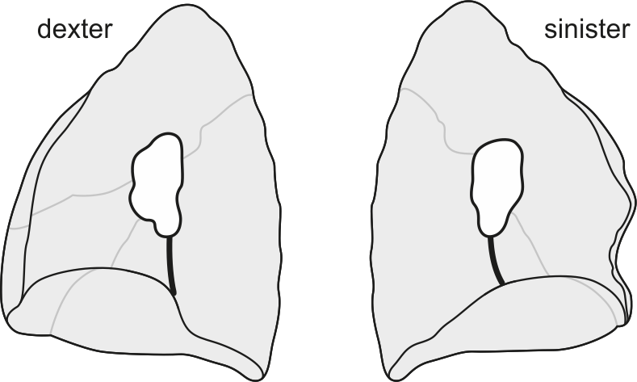

7) LUNGS

Mark and note the lung data in the table:

|  |  |  |
| --- | --- | --- |
|  | RIGHT LUNG | LEFT LUNG |
| number of lobes |  |  |
| horizontal fissure (✓/x) |  |  |
| oblique fissure (✓/x) |  |  |
| accessory fissures (number) |  |  |
| accessory fissures (location) |  |  |
| accessory lobes (number) |  |  |
| accessory lobes (location) |  |  |
| pleural adhesions (✓/x) |  |  |
| pleural adhesions (location) |  |  |

8) VARIATIONS MOST COMMONLY FOUND IN THIS AREA:

Mark the presence/absence of each of the appropriate variations:

|  |  |
| --- | --- |
|  | ✓/x |
| origin of the internal thoracic artery (*a. thoracica interna*) from the thyrocervical trunk (*truncus thyrocervicalis*) |  |
| accessory phrenic nerve (*nervus phrenicus accessorius*) |  |
| right superior accessory fissure |  |
| medial basal fissure |  |

9) DESCRIBE AND DRAW ANY OTHER VARIATIONS IDENTIFIED IN THIS AREA:

**5.6. HEART REMOVAL AND PREPARATION**

|  |  |
| --- | --- |
| SPECIMEN IDENTIFICATION | |
| Specimen number: | side: right/left (*dx/sin*) |

1) PERIKARDIUM

Inspect the pericardium, explore the *sinus transversus* a *sinus obliquus pericardii*, mark the presence of any deviations from a standard state:

2) CORONARY ARTERIES (*ARTERIAE CORONARIAE CORDIS*)

Identify the arteries (veins), mark their presence/absence, course, and include their area of supply (where do they drain). Note any variations found in the appropriate arteries/veins (e.g., unusual branching) or the reason for the absence of the artery/vein:

|  |  |  |  |  |
| --- | --- | --- | --- | --- |
|  | ✓/x | COURSE | AREA OF SUPPLY | NOTE |
| right coronary artery  (*a. coronaria dextra*) |  |  |  |  |
| ramus coni arteriosi |  |  |  |  |
| atrial branches  (*rr. atriales*) |  |  |  |  |
| ventricular branches  (*rr. ventriculares*) |  |  |  |  |
| right marginal branch  (*r. marginalis dexter*) |  |  |  |  |
| posterior interventricular branch  (*r. interventricularis posterior*) |  |  |  |  |
| left coronary artery  (*a. coronaria sinistra*) |  |  |  |  |
| anterior interventricular branch  (*r.interventricularis anterior*) |  |  |  |  |
| ramus coni arteriosi |  |  |  |  |
| anterior ventricular branches  (*rr. ventriculares anteriores*) |  |  |  |  |
| diagonal branches  (*rr. diagonales*) |  |  |  |  |
| circumflex branch  (*r. circumflexus*) |  |  |  |  |
| left marginal branch  (*r. marginalis sinister*) |  |  |  |  |
| atrial branches  (*rr. atriales*) |  |  |  |  |
|  | ✓/x | COURSE | IS A TRIBUTARY OF | NOTE |
| coronary sinus  (*sinus coronarius*) |  |  |  |  |
| great cardiac vein  (*v. cordis magna*) |  |  |  |  |
| middle cardiac vein  (*v. cordis media*) |  |  |  |  |
| small cardiac vein  (*v. cordis parva*) |  |  |  |  |

3) RIGHT ATRIUM (*ATRIUM DEXTRUM*)

Identify the appropriate structures, mark their presence/absence. Note any variations (e.g., unusual branching), or the reason for the absence of the structure:

|  |  |  |
| --- | --- | --- |
|  | ✓/x | NOTE |
| right auricle (*auricula dextra*) |  |  |
| pectinate muscles (*musculi pectinati*) |  |  |
| oval fossa (*fossa ovalis*) |  |  |
| limbus of the oval fossa (*limbus fossae ovalis*) |  |  |
| crista terminalis (*crista terminalis*) |  |  |
| intervenous tubercle  (*tuberculum intervenosum*) |  |  |
| opening of the superior vena cava  (*ostium venae cavae superioris*) |  |  |
| opening of the inferior vena cava  (*ostium venae cavae inferioris*) |  |  |
| valve of the inferior vena cava  (*valvula venae cavae inferioris*) |  |  |
| opening of the coronary sinus  (*ostium sinus coronarii*) |  |  |
| valve of the coronary sinus  (*valvula sinus coronarii*) |  |  |
| openings of the smallest cardiac veins  (*foramina venarum minimarum*) |  |  |

4) RIGHT VENTRICLE (*VENTRICULUS DEXTER*)

Identify the appropriate structures, mark their presence/absence. Note any variations (e.g., unusual branching), or the reason for the absence of the structure:

|  |  |  |
| --- | --- | --- |
|  | ✓/x | NOTE |
| anterior cusp (*cuspis anterior valvae tricuspidalis*) |  |  |
| posterior cusp (*cuspis posterior valvae tricuspidalis*) |  |  |
| septal cusp (*cuspis septalis valvae tricuspidalis*) |  |  |
| anterior papillary muscle |  |  |
| posterior papillary muscle |  |  |
| septal papillary muscle |  |  |
| trabeculae carneae |  |  |
| moderator band (*trabecula septomarginalis*) |  |  |
| supraventricular crest (*crista supraventricularis*) |  |  |
| anterior semilunar cusp  (*valvula semilunaris anterior valvae trunci pulmonalis*) |  |  |
| left semilunar cusp  (*valvula semilunaris sinistra valvae trunci pulmonalis*) |  |  |
| right semilunar cusp  (*valvula semilunaris dextra valvae trunci pulmonalis*) |  |  |

5) LEFT ATRIUM (*ATRIUM SINISTRUM*)

Identify the appropriate structures, mark their presence/absence. Note any variations (e.g., unusual branching), or the reason for the absence of the structure:

|  |  |  |
| --- | --- | --- |
|  | ✓/x | NOTE |
| left auricle (*auricula sinistra*) |  |  |
| pectinate muscles (*musculi pectinati*) |  |  |
| valve of the foramen ovale  (*valvula foraminis ovalis*) |  |  |
| openings of the pulmonary veins  (*ostia venarum pulmonalium*)  - count: … |  |  |
| openings of the smallest cardiac veins (*foramina venarum minimarum*) |  |  |

6) LEFT VENTRICLE (*VENTRICULUS SINISTER*)

Identify the appropriate structures, mark their presence/absence. Note any variations (e.g., unusual branching), or the reason for the absence of the structure:

|  |  |  |
| --- | --- | --- |
|  | ✓/x | NOTE |
| anterior cusp (*cuspis anterior valvae mitralis*) |  |  |
| posterior cusp (*cuspis posterior valvae mitralis*) |  |  |
| anterior papillary muscle |  |  |
| posterior papillary muscle |  |  |
| left semilunar cusp  (*valvula semilunaris sinistra valvae aortae*) |  |  |
| right semilunar cusp  (*valvula semilunaris dextra valvae aortae*) |  |  |
| posterior semilunar cusp  (*valvula semilunaris posterior valvae aortae*) |  |  |
| membranous part of interventricular septum (*pars membranacea septi interventriculare*) |  |  |
| muscular part of interventricular septum  (*pars muscularis septi interventriculare*) |  |  |

7) DRAW AND LABEL THE SCHEMATIC DRAWING OF THE RIGHT ATRIUM:

8) DRAW AND LABEL THE SCHEMATIC DRAWING OF THE BLOOD SUPPLY OF THE HEART:

9) VARIATIONS MOST COMMONLY FOUND IN THIS AREA:

Mark the presence/absence of each of the appropriate variations:

|  |  |
| --- | --- |
|  | ✓/x |
| absence of the trunk of the left coronary artery (*a. coronaria cordis sin.*) |  |
| origin of the circumflex branch (*ramus circumflexus*) from the right coronary artery (*a. coronaria cordis dx.*) |  |
| IMA |  |
| single coronary artery (origin of the right coronary artery from the left coronary artery) |  |
| "bovine arch" (*arcus bovinus*) |  |
| bicuspid aortic valve |  |
| patent foramen ovale |  |

10) DESCRIBE AND DRAW ANY OTHER VARIATIONS IDENTIFIED IN THIS AREA:

**5.7. POSTERIOR MEDIASTINUM**

|  |  |
| --- | --- |
| SPECIMEN IDENTIFICATION | |
| Specimen number: | side: right/left (*dx/sin*) |

1) THORACIC AORTA (*AORTA THORACICA*)

Identify the branches of the thoracic aorta (*aorta thoracica*), mark their presence/absence, course and include their area of supply. Note any variations (e.g., unusual branching), or the reason for the absence of the structure:

|  |  |  |  |  |
| --- | --- | --- | --- | --- |
|  | ✓/x | COURSE | AREA OF SUPPLY | NOTE |
| brachiocephalic trunk (*truncus brachiocephalicus*) |  |  |  |  |
| left common carotid artery (*a. carotis communis sin.*) |  |  |  |  |
| left subclavian artery  (*a. subclavia sinistra*) |  |  |  |  |
| posterior intercostal arteries (*aa. intercostales post.*) |  |  |  |  |
| subcostal arteries  (*aa. subcostales*) |  |  |  |  |
| superior phrenic arteries (*aa. phrenicae superiores*) |  |  |  |  |
| bronchial branches  (*rr. bronchiales*) |  |  |  |  |
| oesophageal branches  (r*r. oesophageales*) |  |  |  |  |
| pericardial branches  (r*r. pericardiaci*) |  |  |  |  |
| mediastinal branches  (r*r. mediastinales*) |  |  |  |  |

*Note: Aortic arch and its branches topographically belong to the anterior superior mediastinum. They are present in the table due to practical dissection reasons.*

2) VEINS

Identify the veins, mark their presence/absence, course, and include where does the vein drain. Note any variations found in the appropriate veins or the reason for the absence of the vein:

|  |  |  |  |  |
| --- | --- | --- | --- | --- |
|  | ✓/x | COURSE | IS A TRIBUTARY OF | NOTE |
| azygos vein  (*v. azygos*) |  |  |  |  |
| hemiazygos vein  (*v. hemiazygos*) |  |  |  |  |
| accessory hemiazygos vein  (*v. hemiazygos accessoria*) |  |  |  |  |

3) VAGUS NERVES (*NERVI VAGI*)

Identify the vagus nerves, mark their presence/absence, course, and include their area of innervation. Note any variations found in the appropriate nerves or the reason for the absence of the nerve:

|  |  |  |  |  |
| --- | --- | --- | --- | --- |
|  | ✓/x | COURSE | AREA OF INNERVATION | NOTE |
| recurrent laryngeal nerves  (*nn. laryngei recurrentes*) |  |  |  |  |
| tracheal branches  (*rr. tracheales*) |  |  |  |  |
| oesophageal branches  (r*r. oesophageales*) |  |  |  |  |
| cardiac branches  (*rr. cardiaci thoracici*) |  |  |  |  |
| anterior vagal trunk  (*tr. vagalis anterior*) |  |  |  |  |
| posterior vagal trunk  (*tr. vagalis posterior*) |  |  |  |  |

4) SYMPATHETIC TRUNKS (*TRUNCI SYMPATHICI*)

Identify the sympathetic trunks, mark their presence/absence, course, and include their area of innervation. Note any variations found in the appropriate nerves or the reason for the absence of the nerve:

|  |  |  |  |  |
| --- | --- | --- | --- | --- |
|  | ✓/x | COURSE | AREA OF INNERVATION | NOTE |
| cardiac nerves  (*nn. cardiaci thoracici*) |  |  |  |  |
| greater splanchnic nerve (*n. splanchnicus major*) |  |  |  |  |
| lesser splanchnic nerve  (*n. splanchnicus minor*) |  |  |  |  |
| least splanchnic nerve  (*n. splanchnicus imus*) |  |  |  |  |

5) THORACIC DUCT (*DUCTUS THORACICUS*)

Describe the entry, course, and drainage place of the thoracic duct in the posterior mediastinum. From which body parts does it drain the lymph?

6) WHAT EFFECT DOES THE STIMULATION OF SYMPATHETIC AND PARASYMPATHETIC FIBERS HAS ON THE HEART AND BRONCHI? EXPLAIN BRIEFLY:

7) EXPLAIN WHY THE AZYGOS VEIN DOES NOT HAVE ANY VALVES:

8) DRAW AND LABEL THE SCHEMATIC DRAWING OF THE INTERCOSTAL NEUROVASCULAR BUNDLE IN THE COSTAL GROOVE (*SULCUS COSTAE*):

9) OESOPHAGUS (*OESOPHAGUS*)

Note the relationship between the thoracic part of the oesophagus and other structures into the schematic drawing:

Oesophagus

Posterior

Anterior

Dexter

Sinister

10) VARIATIONS MOST COMMONLY FOUND IN THIS AREA:

Mark the presence/absence of each of the appropriate variations:

|  |  |
| --- | --- |
|  | ✓/x |
| doubled thoracic duct (*ductus thoracicus*) |  |
| absence of the lesser splanchnic nerve (*n. splanchnicus minor*) |  |

11) DESCRIBE AND DRAW ANY OTHER VARIATIONS IDENTIFIED IN THIS AREA:

**BIBLIOGRAPHY**

ALTIN, C. et al. Coronary anatomy, anatomic variations and anomalies: a retrospective coronary angiography study. *Singapore Medical Journal* 2015, **56**(6), 339-345. ISSN 0037-5675. DOI:10.11622/smedj.2014193

DOUVETZEMIS, S. et al. Accessory muscles of the anterior thoracic wall and axilla. Cadaveric, surgical and radiological incidence and clinical significance during breast and axillary surgery. *Folia Morphologica* 2019, **78**(3), 606-616. ISSN 1644-3284. DOI:10.5603/FM.a2019.0005

KAMEDA, S. et al. Variations of the cephalic vein anterior to the clavicle in humans. *Folia Morphologica*. 2018, **77**(4), 677–682. ISSN 1644-3284. DOI:10.5603/FM.a2018.0018

LEE, W. J. et al. Two different variants of the jugulocephalic vein with supraclavicular course. *Folia Morphologica*.2020, **79**(2), 407 410. ISSN 1644 3284. DOI:10.5603/FM.a2019.0078

POTAU, J. M. et al. Inter- and Intraspecific Variations in the Pectoral Muscles of Common Chimpanzees (Pan troglodytes), Bonobos (Pan paniscus), and Humans (Homo sapiens). *BioMed Research International* 2018, 1 12. ISSN 2314 6133. DOI:10.1155/2018/9404508

RAO, A. a YADU, N. Common origin of the coronary arteries: A rare coronary artery anomaly. *Medical Journal Armed Forces India* 2016, **72**, 189-191. ISSN 0377-1237. DOI:10.1016/j.mjafi.2016.08.009

STANDRING, S. et al. *Gray's Anatomy: The Anatomical Basis of Clinical Practice*. Philadelphia: Elsevier, 2016, 1562 s. ISBN 978-0-7020-5230-9.

TUBBS, S. R., MOHAMMADALI, S. M. a LOUKAS, M. *Bergman´s Comprehensive Encyclopedia of Human Anatomic Variation* [online]. Hoboken, N. J: Wiley-Blackwell, 2016, 1432 s. [cit. 2021-05-24]. ISBN 9781118430354. Retrieved from: <https://eds.a.ebscohost.com/eds/ebookviewer/ebook/bmxlYmtfXzEyMjc5ODFfX0FO0?sid=83fc6545-baf5-4b5c-bcb7-f51051acac65@sessionmgr4006&vid=1&format=EB&rid=1>

1. **DISSECTION OF THE ABDOMEN** *(Zuzana Musilová)*

**6.1. OVERVIEW OF THE MOST COMMON VARIATIONS OF THIS REGION**

|  |  |
| --- | --- |
| **VARIATIONS OF MUSCLES** | |
| lateral rectus abdominis muscle | |
| interfoveolar muscle | |
| Winslow’s iliacus minor muscle (Harrison’s iliocapsularis muscle) | |
| psoas minor muscle | |
| accessory iliopsoas muscle | |
| **VARIATIONS OF ARTERIES** | |
| ABDOMINAL AORTA | left gastric artery |
| COELIAC TRUNK (*TRUNCUS COELIACUS*) | is divided into the left gastric artery (*a. gastrica sin.*) and hepatosplenic trunk *(truncus hepatolienalis)* |
| is divided into the left splenic artery *(a. lienalis sin*.) and hepatogastric trunk *(truncus hepatogastricus)* |
| quadrification: R/L inferior phrenic artery (*a. phrenica inf. dx. et sin.*)*,* dorsal pancreatic artery (*a. pancreatica dorsalis*) |
| coeliacomesenteric trunk (*truncus coeliacomesentericus*) *–* superior mesenteric artery (*a. mesenterica sup.*) |
| accessory left gastric artery *(a. gastrica sin. accessoria)* | |
| COMMON HEPATIC ARTERY  (*A. HEPATICA COMMUNIS*) | aberrant right/left hepatic artery (*a. hepatica dx. /sin.*) from the superior mesenteric a. (*a. mesenterica sup.*), gastroduodenal a. (*a. gastroduodenalis*), left gastric artery (*a. gastrica sin.*) |
| accessory right/left hepatic artery(*a. hepatica dx. /sin.*) from the superior mesenteric a. (*a. mesenterica sup.*) or left gastric artery (*a. gastrica sin.*) |
| duplicated cystic artery (*a. cystica*) |
| cystic artery (*a. cystica*) from the proper hepatic artery (*a. hepatica propria/ r. sin. a. hepaticae propriae*) |
| right gastric artery (*a. gastrica dx.*) from the left hepatic artery (*a. hepatica sin.*)/gastroduodenal artery (*a. gastroduodenalis*) |
| supraduodenal artery (*a. supraduodenalis*) |
| SPLENIC ARTERY  (*A. LIENALIS*) | posterior gastric artery (*a. gastrica post.*)originating from the splenic artery (*a. lienalis*) |
| superior polar artery (*a. polus sup*.) (from the splenic artery/*a. linenalis*, posterior gastric a./*a. gastrica post.*) |
| inferior polar artery (*a. polus inf.*) (from the left gastroepiploic a./*a. gastroepiploica sin.,* splenic a.*/a. lienalis*) |
| SUPERIOR MESENTERIC ARTERY  (*A. MESENTERICA SUPERIOR*) | origin of the inferior posterior or anterior pancreaticoduodenal artery (*a. pancreaticoduodenalis inf.* *post. seu ant.*) from the jejunal arteries (*aa. jejunales*) |
| dorsal pancreatic artery (*a. pancreatica dorsalis*) originating from the superior mesenteric artery (*a. mesenterica sup.*) |
| accessory middle colic artery (*a. colica media accessoria*) |
| right colic artery (*a. colica dx.*) originating from the ileocolic artery (*a. ileocolica*) |
| common trunk of the ileocolic and right colic or middle colic artery (*a. ileocolica et a. colica dx. seu a. colica media*) |
| appendicular artery (*a. appendicularis*) from the  anterior caecal artery (*a. caecalis ant.*) |
| accessory appendicular artery (*a. appendicularis accessoria*) |
| INFERIOR MESENTERIC ARTERY  (*A. MESENTERICA INFERIOR*) | common trunk of the sigmoid and left colic arteries (*a. sigmoidea* *et* *a. colica sin.*) |
| accessory left colic artery (*a. colica sin. accessoria*) |
| PAIRED BRANCHES OF THE ABDOMINAL AORTA | accessory renal artery (*a. renalis accesssoria*) |
| superior polar renal artery (*a. renalis polaris sup.*) |
| origin of the gonadal artery (*a. testicularis / ovarica*) from the renal artery (*a. renalis*) |
| accessory gonadal artery (*a. testicularis/a. ovarica accessoria*) |
| **VARIATIONS OF VEINS** | |
| duplicated inferior vena cava (*vena cava inf. duplex*) | |
| accessory right inferior hepatic vein (*v. hepatica inf. dx. accessoria*) - from S6+S7 | |
| accessory renal vein (*v. renalis accessoria*) | |
| **VARIATIONS OF NERVES** | |
| Lumbar plexus (*pl. lumbalis*) | absence of the iliohypogastric nerve (*n. iliohypogastricus*) |
| common trunk of the iliohypogastric nerve (*n. iliohypogastricus*)and ilioinguinal nerve(*n. ilioinguinalis*) |
| branches of the genitofemoral nerve (*n. genitofemoralis* – *r. genitalis* and *r. femoralis*) originating separately |
| bifurcation of the lateral femoral cutaneous nerve (*n. cutaneus femoris lat*.) |
| accessory femoral nerve (*n. femoralis accessorius*) |
| accessory obturator nerve (*n. obturatorius accessorius*) |
| accessory nerve of Jamieson – L2-L3 – (*r. ventr. cutaneus*) |
| ANS | absence of the right/ left lesser splanchnic nerve (*n. splanchnicus min. dx. /sin.*) |
| absence of the right/ left least splanchnic nerve (*n. splanchnicus imus dx. /* *sin.*) |
| accessory splanchnic nerve (*n. splanchnicus accessorius*) |
| **VARIATION OF ORGANS** | |
| OESOPHAGUS | oesophageal duplication cyst from alimentary tract duplications |
| STOMACH | stomach diverticulum |
| LIVER | hepatic grooves |
| Riedel’s lobe |
| GALLBLADDER AND BILIARY DUCTS | cystoduodenal, cystocolic ligaments (*lig. cystoduodenale, cystocolicum*) |
| accessory gallbladder |
| trifurcation– anterior + posterior left hepatic duct (*ductus hepaticus sin. ant.* + *post.)* and right hepatic duct (*ductus hepaticus. dx.*) |
| posterior right hepatic duct *(ductus hepaticus dx. post.)* to left hepatic duct *(ductus hepaticus sin.)* |
| SPLEEN | accessory spleen |
| floating spleen (*lien migrans*) |
| SMALL AND LARGE INTESTINE | duplication of the intestine (*duplicitas intestini*)*,* duodenal duplication |
| Meckel’s diverticulum |
| mobile left colic flexure (*flexura lienalis elongata*)*,* mobile caecum (*caecum mobile*) |
| PANKREAS | annular pancreas (*pancreas anulare*) |
| separate uncinate process (*proc. uncinatus*) |
| heterotopic *pancreas* |
| accessory pancreatic duct (*ductus pancreaticus accessorius*) Santorini |
| separate openings of the common bile duct (*ductus choledochus*)and major pancreatic duct(*ductus pancreaticus major*) |
| KIDNEY | renculized kidney |
| dystopic kidney |
| floating kidney (*ren migrans*) |
| horseshoe kidney (*ren arcuatus*)  sigmoid shaped kidney (*ren sigmoideus*)  lump kidney (*ren fungiformis*) |
| duplicated ureter (*ureter duplex, fissus*) |
| extravesical ectopic openings of the ureter into the vagina, uterus, prostate |

**6.2. SKIN + SUBCUTANEOUS TISSUE + ABDOMINAL MUSCLE LAYER**

|  |  |
| --- | --- |
| SPECIMEN IDENTIFICATION | |
| Specimen number: | side: right/left (*dx/sin*) |

1) SKIN

Inspect the skin in the abdominal region. Note any scars (extent, localisation) or other damage (hernias, stomas).

2) SUBCUTANEOUS TISSUE

Indicate which structures you have dissected in the subcutaneous tissue. Mark their presence/absence. Note whether the structure has a standard course. Write down any variations or the reason for their absence:

|  |  |  |
| --- | --- | --- |
|  | ✓/x | NOTE |
| fatty layer of the superficial fascia  (Camper’s fascia) |  |  |
| membranous layer of the superficial fascia (Scarpa´s fascia) |  |  |
| fundiform ligament  (*lig. fundiforme penis/clitoridis*) |  |  |
| suspensory ligamentof the penis/clitoris  (*lig. suspensorium penis/clitoridis*) |  |  |
| superficial abdominal fascia  (*fascia abdominis superficialis*) |  |  |

|  |  |  |  |
| --- | --- | --- | --- |
|  | ✓/x | COURSE | NOTE |
| lateral abdominal cutaneous branches of the intercostal nerves(*rr. cutanei laterales abdominales nervorum intercostalium/subcostalis*) |  |  |  |
| anterior abdominal cutaneous branches of the intercostal nerves(*rr. cutanei anteriores abdominales nervorum intercostalium/subcostalis*) |  |  |  |
| lateral cutaneous branch of the iliohypogastric nerve (*r. cutaneus lateralis n. iliohypogastrici*) |  |  |  |
| anterior cutaneous branch of the iliohypogastric nerve (*r. cutaneus anterior n. iliohypogastrici*) |  |  |  |
| superficial epigastric vessels  (*vasa epigastrica superficialia*) |  |  |  |
| superficial circumflex iliac vessels  (*vasa circumflexa ilium superficialia*) |  |  |  |
| external pudendal vessels(*vasa pudenda externa*) |  |  |  |
| thoracoepigastric veins(*vv. thoracoepigastricae*) |  |  |  |

3) DEEP LAYER

MUSCLES

Identify the muscles, mark their presence/absence, include their innervation, origin, and insertion. Note any variations found in the appropriate muscles or the reason for the absence of the muscle:

|  |  |  |  |  |  |
| --- | --- | --- | --- | --- | --- |
|  | ✓/x | INNERVATION | ORIGIN | INSERTION | NOTE |
| external oblique muscle |  |  |  |  |  |
| internal oblique muscle |  |  |  |  |  |
| transversus abdominis muscle |  |  |  |  |  |
| rectus abdominis muscle |  |  |  |  |  |
| pyramidal muscle |  |  |  |  |  |

4) DRAW AND LABEL THE PROJECTION OF THE ABDOMINAL ORGANS INTO THE SCHEMATIC DRAWING OF THE ANTERIOR ABDOMINAL WALL:

5) VARIATIONS MOST COMMONLY FOUND IN THIS AREA:

Mark the presence/absence of each of the appropriate variations:

|  |  |
| --- | --- |
|  | ✓/x |
| lateral rectus abdominis muscle |  |
| interfoveolar muscle |  |
| saphenous muscle |  |
| pubotransversal muscle of Luschke |  |

6) DESCRIBE AND DRAW ANY OTHER VARIATIONS IDENTIFIED IN THIS AREA:

**6.3. RECTUS SHEAT (*VAGINA MUSCULI RECTI ABDOMINIS*) + LATERAL ABDOMINAL MUSCLES**

|  |  |
| --- | --- |
| SPECIMEN IDENTIFICATION | |
| Specimen number: | side: right/left (*dx/sin*) |

1) Inspect the rectus sheath (*vagina musculi recti abdominis*), abdominal muscles of the lateral group and the navel (*umbilicus*). Note any damage (herniations):

2) RECTUS SHEAT (*VAGINA MUSCULI RECTI ABDOMINIS*)

Identify the structures. Mark their absence/presence, position/course and composition of the structures. Identify the muscles, note their origin, insertion, innervation and course after the sheath incision, note any variations found in the appropriate muscles or the reason for the absence of the muscle:

|  |  |  |  |
| --- | --- | --- | --- |
|  | ✓/x | POSITION/COURSE AND COMPOSITION | NOTE |
| *linea alba* |  |  |  |
| semilunar line  (*linea semilunaris* Spigelii) |  |  |  |
| *umbilicus* |  |  |  |
| anterior layer of the rectus sheath |  |  |  |
| posterior layer of the rectus sheath |  |  |  |

|  |  |  |  |  |  |
| --- | --- | --- | --- | --- | --- |
|  | ✓/x | INNERVATION | ORIGIN | INSERTION | NOTE |
| rectus abdominis muscle |  |  |  |  |  |
| pyramidal muscle |  |  |  |  |  |

3) LATERAL ABDOMINAL MUSCLES

Identify the muscles, mark their presence/absence, include their innervation, origin, and insertion. Note any variations found in the appropriate muscles or the reason for the absence of the muscle:

|  |  |  |  |  |  |
| --- | --- | --- | --- | --- | --- |
|  | ✓/x | INNERVATION | ORIGIN | INSERTION | NOTE |
| external oblique muscle |  |  |  |  |  |
| internal oblique muscle |  |  |  |  |  |
| transversus abdominis muscle |  |  |  |  |  |

4) ARTERIES

Identify the arteries, mark their presence/absence, course, and include their area of supply. Note any variations found in the appropriate arteries (e.g., unusual branching) or the reason for the absence of the artery:

|  |  |  |  |  |
| --- | --- | --- | --- | --- |
|  | ✓/x | COURSE | AREA OF SUPPLY | NOTE |
| inferior and superior epigastric artery(*a. epigastrica inf. et sup.*) |  |  |  |  |
| deep circumflex iliac artery(*a. circumflexa ilium profunda*) |  |  |  |  |

5) NERVES:

Identify the nerves, mark their presence/absence, course, and include their area of innervation. Note any variations found in the appropriate nerves or the reason for the absence of the nerve:

|  |  |  |  |  |
| --- | --- | --- | --- | --- |
|  | ✓/x | COURSE | AREA OF INNERVATION | NOTE |
| intercostal nerves  (*nn. intercostales*) |  |  |  |  |
| iliohypogastric nerve  (*n. iliohypogastricus*) |  |  |  |  |
| ilioinguinal nerve  (*n. ilioinguinalis*) |  |  |  |  |

6) DRAW AND LABEL THE SCHEMATIC DRAWING OF THE TRANSVERSE SECTION OF THE RECTUS SHEAT (MADE UP BY THE APONEUROSES OF THE LATERTAL ABDOMINAL MUSCLES) ABOVE AND UNDER THE NAVEL (*UMBILICUS*)

7) VARIATIONS MOST COMMONLY FOUND IN THIS AREA:

Mark the presence/absence of each of the appropriate variations:

|  |  |
| --- | --- |
|  | ✓/x |
| lateral rectus abdominis muscle |  |
| interfoveolar muscle |  |
| saphenous muscle |  |
| pubotransversal muscle of Luschke |  |

8) DESCRIBE AND DRAW ANY OTHER VARIATIONS IDENTIFIED IN THIS AREA:

**6.4. INGUINAL CANAL (*CANALIS INGUINALIS*)**

|  |  |
| --- | --- |
| SPECIMEN IDENTIFICATION | |
| Specimen number: | side: right/left (*dx/sin*) |

1) SKIN

Inspect the skin of the inguinal region. Note any scars (size, localization) or hernias (direct, indirect, femoral, supravesical):

2) ANTERIOR WALL OF THE INGUINAL CANAL

Identify the structures. Mark their absence/presence and position/course. Note any variations found in the appropriate structures or the reason for the absence of the structure:

|  |  |  |  |
| --- | --- | --- | --- |
|  | ✓/x | POSITION/COURSE | NOTE |
| superficial fascia(*fascia abdominis superficialis/fascia spermatica externa*) |  |  |  |
| external oblique muscle |  |  |  |
| superficial inguinal ring(*anulus inguinalis superficialis*) |  |  |  |
| medial crus(*crus mediale*) |  |  |  |
| lateral crus(*crus laterale*) |  |  |  |
| intercrural fibres(*fibrae intercrurales*) |  |  |  |
| reflected inguinal ligament(*ligamentum reflexum Collesi*) |  |  |  |

3) OPENING OF THE INGUINAL CANAL, ITS SUPERIOR AND INFERIOR WALL

Identify the contents of the inguinal canal and superior as well as the inferior wall of the canal after opening the inguinal canal. Mark their absence/presence and position/course. Note any variations found in the appropriate structures or the reason for the absence of the structure:

|  |  |  |  |
| --- | --- | --- | --- |
|  | ✓/x | POSITION/COURSE | NOTE |
| internal oblique muscle |  |  |  |
| transversus abdominis muscle |  |  |  |
| cremaster muscle |  |  |  |
| inguinal ligament  (*ligamentum inguinale* Pouparti) |  |  |  |
| iliohypogastric nerve(*n.iliohypogastricus*) |  |  |  |
| ilioinguinal nerve(*n. ilioinguinalis*) |  |  |  |
| genital branch of the genitofemoral nerve  (*r. genitalis n. genitofemoralis*) |  |  |  |
| conjoint tendon(*falx inguinalis*) |  |  |  |
| spermatic cord(*funiculus spermaticus*) |  |  |  |
| ductus/vas deferens(*ductus deferens*) |  |  |  |
| artery to ductus/vas deferens(*a. ductus deferentis*) |  |  |  |
| testicular artery(*a. testicularis*) |  |  |  |
| pampiniform plexus  (*plexus pampiniformis*) |  |  |  |
| deferential plexus(*plexus deferentialis*) |  |  |  |
| round ligament of the uterus  (*lig. teres uteri* (*rotundum*)) |  |  |  |

4) POSTERIOR WALL OF THE INGUINAL CANAL

Identify the structures after opening the inguinal canal, abdominal cavity and after the transection of the peritoneum. Mark absence/presence and position/course of these structures. Note any variations found in the appropriate structures or the reason for the absence of the structure:

|  |  |  |  |
| --- | --- | --- | --- |
|  | ✓/x | POSITION/COURSE | NOTE |
| transversal fascia  (*fascia transversalis*) |  |  |  |
| interfoveolar ligament(*ligamentum interfoveolare*) |  |  |  |
| inferior epigastric vessels  (*vasa epigastrica inferiora*) |  |  |  |
| inguinal triangel(*trigonum inguinale mediale Hesselbachi*) |  |  |  |
| deep inguinal ring  (*anulus inguinalis profundus*) |  |  |  |

5) DRAW AND LABEL THE SCHEMATIC DRAWING OF THE INGUINAL CANAL (*CANALIS INGUINALIS*):

6) VARIATIONS MOST COMMONLY FOUND IN THIS AREA:

Mark the presence/absence of each of the appropriate variations:

|  |  |
| --- | --- |
|  | ✓/x |
| interfoveolar muscle |  |
| saphenous muscle |  |
| pubotransversal muscle of Luschke |  |

7) DESCRIBE AND DRAW ANY OTHER VARIATIONS IDENTIFIED IN THIS AREA:

**6.5. OPENING OF THE ABDOMINAL CAVITY**

|  |  |
| --- | --- |
| SPECIMEN IDENTIFICATION | |
| Specimen number: | side: right/left (*dx/sin*) |

1) INNER SIDE OF THE VENTROLATERAL ABDOMINAL WALL

Inspect the inner side of the ventrolateral abdominal wall. Identify the structures. Mark absence/presence and position/course of these structures. Note any variations found in the appropriate structures or the reason for the absence of the structure:

|  |  |  |  |
| --- | --- | --- | --- |
|  | ✓/x | POSITION/COURSE | NOTE |
| semilunar line  (*linea semilunaris – Spigelii*) |  |  |  |
| arcuate line  (*linea arcuata – Douglasi*) |  |  |  |
| supravesical fossa  (*fossa supravesicalis*) |  |  |  |
| medial inguinal fossa  (*fossa inguinalis medialis*) |  |  |  |
| lateral inguinal fossa  (*fossa inguinalis lateralis*) |  |  |  |
| median umbilical fold(*plica umbilicalis mediana*) |  |  |  |
| medial umbilical fold  (*plica umbilicalis medialis*) |  |  |  |
| lateral umbilical fold  (*plica umbilicalis lateralis*) |  |  |  |

Identify the structures after removing the peritoneum:

|  |  |  |  |
| --- | --- | --- | --- |
|  | ✓/x | POSITION/COURSE | NOTE |
| transversal fascia  (*fascia transversalis*) |  |  |  |
| umbilical fascia  (*fascia umbilicalis*) |  |  |  |
| conjoint tendon(*falx inguinalis*) |  |  |  |
| interfoveolar ligament  (*lig. interfoveolare,*  (*vasa epigastrica inferiora*)) |  |  |  |
| spermatic cord (*funiculus spermaticus*) */* round ligament of the uterus (*ligamentum teres uteri*) |  |  |  |

2) DRAW A SCHEMATIC DRAWING OF THE PERITONEAL FOLDS AROUND THE UMBILICUS AND THE INGUINAL CANAL. NOTE WHAT FORMS THESE FOLDS:

3) DESCRIBE AND DRAW ANY VARIATIONS IDENTIFIED IN THIS AREA:

**6.6. SUPRAMESOCOLIC PART OF THE PERITONEAL CAVITY**

|  |  |
| --- | --- |
| SPECIMEN IDENTIFICATION | |
| Specimen number: | side: right/left (*dx/sin*) |

1) Inspect the supramesocolic part of the peritoneal cavity and its borders. Note any scars caused by possible past surgical procedures or possible absence of organs:

2) MESENTERY DERIVATES AND RECESSES

Inspect and note the presence of the recesses and mesentery derivates of the supramesocolic part of the peritoneal cavity. Note any variations found in the appropriate structures or the reason for the absence of the structure:

|  |  |  |
| --- | --- | --- |
|  | ✓/x | NOTE |
| omental bursa(*bursa omentalis*) |  |  |
| lesser omentum(*omentum minus*) |  |  |
| hepatooesophageal ligament(*lig.hepatooesophageum*) |  |  |
| hepatogastric ligament(*lig.hepatogastricum*) |  |  |
| hepatoduodenal ligament(*lig.hepatoduodenale*) |  |  |
| omental foramen(*foramen epiploicuml Winslowi*) |  |  |
| hepatorenal ligamen*t* (*lig.hepatorenale*) |  |  |
| duodenorenal ligament (*lig.duodenorenale*) |  |  |
| superior recess(*recessus superior*) |  |  |
| splenic recess(*recessus splenicus*) |  |  |
| inferior recess(*recessus inferior*) |  |  |

3) LIVER AND SUBHEPATIC REGION

Inspect and note the recesses around the liver. Note any variations found in the appropriate structures or the reason for the absence of the structure:

|  |  |  |
| --- | --- | --- |
|  | ✓/x | NOTE |
| falciform ligament(*lig. falciforme hepatis*) |  |  |
| round ligament of the liver (*lig. teres hepatis*) |  |  |
| triangular ligament R/L(*lig. triangulare dx. et sin.*) |  |  |
| coronary ligament R/L(*lig. coronarium dx. et sin.*) |  |  |
| lesser omentum(*omentum minus*) |  |  |
| hepatooesophageal ligament(*lig.hepatooesophageum*) |  |  |
| hepatogastric ligament(*lig.hepatogastricum*) |  |  |
| hepatoduodenal ligament(*lig.hepatoduodenale*) |  |  |

Inspect the liver and subhepatic regions. Identify the arteries (veins), mark their presence/absence, course, and include their area of supply (where does it drain). Note any variations found in the appropriate arteries (veins) (e.g., unusual branching) or the reason for the absence of the artery (vein):

|  |  |  |  |  |
| --- | --- | --- | --- | --- |
|  | ✓/x | COURSE | AREA OF SUPPLY/ IS A TRIBUTARY OF | NOTE |
| common hepatic artery  (*a. hepatica communis*) |  |  |  |  |
| proper hepatic artery  (*a. hepatica propria*) |  |  |  |  |
| right branch (*r. dexter*) |  |  |  |  |
| left branch (*r. sinister*) |  |  |  |  |
| portal vein(*v. portae*) |  |  |  |  |
| right branch (*r. dexter*) |  |  |  |  |
| left branch (*r. sinister*) |  |  |  |  |
| inferior vena cava(*v. cava inferior*) |  |  |  |  |
| hepatic veins(*vv. hepaticae*) |  |  |  |  |

4) GALLBLADDER

Inspect the gallbladder or the place after the cholecystectomy and note this:

Identify the arteries (veins), mark their presence/absence, course, and include their area of supply (where does it drain). Note any variations found in the appropriate arteries (veins) (e.g., unusual branching) or the reason for the absence of the artery (vein):

|  |  |  |  |  |
| --- | --- | --- | --- | --- |
|  | ✓/x | COURSE | AREA OF SUPPLY/ IS A TRIBUTARY OF | NOTE |
| cystic artery  (*a. cystica*) |  |  |  |  |
| cystic vein  (*v. cystica*) |  |  |  |  |

5) STOMACH AREA AND OESOPHAGUS

Inspect the oesophageal hiatus (*hiatus oesophageus*), note any hernias. Identify the recesses around the stomach and note their presence/absence. Note any variations found in the appropriate structures or the reason for the absence of the structure:

|  |  |  |
| --- | --- | --- |
|  | ✓/x | NOTE |
| phreno-gastric ligament (*lig.phrenicogastricum*) |  |  |
| lesser omentum(*omentum minus*)  hepatogastric ligament (*lig.hepatogastricum*) |  |  |
| greater omentum (*omentum majus*) |  |  |
| gastrocolic ligament(*lig.gastrocolicum*) |  |  |
| gastrosplenic ligament (*lig.gastrolienale*) |  |  |

Identify the arteries, mark their presence/absence, course, and include their area of supply. Note any variations found in the appropriate arteries (e.g., unusual branching) or the reason for the absence of the artery:

|  |  |  |  |  |
| --- | --- | --- | --- | --- |
|  | ✓/x | COURSE | AREA OF SUPPLY | NOTE |
| gastroduodenal artery and vein (*a.,v.gastroduodenalis*) |  |  |  |  |
| right gastroepiploic artery and vein (*a.,v. gastroepiploica dx.*) |  |  |  |  |
| left gastroepiploic artery and vein (*a.,v. gastroepiploica sin.*) |  |  |  |  |
| short gastric arteries and veins  (*aa., vv. gastricae breves*) |  |  |  |  |

Identify the nerves, mark their presence/absence, course, and include their area of innervation. Note any variations found in the appropriate nerves or the reason for the absence of the nerve:

|  |  |  |  |  |
| --- | --- | --- | --- | --- |
|  | ✓/x | COURSE | INNERVATION AREA | NOTE |
| posterior vagal trunk (*truncus vagalis post.*) |  |  |  |  |
| anterior vagal trunk  (*truncus vagalis ant.*) |  |  |  |  |
| gastric, oesophageal plexus(*plx. gastricus,oesophageus*) |  |  |  |  |

6) SPLEEN REGION

Identify the recesses around the spleen and note their presence/absence. Note any variations found in the appropriate structures or the reason for the absence of the structure:

|  |  |  |
| --- | --- | --- |
|  | ✓/x | NOTE |
| gastrosplenic ligament  (*lig. gastrolienale*) |  |  |
| phrenicosplenic ligament (*lig.phrenicolienale*) |  |  |
| splenorenal fold  (*plica splenorenalis*) |  |  |
| splenopancreatic fold  (*plica pancreaticolienalis*) |  |  |
| phrenocolic ligament  (*lig. phrenicocolicum*) |  |  |

Identify the arteries, mark their presence/absence, course, and include their area of supply. Note any variations found in the appropriate arteries (e.g., unusual branching) or the reason for the absence of the artery:

|  |  |  |  |  |
| --- | --- | --- | --- | --- |
|  | ✓/x | COURSE | AREA OF SUPPLY | NOTE |
| splenic artery (*a. lienalis*) |  |  |  |  |
| splenic vein (*v. lienalis*) |  |  |  |  |

7) REGIONS OF THE DUODENUM AND PANCREAS

Inspect and mark the basic parts of the duodenum and pancreas. Note their supramesocolic and intraperitoneal parts:

Identify the arteries (veins), mark their presence/absence, course, and include their area of supply (where does it drain). Note any variations found in the appropriate arteries (veins) (e.g., unusual branching) or the reason for the absence of the artery (vein):

|  |  |  |  |  |
| --- | --- | --- | --- | --- |
|  | ✓/x | COURSE | AREA OF SUPPLY/IS A TRIBUTARY OF | NOTE |
| gastroduodenal artery  (*a. gastroduodenalis*) |  |  |  |  |
| superior pancreatoduodenal artery (*a.pancreaticoduodenalis sup.*) |  |  |  |  |
| retroduodenal arteries  (*aa. retroduodenales*) |  |  |  |  |
| superior mesenteric artery  (*a. mesenterica sup.*) |  |  |  |  |
| inferior pancreatoduodenal artery(*a.pancreaticoduodenalis inf.*) |  |  |  |  |
| dorsal pancreatic artery  (*a. pancreatica dorsalis*) |  |  |  |  |
| greater pancreatic artery  (*a. pancreatica magna*) |  |  |  |  |
| caudal pancreatic artery  (*a. pancreatica caudalis*) |  |  |  |  |
| portal vein(*v. portae*) |  |  |  |  |
| superior mesenteric vein  (*v. mesenterica sup.*) |  |  |  |  |
| splenic vein(*v. lienalis*) |  |  |  |  |
| inferior mesenteric vein  (*v. mesenterica inf.*) |  |  |  |  |

8) DRAW THE SCHEMATIC DRAWING OF THE VISCERAL SURFACE OF THE LIVER, ITS LOBES AND IMPRESSIONS OF ANY ADJACENT ORGANS:

9) DESCRIBE THE WALLS OF THE OMENTAL BURSA (*BURSA OMENTALIS*) AND DRAW THE SCHEMATIC DRAWING OF THE TRANSVERSE SECTION OF THE HEPATODUODENAL LIGAMENT (*LIG. HEPATODUODENALE*):

anterior wall:

posterior wall:

inferior wall:

superior wall:

10) VARIATIONS MOST COMMONLY FOUND IN THIS AREA:

Mark the presence/absence of each of the appropriate variations:

|  |  |
| --- | --- |
|  | ✓/x |
| Coeliac trunk (*truncus coeliacus*) is divided into the left gastric artery (*a. gastrica sin.*) and hepatosplenic trunk (*truncus hepatolienalis*) |  |
| Coeliac trunk (*truncus coeliacus*) is divided into the left splenic artery (*a. lienalis sin*.) and hepatogastric trunk (*truncus hepatogastricus*) |  |
| Coeliac trunk (*truncus coeliacus*) - quadrification: R/L inferior phrenic artery (*a. phrenica inf. dx. et sin.*)*,* dorsal pancreatic artery (*a. pancreatica dorsalis*) |  |
| accessory left gastric artery(*a. gastrica sin. accessoria*) |  |
| Common hepatic artery (*a. hepatica* *comm*.): right gastric artery (*a. gastrica dx.*) from the left hepatic artery (*a. hepatica sin.*)/gastroduodenal artery (*a. gastroduodenalis*) |  |
| Common hepatic artery (*a. hepatica* *comm*.): supraduodenal artery (*a. supraduodenalis*) |  |
| Splenic artery (*a. lienalis*)*:* posterior gastric artery (*a. gastrica post.*)originating from the splenic artery (*a. lienalis*) |  |
| duplicated inferior vena cava (*vena cava inf. duplex*) |  |
| hepatic grooves |  |
| Riedel’s lobe |  |
| accessory spleen |  |
| accessory pancreatic duct (*ductus pancreaticus accessorius*) Santorini |  |
| annular pancreas (*pancreas anulare*) |  |
| separate openings of the common bile duct (*ductus choledochus*)and major pancreatic duct(*ductus pancreaticus major*) |  |

11) DESCRIBE AND DRAW ANY OTHER VARIATIONS IDENTIFIED IN THIS AREA:

**6.7. INFRAMESOCOLIC PART OF THE PERITONEAL CAVITY**

|  |  |
| --- | --- |
| SPECIMEN IDENTIFICATION | |
| Specimen number: | side: right/left (*dx/sin*) |

1) Inspect the inframesocolic part of the peritoneal cavity and its borders. Note any scars caused by possible past surgical procedures or possible absence of any organs:

2) MESENTERIC DERIVATES AND RECESSES

Inspect and note the presence of the recesses and mesentery derivates of the inframesocolic part of the peritoneal cavity. Note any variations found in the appropriate structures or the reason for the absence of the structure:

|  |  |  |
| --- | --- | --- |
|  | ✓/x | NOTE |
| mesentery (*mesenterium*) |  |  |
| greater omentum (*omentum majus*) |  |  |
| superior duodenal recess  (*recessus duodenalis sup.*) |  |  |
| inferior duodenal recess  (*recessus duodenalis inf.*) |  |  |
| paraduodenal recess  (*recessus paraduodenalis*) |  |  |
| retroduodenal recess  (*recessus retrodudodenalis*) |  |  |
| superior ileocaecal recess  (*recessus ileocaecalis sup.*) |  |  |
| inferior ileocaecal recess  (*recessus ileocaecallis inf.*) |  |  |
| paracolic recess (*recessus paracolici*) |  |  |
| intersigmoid recess  *(recessus intersigmoideus)* |  |  |

3) RIGHT INFRAMESOCOLIC SPACE

Identify the arteries (veins), mark their presence/absence, course, and include their area of supply (where does it drain). Note any variations found in the appropriate arteries (veins) (e.g., unusual branching) or the reason for the absence of the artery (vein):

|  |  |  |  |  |
| --- | --- | --- | --- | --- |
|  | ✓/x | COURSE | AREA OF SUPPLY/IS A TRIBUTARY OF | NOTE |
| superior mesenteric artery  (*a. mesenterica sup.*) |  |  |  |  |
| inferior pancreaticoduodenal artery (*a. pancreaticoduodenalis inf*.) |  |  |  |  |
| anterior ramus (*r. anterior*) |  |  |  |  |
| posterior ramus (*r. posterior*) |  |  |  |  |
| jejunal arteries (*aa. jejunales*) |  |  |  |  |
| ileal arteries (*aa. ileales*) |  |  |  |  |
| ileocolic artery (*a. ileocolica*) |  |  |  |  |
| appendicular artery  (*a. appendicularis*) |  |  |  |  |
| anterior caecal artery  (*a. caecalis ant.*) |  |  |  |  |
| posterior caecal artery  (*a. caecalis post.*) |  |  |  |  |
| right colic artery  (*a. colica dx*.) |  |  |  |  |
| middle colic artery  (*a. colica media*) |  |  |  |  |
| superior mesenteric vein  (*v. mesenterica sup.*) |  |  |  |  |

Identify the structures. Mark absence/presence and position of these structures. Note any variations found in the appropriate structures or the reason for the absence of the structure:

|  |  |  |  |
| --- | --- | --- | --- |
|  | ✓/x | POSITION | NOTE |
| duodenum – horizontal and ascending part  (*duodenum – pars horizontalis et ascendens*) |  |  |  |
| pancreas – caudal part of the head  (*pancreas – caput*) |  |  |  |
| jejunum (*jejunum*) |  |  |  |
| ileum (*ileum*) |  |  |  |
| caecum (*caecum*) |  |  |  |
| appendix (*appendix vermiformis*) |  |  |  |
| ascending colon (*colon ascendens*) |  |  |  |
| right colic flexure (*flexura coli dx.*) |  |  |  |
| transverse colon (*colon transversum*) |  |  |  |

4) APPENDIX

Identify in which position is the appendix if present in the specimen:

|  |  |
| --- | --- |
| POSITION OF THE APPENDIX | ✓/x |
| retrocaecal position (*positio retrocaecalis*) (65%) |  |
| pelvic position (*positio pelvica*) (25-31%) |  |
| ileocaecal position (*positio ileocaecalis*) (15%) |  |
| laterocaecal position (*positio laterocaecalis*) (2-16%) |  |
| subcaecal position (*positio subcaecalis*) (2-12%) |  |
| praecaecal position (*positio praecaecalis*) (5%) |  |

5) LEFT INFRAMESOCOLIC SPACE

Identify the arteries (veins), mark their presence/absence, course, and include their area of supply (where does it drain). Note any variations found in the appropriate arteries (veins) (e.g., unusual branching) or the reason for the absence of the artery (vein):

|  |  |  |  |  |
| --- | --- | --- | --- | --- |
|  | ✓/x | COURSE | AREA OF SUPPLY/IS A TRIBUTARY OF | NOTE |
| inferior mesenteric artery  (*a. mesenterica inf.*) |  |  |  |  |
| left colic artery  (*a. colica sin.*) |  |  |  |  |
| sigmoid arteries  (*aa. sigmoideae*) |  |  |  |  |
| superior rectal artery  (*a. rectalis sup.*) |  |  |  |  |
| inferior mesenteric vein  (*v. mesenterica inf.*) |  |  |  |  |

Identify the structures. Mark absence/presence and position of these structures. Note any variations found in the appropriate structures or the reason for the absence of the structure:

|  |  |  |  |
| --- | --- | --- | --- |
|  | ✓/x | POSITION | NOTE |
| left colic flexure  (*flexura coli sin.*) |  |  |  |
| descending colon  (*colon descendens*) |  |  |  |
| sigmoid colon  (*colon sigmoideum*) |  |  |  |

6) DRAW A SCHEMATIC DRAWING OF THE BORDERS OF THE MESENTERIC ROOT (RADIX MESENTERII):

7) DESCRIBE THE DIFFERENCES BETWEEN THE INTESTINAL COILS AND PERITONEAL FOLDS:

8) VARIATIONS MOST COMMONLY FOUND IN THIS AREA:

Mark the presence/absence of each of the appropriate variations:

|  |  |
| --- | --- |
| VARIATION | ✓/x |
| accessory middle colic artery (*a. colica media accessoria*) |  |
| right colic artery (*a. colica dx.*) originating from the ileocolic artery (*a. ileocolica*) |  |
| accessory right colic artery (*a. colica dx. accessoria*) |  |
| common trunk of the ileocolic and right colic or middle colic artery (*a. ileocolica et a. colica dx. seu a. colica media*) |  |
| common trunk of the sigmoid and left colic arteries (*a. sigmoidea* *et* *a. colica sin.*) |  |
| mobile caecum (*caecum mobile*) |  |

9) DESCRIBE AND DRAW ANY OTHER VARIATIONS IDENTIFIED IN THIS AREA:

**6.8. RETROPERITONEUM**

|  |  |
| --- | --- |
| SPECIMEN IDENTIFICATION | |
| Specimen number: | side: right/left (*dx/sin*) |

1) Inspect the retroperitoneal space and its borders. Note any scars possibly caused by past surgical procedures or possible absence of any organs:

2) VESSELS

Identify the arteries (veins), mark their presence/absence, course, and include their area of supply (where does it drain). Note any variations found in the appropriate arteries (veins) (e.g., unusual branching) or the reason for the absence of the artery (vein):

|  |  |  |  |  |
| --- | --- | --- | --- | --- |
|  | ✓/x | COURSE | AREA OF SUPPLY/IS A TRIBUTARY OF | NOTE |
| **Abdominal aorta *(Aorta abdominalis)*** | | |  | |
| Parietal branches: | | | | |
| inferior phrenic arteries  (*aa. phrenicae inf.*) |  |  |  |  |
| lumbar arteries  (*aa. lumbales*) |  |  |  |  |
| median sacral artery  (*a. sacralis mediana*) |  |  |  |  |
| Paired visceral branches: | | |  | |
| middle suprarenal artery  (*a. suprarenalis media*) |  |  |  |  |
| renal artery  (*a. renalis*) |  |  |  |  |
| gonadal artery  (*a.ovarica/testicularis*) |  |  |  |  |
| Unpaired visceral branches: | | | | |
| coeliac trunk  (*truncus coeliacus*) |  |  |  |  |
| superior mesenteric artery  (*a. mesenterica sup.*) |  |  |  |  |
| inferior mesenteric artery  (*a. mesenterica inf.*) |  |  |  |  |
| **Inferior vena cava (*Vena cava inf.)*** | | | | |
| Parietal branches: | | | | |
| lumbar veins  (*vv. lumbales*) |  |  |  |  |
| ascending lumbar vein  (*v. lumbalis ascendens*) |  |  |  |  |
| inferior phrenic veins  (*vv. phrenicae inf.*) |  |  |  |  |
| median sacral vein  (*v. sacralis mediana*) |  |  |  |  |
| Visceral branches: | | | | |
| hepatic veins  (*vv. hepaticae*) |  |  |  |  |
| right suprarenal vein  (*v. suprarenalis dx.*) |  |  |  |  |
| renal veins  (*vv. renales*) |  |  |  |  |
| gonadal vein  (*v. testicularis/*  *ovarica*) |  |  |  |  |

3) NERVES

Identify the nerves, mark their presence/absence, course, and include their area of innervation. Note any variations found in the appropriate nerves or the reason for the absence of the nerve:

|  |  |  |  |  |  |
| --- | --- | --- | --- | --- | --- |
|  | ✓/x | | COURSE/POSITION | INNERVATION AREA | NOTE |
| right sympathetic trunk  (*tr. sympathicus dx.*) |  | |  |  |  |
| left sympathetic trunk  (*tr. sympathicus sin.*) |  | |  |  |  |
| lumbar ganglia  (*ggll. lumbales*) |  | |  |  |  |
| **abdominal aortic plexus (*plexus aorticus abdominalis)*** | | | | | |
| coeliac plexus  (*plexus coeliacus*) |  | |  |  |  |
| coeliac ganglion  (*ggl. coeliacum*) |  | |  |  |  |
| hepatic plexus  (*plexus hepaticus*) |  | |  |  |  |
| gastric plexus  *(plexus gastricus*) | |  |  |  |  |
| splenic plexus  (*plexus splenicus*) | |  |  |  |  |
| pancreatic plexus  (*plexus pancreaticus*) | |  |  |  |  |
| renal plexus  (*plexus renalis*) | |  |  |  |  |
| suprarenal plexus  (*plexus suprarenalis*) | |  |  |  |  |
| aorticorenal ganglia  (*ggll. aorticorenale*) | |  |  |  |  |
| gonadal plexus  (*plexus testicularis/*  *ovaricus*) | |  |  |  |  |
| ureteric plexus  (*plexus uretericus*) | |  |  |  |  |
| superior mesenteric plexus  (*plexus mesentricus sup.*) | |  |  |  |  |
| superior mesenteric ganglion  (*ggl. mesentericum sup.*) | |  |  |  |  |
| inferior mesenteric plexus  (*plexus mesentericus inf.*) | |  |  |  |  |
| inferior mesenteric ganglion  (*ggl. mesentericum inf.*) | |  |  |  |  |
| **superior hypogastric plexus**  **(*plexus hypogastricus sup.*)** | |  |  |  |  |
| **subcostal nerve**  **(*n. subcostalis*)** | |  |  |  |  |
| **lumbar plexus (*plexus lumbalis)*** | | | | | |
| iliohypogastric nerve  (*n. iliohypogastricus*) |  | |  |  |  |
| ilioinguinal nerve  (*n. ilioinguinalis*) |  | |  |  |  |
| lateral femoral cutaneous nerve (*n. cutaneus fem. lat.*) |  | |  |  |  |
| genitofemoral nerve  (*n. genitofemoralis)* |  | |  |  |  |
| genital ramus (*r. genitalis)* |  | |  |  |  |
| femoral ramus (*r.femoralis)* |  | |  |  |  |
| femoral nerve  (*n. femoralis)* |  | |  |  |  |
| obturator nerve  (*n. obturatorius*) |  | |  |  |  |

4) IDENTIFY THE THORACIC DUCT (*DUCTUS THORACICUS*) AND *CISTERNA CHYLI*, WHAT LEVEL IS IT SITUATED AT?

5) KIDNEY, SUPRARENAL GLAND, URETHER

Inspect the position of the suprarenal glands. Identify the arteries, mark their presence/absence, course, and include their area of supply. Note any variations found in the appropriate arteries (e.g., unusual branching) or the reason for the absence of the artery:

|  |  |  |  |
| --- | --- | --- | --- |
|  | ✓/x | ORIGIN | NOTE |
| superior suprarenal artery  (*a. suprarenalis sup.*) |  |  |  |
| middle suprarenal artery  (*a. suprarenlis media*) |  |  |  |
| inferior suprarenal artery  (*a. suprarenalis inf.*) |  |  |  |

6) INSPECT THE COVERINGS OF THE KIDNEYS AND NOTE THEIR PRESENCE/ABSENCE. NOTE ANY VARIATIONS FOUND IN THE APPROPRIATE STRUCTURES OR THE REASON FOR THE ABSENCE OF THE STRUCTURE:

|  |  |  |
| --- | --- | --- |
|  | ✓/x | NOTE |
| adipose pararenal corpus  (*corpus adiposum pararenale*) |  |  |
| Gerot’s renal fascia  (*fascia renalis* Gerotae) |  |  |
| anterior renal fascia  (*lamina praerenalis*) |  |  |
| posterior renal fascia  (*lamina retrorenalis*) |  |  |
| adipose capsule  (*capsula adiposa*) |  |  |
| renal fibrous capsule  (*capsula fibrosa*) |  |  |

7) NOTE THREE CONSTRICTIONS OF THE URETHER AND MARK THREE STRUCTURES WHICH THE URETHER CROSSES DURING ITS COURSE:

8) MUSCLES OF THE POSTERIOR ABDOMINAL WALL AND THE DIAPHRAGM

Identify the muscles, mark their presence/absence, include their innervation, origin, and insertion. Note any variations found in the appropriate muscles or the reason for the absence of the muscle:

|  |  |  |  |  |  |
| --- | --- | --- | --- | --- | --- |
|  | ✓/x | INNERVATION | ORIGIN | INSERTION | NOTE |
| psoas major muscle |  |  |  |  |  |
| quadratus lumborum muscle |  |  |  |  |  |
| lumbar part of the diaphragm  (*pars lumbalis diaphragm*) |  |  |  |  |  |
| lateral arcuate ligament  (*lig. arcuatum lat.*) |  |  |  |  |  |
| medial arcuate ligament  (*lig. arcuatum med.*) |  |  |  |  |  |
| median arcuate ligament  (*lig. arcuatum medianum*)  right and left crus  (*crus dx., crus sin.*) |  |  |  |  |  |

9) DRAW AND LABEL A SCHEME OF THE ORIGIN OF THE THORACIC DUCT (*DUCTUS THORACICUS*):

10) VARIATIONS MOST COMMONLY FOUND IN THIS AREA:

Mark the presence/absence of each of the appropriate variations:

|  |  |
| --- | --- |
| VARIATION | ✓/x |
| psoas minor muscle |  |
| accessory renal artery (*a. renalis accesssoria*) |  |
| superior polar renal artery (*a. renalis polaris sup.*) |  |
| origin of the gonadal artery (*a. testicularis / ovarica*) from the renal artery (*a. renalis*) |  |
| bifurcation of the lateral femoral cutaneous nerve (*n. cutaneus femoris lat.*) |  |
| accessory femoral nerve (*n. femoralis accessorius*) |  |
| accessory obturator nerve (*n. obturatorius accessorius*) |  |
| renculized kidney |  |
| duplicated ureter (*ureter duplex, fissus*) |  |

11) DESCRIBE AND DRAW ANY OTHER VARIATIONS IDENTIFIED IN THIS AREA:

BIBLIOGRAPHY:

ČIHÁK, R. *Anatomie*. Třetí, upravené a doplněné vydání. Praha: Grada, 2016, 832 s. ISBN 978-80-247-5636-3.

GRIM, M., DRUGA, R. et al. *Základy anatomie. 5. Anatomie krajin těla.* Praha: Galén; Univerzita Karlova, 2002, 119 s. ISBN 80-7262-179-3.

MALINOVSKÝ, L. *Anatomická pitva: učebnice pro lékařské fakulty*. Praha: Avicenum, 1988, 171 s.

PÁČ, L. *Anatomie člověka*. 2. vydání. Brno: Masarykova univerzita, 2019, 192 s. ISBN 978-80-210-9207-5.

PLATZER, W. *Atlas topografické anatomie*. Vyd. 1. Praha: Grada, 1996, 290 s. ISBN 978-80-7169-214-0.

SOBOTTA, J. et al. *Sobottův Atlas anatomie člověka*. 1. české vyd. Praha: Grada, 2007, 399 s. ISBN 978-80-247-1870-5.

TUBBS, S. R., MOHAMMADALI, S. M. a LOUKAS, M. *Bergman´s Comperhesive Encyclopedia of Human Anatomic Variation* [online]. Hoboken, N. J: Wiley-Blackwell, 2016, 1432 s. [cit. 2021-05-26]. ISBN 9781118430354. Retrieved from: <https://eds.a.ebscohost.com/eds/ebookviewer/ebook/bmxlYmtfXzEyMjc5ODFfX0FO0?sid=83fc6545-baf5-4b5c-bcb7-f51051acac65@sessionmgr4006&vid=1&format=EB&rid=1>

1. **PELVIS DISSECTION** (*Karolína Bretová*)

**7.1. OVERVIEW OF SELECTED VARIATIONS IN THE PELVIC REGION**

|  |
| --- |
| **MUSCLE VARIATIONS** |
| psoas minor muscle (*m. psoas minor*) |
| **ARTERIAL VARIATIONS** |
| Obturator artery (*a. obturatoria*)– origin from the internal or external iliac artery (*a. iliaca interna*/*a.iliaca externa*) |
| *corona mortis* – variable origin |
| middle rectal artery(*a. rectalis media*)– origin from the internal iliac artery/inferior vesical artery/internal pudendal artery/inferior gluteal artery (*a. iliaca interna*/*a. vesicalis inf*./*a. pudenda int*./*a. glutea inf*.) |
| ovarian arteries (*aa. ovaricae*) originate from the renal artery (*a. renalis*) /their branches are the accessory renal artery (*a. renalis accessoria*) |
| **VENOUS VARIATIONS** |
| right ovarian vein (*v. ovarica dx.*) drains into the right renal vein (*v. renalis dx.*) |
| origin of the left common iliac vein (*v. iliaca communis sin.*) at a higher level |
| **NERVOUS VARIATIONS** |
| absent iliohypogastric nerve (*n. iliohypogastricus*) |
| genitofemoral nerve (*n. genitofemoralis*) – considered one of the most variable nerves of the lumbar plexus; the most common variation includes splitting into the genital and femoral branch within the psoas major muscle |
| absent lateral femoral cutaneous nerve (*n. cutaneus femoris lateralis*); high division |
| accessory obturator nerve (*n. obturatorius accessorius*) |
| **UTERUS VARIATIONS** |
| agenesis or different spectra of hypoplasia of the uterus, cervix and vagina |
| *uterus unicornis* |
| *uterus didelphys* |
| *uterus bicornis* |
| *uterus septus* |
| *uterus arcuatus* |
| retroversion (+retroflexion) |

**7.2.** **DISSECTION OF THE PENIS AND SCROTUM**

|  |
| --- |
| SPECIMEN IDENTIFICATION |
| Specimen number: |

1) SKIN

Inspect the skin in the region of the penis and scrotum. Note any scars or other damage:

2) SUBCUTANEOUS TISSUE

Indicate which structures you have dissected in the subcutaneous tissue. Note whether the structure has a standard course. Write down any variations or the reason for the absence of the given structures:

|  |  |  |  |
| --- | --- | --- | --- |
|  | ✓/x | COURSE | NOTE |
| dorsal veins of the penis  (*vv. dorsales penis superficiales*) |  |  |  |
| fundiform ligament of the penis (*lig. fundiforme penis*) |  |  |  |

3) DEEP LAYER OF PENIS

Identify the blood vessels and nerves and mark their presence/absence. Note whether the course is standard and write down any variations (e.g., in branching):

|  |  |  |  |
| --- | --- | --- | --- |
|  | ✓/x | COURSE | NOTE |
| deep dorsal vein of the penis (*v. dorsalis penis profunda*) |  |  |  |
| dorsal arteries of the penis (*aa. dorsales penis*) |  |  |  |
| dorsal nerves of the penis (*nn. dorsales penis*) |  |  |  |

4) COVERINGS OF THE TESTIS

Find the listed structures, mark their presence and state their origin and possible variations:

|  |  |  |  |
| --- | --- | --- | --- |
|  | ✓/x | ORIGIN | NOTE |
| scrotal skin, *tunica dartos scroti* |  |  |  |
| external spermatic fascia(*fascia spermatica externa*) |  |  |  |
| cremaster muscle (*fascia cremasterica*) |  |  |  |
| internal spermatic fascia(*fascia spermatica interna*) |  |  |  |
| *lamina parietalis tunicae vaginalis testis* |  |  |  |
| *lamina visceralis tunicae vaginalis testis* |  |  |  |

5) DRAW AND DESCRIBE THE SCHEME OF COVERINGS OF THE TESTIS*:*

6) DRAW AND DESCRIBE THE CROSS-SECTION SCHEME OF *CORPUS PENIS:*

7) DESCRIBE AND DRAW ANY ANATOMICAL VARIATIONS IN THIS AREA:

**7.3. DISSECTION OF THE MALE PELVIC ORGANS AND INTERNAL ILIAC ARTERY**

|  |  |
| --- | --- |
| SPECIMEN IDENTIFICATION | |
| Specimen number: | side: right/left (*dx/sin*) |

1) MUSCLES

Identify the muscles, mark their presence/absence, include their innervation, origin, and insertion. Note any variations found in the appropriate muscles or the reason for the absence of the muscle:

|  |  |  |  |  |  |
| --- | --- | --- | --- | --- | --- |
|  | ✓/x | INNERVATION | ORIGIN | INSERTION | NOTE |
| levator ani muscle |  |  |  |  |  |
| internal obturator muscle |  |  |  |  |  |
| iliacus muscle |  |  |  |  |  |
| psoas major muscle |  |  |  |  |  |
| psoas minor muscle |  |  |  |  |  |

2) ARTERIES

Identify the arteries, mark their presence/absence, course, and include their area of supply. Note any variations found in the appropriate arteries (e.g., unusual branching) or the reason for the absence of the artery:

|  |  |  |  |  |
| --- | --- | --- | --- | --- |
|  | ✓/x | COURSE | AREA OF SUPPLY | NOTE |
| umbilical artery  (*a. umbilicalis*) |  |  |  |  |
| superior vesical artery  (*a. vesicalis superior*) |  |  |  |  |
| inferior vesical artery  (*a. vesicalis inferior*) |  |  |  |  |
| middle rectal artery  (*a. rectalis media*) |  |  |  |  |
| artery to the ductus/vas deferens  (*a. ductus deferentis*) |  |  |  |  |
| iliolumbar artery  (*a. iliolumbalis*) |  |  |  |  |
| lateral sacral artery  (*a. sacralis lateralis*) |  |  |  |  |
| obturator artery  (*a. obturatoria*) |  |  |  |  |
| superior gluteal artery  (*a. glutea superior*) |  |  |  |  |
| inferior gluteal artery  (*a. glutea inferior*) |  |  |  |  |
| internal pudendal artery (*a. pudenda interna*) |  |  |  |  |
| inferior rectal artery  (*a. rectalis inferior*) |  |  |  |  |

3) NERVES

Identify the nerves, mark their presence/absence, course, and include their area of innervation. Note any variations found in the appropriate nerves or the reason for the absence of the nerve:

|  |  |  |  |  |
| --- | --- | --- | --- | --- |
|  | ✓/x | COURSE | AREA OF INNERVATION | NOTE |
| lateral cutaneous femoral nerve ***(****n. cutaneus femoris lateralis*) |  |  |  |  |
| femoral nerve  (*n. femoralis*) |  |  |  |  |
| genitofemoral nerve  (*n. genitofemoralis*) |  |  |  |  |
| obturator nerve  (*n. obturatorius*) |  |  |  |  |
| iliohypogastric nerve  (*n. iliohypogastricus*) |  |  |  |  |
| ilioinguinal nerve  (*n. ilioinguinalis*) |  |  |  |  |

4) ORGANS

Identify the organs, mark their presence/absence, and note any variations:

|  |  |  |
| --- | --- | --- |
|  | ✓/x | NOTE |
| urinary bladder (*vesica urinaria*) |  |  |
| *ureter* |  |  |
| *rectum* |  |  |
| seminal vesicles (*vesiculae seminales*) |  |  |
| ductus/vas deferens(*ductus/vasa defferentes*) |  |  |
| prostate |  |  |

5) DRAW AND DESCRIBE THE SCHEME OF INTERNAL ILIAC ARTERY (*A. ILIACA INTERNA*)BRANCHING:

6) DRAW AND DESCRIBE THE SCHEME OF *CORONA MORTIS*:

7) DRAW AND DESCRIBE THE SCHEME OF ISCHIORECTAL FOSSA:

8) THE MOST COMMON VARIATIONS OF THIS AREA

Mark the presence/absence of the following variations:

|  |  |
| --- | --- |
|  | ✓/x |
| psoas minor muscle (*m. psoas minor*) |  |
| middle rectal artery (*a. rectalis media*) *–* origin from the inferior vesical artery/internal pudendal artery/inferior gluteal artery (*a. iliaca interna/a. vesicalis inf./a. pudenda int./a. glutea inf.*) |  |
| absent lateral cutaneous femoral nerve(*n. cutaneus femoris lateralis*) |  |
| high division of the lateral cutaneous femoral nerve(*n. cutaneus femoris lateralis*) |  |
| accessory obturator nerve (*n. obturatorius accessorius*) |  |

9) DESCRIBE AND DRAW ANY OTHER ANATOMICAL VARIATIONS IN THIS AREA:

**7.4. DISSECTION OF THE FEMALE PELVIC ORGANS AND INTERNAL ILIAC ARTERY**

|  |  |
| --- | --- |
| SPECIMEN IDENTIFICATION | |
| Specimen number: | side: right/left (*dx/sin*) |

1) MUSCLES

Identify the muscles, mark their presence/absence, include their innervation, origin, and insertion. Note any variations found in the appropriate muscles or the reason for the absence of the muscle:

|  |  |  |  |  |  |
| --- | --- | --- | --- | --- | --- |
|  | ✓/x | INERVATION | ORIGIN | INSERTION | NOTE |
| levator ani muscle |  |  |  |  |  |
| internal obturator |  |  |  |  |  |
| iliacus muscle |  |  |  |  |  |
| psoas major muscle |  |  |  |  |  |
| psoas minor muscle |  |  |  |  |  |

2) ARTERIES

Identify the arteries, mark their presence/absence, course, and include their area of supply. Note any variations found in the appropriate arteries (e.g., unusual branching) or the reason for the absence of the artery:

|  |  |  |  |  |
| --- | --- | --- | --- | --- |
|  | ✓/x | COURSE | AREA OF SUPPLY | NOTE |
| umbilical artery  (*a. umbilicalis*) |  |  |  |  |
| superior vesical artery (*a. vesicalis superior*) |  |  |  |  |
| inferior vesical artery (*a. vesicalis inferior*) |  |  |  |  |
| middle rectal artery  (*a. rectalis media*) |  |  |  |  |
| uterine artery  (*a. uterina*) |  |  |  |  |
| iliolumbar artery  (*a. iliolumbalis*) |  |  |  |  |
| lateral sacral artery  (*a. sacralis lateralis*) |  |  |  |  |
| obturator artery  (*a. obturatoria*) |  |  |  |  |
| superior gluteal artery (*a. glutea superior*) |  |  |  |  |
| inferior gluteal artery (*a. glutea inferior*) |  |  |  |  |
| internal pudendal artery (*a. pudenda interna*) |  |  |  |  |
| inferior rectal artery (*a. rectalis inferior*) |  |  |  |  |

3) NERVES

Identify the nerves, mark their presence/absence, course, and include their area of innervation. Note any variations found in the appropriate nerves or the reason for the absence of the nerve:

|  |  |  |  |  |
| --- | --- | --- | --- | --- |
|  | ✓/x | COURSE | AREA OF INNERVATION | NOTE |
| lateral cutaneous femoral nerve (*n. cutaneus femoris lateralis*) |  |  |  |  |
| femoral nerve  (*n. femoralis*) |  |  |  |  |
| genitofemoral nerve  (*n. genitofemoralis*) |  |  |  |  |
| obturator nerve  (*n. obturatorius*) |  |  |  |  |
| iliohypogastric nerve  (*n. iliohypogastricus*) |  |  |  |  |
| ilioinguinal nerve  (*n. ilioinguinalis*) |  |  |  |  |

4) ORGANS

Identify the organs, mark their presence/absence, and note any variations:

|  |  |  |
| --- | --- | --- |
|  | ✓/x | NOTE |
| urinary bladder |  |  |
| *ureter* |  |  |
| *rectum* |  |  |
| *urethra* |  |  |
| *uterus* |  |  |
| *vagina* |  |  |
| ovaries, Fallopian tubes |  |  |

5) DRAW AND DESCRIBE THE SCHEME OF THE INTERNAL ILIAC ARTERY (*A. ILIACA INTERNA*)BRANCHING:

6) DRAW AND DESCRIBE THE SCHEME OF *CORONA MORTIS*:

7) DRAW AND DESCRIBE THE SCHEME OF THE ISCHIORECTAL FOSSA:

5) THE MOST COMMON VARIATIONS OF THIS AREA

Mark the presence/absence of the following variations:

|  |  |
| --- | --- |
|  | ✓/x |
| psoas minor muscle |  |
| middle rectal artery (*a. rectalis media*) *–* origin from the inferior vesical artery/internal pudendal artery/inferior gluteal artery (*a. iliaca interna/a. vesicalis inf./a. pudenda int./a. glutea inf.*) |  |
| missing lateral cutaneous femoral nerve(*n. cutaneus femoris lateralis*) |  |
| high division of the lateral cutaneous femoral nerve(*n. cutaneus femoris lateralis*) |  |
| right ovarian vein (*v. ovarica dx.*)drains into the right renal vein (*v. renalis dx.*) |  |
| accessory obturator nerve (*n. obturatorius accesorius*) |  |
| retroversion (+ retroflexion) of the uterus |  |

6) DESCRIBE AND DRAW ANY OTHER ANATOMICAL VARIATIONS IN THIS AREA:

**BIBLIOGRAPHY:**

MALINOVSKÝ, L. *Anatomická pitva: učebnice pro lékařské fakulty*. Praha: Avicenum, 1988, 171 s.

TUBBS, S. R., MOHAMMADALI, S. M. a LOUKAS, M. *Bergman´s Comprehensive Encyclopedia of Human Anatomic Variation* [online]. Hoboken, N. J: Wiley-Blackwell, 2016, 1432 s. [cit. 2021-05-26]. ISBN 9781118430354. Retrieved from: <https://eds.a.ebscohost.com/eds/ebookviewer/ebook/bmxlYmtfXzEyMjc5ODFfX0FO0?sid=83fc6545-baf5-4b5c-bcb7-f51051acac65@sessionmgr4006&vid=1&format=EB&rid=1>

**8. DISSECTION OF THE HEAD** *(Ivana Pračková, Veronika Dzetkuličová)*

**8.1. OVERVIEW OF THE MOST COMMON VARIATIONS OF THIS REGION**

|  |
| --- |
| **VARIATIONS OF MUSCLES** |
| Missing superior/middle/inferior pharyngeal raphe (*raphe pharyngis sup. /med./inf.*) |
| *m. levator glandulae thyroideae* |
| *m. thyreotrachealis* |
| *m. cricoepiglotticus* |
| *m. retractor bulbi* |
| lateral pterygoid muscle with one head /three heads |
| **VARIATIONS OF ARTERIES** |
| ascending pharyngeal artery(*a. pharyngea ascendens*)as a branch of occipital artery  (*a. occipitalis*) |
| superior laryngeal artery(*a. laryngea superior*)as a branch of external carotid artery  (*a. carotis externa*) |
| course of maxillary artery (*a. maxillaris*) medially from the lateral pterygoid muscle  (*m. pterygoideus lateralis*) |
| presence of the temporomasseteric trunk(*truncus temporomassetericus*)(branch of the maxillary artery(*a. maxillaris*)) |
| **VARIATIONS OF NERVES** |
| glossopharyngeal nerve (*n. glossopharyngeus*) pierces the stylopharyngeus muscle  (*m. stylopharyngeus*) |
| communication between the sympathetic trunk(*truncus sympathicus*)and the right recurrent laryngeal nerve(*n. laryngeus recurrens dex.*)or phrenic nerve (*n. phrenicus*) |
| missing Galen’s anastomosis |
| course of the hypoglossal nerve (*n. hypoglossus*) caudally from the lingual artery  (*a. lingualis*) |
| **OTHER VARIATIONS** |
| thyroid foramen (*foramen thyroideum*) |
| communication between the superior horns of the thyroid cartilage (*cornua thyroidea superiora*) and the hyoid bone (*os hyoideum*) |
| cartilaginous connection between the cricoid cartilage (*cartilago cricoidea*) and the first ring of the tracheal cartilage |
| bifid *epiglottis* |
| double-layered lacrimal gland (*glandula lacrimalis*) |
| separate opening for the major sublingual duct (*ductus sublingualis major*) |
| absent major sublingual duct(*ductus sublingualis major*) |

**8.2. PAROTIDEOMASSETERIC REGION**

**(*REGIO PAROTIDEOMASSETERICA*)**

|  |  |
| --- | --- |
| SPECIMEN IDENTIFICATION | |
| Specimen number: | side: right/left (*dx/sin*) |

1) SKIN

Inspect the skin in the parotideomasseteric region (*regio parotideomasseterica*)*.* Note any scars or other damage.

2) SUBCUTANEOUS TISSUE

Indicate which structures you have dissected in the subcutaneous tissue. Mark their presence/absence. Write down any variations or the reason for their absence:

|  |  |  |
| --- | --- | --- |
|  | ✓/x | NOTE |
| temporal branches of the facial nerve  (*rr. temporales nervi facialis*) |  |  |
| zygomatic branches of the facial nerve  (*rr. zygomatici nervi facialis*) |  |  |
| buccal branches of the facial nerve  (*rr. buccales nervi facialis*) |  |  |
| marginal mandibular branch of the facial nerve  (*r. marginalis mandibulae nervi facialis*) |  |  |
| cervical branch of the facial nerve  (*r. colli nervi facialis*) |  |  |
| auriculotemporal nerve  (*n. auriculotemporalis*) |  |  |
| anterior auricular nerve  (*n. auricularis anterior*) |  |  |
| parotideomasseteric fascia  (*fascia parotideomasseterica*) |  |  |

3) DEEP LAYER

A) MUSCLES

Identify the muscles, mark their presence/absence, include their innervation, origin and insertion. Note any variations found in the appropriate muscles or the reason for the absence of the muscle:

|  |  |  |  |  |  |
| --- | --- | --- | --- | --- | --- |
|  | ✓/x | INNERVATION | ORIGIN | INSERTION | NOTE |
| masseter muscle |  |  |  |  |  |

B) VESSELS

Identify the arteries (veins), mark their presence/absence, course, and include their area of supply (where does it drain). Note any variations found in the appropriate arteries (veins) (e.g., unusual branching) or the reason for the absence of the artery (vein):

|  |  |  |  |  |  |
| --- | --- | --- | --- | --- | --- |
|  | ✓/x | COURSE | AREA OF SUPPLY | NOTE | |
| external carotid artery  (*a. carotis externa*) |  |  |  |  | |
| superficial temporal artery  (*a. temporalis spf.*) |  |  |  |  | |
| transverse facial artery  (*a. transversa faciei*) |  |  |  |  | |
|  | ✓/x | COURSE | IS A TRIBUTARY OF | | NOTE |
| retromandibular vein  (*v. retromandibularis*) |  |  |  | |  |
| superficial temporal vein (*v. temporalis spf.*) |  |  |  | |  |

C) OTHER STRUCTURES

Identify the structures, mark their presence/absence. Note any variations or the reason for the absence of the following structures:

|  |  |  |
| --- | --- | --- |
|  | ✓/x | NOTE |
| parotid gland (*glandula parotis*) |  |  |
| parotid duct (*ductus parotideus*) |  |  |

4) DRAW AND LABEL THE SCHEMATIC DRAWING OF PAROTID GLAND (*GLANDULA PAROTIS*), PAROTID DUCT (*DUCTUS PAROTIDEUS*) AND BRANCHES OF THE PAROTID PLEXUS (*PLEXUS PAROTIDEUS*)*.*

5) VARIATIONS MOST COMMONLY FOUND IN THIS AREA

Mark the presence/absence of each of the appropriate variations:

|  |  |
| --- | --- |
|  | ✓/x |
| accessory parotid gland (*glandula parotis accessoria*) |  |
| occipitoauricular trunk (*truncus occipitoauricularis*) |  |
| unilateral duplication of the parotid duct (*ductus parotideus*) |  |

6) DESCRIBE AND DRAW ANY OTHER VARIATIONS IDENTIFIED IN THIS AREA:

**8.3. FACIAL REGIONS (*REGIONES FACIALES*)**

|  |  |
| --- | --- |
| SPECIMEN IDENTIFICATION | |
| Specimen number: | side: right/left (*dx/sin*) |

Find all facial regions (*regiones faciei*)– nasal region (*regio nasalis*)*,* oral region(*regio oralis*)*,* mental region(*regio mentalis*)*,* orbital region(*regio orbitalis*)*,* infraorbital region(*regio infraorbitalis*)*,* buccal region(*regio buccalis*)*,* zygomatic region(*regio zygomatica*)*.*

1) SKIN

Inspect the skin in the facial regions. Note any scars or other damage.

2) SUBCUTANEOUS TISSUE

Indicate which structures you have dissected in the subcutaneous tissue. Mark their presence/absence. Note whether the structure has a standard course. Write down any variations or the reason for their absence:

|  |  |  |  |
| --- | --- | --- | --- |
|  | ✓/x | COURSE | NOTE |
| external nasal nerve(*n. nasalis externus*) |  |  |  |
| zygomaticofacial branch of the zygomatic nerve  (*r. zygomaticofacialis n. zygomatici*) |  |  |  |
| zygomaticotemporal branch of the zygomatic  nerve(*r. zygomaticotemporalis n. zygomatici*) |  |  |  |
| lacrimal nerve(*n. lacrimalis*) |  |  |  |
| mental nerve(*n. mentalis*) |  |  |  |
| supraorbital nerve(*n. supraorbitalis*) |  |  |  |
| infraorbital nerve(*n. infraorbitalis*) |  |  |  |

3) DEEP LAYER

A) MUSCLES

Identify the muscles, mark their presence/absence and include their innervation. Note any variations found in the appropriate muscles or the reason for the absence of the muscle:

|  |  |  |  |
| --- | --- | --- | --- |
|  | ✓/x | INNERVATION | NOTE |
| zygomaticus major muscle |  |  |  |
| zygomaticus minor muscle |  |  |  |
| risorius muscle |  |  |  |
| levator labii superioris muscle |  |  |  |
| levator anguli oris muscle |  |  |  |
| orbicularis oris muscle |  |  |  |
| depressor labii inferioris muscle |  |  |  |
| depressor anguli oris muscle |  |  |  |
| mentalis muscle |  |  |  |
| buccinator muscle |  |  |  |
| nasalis muscle |  |  |  |
| levator labii superioris alequae nasi muscle |  |  |  |
| orbicularis oculi muscle |  |  |  |
| corrugator supercilli muscle |  |  |  |
| procerus muscle |  |  |  |

B) ARTERIES

Identify the arteries, mark their presence/absence, course, and include their area of supply (where does it drain). Note any variations found in the appropriate arteries (e.g., unusual branching) or the reason for the absence of the artery:

|  |  |  |  |  |
| --- | --- | --- | --- | --- |
|  | ✓/x | COURSE | AREA OF SUPPLY | NOTE |
| supraorbital artery  (*a. supraorbitalis*) |  |  |  |  |
| dorsal nasal artery  (*a. dorsalis nasi*) |  |  |  |  |
| infraorbital artery  (*a. infraorbitalis*) |  |  |  |  |
| infratrochlear artery  (*a. infratrochlearis*) |  |  |  |  |
| supratrochlear artery  (*a. supratrochlearis*) |  |  |  |  |
| facial artery  (*a. facialis*) |  |  |  |  |
| superior labial artery  (*a. labialis superior*) |  |  |  |  |
| inferior labial artery (*a. labialis inferior*) |  |  |  |  |
| naso-alar artery  (*a. alaris nasi*) |  |  |  |  |
| angular artery  (*a. angularis*) |  |  |  |  |
| mental artery  (*a. mentalis*) |  |  |  |  |
| transverse facial artery  (*a. transversa faciei*) |  |  |  |  |

4) DRAW AND LABEL THE SCHEMATIC DRAWING OF THE FACIAL ARTERY (*ARTERIA FACIALIS*)AND ITS BRANCHES.

5) NERVES

Identify the nerves, mark their presence/absence, course, and include their area of innervation. Note any variations found in the appropriate nerves or the reason for the absence of the nerve:

|  |  |  |  |  |
| --- | --- | --- | --- | --- |
|  | ✓/x | COURSE | AREA OF INNERVATION | NOTE |
| zygomatic branches of the facial nerve (*n. facialis – rr. zygomatici*) |  |  |  |  |
| buccal branches of the facial nerve (*n. facialis – rr. buccales*) |  |  |  |  |
| marginal mandibular branch of the facial nerve (*n. facialis – r. marginalis mandibulae*) |  |  |  |  |

6) VARIATIONS MOST COMMONLY FOUND IN THIS AREA:

Mark the presence/absence of each of the appropriate variations:

|  |  |
| --- | --- |
|  | ✓/x |
| absent zygomaticus minor muscle (*m. zygomaticus minor*) |  |
| linguofacial trunk(*truncus linguofacialis*) |  |
| rudimental facial artery (*a. facialis*) |  |

7) DESCRIBE AND DRAW ANY OTHER VARIATIONS IDENTIFIED IN THIS AREA

**8.4. TEMPORAL REGION (*REGIO TEMPORALIS*)**

|  |  |
| --- | --- |
| SPECIMEN IDENTIFICATION | |
| Specimen number: | side: right/left (*dx/sin*) |

1) SKIN

Inspect the skin in the temporal region (*regio temporalis*)*.* Note any scars or other damage.

2) SUBCUTANEOUS TISSUE

Indicate which structures you have dissected in the subcutaneous tissue. Mark their presence/absence. Note whether the structure has a standard course. Write down any variations or the reason for their absence:

|  |  |  |  |
| --- | --- | --- | --- |
|  | ✓/x | COURSE | NOTE |
| great auricular nerve (*n. auricularis magnus*) |  |  |  |
| auriculotemporal nerve  (*n. auriculotemporalis*) |  |  |  |
| zygomaticotemporal branch of the zygomatic nerve (*r. zygomaticotemporalis n. zygomatici*) |  |  |  |
| superficial temporal artery (*a. temporalis superficialis*) |  |  |  |

3) DEEP LAYER

A) MUSCLES

Identify the muscles, mark their presence/absence, include their innervation, origin, and insertion. Note any variations found in the appropriate muscles or the reason for the absence of the muscle:

|  |  |  |  |  |  |
| --- | --- | --- | --- | --- | --- |
|  | ✓/x | INNERVATION | ORIGIN | INSERTION | NOTE |
| temporal muscle |  |  |  |  |  |
| temporoparietal muscle |  |  |  |  |  |

B) ARTERIES

Identify the arteries, mark their presence/absence, course, and include their area of supply. Note any variations found in the appropriate arteries (e.g., unusual branching) or the reason for the absence of the artery:

|  |  |  |  |  |
| --- | --- | --- | --- | --- |
|  | ✓/x | COURSE | AREA OF SUPPLY | NOTE |
| deep temporal artery  (*a. temporalis profunda*) |  |  |  |  |

C) NERVES

Identify the nerves, mark their presence/absence, course, and include their area of innervation. Note any variations found in the appropriate nerves or the reason for the absence of the nerve:

|  |  |  |  |  |
| --- | --- | --- | --- | --- |
|  | ✓/x | COURSE | AREA OF INNERVATION | NOTE |
| deep temporal nerve  (*n. temporalis profundus*) |  |  |  |  |
| temporal branches of the facial nerve (*rr. temporales n. facialis*) |  |  |  |  |

4) DRAW AND LABEL THE MASTICATORY MUSCLES INTO THE SCHEMATIC DRAWING.:

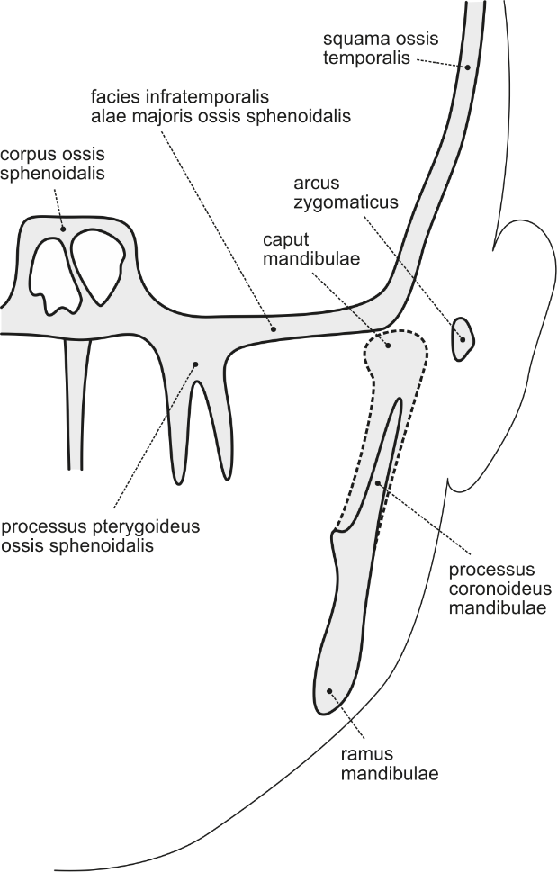

5) DESCRIBE AND DRAW ANY VARIATIONS IDENTIFIED IN THIS AREA:

**8.5** **INFRATEMPORAL FOSSA (*FOSSA INFRATEMPORALIS*)**

|  |  |
| --- | --- |
| SPECIMEN IDENTIFICATION | |
| Specimen number: | side: right/left (*dx/sin*) |

1) MUSCLES

Identify the muscles, mark their presence/absence, include their innervation, origin, and insertion. Note any variations found in the appropriate muscles or the reason for the absence of the muscle:

|  |  |  |  |  |  |
| --- | --- | --- | --- | --- | --- |
|  | ✓/x | INNERVATION | ORIGIN | INSERTION | NOTE |
| medial pterygoid muscle |  |  |  |  |  |
| lateral pterygoid muscle |  |  |  |  |  |

2) ARTERIES

Identify the arteries, mark their presence/absence, course, and include their area of supply. Note any variations found in the appropriate arteries (e.g., unusual branching) or the reason for the absence of the artery:

|  |  |  |  |  |
| --- | --- | --- | --- | --- |
|  | ✓/x | COURSE | AREA OF SUPPLY | NOTE |
| maxillary artery(*a. maxillaris*) |  |  |  |  |

3) NERVES:

Identify the nerves, mark their presence/absence, course, and include their area of innervation. Note any variations found in the appropriate nerves or the reason for the absence of the nerve:

|  |  |  |  |  |
| --- | --- | --- | --- | --- |
|  | ✓/x | COURSE | AREA OF INNERVATION | NOTE |
| lingual nerve(*n. lingualis*) |  |  |  |  |
| inferior alveolar nerve  (*n. alveolaris inferior*) |  |  |  |  |
| mylohyoid nerve  (*n. mylohyoideus*) |  |  |  |  |
| chorda tympani  (*chorda tympani*) |  |  |  |  |
| buccal nerve(*n. buccalis*) |  |  |  |  |
| auriculotemporal nerve  (*n. auriculotemporalis*) |  |  |  |  |

4) LIST THE BONY BORDERS OF THE INFRATEMPORAL FOSSA (*FOSSA INFRATEMPORALIS*)?

5) DRAW AND LABEL THE MAXILLARY ARTERY (*A. MAXILLARIS*) – ITS THREE MAIN PARTS AND BRANCHES ORIGINATING FROM EACH OF THE PARTS

6) DRAW AND LABEL THE COURSE AND RELATIVE POSITION OF THE FOLLOWING NERVES IN THE INFRATEMPORAL FOSSA (*FOSSA INFRATEMPORALIS*): AURICULOTEMPORAL NERVE (*N. AURICULOTEMPORALIS*)*,* BUCCAL NERVE(*N. BUCCALIS*)*,* LINGUAL NERVE (*N. LINGUALIS*)*,* INFERIOR ALVEOLAR NERVE (*N. ALVELOLARIS INFERIOR*)*,* MYLOHYOID NERVE(*N. MYLOHYOIDEUS*)

7) THE MOST COMMONLY OBSERVED VARIATIONS IN THIS AREA:

Mark the presence/absence of each of the appropriate variations:

|  |  |
| --- | --- |
|  | ✓/x |
| one-headed/three-headed lateral pterygoid muscle |  |
| maxillary artery (*a. maxillaris*) runs medially to the lateral pterygoid muscle |  |
| temporomasseteric trunk(*truncus temporomassetericus*)as a branch of the maxillary artery(*a. maxillaris*) |  |

8) DESCRIBE AND DRAW ANY OTHER VARIATIONS IDENTIFIED IN THIS AREA:

**8.6 FRONTOPARIETOOCCIPITAL REGION, OPENING OF THE SKULL AND DISSECTION OF DURA MATER**

|  |  |
| --- | --- |
| SPECIMEN IDENTIFICATION | |
| Specimen number: | side: right/left (*dx/sin*) |

1) SKIN

Inspect the skin in the frontoparietooccipital region. Note any scars or other damage.

2) SUBCUTANEOUS TISSUE

Indicate which structures you have dissected in the subcutaneous tissue. Mark their presence/absence. Note whether the structure has a standard course. Write down any variations or the reason for their absence:

|  |  |  |  |
| --- | --- | --- | --- |
|  | ✓/x | COURSE | NOTE |
| supratrochlear nerve (*n. supratrochlearis*) |  |  |  |
| supraorbital nerve (*n. supraorbitalis*) |  |  |  |
| frontal and parietal branch of auriculotemporal nerve (*r. frontalis et r. parietalis - n. auriculotemporalis*) |  |  |  |
| greater occipital nerve (*n. occipitalis major*) |  |  |  |
| lesser occipital nerve (*n. occipitalis minor*) |  |  |  |
| supratrochlear artery (*a. supratrochlearis*) |  |  |  |
| supraorbital artery (*a. supraorbitalis*) |  |  |  |
| superficial temporal artery (*a. temporalis superficialis*) |  |  |  |
| occipital artery (*a. occipitalis*) |  |  |  |

3) DEEP LAYER

A) MUSCLES

Identify the muscles, mark their presence/absence, include their innervation, origin, and insertion. Note any variations found in the appropriate muscles or the reason for the absence of the muscle:

|  |  |  |  |  |  |
| --- | --- | --- | --- | --- | --- |
|  | ✓/x | INNERVATION | ORIGIN | INSERTION | NOTE |
| occipitofrontalis muscle |  |  |  |  |  |

4) CRANIAL CAVITY

Identify following structures andmark their presence/absence. Note any variations found in the appropriate structures or the reason for the absence of the structure:

|  |  |  |
| --- | --- | --- |
|  | ✓/x | NOTE |
| cerebral falx (*falx cerebri*) |  |  |
| cerebellar tentorium (*tentorium cerebelli*) |  |  |
| cerebellar falx (*falx cerebelli*) |  |  |
| superior sagittal sinus (*sinus sagittalis superior*) |  |  |
| inferior sagittal sinus (*sinus sagittalis inferior*) |  |  |
| transverse sinus (*sinus transversus*) |  |  |
| occipital sinus (*sinus occipitalis*) |  |  |
| straight sinus (*sinus rectus*) |  |  |
| sigmoid sinus (*sinus sigmoideus*) |  |  |
| marginal sinus (*sinus marginalis*) |  |  |
| superior petrosal sinus (*sinus petrosus superior*) |  |  |
| inferior petrosal sinus (*sinus petrosus inferior*) |  |  |
| cavernous sinus (*sinus cavernosus*) |  |  |
| confluence of sinuses (*confluens sinuum*) |  |  |

5) NERVES AND VESSELS

Identify following nerves and vessels, mark their course and presence/absence. Note any variations found in the appropriate structures or the reason for the absence of the structure:

|  |  |  |  |
| --- | --- | --- | --- |
|  | ✓/x | COURSE | NOTE |
| olfactory nerve (*n. olfactorius*) |  |  |  |
| optic nerve (*n. opticus*) |  |  |  |
| oculomotor nerve  (*n. oculomotorius*) |  |  |  |
| trochlear nerve (*n. trochlearis*) |  |  |  |
| trigeminal nerve (*n. trigeminus*) |  |  |  |
| abducens nerve (*n. abducens*) |  |  |  |
| facial nerve (*n. facialis*) |  |  |  |
| vestibulocochlear nerve  (*n. vestibulocochlearis*) |  |  |  |
| glossopharyngeal nerve  (*n. glossopharyngeus*) |  |  |  |
| vagus nerve (*n. vagus*) |  |  |  |
| accessory nerve (*n. accessorius*) |  |  |  |
| hypoglossal nerve (*n. hypoglossus*) |  |  |  |
| internal carotid artery  (*a. carotis interna*) |  |  |  |
| ophthalmic artery (*a. ophthalmica*) |  |  |  |
| vertebral artery (*a. vertebralis*) |  |  |  |

6) TRIGEMINAL NERVE

Identify following branches of the trigeminal nerve (*nervus trigeminus*)*,* mark their presence/absence. Note any variations found in the appropriate nerves or the reason for the absence of the nerve:

|  |  |  |
| --- | --- | --- |
|  | ✓/x | NOTE |
| ophthalmic nerve (*n. ophthalmicus*) |  |  |
| maxillary nerve (*n. maxillaris*) |  |  |
| mandibular nerve (*n. mandibularis*) |  |  |

7) LIST THE BONY BORDERS OF THE CRANIAL FOSSAE:

|  |  |
| --- | --- |
| anterior cranial fossa  (*fossa cranii anterior*) |  |
| middle cranial fossa  (*fossa cranii media*) |  |
| posterior cranial fossa  (*fossa craniii posterior*) |  |

8) NAME THE VESSELS AND NERVES WHICH ENTER THE SKULL THROUGH THE FOLLOWING OPENINGS:

|  |  |
| --- | --- |
| cribriform plate of the ethmoid bone  (*lamina cribrosa ossis ethmoidalis*) |  |
| optic canal  (*canalis opticus*) |  |
| superior orbital fissure  (*fissura orbitalis superior*) |  |
| internal opening of the carotid canal  (*apertura interna canalis carotici*) |  |
| hiatus for the greater petrosal nerve  (*hiatus canalis nervi petrosi majoris*) |  |
| hiatus for the lesser petrosal nerve  (*hiatus canalis nervi petrosi minoris*) |  |
| foramen rotundum  (*foramen rotundum*) |  |
| foramen ovale  (*foramen ovale*) |  |
| foramen spinosum  (*foramen spinosum*) |  |
| internal auditory meatus  (*porus acusticus internus*) |  |
| jugular foramen  (*foramen jugulare*) |  |
| hypoglossal canal  (*canalis hypoglossi*) |  |
| condylar canal  (*canalis condylaris*) |  |
| foramen magnum  (*foramen magnum*) |  |

9) VARIATIONS MOST COMMONLY FOUND IN THIS AREA:

Mark the presence/absence of each of the appropriate variations:

|  |  |
| --- | --- |
|  | ✓/x |
| aplasia of the left transverse sinus (*sinus transversus sinister*) |  |
| aplasia of the right transverse sinus (*sinus transversus dexter*) |  |
| cerebral falx (*falx cerebri*)ossification |  |

10) DESCRIBE AND DRAW ANY OTHER VARIATIONS IDENTIFIED IN THIS AREA:

**8.7. BRAIN DISSECTION, CIRCLE OF WILLIS (*CIRCULUS ARTERIOSUS CEREBRI*)**

|  |  |
| --- | --- |
| SPECIMEN IDENTIFICATION | |
| Specimen number: | side: right/left (*dx/sin*) |

1) CIRCLE OF WILLIS (*CIRCULUS ARTERIOSUS CEREBRI*)

1. Identify the arteries of the circle of Willis, mark their presence/absence and include their area of supply. Note any variations found in the appropriate arteries (e.g., unusual branching) or the reason for the absence of the artery:

|  |  |  |  |
| --- | --- | --- | --- |
|  | ✓/x | AREA OF SUPPLY | NOTE |
| vertebral arteries (*aa. vertebrales*) |  |  |  |
| posterior inferior cerebellar arteries  (*aa. cerebellares inferiores posteriores*) |  |  |  |
| basilar artery (*a. basilaris*) |  |  |  |
| anterior inferior cerebellar arteries (*aa. cerebellares inferiores anteriores*) |  |  |  |
| pontine arteries (*aa. pontis*) |  |  |  |
| superior cerebellar arteries  (*aa. cerebellares superiores*) |  |  |  |
| posterior cerebral arteries  (*aa. cerebrales posteriores*) |  |  |  |
| internal carotid arteries  (*aa. carotidae internae*) |  |  |  |
| posterior communicating artery  (*a. communicans posterior*) |  |  |  |
| middle cerebral arteries  (*aa. cerebrales mediae*) |  |  |  |
| anterior cerebral arteries  (*aa. cerebrales anteriores*) |  |  |  |
| anterior communicating artery  (*a. communicans anterior*) |  |  |  |

1. NAME THE LABELED ARTERIES IN THE SCHEMATIC DRAWING OF THE CIRCLE OF WILLIS (*CIRCULUS ARTERIOSUS CEREBRI*):

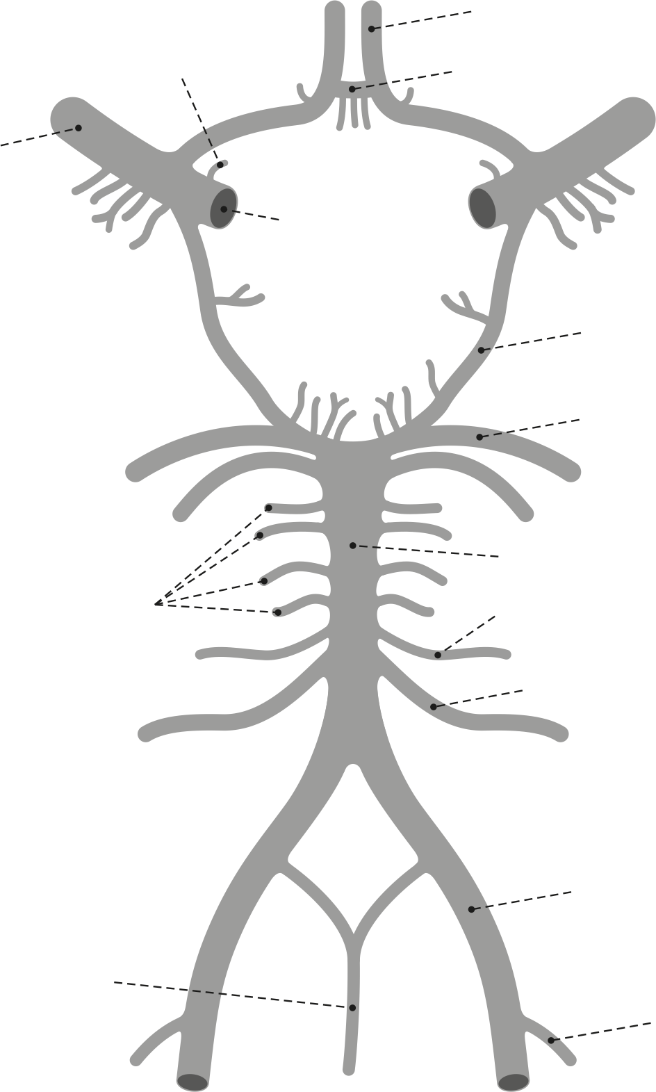

2) DISSECTION OF THE BRAIN

1. DISSECTION OF THE MEDULLA OBLONGATA

Identify the structures of the *medulla oblongata* andmark their presence/absence. Note any variations found in the appropriate structures or the reason for the absence of the structure:

|  |  |  |
| --- | --- | --- |
|  | ✓/x | NOTE |
| anterior median fissure (*fissura mediana anterior*) |  |  |
| posterior median sulcus (*sulcus medianus posterior*) |  |  |
| anterolateral sulcus (*sulcus anterolateralis*) |  |  |
| posterolateral sulcus (*sulcus posterolateralis*) |  |  |
| posterior intermediate sulcus (*sulcus intermedius posterior*) |  |  |
| medullary pyramids (*pyramis medullae oblongatae*) |  |  |
| pyramidal decussation (*decussatio pyramidum*) |  |  |
| olivary body (*oliva*) |  |  |
| gracile fasciculus + gracile tubercle (*fasciculus gracilis + tuberculum gracile*) |  |  |
| cuneate fasciculus and cuneate tubercle (*fasciculus cuneatus + tuberculum cuneatum*) |  |  |
| fourth ventricle (*ventriculus quartus*) |  |  |

1. DISSECTION OF THE PONS (*PONS VAROLI*)

Identify the parts of the *pons Varoli* andmark their presence/absence. Note any variations found in the appropriate structures or the reason for the absence of the structure:

|  |  |  |
| --- | --- | --- |
|  | ✓/x | NOTE |
| bulbopontine sulcus (*sulcus bulbopontinus*) |  |  |
| basilar sulcus (*sulcus basilaris*) |  |  |
| middle cerebellar peduncle (*pedunculus cerebell. med.*) |  |  |
| pontocerebellar angle (*angulus pontocerebellaris*) |  |  |
| fourth ventricle (*ventriculus quartus*) |  |  |

1. LABEL THE CRANIAL NERVES AND THE IMPORTANT STRUCTURES OF *MEDULLA OBLONGATA* AND *PONS VAROLI* IN THE SCHEMATIC DRAWING*:*

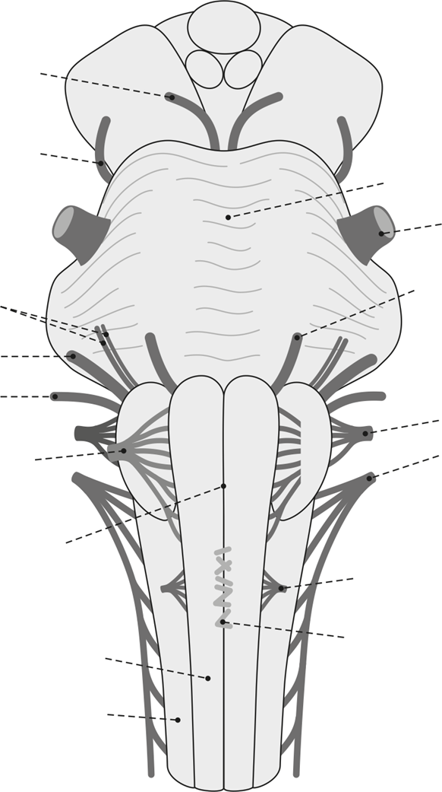

1. LABEL ALL IMPORTANT STRUCTURES IN THE SCHEMATIC DRAWING OF THE RHOMBOID FOSSA (*FOSSA RHOMBOIDEA*):

1. DISSECTION OF THE MESENCEPHALON

Identify the parts of the *mesencephalon* andmark their presence/absence. Note any variations found in the appropriate structures or the reason for the absence of the structure:

|  |  |  |
| --- | --- | --- |
|  | ✓/x | NOTE |
| interpeduncular fossa (*fossa interpeduncularis*) |  |  |
| posterior perforated substance  (*substantia perforata posterior*) |  |  |
| oculomotor sulcus (*sulcus nervi oculomotorii*) |  |  |
| cerebral peduncles (*pedunculi cerebri*) |  |  |
| superior cerebellar peduncle  (*pedunculus cerebellaris superior*) |  |  |
| inferior colliculus + brachium of inferior colliculus (*colliculus inferior + brachium colliculi inferioris*) |  |  |
| superior colliculus + brachium of superior colliculus (*colliculus superior + brachium colliculi superioris*) |  |  |
| cerebral aqueduct (*aqueductus cerebri*) |  |  |

1. DISSECTION OF THE CEREBELLUM

Identify the parts of the *cerebellum* andmark their presence/absence. Note any variations found in the appropriate structures or the reason for the absence of the structure:

|  |  |  |
| --- | --- | --- |
|  | ✓/x | NOTE |
| anterior lobe of the cerebellum  (*lobus cerebelli anterior*) |  |  |
| posterior lobe of the cerebellum  (*lobus cerebelli posterior*) |  |  |
| flocculonodular lobe (*lobus flocculonodularis*) |  |  |
| primary fissure (*fissura prima*) |  |  |
| posterolateral fissure (*fissura posterolateralis*) |  |  |
| cerebellar vermis (*vermis cerebelli*) |  |  |
| lingula of the cerebellum (*lingula*) |  |  |
| nodule of the vermis (*nodulus*) |  |  |
| cerebellar tonsil (*tonsilla cerebelli*) |  |  |

1. DISSECTION OF THE DIENCEPHALON

Identify the parts of the *diencephalon* andmark their presence/absence. Note any variations found in the appropriate structures or the reason for the absence of the structure:

|  |  |  |
| --- | --- | --- |
|  | ✓/x | NOTE |
| pineal gland (*glandula pinealis*) |  |  |
| suprapineal recess (*recessus suprapinealis*) |  |  |
| pineal recess (*recessus pinealis*) |  |  |
| posterior commissure (*commissura posterior*) |  |  |
| lateral geniculate body (*corpus geniculatum lat.*) |  |  |
| medial geniculate body (*corpus geniculatum med*.) |  |  |
| mammillary body (*corpus mamillare*) |  |  |
| infundibulum (*infundibulum*) |  |  |
| infundibular recess (*recessus infundibuli*) |  |  |
| tuber cinereum (*tuber cinereum*) |  |  |
| optic chiasm (*chiasma opticum*) |  |  |
| supraoptic recess (*recessus supraopticus*) |  |  |
| optic tract (*tractus opticus*) |  |  |
| interventricular foramen (*foramen interventr.*) |  |  |
| third ventricle (*ventriculus tertius*) |  |  |
| interthalamic adhesion (*adhesio interthalamica*) |  |  |
| hypothalamic sulcus (*sulcus hypothalamicus*) |  |  |
| stria terminalis |  |  |
| stria medullaris thalami |  |  |
| lamina affixa |  |  |
| habenular tiagon (*trigonum habenulae*) |  |  |
| habenular commissure (*commisura habenularum*) |  |  |

1. DISSECTION OF THE TELENCEPHALON

Identify the parts of the *telencephalon* andmark their presence/absence. Note any variations found in the appropriate structures or the reason for the absence of the structure:

|  |  |  |
| --- | --- | --- |
|  | ✓/x | NOTE |
| frontal lobe (*lobus frontalis*) |  |  |
| parietal lobe (*lobus parietalis*) |  |  |
| temporal lobe (*lobus temporalis*) |  |  |
| occipital lobe (*lobus occipitalis*) |  |  |
| insular lobe (*lobus insularis*) |  |  |
| central sulcus (*sulcus centralis*) |  |  |
| lateral sulcus (*sulcus lateralis*) |  |  |
| parietooccipital sulcus (*sulcus parietooccipitalis*) |  |  |
| preoccipital notch (*incisura praeoccipitalis*) |  |  |
| superior frontal sulcus (*sulcus frontalis superior)* |  |  |
| inferior frontal sulcus (*sulcus frontalis inferior*) |  |  |
| precentral sulcus (*sulcus praecentralis*) |  |  |
| postcentral sulcus (*sulcus postcentralis*) |  |  |
| interparietal sulcus (*sulcus interparietalis*) |  |  |
| transverse occipital sulcus (*sulcus occipitalis trans.*) |  |  |
| superior temporal sulcus (*sulcus temporalis sup.*) |  |  |
| inferior temporal sulcus (*sulcus temporalis inferior*) |  |  |
| superior frontal gyrus (*gyrus frontalis superior*) |  |  |
| middle frontal gyrus (*gyrus frontalis medius*) |  |  |
| inferior frontal gyrus (*gyrus frontalis inferior*) |  |  |
| precentral gyrus (*gyrus praecentralis*) |  |  |
| postcentral gyrus (*gyrus postcentralis*) |  |  |
| superior temporal gyrus (*gyrus temporalis superior*) |  |  |
| middle temporal gyrus (*gyrus temporalis medius*) |  |  |
| inferior temporal gyrus (*gyrus temporalis inferior*) |  |  |
| supramarginal gyrus (*gyrus supramarginalis*) |  |  |
| angular gyrus (*gyrus angularis*) |  |  |
| superior parietal lobule (*lobulus parietalis superior*) |  |  |
| inferior parietal lobule (*lobulus parietalis inferior*) |  |  |
| superior occipital and lateral gyri  (*gyri occipitales superiores et laterales*) |  |  |
| olfactory sulcus (*sulcus olfactorius*) |  |  |
| hippocampal sulcus (*sulcus hippocampi*) |  |  |
| collateral sulcus (*sulcus collateralis*) |  |  |
| occipitotemporal sulcus (*sulcus occipitotemporalis*) |  |  |
| calcarine sulcus (*sulcus calcarinus*) |  |  |
| straight gyrus (*gyrus rectus*) |  |  |
| orbital gyri (*gyri orbitales*) |  |  |
| parahippocampal gyrus (*gyrus parahippocampalis*) |  |  |
| the uncus (*uncus*) |  |  |
| lateral occipitotemporal gyrus  (*gyrus occipitotemporalis lateralis*) |  |  |
| medial occipitotemporal gyrus  (*gyrus occipitotemporalis medialis*) |  |  |
| sulcus of the corpus callosum  (*sulcus corporis callosi*) |  |  |
| cingulate sulcus (*sulcus cinguli*) |  |  |
| calcarine sulcus (*sulcus calcarinus*) |  |  |
| paracentral lobule (*lobulus paracentralis*) |  |  |
| the precuneus (*precuneus*) |  |  |
| the cuneus (*cuneus*) |  |  |
| paraterminal gyrus (*gyrus paraterminalis*) |  |  |
| subcallosal area (*area subcallosa*) |  |  |
| the corpus callosum (*corpus callosum*) |  |  |
| the septum pellucidum (*septum pellucidum*) |  |  |

1. NAME THE MARKED GROOVES IN THE SCHEMATIC DRAWING OF THE SUPEROLATERAL SURFACE OF THE CEREBRAL HEMISPHERE (*FACIES SUPEROLATERALIS CEREBRI*):

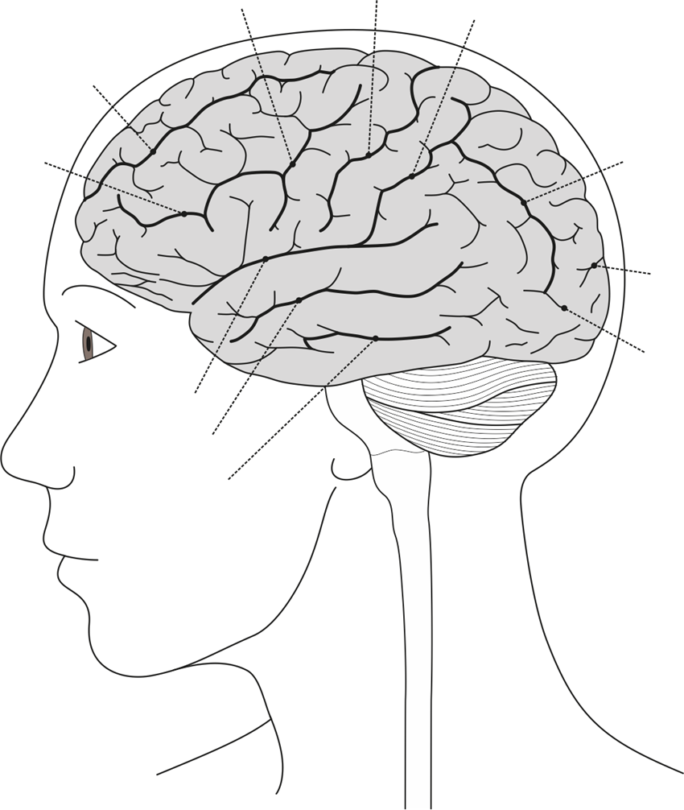

1. NAME THE MARKED GROOVES IN THE SCHEMATIC DRAWING OF THE MEDIAL SURFACE OF THE CEREBRAL HEMISPHERE (*FACIES MEDIALIS CEREBRI*):

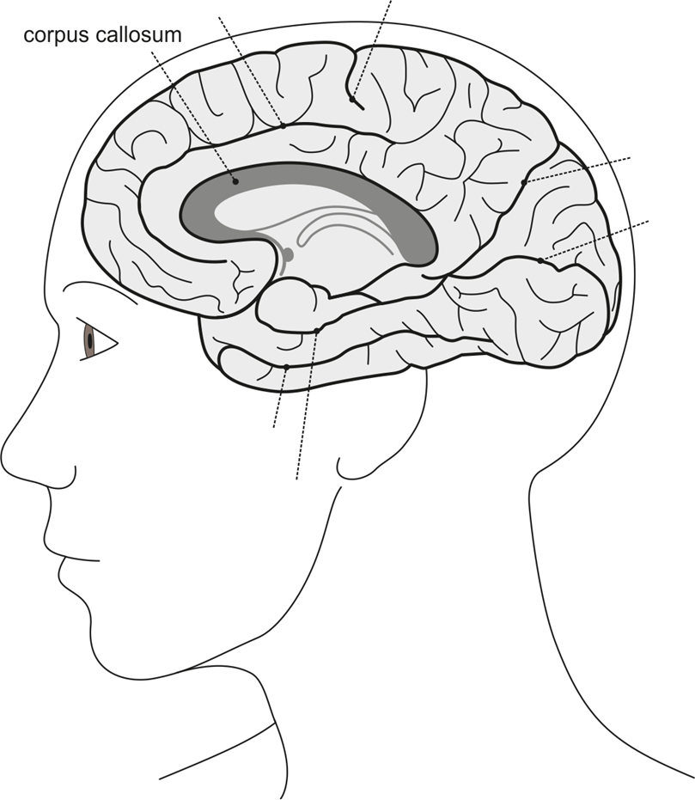

1. NAME THE MARKED GROOVES OF THE INFERIOR SURFACE OF THE CEREBRAL HEMISPHERES (*FACIES INFERIOR CEREBRI*):

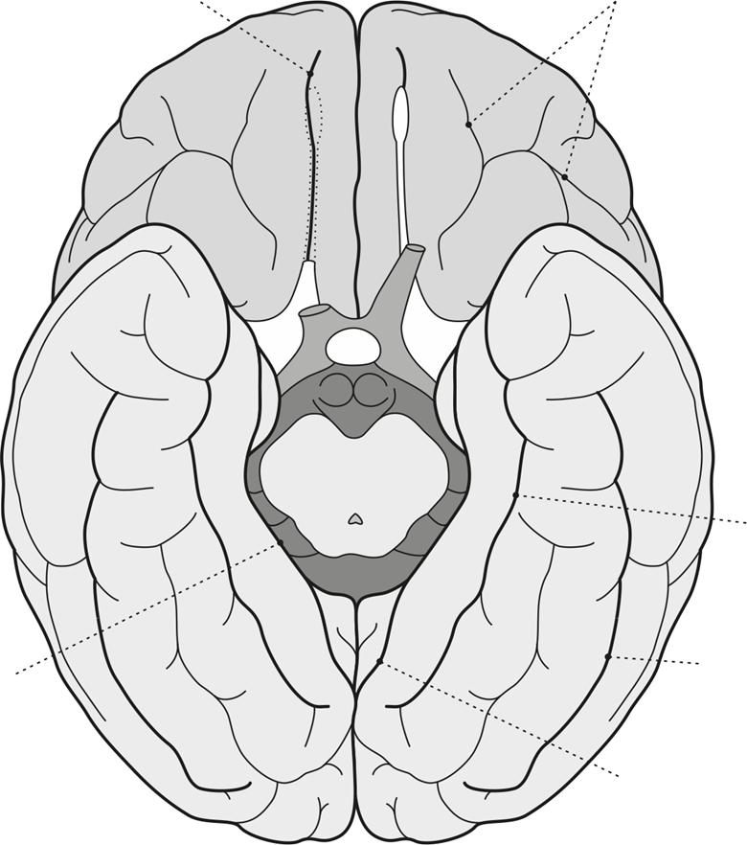

3) THE MOST COMMONLY OBSERVED VARIATIONS IN THIS AREA:

Mark the presence/absence of each of the appropriate variations:

|  |  |
| --- | --- |
|  | ✓/x |
| hypoplasia of the posterior communicating artery (*arteria communicans posterior*) |  |
| posterior cerebral artery (*arteria cerebri posterior*) is a branch of the internal carotid artery (*arteria carotis interna*) |  |
| hypoplasia/absence of the anterior cerebral artery (*arteria cerebri anterior*) |  |
| absent anterior communicating artery (*arteria communicans anterior*) |  |
| duplication of the vertebral artery (*arteria vertebralis*) |  |

4) DESCRIBE AND DRAW ANY OTHER VARIATIONS IDENTIFIED IN THIS AREA:

**8.8. PHARYNX – SECTIONING PHARYNX**

|  |  |
| --- | --- |
| SPECIMEN IDENTIFICATION | |
| Specimen number: | side: right/left (*dx/sin*) |

1) MUSCLES

Identify the muscles, mark their presence/absence, include their innervation, origin, and insertion. Note any variations found in the appropriate muscles or the reason for the absence of the muscle:

|  |  |  |  |  |  |
| --- | --- | --- | --- | --- | --- |
|  | ✓/x | INNERVATION | ORIGIN | INSERTION | NOTE |
| superior pharyngeal constrictor |  |  |  |  |  |
| middle pharyngeal constrictor |  |  |  |  |  |
| inferior pharyngeal constrictor |  |  |  |  |  |
| stylopharyngeus muscle |  |  |  |  |  |
| palatopharyngeus muscle |  |  |  |  |  |
| salpingopharyngeus muscle |  |  |  |  |  |
| palatoglossus muscle |  |  |  |  |  |
| muscle of the uvula |  |  |  |  |  |
| levator veli palatini muscle |  |  |  |  |  |
| tensor veli palatini muscle |  |  |  |  |  |

2) ARTERIES

Identify the arteries, mark their presence/absence, course, and include their area of supply. Note any variations found in the appropriate arteries (e.g., unusual branching) or the reason for the absence of the artery:

|  |  |  |  |  |
| --- | --- | --- | --- | --- |
|  | ✓/x | COURSE | AREA OF SUPPLY | NOTE |
| internal carotid artery(*a. carotis interna*) |  |  |  |  |
| external carotid artery(*a. carotis externa*) |  |  |  |  |
| ascending pharyngeal artery(*a. pharyngea ascendens*) |  |  |  |  |

3) NERVES:

Identify the nerves, mark their presence/absence, course, and include their area of innervation. Note any variations found in the appropriate nerves or the reason for the absence of the nerve:

|  |  |  |  |  |
| --- | --- | --- | --- | --- |
|  | ✓/x | COURSE | AREA OF INNERVATION | NOTE |
| glossopharyngeal nerve(*n. glossopharyngeus*) |  |  |  |  |
| vagus nerve(*n. vagus)* |  |  |  |  |
| accessory nerve  (*n. accessorius*) |  |  |  |  |
| hypoglossal nerve  (*n. hypoglossus*) |  |  |  |  |
| sympathetic trunk and the superior cervical ganglion(*truncus sympathicus et ganglion cervicale superius*) |  |  |  |  |

1. LABEL THE MAIN PARTS OF THE PHARYNX INTO THE SCHEMATIC DRAWING. DRAW AND LABEL THE SCHEMATIC DRAWING OF THE PHARYNGEAL OPENING OF THE AUDITORY TUBE (*OSTIUM PHARYNGEUM TUBAE AUDITIVAE*), DESCRIBE ITS BORDERS. DRAW AND LABEL THE PARTS OF THE NASAL SEPTUM:

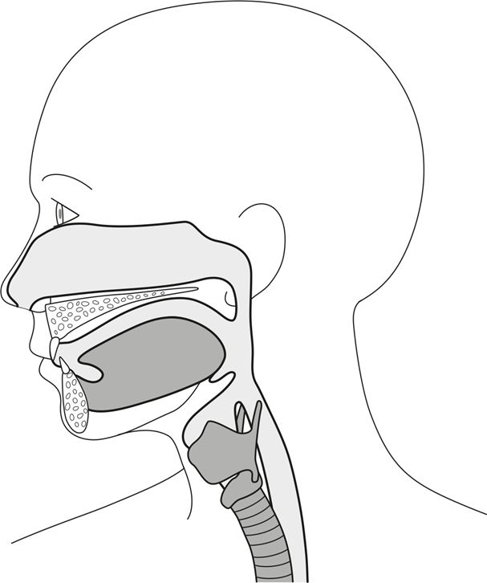

5) LABEL ALL THE PARTS OF THE PHARYNGEAL CONSTRICTORS INTO THE SCHEMATIC DRAWING:

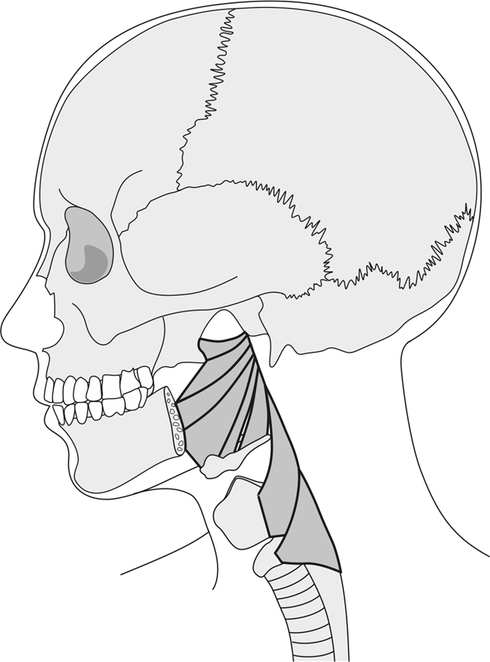

6) DRAW AND LABEL THE WALDEYER’S LYMPHATIC RING:

7) DRAW AND LABEL THE MUSCLES OF THE SOFT PALATE (*MUSCULI PALATI*) INTO THE SCHEMATIC DRAWING

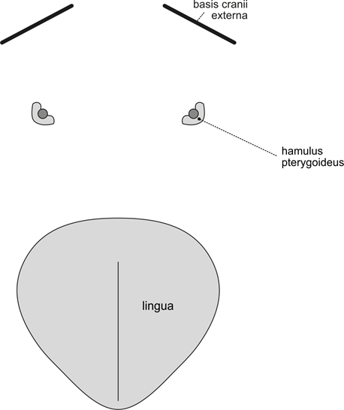

8) LABEL THE STRUCTURES FORMING THE SYLOID SEPTUM AND THE STRUCTURES FOUND IN THE PRESTYLOID AND RETROSTYLOID SPACE (*SPATIUM PRESTYLOIDEUM ET RETROSTYLOIDEUM*) INTO THE SCHEMATIC DRAWING:

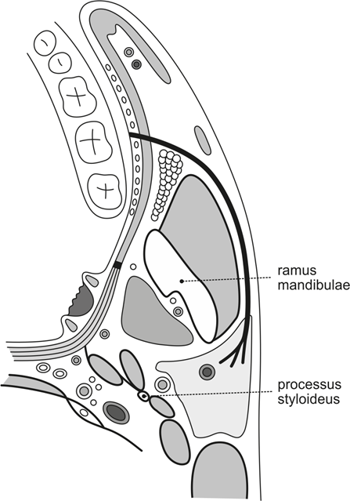

9) VARIATIONS MOST COMMONLY FOUND IN THIS AREA:

Mark the presence/absence of each of the appropriate variations:

|  |  |
| --- | --- |
|  | ✓/x |
| absent superior/middle/inferior pharyngeal raphe (*raphe pharyngis sup./med./inf.*) |  |
| glossopharyngeal nerve(*n. glossopharyngeus*) pierces through the stylopharyngeus muscle |  |
| branching of the ascending pharyngeal artery (*a. pharyngea ascendens*)from the occipital artery(*a. occipitalis*) |  |
| communication of the sympathetic trunk (*truncus sympathicus*)with the right/left recurrent laryngeal nerve or phrenic nerve(*n. laryngeus recurrens dx./n. phrenicus*) |  |

10) DESCRIBE AND DRAW ANY OTHER VARIATIONS IDENTIFIED IN THIS AREA:

**8.9.** **ORBIT (*ORBITA*)**

|  |  |
| --- | --- |
| SPECIMEN IDENTIFICATION | |
| Specimen number: | side: right/left (*dx/sin*) |

1) MUSCLES

Identify the muscles, mark their presence/absence, include their innervation, origin, and insertion. Note any variations found in the appropriate muscles or the reason for the absence of the muscle:

|  |  |  |  |  |  |
| --- | --- | --- | --- | --- | --- |
|  | ✓/x | INNERVATION | ORIGIN | INSERTION | NOTE |
| levator palpebrae superioris muscle |  |  |  |  |  |
| superior oblique muscle |  |  |  |  |  |
| superior rectus muscle |  |  |  |  |  |
| lateral rectus muscle |  |  |  |  |  |
| medial rectus muscle |  |  |  |  |  |
| inferior oblique muscle |  |  |  |  |  |
| inferior rectus muscle |  |  |  |  |  |

2) ARTERIES

Identify the arteries, mark their presence/absence, course, and include their area of supply. Note any variations found in the appropriate arteries (e.g., unusual branching) or the reason for the absence of the artery:

|  |  |  |  |  |
| --- | --- | --- | --- | --- |
|  | ✓/x | COURSE | AREA OF SUPPLY | NOTE |
| ophthalmic artery  (*a. ophthalmica*) |  |  |  |  |

3) NERVES:

Identify the nerves, mark their presence/absence, course, and include their area of innervation. Note any variations found in the appropriate nerves or the reason for the absence of the nerve:

|  |  |  |  |  |
| --- | --- | --- | --- | --- |
|  | ✓/x | COURSE | AREA OF INNERVATION | NOTE |
| optic nerve  (*n. opticus*) |  |  |  |  |
| oculomotor nerve(*n. oculomotorius*) |  |  |  |  |
| trochlear nerve  (*n. trochlearis*) |  |  |  |  |
| frontal nerve  (*n. frontalis*) |  |  |  |  |
| abducent nerve  (*n. abducens*) |  |  |  |  |

4) DRAW AND LABEL OCULOMOTOR MUSCLES AND THEIR INSERTION SITES:

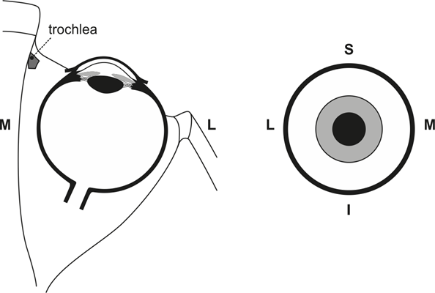

5) DRAW AND LABEL STRUCTURES PASSING THROUGH THE OPTIC CANAL (*CANALIS OPTICUS*), SUPERIOR AND INFERIOR ORBITAL FISSURE (*FISSURA ORBITALIS SUPERIOR ET INFERIOR*):

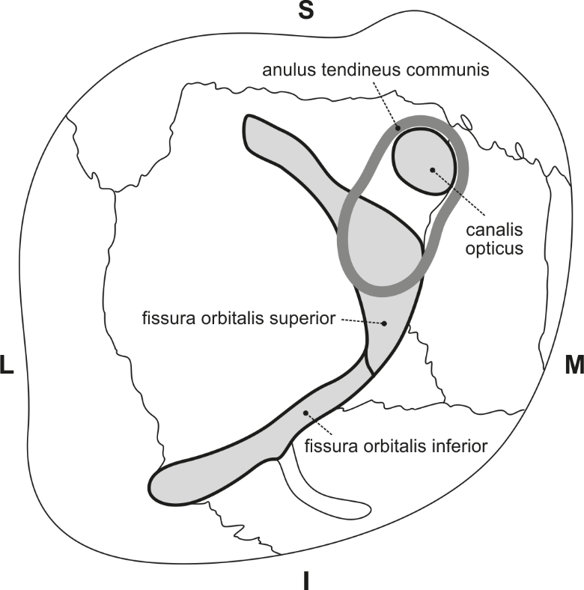

6) DRAW AND LABEL THE STRUCTURES PASSING THROUGH THE CAVERNOUS SINUS (*SINUS CAVERNOSUS*):

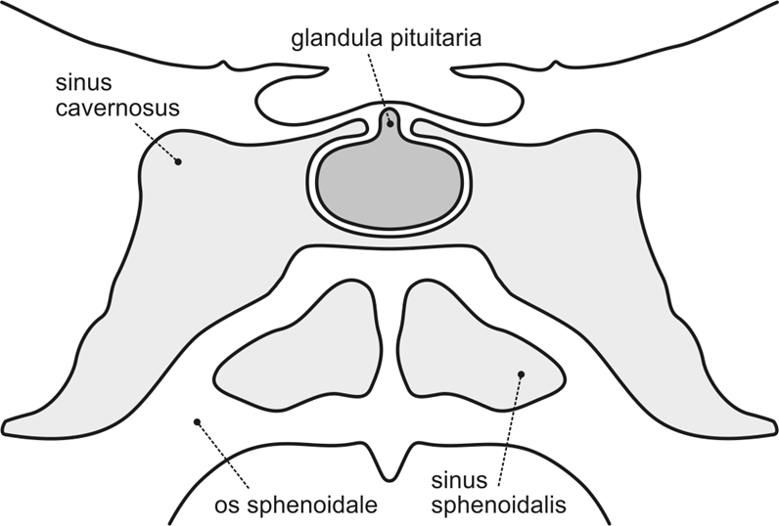

7) FILL IN THE TABLE WITH THE STRUCTURES FORMING THE BORDER AND CONTENT OF EACH OF THE LEVELS OF THE RETROBULBAR ORBITAL SPACE:

|  |  |  |  |
| --- | --- | --- | --- |
|  | UPPER LEVEL | MIDDLE LEVEL | LOWER LEVEL |
| BORDER |  |  |  |
| CONTENT   * NERVE * BLOOD VESSEL * MUSCLE |  |  |  |

8) VARIATIONS MOST COMMONLY FOUND IN THIS AREA:

Mark the presence/absence of each of the appropriate variations:

|  |  |
| --- | --- |
|  | ✓/x |
| retractor bulbi muscle |  |
| double-layered lacrimal gland (*glandula lacrimalis*) |  |

9) DESCRIBE AND DRAW ANY OTHER VARIATIONS IDENTIFIED IN THIS AREA:

**8.10.** **SUBLINGUAL REGION (*REGIO SUBLINGUALIS*)**

|  |  |
| --- | --- |
| SPECIMEN IDENTIFICATION | |
| Specimen number: | side: right/left (*dx/sin*) |

1) MUSCLES

Identify the muscles, mark their presence/absence, include their innervation, origin, and insertion. Note any variations found in the appropriate muscles or the reason for the absence of the muscle:

|  |  |  |  |  |  |
| --- | --- | --- | --- | --- | --- |
|  | ✓/x | INNERVATION | ORIGIN | INSERTION | NOTE |
| geniohyoid muscle |  |  |  |  |  |
| mylohyoid muscle |  |  |  |  |  |

2) ARTERIES

Identify the arteries, mark their presence/absence, course, and include their area of supply. Note any variations found in the appropriate arteries (e.g., unusual branching) or the reason for the absence of the artery:

|  |  |  |  |  |
| --- | --- | --- | --- | --- |
|  | ✓/x | COURSE | AREA OF SUPPLY | NOTE |
| lingual artery  (*a. lingualis*) |  |  |  |  |
| sublingual artery(*a. sublingualis*) |  |  |  |  |

3) NERVES:

Identify the nerves, mark their presence/absence, course, and include their area of innervation. Note any variations found in the appropriate nerves or the reason for the absence of the nerve:

|  |  |  |  |  |
| --- | --- | --- | --- | --- |
|  | ✓/x | COURSE | AREA OF INNERVATION | NOTE |
| lingual nerve  (*n. lingualis*) |  |  |  |  |
| hypoglossal nerve(*n. hypoglossus*) |  |  |  |  |

4) OTHER STRUCTURES

Identify the structures, mark their presence/absence and course. Note any variations found in the appropriate structures or the reason for the structure’s absence:

|  |  |  |  |
| --- | --- | --- | --- |
|  | ✓/x | COURSE | NOTE |
| submandibular duct  (*ductus submandibularis*) |  |  |  |
| sublingual gland  (*glandula sublingualis*) |  |  |  |
| major sublingual duct  (*ductus sublingualis major*) |  |  |  |

5) LABEL THE SCHEMATIC DRAWING OF THE TONGUE:

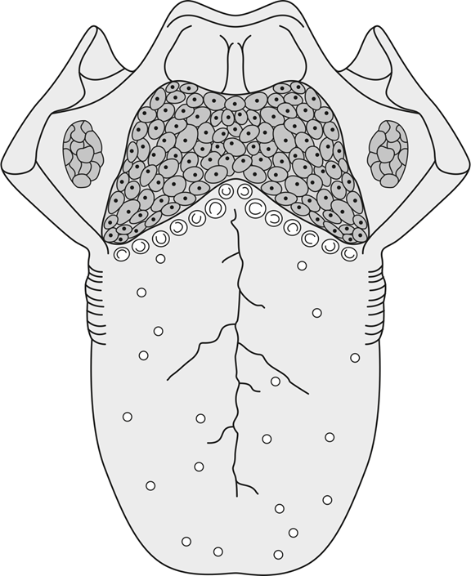

6) DESCRIBE THE BORDERS OF THE SUBLINGUAL REGION (*REGIO SUBLINGUALIS*):

7) LABEL THE LINGUAL NERVE (*N. LINGUALIS*), SUBMANDIBULAR DUCT (*DUCTUS SUBMANDIBULARIS*), SUBMANDIBULAR AND SUBLINGUAL GLAND (*GL. SUBMANDIBULARIS* *ET SUBLINGUALIS*) INTO THE SCHEMATIC DRAWING. DRAW AND LABEL THE DUCTS LEADING SALIVA FROM THE SUBLINGUAL GLAND (*GL. SUBLINGUALIS*):

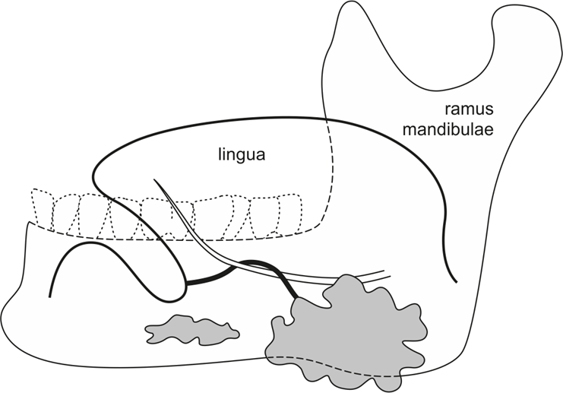

8) VARIATIONS MOST COMMONLY FOUND IN THIS AREA:

Mark the presence/absence of each of the appropriate variations:

|  |  |
| --- | --- |
|  | ✓/x |
| passage of the hypoglossal nerve (*n. hypoglossus*) caudally under the lingual artery (*a. lingualis*) |  |
| separate opening for the major sublingual duct (*ductus sublingualis major*) |  |
| absentmajor sublingual duct (*ductus sublingualis major*) |  |

9) DESCRIBE AND DRAW ANY OTHER VARIATIONS IDENTIFIED IN THIS AREA:

**8.11. LARYNX**

|  |  |
| --- | --- |
| SPECIMEN IDENTIFICATION | |
| Specimen number: | side: right/left (*dx/sin*) |

1) MUSCLES

Identify the muscles, mark their presence/absence, include their innervation, origin, and insertion. Note any variations found in the appropriate muscles or the reason for the absence of the muscle:

|  |  |  |  |  |  |
| --- | --- | --- | --- | --- | --- |
|  | ✓/x | INNERVATION | ORIGIN | INSERTION | NOTE |
| posterior cricoarytenoid muscle |  |  |  |  |  |
| lateral cricoarytenoid muscle |  |  |  |  |  |
| oblique arytenoid muscle |  |  |  |  |  |
| transverse arytenoid muscle |  |  |  |  |  |
| cricothyroid muscle |  |  |  |  |  |
| thyroarytenoid muscle |  |  |  |  |  |
| vocalis muscle |  |  |  |  |  |
| thyroepiglottic muscle |  |  |  |  |  |
| aryepiglottic muscle |  |  |  |  |  |

2) ARTERIES

Identify the arteries, mark their presence/absence, course, and include their area of supply. Note any variations found in the appropriate arteries (e.g., unusual branching) or the reason for the absence of the artery:

|  |  |  |  |  |
| --- | --- | --- | --- | --- |
|  | ✓/x | COURSE | AREA OF SUPPLY | NOTE |
| superior laryngeal artery(*a. laryngea superior*) |  |  |  |  |
| inferior laryngeal artery(*a. laryngea inferior*) |  |  |  |  |

3) NERVES:

Identify the nerves, mark their presence/absence, course, and include their area of innervation. Note any variations found in the appropriate nerves or the reason for the absence of the nerve:

|  |  |  |  |  |
| --- | --- | --- | --- | --- |
|  | ✓/x | COURSE | AREA OF INNERVATION | NOTE |
| superior laryngeal nerve(*n. laryngeus superior*) |  |  |  |  |
| inferior laryngeal nerve(*n. laryngeus inferior*) |  |  |  |  |

4) DRAW AND LABEL A SCHEMATIC DRAWING OF *RIMA GLOTTIDIS* (THE POSITION OF VOCAL LIGAMENTS AND ARYTHENOID CARTILAGE) DURING RESPIRATION AND PHONATION:

5) DRAW AND LABEL THE MUSCLES OF THE LARYNX INTO THE SCHEMATIC DRAWING AND INCLUDE THE MUSCLE FUNCTIONS:

6) VARIATIONS MOST COMMONLY FOUND IN THIS AREA:

Mark the presence/absence of each of the appropriate variations:

|  |  |
| --- | --- |
|  | ✓/x |
| levator glandulae thyroideae muscle |  |
| thyreotracheal muscle |  |
| cricoepiglottic muscle |  |
| branching of the superior laryngeal artery (*a. laryngea superior*)from the external carotid artery (*a. carotis externa*) |  |
| superior laryngeal artery(*a. laryngea superior*)entering the larynx through the thyroid foramen (*foramen thyroideum*)/ between the thyroid and cricoid cartilage (*cartilago thyroidea et cricoidea*) |  |
| absence of the Galen’s anastomosis |  |
| presence of the thyroid foramen (*foramen thyroideum*) |  |
| communication of the superior horns of the thyroid cartilage (*cornua thyroidea superiora*) with the hyoid bone (*os hyoideum*) |  |
| cartilaginous connection of the cricoid cartilage (*cartilago cricoidea*) with the tracheal cartilage(s) |  |
| bifid epiglottis (*epiglottis*) |  |
| pyramidal lobe (*lobus pyramidalis*) |  |

7) DESCRIBE AND DRAW ANY OTHER VARIATIONS IDENTIFIED IN THIS AREA:

**BIBLIOGRAPHY:**

CALIOT, P. The nerve loops crossing below the subclavian artery and their anatomical variations. *Anatomia Clinica* 1984, **6**, s. 209–213. ISSN 0343-6098.

CAVALCANTI, D. D., et al. The ascending pharyngeal artery and its relevance for neurosurgical and endovascular procedures. *Neurosurgery* 2009,**65**, s. 114–120. ISSN 2332-4252.

DORA, F. a T. ZILELI. Common variations of the lateral and occipital sinuses at the confluens sinuum. *Neuroradiology* 1980, **20**(1), 23-27. ISSN 0028-3940. Dostupné z: doi:10.1007/BF00346857

FERNANDES, Atson Carlos de Souza, Rafael Guimarães LIMA, Marcelle Alvarez ROSSI a Márcio Cajazeira AGUIAR. Parotid Gland with Double Duct: An Anatomic Variation Description. *International Journal of Morphology*. 2009, **27**(1), 23-27. ISSN 0717-9502. Dostupné z: doi:10.4067/S0717-95022009000100023

FURLAN, J. C., BRANDAO, L. G. a FERRAZ, A. R. 2002. Prevalence of Galen’s anastomosis: an anatomical and comparative study. *The Journal of Laryngology and Otology* 2002*.* **116**, s. 823–825. ISSN 0022-2151.

GOLDEMUND, David. *CMP manuál* [online]. © 2021 [cit. 2021-05-24]. Dostupné z: <https://www.manual-cmp.cz/>

KEEN, J. A. a WAINWRIGHT, J. Ossification of the thyroid, cricoid and arytenoid cartilages. *South African Journal of Laboratory and Clinical Medicine* 1958, **4**(2), s. 83–108. ISSN 0038-2299.

LANG, J. *Clinical Anatomy of the Masticatory Apparatus and Peripharyngeal Spaces*. New York: Theime, 1995, 184 s. ISBN-10: 0865775516.

LEON, X., et al. Foramen thyroideum: a comparative study in embryos, fetuses, and adults. *Laryngoscope* 1997, **107**(8), s. 1146–1150. ISSN 0023-852X.

LIPPERT, H. a PABST, R. *Arterial variations in man – classification and frequency*. Munich: J. F. Bergmann Verlag, 1985, 122 s. ISBN 978-3-642-80510-3.

LUSCHKA, H. *Der Kehlkopf des Menschen*. Tübingen: H. Laupp, 1871, 63–89 s. ISBN 0282221026.

MALINOVSKÝ, Lubomír. *Anatomická pitva: učebnice pro lékařské fakulty*. Praha: Avicenum, 1988, 171 s.

NAIDU, L., et al. Galen’s “anastomosis” revisited. *Clinical Anatomy* 2012, **25**(6), s. 722–728. ISSN 1098-2353.

NIRANJAN, N S. An Anatomical Study of the Facial Artery. *Annals of Plastic Surgery*. 1988, **21**(1), 14-22. ISSN 0148-7043. Dostupné z: doi:10.1097/00000637-198807000-00003

RUSU, M. C., et al. The morphology and topography of the superior laryngeal artery. *Surgical and Radiologic Anatomy* 2007, **29**(8), s. 653–660. ISSN 09301038.

SALAME, K., et al. Surgical anatomy of the cervical segment of the hypoglossal nerve. *Clinical Anatomy* 2006, **19**(1), s. 37–43. ISSN 1098-2353.

SHIMADA, K. a GASSER, R. F. Variations of the pharyngeal raphe. *Clinical Anatomy* 1988, **1**(4), s. 285–294. ISSN 1098-2353.

STINGL, Josef, Miloš GRIM a Rastislav DRUGA. *Regional anatomy*. Praha: Galén, 2012, 130 s. ISBN 978-80-7262-879-7.

TSURUMI, H., et al. Bifid epiglottis: syndromic constituent rather than isolated anomaly. *Pediatrics International* 2010, **52**(5), s. 723–728. ISSN 1442-200X.

TUBBS, Shane R., MOHAMMADALI, Shoja M. a LOUKAS, Marios. *Bergman´s Comperhesive Encyclopedia of Human Anatomic Variation* [online]. Hoboken, N. J: Wiley-Blackwell, 2016, 1432 s. [cit. 2021-05-24]. ISBN 9781118430354. Dostupné z: <https://eds.a.ebscohost.com/eds/ebookviewer/ebook/bmxlYmtfXzEyMjc5ODFfX0FO0?sid=83fc6545-baf5-4b5c-bcb7-f51051acac65@sessionmgr4006&vid=1&format=EB&rid=1>