# Slide 5

The general practitioner recorded these notes in the patient's file.

### Subjective:

Lump in the right breast, self-detected approximately three weeks ago during showering, persists throughout the menstrual cycle. The patient reports it to be hard on palpation, with no nipple discharge or skin changes. No previous occurrence of lumps, no ultrasound or mammography done.

### Objective:

Under observation for allergies at an allergology clinic - pollen allergies (antihistamines), otherwise not undergoing any treatment or monitoring.

### Family History:

Mother healthy; maternal grandmother had uterine cancer at age 83, alive; father healthy; his sister had breast cancer at 45; paternal grandmother died of a gynecological tumor at 67; two sisters healthy, one recently investigated for recurrent abdominal pain, results pending, possibly digestive issues?; one healthy daughter.

### Gynecological Anamnesis:

Menstruation since age 13, one childbirth, breastfeeding for 5 months, more intense bilateral mastitis, no spontaneous miscarriages.

### Personal Anamnesis:

High school teacher.

### Social Anamnesis:

Married, one daughter in care (4 years old), living in a rented apartment.

### Family Anamnesis:

Flonidan 10mg tablet orally 1-0-0, denies oral contraception or other hormone use.

### Abuse:

Denies alcohol, denies smoking.

### Local Status:

Symmetrical breasts, smooth contours, no discharge, skin changes, swelling, or peau d’orange. No nipple inversion. Discrete, non-tender lump measuring 3 x 2 cm in the upper outer quadrant on the right. Not fixed to muscle. Palpable small axillary lymph node on the right side. No enlarged lymph nodes palpated in other locations.

### Recommendation:

# Slide 9

Ultrasound of the Breast and Axilla, May 25, 2022:

Obsah obrázku text

Popis se vygeneroval automaticky.

Bilateral generally regular fibroglandular structure of the gland, no focal lesions on the left. On the right in the upper outer quadrant, there is a hypoechogenic vascularized tumorous lesion measuring 20x15 mm. Medially adjacent to it is another suspicious infiltrate approximately 13x5 mm in size, total area about 28x15 mm. Lateral to the tumor, a strip-like hypoechogenicity is indicated, likely glandular structure. Otherwise, no focal lesions.

Normal left axilla, multiple pathological lymph nodes up to 12 mm in the right axilla.

**Conclusion: Breast tumor in the right upper outer quadrant, pathological lymph nodes in the right axilla.**

Mammogram, May 27, 2022:

Medium density fibroglandular structure, Tabár type I, bilateral, no evidence of malignancy on the left.

On the right in the upper outer quadrant, an indistinctly bordered lesion approximately 19 mm in size is indicated, merging with the dense gland in the right oblique projection. No evidence of malignant microcalcifications bilaterally. At the apex of the right axilla, a minimal part of a suspected pathological lymph node is captured, with no evidence of pathological lymph nodes in the surveyed areas.

**Conclusion: Lesion in the right upper outer quadrant. Lymph nodes: pathological. Tabár I.**

# Slide 13

Chest X-ray, August 2, 2022:

Conclusion: No evidence of focal pulmonary changes.

Ultrasound of the Liver + Doppler of the Epigastrium, August 2, 2022:

Conclusion: No pathological findings.

Breast Magnetic Resonance Imaging, August 12, 2022:

Conclusion: Carcinoma of the right breast in the upper outer quadrant at the interface with the upper central quadrant, marginally extending into the lower outer quadrant, histologically verified. On the left in the upper outer quadrant, a lesion with post-contrast enhancement is present - histological verification under ultrasound guidance is recommended.

August 2, 2022:

CEA: 0.9 ug/l (normal up to 4.6)

CA 15-3: 8.6 kU/l (normal up to 34.0)

# Slide 16

Biopsy from the Right Breast Under Ultrasound Guidance, August 16, 2022:

Four samples taken:

1-4: Solidly growing carcinoma with high nuclear polymorphism. Extensive colonization of acini, strong lymphocytic response.

ER (Estrogen Receptor): 0%

PR (Progesterone Receptor): 0%

Proliferative antigen Ki-67: 66%

HER2: IHC 0, FISH 0

**Conclusion: Invasive carcinoma NST G3, lymphocyte-rich type. ER and PR 0%, Ki67 66%, HER2 negative (confirmed by immunohistochemistry and FISH).**

# Slide 18

Breast Cancer Commission:

This case involves a newly diagnosed **triple-negative carcinoma** G3, cT2 N1 M0, ER and PR 0%, Ki67 66%, HER2 negative.

The patient is indicated for neoadjuvant **chemotherapy** based on anthracyclines and taxanes (doxorubicin and cyclophosphamide) aimed at reducing the tumor size (not only in the axillary area but also in the breast). Due to the high Ki67 value, we choose dose-dense AC every 14 days for 4 cycles.

**Surgical intervention** is indicated after completion of neoadjuvant therapy.

# Slide 21

Genetic Consultation, August 22, 2022:

### Family History

* Patient's maternal family: Mother healthy; maternal grandmother had uterine cancer at age 83, alive; maternal grandfather died of myocardial infarction at 55; maternal aunt healthy.
* Paternal family: Father healthy; paternal grandmother died of ovarian cancer at age 67; paternal grandfather healthy; paternal aunt had breast cancer at 45 (underwent genetic testing?), currently in treatment.
* Siblings: Two healthy sisters, one recently investigated for recurrent abdominal pain, results pending, likely digestive issues?
* Children: One healthy daughter (4 years old).

**Conclusion: Due to suspicion of a hereditary form of cancer, molecular genetic testing is indicated for the proband in an urgent manner, with results expected within 2 months.**

# Slide 24

Record:

Basic ultrasound control of the venous system and selection of the optimal vein performed. Sterile field preparation, application of 1% Mesocain at the site, ultrasound-guided implantation of PICC into the right arm - 5mm brachial vein, sufficient. **The venous system relatively collapsed, low flow, multiple punctures (4x), guide wire freely up to 20cm, then firm resistance, maneuvers with head and shoulder tilting, then freely inserted.** Catheter inserted, necessary readjustment of guide wire position due to suspected entry into the jugular vein, thereafter no complications, catheter functional (free aspiration and application). Catheter position verified by iEKG, end at the cavoatrial junction.

Recommendations:

No need for control X-ray, can be used immediately. Dressing change and catheter flushing with FR pulsation required every 7 days. To be managed by the clinic where the patient is being treated. Carry the PICC card for recording applications and flushes to the clinic. Regular physical activity of the limb is recommended to prevent thrombosis. PICC must not be submerged in water, showering possible with catheter covered by food wrap. **Due to the procedure and after assessing risk factors, anticoagulation with a prophylactic dose of LMWH for 14 days is indicated, prescription issued.**

# Slide 27

Obsah obrázku stůl

Popis se vygeneroval automaticky.

# Slide 30-31

### Subjective:

Shortness of breath even with minimal exertion, increasing in severity, no cough, fatigue, weakness, heart palpitations, heavy menstruation, cold extremities, denies chest pain or collapse, no signs of infection (temperature, chills, shivering), denies swelling of the lower extremities, normal bowel movements and urination, no other signs of bleeding.

### Objective:

Patient lucid, oriented, neurologically normal, no signs of lateralization, afebrile, non-icteric, pallor of skin and mucous membranes. Breathing clear alveolar, no additional phenomena, percussion symmetrical. Auscultation right, tachycardia, heart sounds bounded, no murmur heard. Abdomen level, soft to palpation, non-tender, normal peristalsis, no signs of ascites, liver under the arch, no palpable resistance. Lower extremities without swelling, notably cold, palpable pulses to the periphery, negative Homans' and plantar signs, no varices. Patient refuses rectal examination.

BP: 95/60mmHg, HR: 115/min, Saturation: 96%, Respiratory rate: 18/min, Body temperature: 36.5°C

### Additional Laboratory Investigations:

D-dimers, cardio-specific markers, coagulation normal

CRP, procalcitonin, IL-6 normal

Biochemistry without pathological findings, electrolytes normal

EKG: Sinus tachycardia

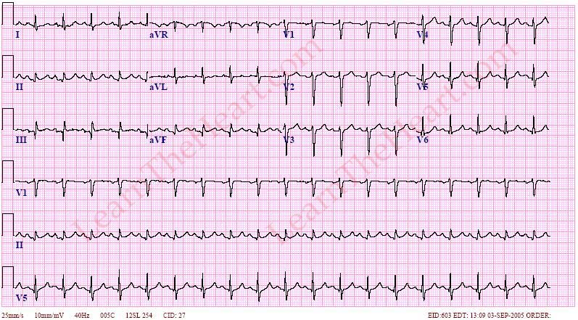

Chest X-ray: No pathological findings, within normal limits.

# Slide 35

Genetic Testing Report, October 31, 2022:

Conclusion: A mutation in the **BRCA1** gene /c.53T>A/p.Met18Lys, a missense mutation, Class 4-5, was detected. This mutation very likely causes a hereditary form of breast and ovarian cancer.

For carriers of the BRCA1 mutation, the lifetime risk of developing breast cancer can be up to 85%. For women who have already had breast cancer, the risk of developing a contralateral tumor is up to 60%. The risk of ovarian cancer can reach up to 65%. There is also an increased risk for colorectal cancer, uterine and cervical cancers, and breast and prostate cancers in men. Preventive monitoring is necessary.

The patient's own sisters have a 50% risk of also carrying this BRCA1 mutation.