1. **Coagulation cascade**

Fill in the blanks in the scheme below (coagulation components – blue boxes, haemocoagulation tests – red boxes)

*help:* [*https://www.youtube.com/watch?v=MRqcgYdB5Ng*](https://www.youtube.com/watch?v=MRqcgYdB5Ng)

tissue damage

endothelial cell damage

tissue factor (III)

VIIa

antithrombin

tissue phospholipids

Ca2+

Ca2+

XIII

XIIIa

X Xa X

Ca2+

Ca2+

prothrombin (II)

fibrinogen (I)

1. **Which of the following coagulation factors are dependent on the presence of vitamin K?**
2. **Which factor connects the internal and external pathways of haemocoagulation?**
3. **Give examples of drugs that interfere with the coagulation cascade by their mechanism of action. Arrange the names of these drugs in the coagulation cascade scheme (green boxes) above.**

Select drugs from the following list: apixaban, enoxaparin, dabigatran, heparin, clopidogrel, warfarin

1. **Give the names of the drug groups influencing the blood clotting processes (blue fields) and their representatives:**

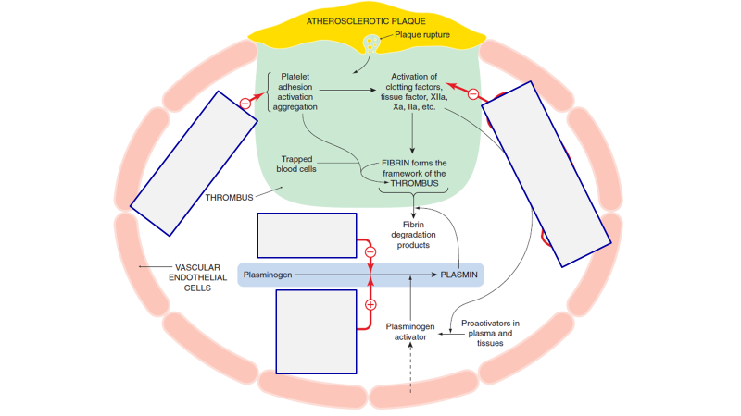

1. **Divide the drugs into pharmacotherapeutic groups and complete the tables below:**

alteplase, cilostazol, dabigatran, enoxaparin, eptifibatide, etamsylate, heparin, clopidogrel, ASA (aspirin), tranexamic acid, rivaroxaban, terlipressin, ticagrelor, tissue sealants, warfarin

1. **Drugs inhibiting haemocoagulation**

|  |  |  |
| --- | --- | --- |
| **Pharmacological class** | **Mechanism of action** | **Drug representatives** |
| **Anticoagulants** |  |  |
|  |  |
|  |  |
|  |  |
| **Fibrinolytics** |  |  |
| **Antiplatelet drugs** |  |  |
|  |  |
|  |  |
|  |  |
|  |  |

1. **Drugs enhancing haemocoagulation**

|  |  |  |
| --- | --- | --- |
| **Pharmacological class** | **MoA** | **Drugs** |
| **Antifibrinolytitics** |  |  |
| **Haemostatics** |  |  |
|  |  |