Didaktický test

1. Doplň do vět chybějící slova z rámečku

football breakfast piano bus swim book

Thomas is having toast and milk for _______________ .

Lucy is playing the ________________ and her mother is listening.

Tracy is reading a ___________________ for her little sister.

Mary can ________________ in the swimming pool .

Peter plays _________________ with his new ball.

John goes to school by _________________ .

2. Napiš, jaký čas ukazují hodiny:
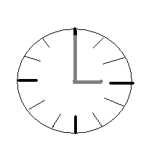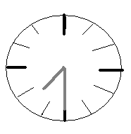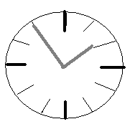

_______________________ ______________________ ______________________

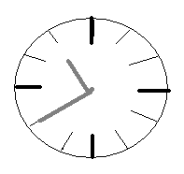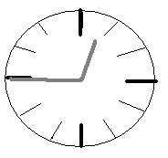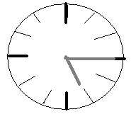

_______________________ _______________________ _____________________

3. Odpověz celou větou v anglickém jazyce na otázky :

What is your name? ..........................................................................................................

Where do you live?............................................................................................................

How old are you?...............................................................................................................

What colour do you like best?...........................................................................................

What is your favorite food?...............................................................................................

What do you like to drink?................................................................................................

What are your hobbies? .....................................................................................................

4. Spoj odpovídající části vět podle vzoru:

I live with my family __________ in a small house near London.

Bob and Suzie have tennis every Friday

At school I like to catch the bus..

My younger sister plays small dog which name is Peggy

You must hurry up biology but I do not like math.

5. Tato slova mají přeházená písmenka, napiš je ve správném tvaru:

O C H O S L ______________

B O K A L A R D C B _______________

E E C H R T A _____________

S P p l u i ______________

Vypracovala Hrdinová Štěpánka, 104772

