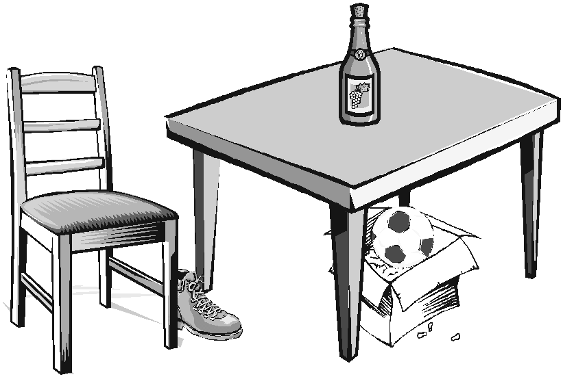
1. Doplňte správně podle obrázku
- The ball is ______the box.
- The bottle is _______the table.
- The chair is ________the shoe.
- The box is ________the table.
- The shoe is _______table and chair.

2. Kolik je hodin?
a) Dopiš podle obrázků.
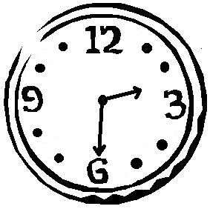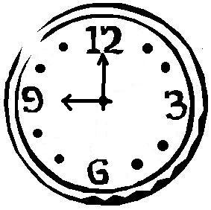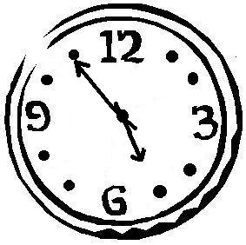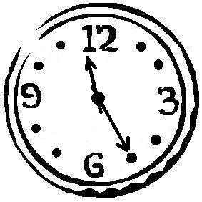
__________________ ___________________ ___________________ ___________________

b) Nakresli hodinám ručičky podle popisků.

a half past seven ten minutes to eleven twenty past eight ten to six

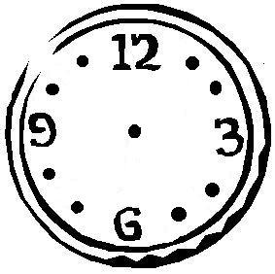

3. Doplňte věty.
- I´m watching___________.
- I´m eating_____________.
- He is playing_____________.
- She is cooking_____________.
- We are reading_____________.
- I have ______________.
- I like______________.

4. Kdo je kdo? Přeložte slovíčka.
a baker
an artist
a teacher
a doctor
an architect
a dentist
a hairdresser
a businesmann
a driver
a policeman

5. Najděte slovíčka a napište je. Písmenka, která zbývají tvoří tajenku.

LDOORIROOFVKITCHENIDOORBELLNBATHROOMGWINDOWRBADROOMOTOILETOGARAGEM

☺
Najdi a vypiš
slova, která souvisí s
☺ domem a jeho vybavením. ☺
C | W | A | R | D | R | O | B | E | ☺ | C
U | B | R | B | A | T | H | O | ☺ | C | U
P | E | M | I | ☺ | D | O | O | R | A | R
B | D | C | N | C | O | O | K | E | R | T
O | S | H | O | W | E | R | C | S | P | A
A | ☺ | A | L | A | M | P | A | I | E | I
R | M | I | R | R | O | R | S | N | T | N
D | F | R | I | D | G | E | E | K | A | D
L | O | O | W | I | N | D | O | W | B | E
P | I | C | T | U | R | E | T | V | L | S
W | A | S | H | B | A | S | I | N | E | K

