Uhrová
Didaktický test

1) Doplnit
Where ……… you from?
……… you at home?
He ……… from Germany.
The picture ……… very nice.
Where ……… John now?
It ……… an English bool.
I ……… here, in the classroom.
We ……… on holiday.

2) Utvořte otázky k následujícím větám
a) This is a Czech book.
b) This colour is red.
c) The dog is under the table.
d) She is at home.
e) My favorite colour is green.
f) I am from Czech republic.

3) Doplňte anglický název barvy
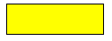
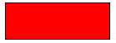
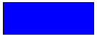

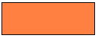




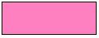


4) Utvořte větu

my / is / brother / this
football / good / is / Jim / at
favorite / my / is / math / subjekt
is / a / not / large / room
have / house / a / they / got / big

5) Npište slova, která nepatří do řady

fater – mother – sister – table
Good bye – Hallo! – Bye bye! – See you
Lucy – Tom – Peggy – Alice
English – volleyball – football – badminton
nice – banana – strong – good
Look .- Read. – Picture – Sing

6) Napište alespoň 8 vět o své rodině

