Visual Impairment – Key Terms

- Visual acuity
- Normal vision
- Low vision
- Blindness
- Partially sighted
- Errors of refraction
- Nearsightedness

- Farsightedness
- Binocular vision
- Spatial and tactual skills
- Remaining sight
- Motor skills
- Long cane

Physiology of the eye:
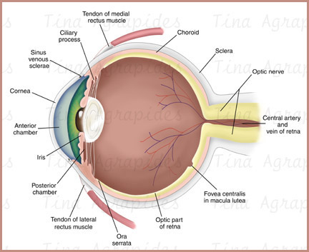

- Cornea
- Aqueous humor
- Pupil
- Lens
- Sclera
- Vitreous humor
- Retina
- Iris
- Fovea
- Optic nerve

