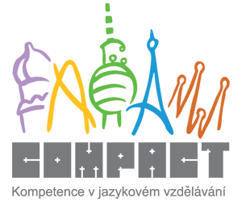

Home preparation2

1.Which of the following school activities are done by teacher / students / both?

teach learn read aloud count discuss
make a mistake correct a mistake catch sb. cheating take attendance
be in detention collect homework be late for school answer/reply
examine orally ask a question put up one’s hand give/set homework
copy from one’s neighbour cut/skip classes / play truant (GB)/ play hooky (US)
answer a question give feedback on memorise concentrate on sth.

Teacher | Both | Students

2. Match the following words on the left with their Czech equivalents on the right:
assessment předmět
mark /grade (US) téma
class/ form (GB) /grade vysvědčení
timetable/ schedule hodnocení
subject známka (ve škole)
instruction ročník
school report výuka
topic rozvrh hodin
subject povinný
compulsory vědomosti/znalosti
optional schopnost/dovednost
break nadání
lesson předmět
aptitude přestávka
knowledge vyučovací hodina
ability volitelný/nepovinný

3. Read this article and get ready to discuss the following questions in class.

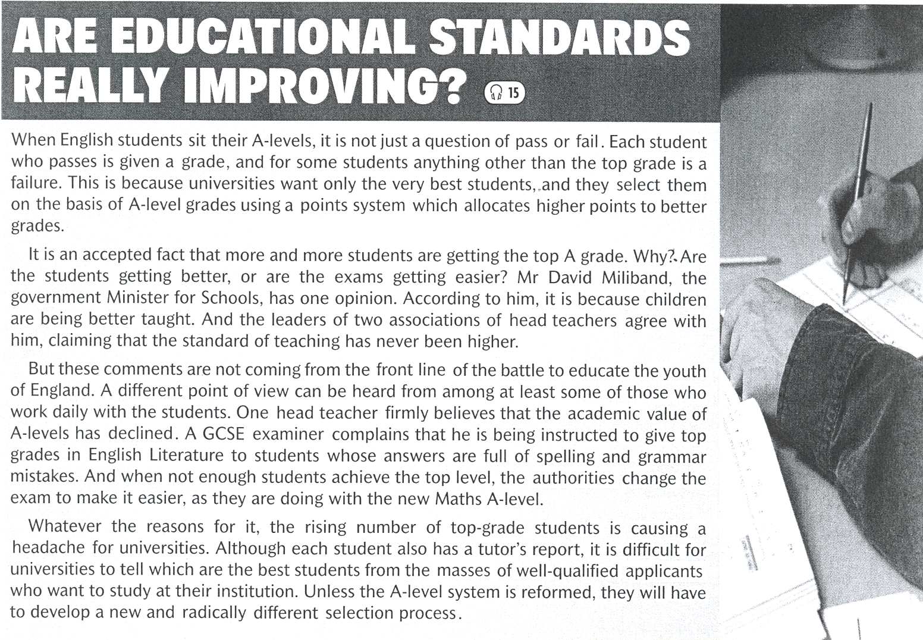

Questions for discussion:

- Do you think it is a good system of accepting students to universities?
- Get ready to explain the system of „Maturita“ exam and the process of entry to universities in the Czech Republic?
- Should universities be tuition-free or should students pay a tuition fee?
- What’s your opinion on private schools/universities? Do their educational standards tend to be higher?

