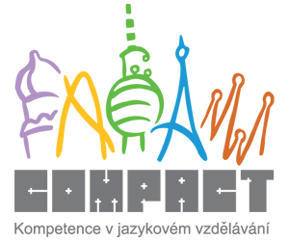

EDUCATION

Revision of vocabulary

1. A school paid for by the government which gives free education. __________________
2. A non-government school where you have to pay. __________________
3. A school for very small babies, only approx. 1 year old __________________
4. A school for very young children, e.g. 3-6 years old __________________
5. A school for young children, e.g. from 6-11/12 years old __________________
6. A school for older children, e.g. 11/12 – 15 years old __________________
7. A school where pupils/students live, eat, and even sleep __________________
8. Students of this school can work as nurses in hospital after graduating sucessfully from this school __________________
9. Students of this school are systematically prepared for passing entrace exams to universities __________________
10. Students of this school are prepared for manual/practical jobs such as plumber, mechanic, bricklayer etc. __________________
11. A person who hasn’t finished Bachelor’s study programme yet __________________
12. A person who has already finished his Bachelor’s study programme and continues studying Master’s programme __________________
13. The ‘boss’ of a basic school __________________
14. The ‘head’ of a faculty __________________
15. A student who is copying his colleagues work when writing a test is _____________ (verb)
16. You have to attend school until you are 15 in the Czech Republic, it means that education in the CR is ____________ (adjective) until the 9th class.
17. An exam that students sit for at the age of 19 in the CR __________________
18. When you finish your exam successfully, you __________________ (verb) your exam, if you were not successful, it means that you __________________ (verb) the exam.
19. When you don’t have to pay any money to your school for your education then your education is __________________
20. Money that you pay for your education to school is called __________________

Listening 1 (Timesaver Intermediate Listening, track 20)
Some students are going to give you some information about the education system in Britain.
Listen and complete the missing information.

- .................. education is ……....……. but some parents pay for …….....……. education.
- Private schools are very ……………. and about …………… % of British kids go to them.
- Children go to ………… school from ................... years old to .......……….. years old.
- They go to …………….. school when ................... ................ five years old.
- They start ……………...…. school at 11. Children in the UK ...................... go to school ........................ they are …….... years old.
- They can stay at school for two ...................... years until they are .......……….. years old.
- Children ................. secondary school in Britain have to study ………... subjects.
- The ......................... subjects are English, mathematics, and ....……………. Children must .................…….. more time studying these subjects.
- ............................ subjects are history, geography, art, one .................... language (French is the most ........................), design and technology, ................................ and music.
- When they are 16 years old, students have to take G........................ C................. of S...................... E...................... exams (GCSEs) in as many subjects as they can manage, often about eight or ten.
- At 18, they take A levels which qualify them for ...................... to universities. Students in the UK specialise early, ....................... just three or four subjects to study at A level.
- About …………….. % of young people go to study to university or ……………..

What activities can you usually observe in schools?
reading aloud taking notes counting tutoring putting up one’s hand
discussing and cooperation calling upon/ask a pupil to answer a question being in detention

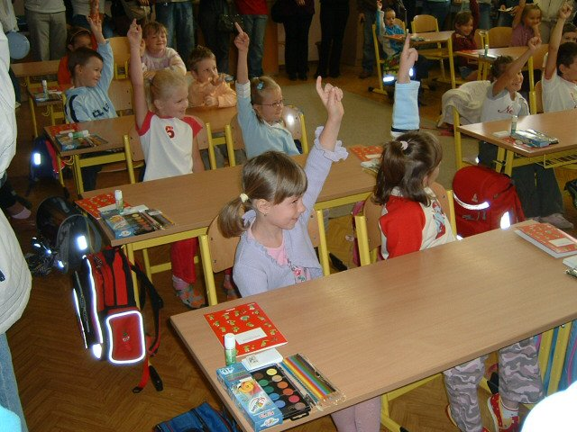
_______________________________ ___________________________

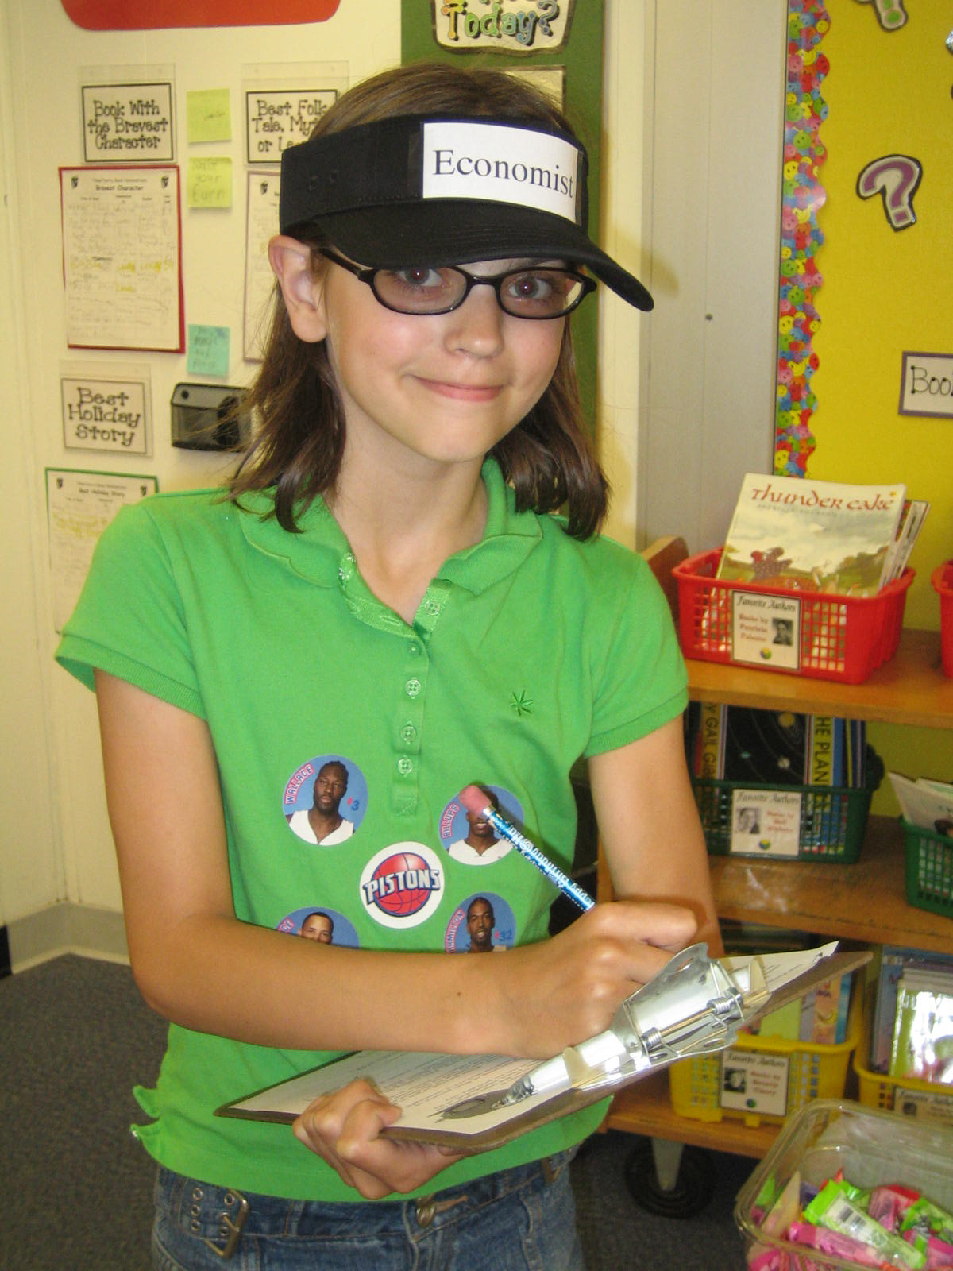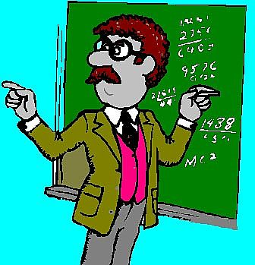

____________________________ ______________________________

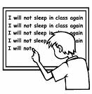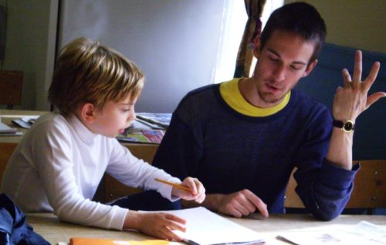

____________________________ _____________________________________

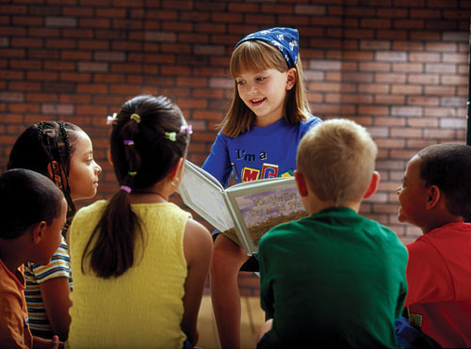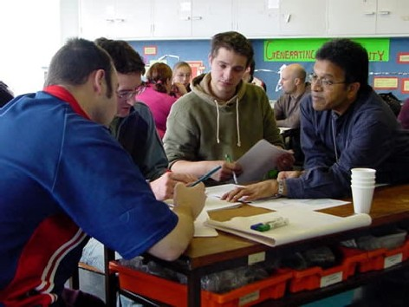

____________________________ _____________________________________

Questions for discussion:

- Did you go to crèche/nursery school? Do you remember anything from that time?
- Did you like attending your elementary school? What did you/didn’t you like about it?
- What kind of secondary school did you go to? Did you like it?
- How many students were there in your class?
- Which subjects were you good and bad at?
- Which students/teachers did you have bad relationships with?
- Which teachers did you like? Why? Which subject did they teach? Which personal and professional qualities of your favourite teacher would you like to have yourself (as a teacher)?

Listening 2 (Timesaver Intermediate, track 18)

Listen to some students describing their secondary schools. Focus on the following information:

- How many students did you hear talking about their schools?
- What type of secondary schools do the individual students attend?
- How do they describe their school? What is special about their school/studying?
- Do they like going to their schools? Why/why not?
- Do they have to wear school uniforms?

