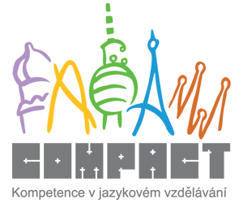

Home preparation 1

EDUCATION

1. Complete the following sentences with the most appropriate verb from the list.

learn do pay cheat pass revise start finish fail copy graduate teach

1. “I’m sure that you ............... his homework. They are exactly the same!”
2. I should ............... tonight because we are writing a very difficult test tomorrow.
3. I didn’t like my geography teacher. He was terrible and we didn‘t ............... anything. He ............... us absolutely nothing.
4. If you want to finish this semester successfully, you have to ............... all 5 exams!
5. In the CR children ............... school when they are 6 or 7 and don’t ............... it until they are 15 years old.
6. If you don’t ............... your homework, you can’t watch TV in the evening.
7. Our history teacher was very angry because three students had tried to ............... in the exam.
8. My parents will be terribly angry if I ............... a resit examination!
9. It is very difficult for young children to ............... attention for more than 10-15 minutes.
10. I ............... from my secondary school last year and I miss my classmates very much.

SCHOOL SUBJECTS

2. Complete this puzzle with the names of some subjects and activities you can study at school, university or college.
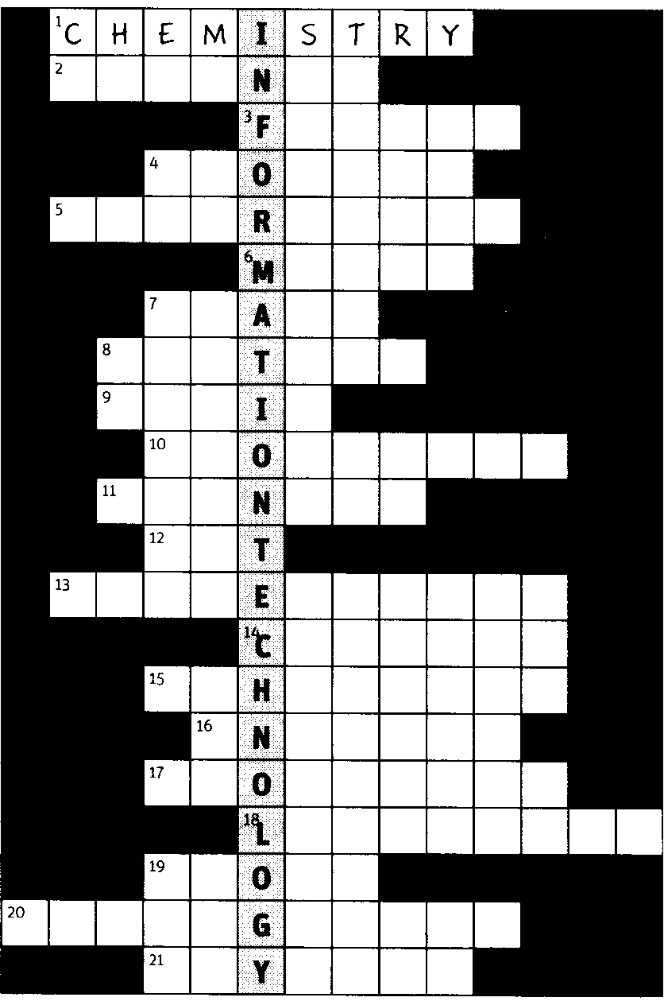
1You often do this subject in a laboratory.
2 The answers to clues 1, 4 and 21 are examples of this.
3 They speak this language in France.
4 This is the study of living things.
5 In this subject you read and discuss novels, poetry and plays.
6 This is a short way to say the answer to clue 13.
7 In this subject you learn how to act.
8 In this subject you learn about the past.
9 In this subject you learn about instruments and you can learn
to play one.
10 This is the study of money and the financial world.
11 They speak this language in Mexico.
12 This is the study of painting and drawing.
13 In this subject you work with numbers.
14 In this subject you learn how to prepare food.
15 In this activity you run, jump and throw.
16 This is the name of the language you are practising now.
17 This is the study of the world and all the countries.
18 In this subject you might learn Chinese, Polish, German,
Russian or Spanish etc.
19 In this subject you might play football, hockey, basketball or
volleyball etc.
20 In this subject you learn how to use a camera.
21 This is the study of heat, light and movement etc.

3. Say or write down your favourite and least favourite subjects at school. Why did/didn’t you like them?

4. Study the following terminology connected to the structure of education in the CR and get ready to use it in our next lesson

Terminology Connected to the System of Education in the CR

1– 3 years old crèche

3 – 6 years old nursery school / kindergarten

6 – 15 years old primary school (BrE) / elementary school (AmE) / (basic school/ junior school/ grade school)
- consists of lower primary school (1.stupeň) and upper primary school (2.stupeň) or primary school (1.stupeň) and lower secondary school (2.stupeň)
- compulsory school attendance
- headmaster/headmistress / head teacher /principal (US)

15 – 19 years old ( higher) secondary school/ high school (AmE)
general secondary school (grammar school) /
secondary technical /nursery (also nursing college) / agricultural / art / business / pedagogical school /
vocational school/ vocational training ((apprentice))

- entrance examination
- school living examination = “maturita” exam
- boarding school
- state school (tuition-free education) x private schools (tuition fees)

approx. 19 – 25 years old tertiary education/ university
- Masaryk University in Brno, Charles University in Prague, Palacky University in Olomouc etc.
- University - the Rector
- → faculties: Faculty of Education / Law / Medicine / Architecture / Arts (= Filozofická fakulta) / Social Studies / Economics and Administration / Informatics / Information Science / Veterinary Science / Civil Engineering etc. - the Dean of the Faculty of Education
- → departments: Department of Biology / Physics / Mathematics / Civics / Geography etc. - the Head of the Department of English Language
- Bachelor’s study programme – undergraduate (students)
- Master’s study programme – post-graduate (students)
- Doctoral study programme

