File 5A
Grammar
1c

Pronunciation
2b
Listening
3a
3b
Reading and vocabulary
4a
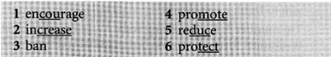
4b
4c
Vocabulary
5b

