Unit 6A

1 Grammar
1c
1d

2 Vocabulary
a
3 Pronunciation
5 Reading
b
c
d
6 Grammar
a
b
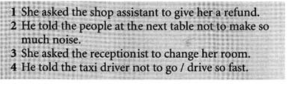

7 Listening and speaking
a

