Unit 6C

1 Grammar
a
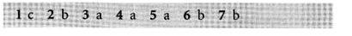
d
e
2 Listening and speaking
a
3 Reading
a
b
c
d
4 Vocabulary and pronunciation
a

