MASARYK UNIVERSITY

Faculty of Education

Brno

Essay
(London in literature)

Worked:
Žaneta Petraturová
237168
The comparison of Deaf theatre in the United Kingdom and Czech Republic
Deaf theatre in the United Kingdom
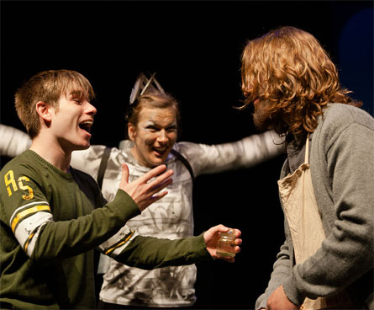
In my presentation, I said about the Deafinitely Theatre that was founded in London in 2002 and is a professional and popular theatre group of Deaf people in London. Its team is artistic director, Paula Garfield with Steven R. Webb, Kate Furby and others. They use British and British Sign languages. They are doing tutorials and workshops for a few groups – pupils, students, hearing impaired people and hearing people.

Deaf theatres in the Czech Republic
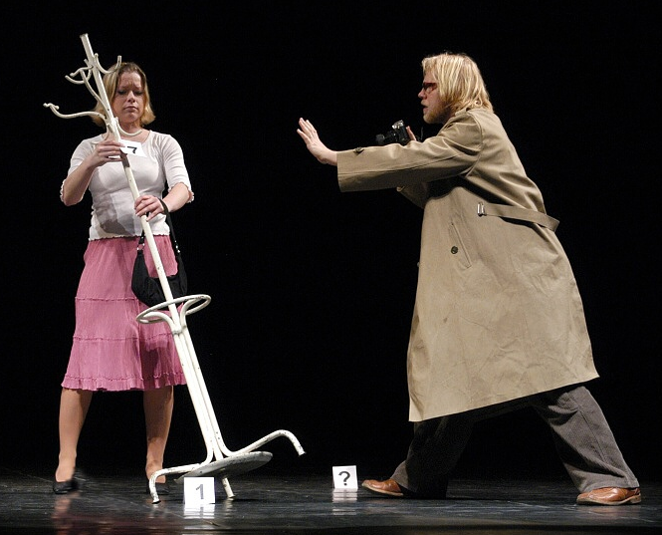
In the Czech Republic, two most known theatres which are only deaf people are NEPANTO and Neslysim Theatre Company (originally Divadlo Neslyším). NEPANTO is founded in 1973 by deaf headmaster – Ladislav Spilka, later by Zralý, – in the project Deaf pantomime. This name NEPANTO was abbreviation of words NEslyšící PANTOmima. The deaf team has acted many performances in our country, e.g. Mluvící ruce in Prague on August, Otevřeno Kolín in Kolín and International pantomime of Deaf in Brno.

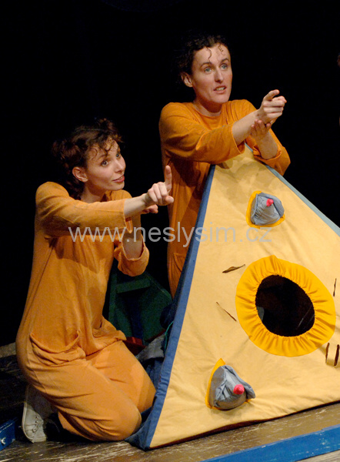
Neslysim Theatre Company is founded by deaf team in Brno as well. Thanks to their first establishment they studied this study field of Janacek University of musical art in Brno and then they didn’t want to break their way. As they founded it and they wanted to show a few performances for children and adults. They have visited many various places in our country and in other foreign countries as well. It focuses on known story tales or stories for small children, e.g. About a large beet, Hrnečku, vař!, Putování ošklivého kačátka, …

Comparison of these deaf theatres
I think these all deaf theatres in both countries are similar types of theatres however the NEPANTO is focused on pantomime. Personally, I saw and knew the group of NEPANTO because I met him on a few performances when I was in another group of Silent Music (Tichá Hudba) that means a song in Sign language. NEPANTO wants to show a bit humour and funny.
On the other hand, I saw a deaf theatre – Neslysim Theatre Company – once, I think, when I was in primary school. They showed a story tale about a large beet and they played nicely with biased pictures. I enjoyed it and small children enjoyed it much as well.

I found out that Deafinitely Theatre is on the Facebook and they give us news, information, remarks on change of dates or places, photos of performances and trainings etc. However, Czech theatres – NEPANTO and Neslysim Theatre Company – aren’t on Facebook and it is pity because they would give amount of information and events as Deafinitely Theatre. Also, I always go to my faculty and some information about Neslysim Theatre Company and others are given on the noticeboard in the first floor (department of Special Pedagogy). But I don’t realize the information on the noticeboard and then I know it later. I think it is better to give information on the Facebook where I sign on everyday and I update every hour. If they are on it, I should know immediately.

Conclusion:
I said important points and comparisons of deaf theatres in the United Kingdom and the Czech Republic. Then I suggested many points of them to improve for us. In my conclusion, the deaf theatres are good for deaf children and adults who could watch interesting, known and funny plays in their Sign Languages in both countries. I am glad that they exist for long time nowadays. Also, they are important for children to know story tales or plays from known and famous writers thanks to literature in schools. It is easy to remember these stories. When I was a child, I had some problems with literature or stories from the writers and these deaf theatres weren’t presented mostly earlier. If I am a child now, I should always go to the theatres.

