Reading techniques, taking notes
Taken and adapted from:
Philpot,Sarah. Academic Skills. Level 2. Oxford: OUP, 2006. ISBN 978-0-19-471567-6

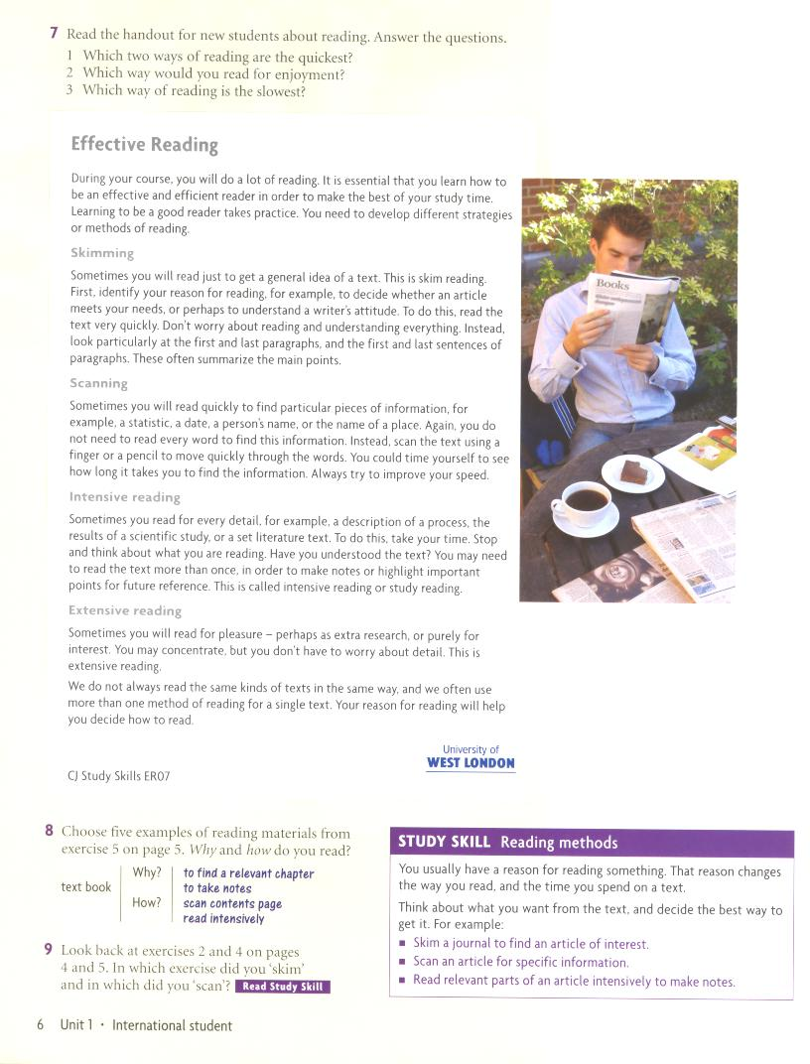
Taking notes
Taken from:
Gairns, Ruth.Redman, Stuart. Oxford Word Skills. Oxford:OUP, 2008. ISBN 978-019-462003-1

