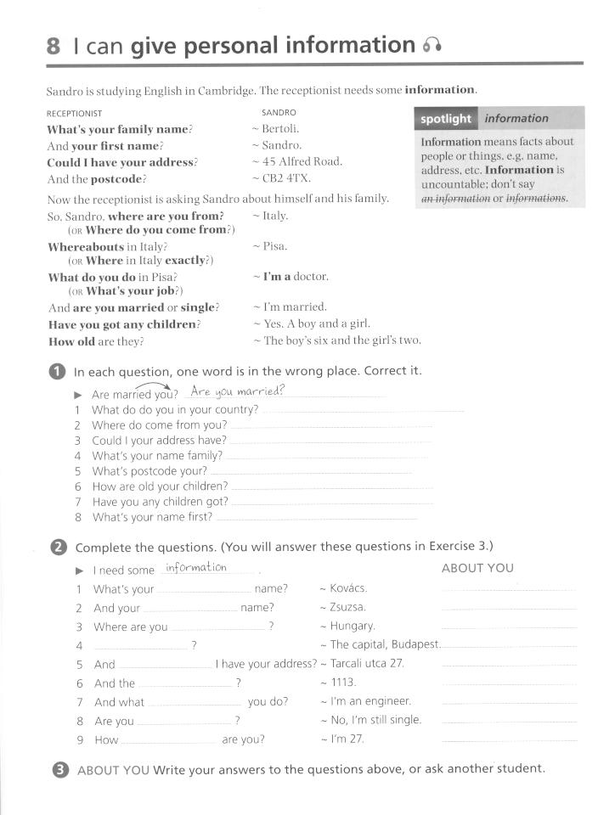

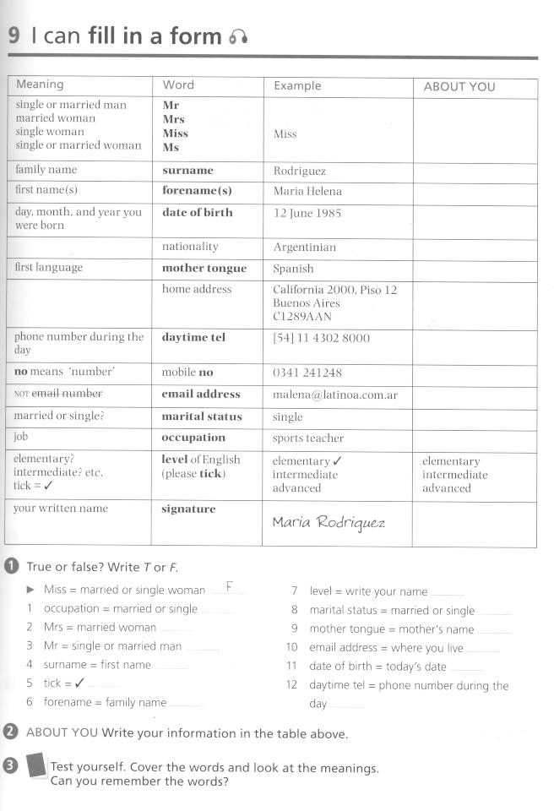
Taken from:
Gairns, Ruth.Redman, Stuart. Oxford Word Skills. Oxford:OUP, 2008. ISBN 978-019-462003-1

