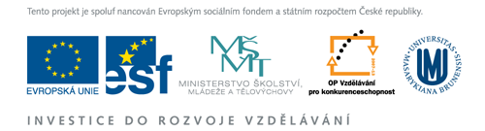

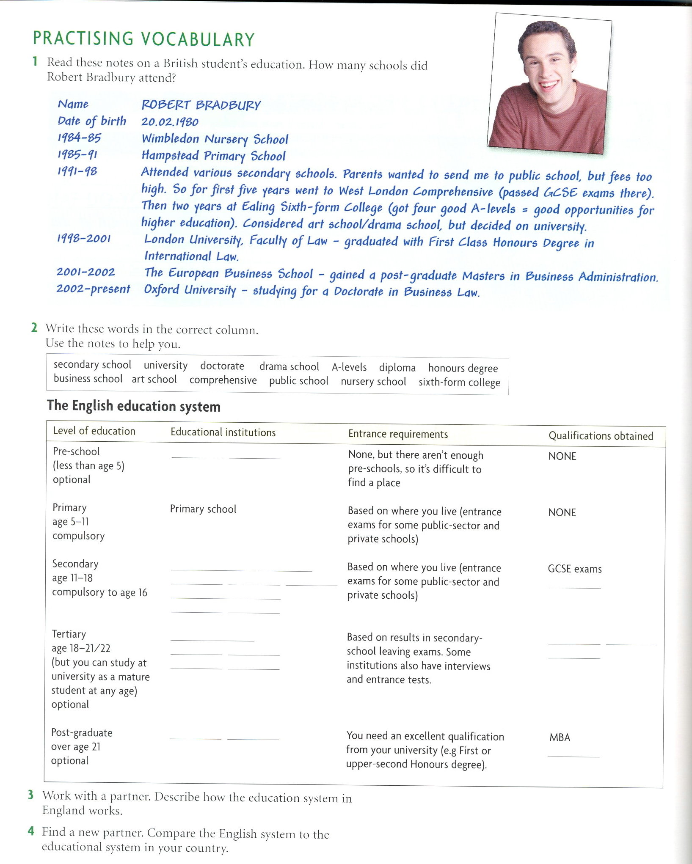

Taken from:
Gault, James. Talking Points. Speaking preparation for Maturita exam. Oxford:OUP, 2005. ISBN 0-19-471540-X

