

Part 1
READING SKILLS

Ways of reading

A good reader reads in different ways.
Sometimes you read slowly and carefully (intensive reading/study reading).
At other times you read quickly for the general idea (skimming) or for information (scanning).

REMEMBER

Skimming is reading very quickly to get the general idea from a text (a book, an article, a chapter, or just a paragraph).
Scanning is reading quickly to find information. One way to scan for information is to use headings of paragraphs, sections, and chapters.

WHAT CAN HELP YOU?

Predicting content – before you read, look at the pictures, headings in a text. They can help you predict the content. They can tell you what the text is about and help you understand it.
Before you read the whole text, read the title and the first few sentences.
Make predictions about the content of the text.
      - the topic (What is it about?)
      - information (What information will it give?)
      - vocabulary (What words will you find?)
Predicting will help you read. It will also tell you if the text is useful before you read it.

Meaning from context
Texts often contain words we don’t know. Looking up every word takes time and slows down your reading.
To help you guess the meaning from the context:
- look at the words and sentences around the unknown word.
- identify the part of speech.
- use your knowledge of the world (what you already know about the situation)
- think about whether the word has a generally negative or positive meaning.
- replace the unknown word with another word with a similar meaning and check that it makes sense in the sentence.

Making notes is an important skill. Use it for study or intensive reading. Read slowly and carefully when you make notes.
Note-making help you:
- understand what you read
- remember the important points
- write about the topic
- revise later for exams
There are many ways of making notes.

Revise what you read and learnt in the text below.

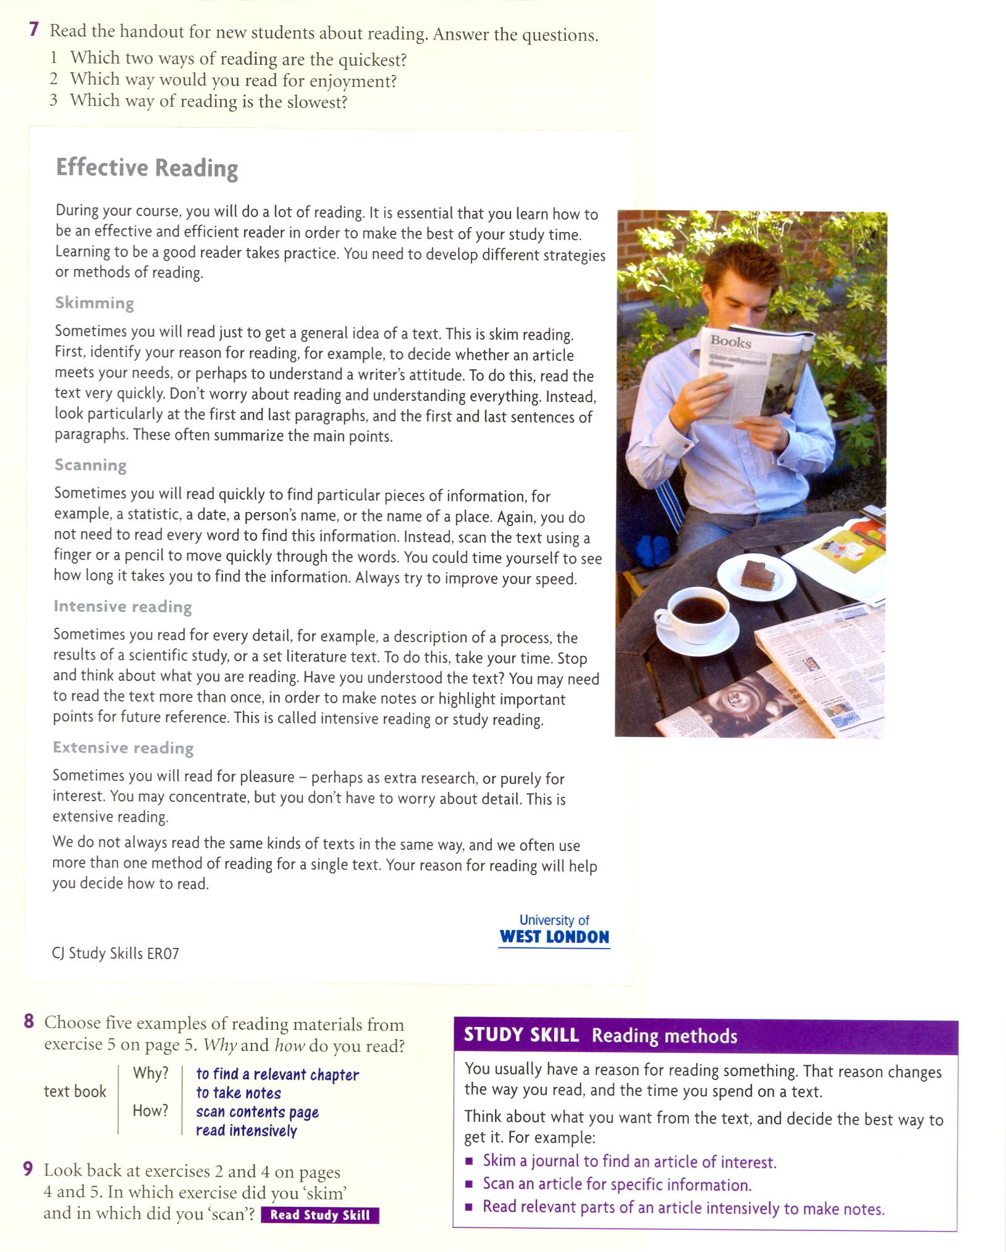

Taken and adapted from:
Harrison, Richard. Academic Skills. Level 1. Oxford: OUP, 2006. ISBN 978-0-19-471558-4
Philpot,Sarah. Academic Skills. Level 2. Oxford: OUP, 2006. ISBN 978-0-19-471567-6

