

Grammar Revision

Present Perfect Simple
Form
Have/has + past participle (regular past participle end –ed, like simple past, with irregular verbs, past participle is often different!!)

Positive
I/we/they/you have (= I’ve etc.) worked
lived
done
He/she/it has (= he’s etc.) been
arrived
made
Negative
I/we/they/you have not (haven’t) worked/lived/done
He/she/it has not (hasn’t) been/arrived/made
Question
Have you/we/they worked …..?
Has he/she made …?

Use
1. We think about the past and the present together – we use the present perfect for actions that began in the past, still continue and are likely to continue in future.
We have worked for the company for 4 years.
Have they worked for the company since 2006?

2. We often use the present perfect to tell people about new things that have happened, for recent actions and events which have present results (sth. that happened not long ago and is linked to present).
England footballers have arrived back in Britain after their match in Italy.
I have (I’ve) made a cake. Would you like some?
He hasn’t broken his leg.
Who has eaten my dinner?

3. We use the present perfect for an experience that happened at some time of one’s life.
Have you been to Norway? No, but I have been to Finland several times.
I have never watched tennis on TV.
I’ve just met Helen. She looked really smart!
Have you seen Mr. Burns today yet?
She has already seen Mr. Burns today. X She hasn’t seen Mr. Burns yet.

Present Perfect Continuous (Progressive)
Form
Positive
I/we/they/you have (= I’ve etc.) been working/living
He/she/it has (= he’s etc.) been doing
Negative
I/we/they/you have not (haven’t) been working
He/she/it has not (hasn’t) been doing
Questions
Have I/we/they/you been living …. ?
Has he/she/ been doing …?

Use
1. We use the present perfect continuous to say how long things have been continuing up to now, an action is not completed, or has recently stopped.
We have been travelling for six hours.
How long have you been learning English?
Mary has been painting her house for two days.
2. We use the present perfect continuous for an activity that has recently stopped or just stopped. There is a connection with now.
You look tired. Yes, I have been working in the garden.
My hair is wet, it has been raining outside.

!! We don’t use the progressive with be, have (meaning ‘possess’), know and other non-progressive verbs (like, love, mean, need, prefer, seem, understand, want)

Practice

1 Make present perfect simple affirmative, negative sentences and questions.
1 John/learn/not/anything
2 Where/you/put the keys?
3 The rain/stop/just
4 Bill/phone/already?
5 I/break/a red cup
6 Why/Mary/go home?
7 The postman/not/come/yet

2 Make present perfect continuous affirmative, negative sentences and questions
1 We/wait/the bus/since 8.30
2 How long/your brother/play/the piano?
3 They/drive/not/for about six hours
4 I/learn/English/for four years
5 Jane/talk/on the phone/20 minutes
6 I/live/here/since I was born
7 How long/your brother/work/in Glasgow?

3 Underline the correct form
1 How long have you learnt/been learning the piano?
2 Look! I have bought/been buying a coat.
3 It has rained/been raining since Tuesday.
4 John has broken/been breaking his leg.
5 He hasn’t told/been telling me his address.
6 How long have we driven/been driving now?
7 Have you ever read/been reading this book?
9 How long have you played/been playing tennis?
10 How many games have you played/been playing?

Summary of three tenses

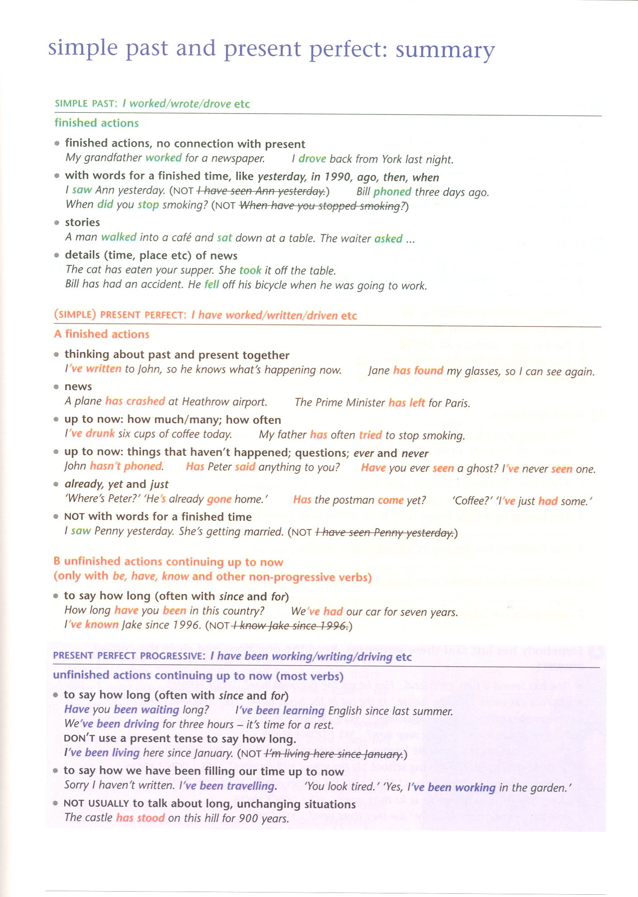

Present perfect and past simple: revision exercises

1 Put in the past simple, present perfect or present perfect progressive.

1.‘Where’s the car?’ ‘Bill …………… it. He …………… it to go shopping.’ (take;need)
2. I …………… tickets for the match. Do you want to come with me? (buy)
3. My grandfather …………… to school in Ireland. (go)
4. How long ............... you …………… there? (stand)
5. ‘I …………… my job.’ ‘Why?’ ‘I …………… the hours.’ (change; not like)
6. Mike …………… his new watch. (already lose)
7. It …………… since Sunday. (snow)
8. You can have the newspaper. I …………… it. (finish)
9. I …………… mathematics from 1996 to 1998. (study)
10. How long …………… you …………… Mary? (know)
11. …………… you ever …………… a poem? (write)
12. We …………… for the electrician all day yesterday. (wait)
13. ‘Where’s Robert?’ ‘He …………… out.’ (just go)
14. ‘Do you like skiing?’ ‘ I …………… it.’ (not try)
15. That child ……………- chocolate all day. (eat)

2 Underline the correct answer (the correct tense).

I know / have known Adrian for a very long time – we are / have been friends since our first day at school, thirty years ago / before / since. He came / has come round to see me last night to ask for my advice. His company did / has been doing very well for the last few years, and they opened / have opened several new offices. They just asked / have just asked Adrian to move to Scotland, to run an office there. He didn’t decide / hasn’t decided what to do yet. He doesn’t really want to move: he never lived / has never lived outside Manchester, and he bought / has bought a new house there last year. But the new job would be interesting, and very well paid. We talked / have talked / have been talking about it for a long time last night, but of course I couldn’t tell him what to do.

3 Underline the correct answer (in italics)

1 We know/We’ve known/We’ve been knowing John and Andy for/since years.
2 I work/I’m working/I’ve been working here since last summer.
3 ‘Good news! John passed/has passed his exam.’ ‘Has he got/Did he get good marks?’
4 ‘Mary went/has gone to London.’ ‘When did she leave?/has she left?’
5 This house has stood/been standing here for 500 years.

Taken and adapted from:
Swan, Michael. Walter, Catherine. The Good Grammar Book with answers. Oxford:OUP, 2004. ISBN 0-19-431519-3

