

Topic 2 – Vocabulary Practice
Taken from:
Redman, S. Gairns,R. Test Your English Vocabulary in Use – pre-intermediate + intermediate. Cambridge:CUP, 2000, p. 50

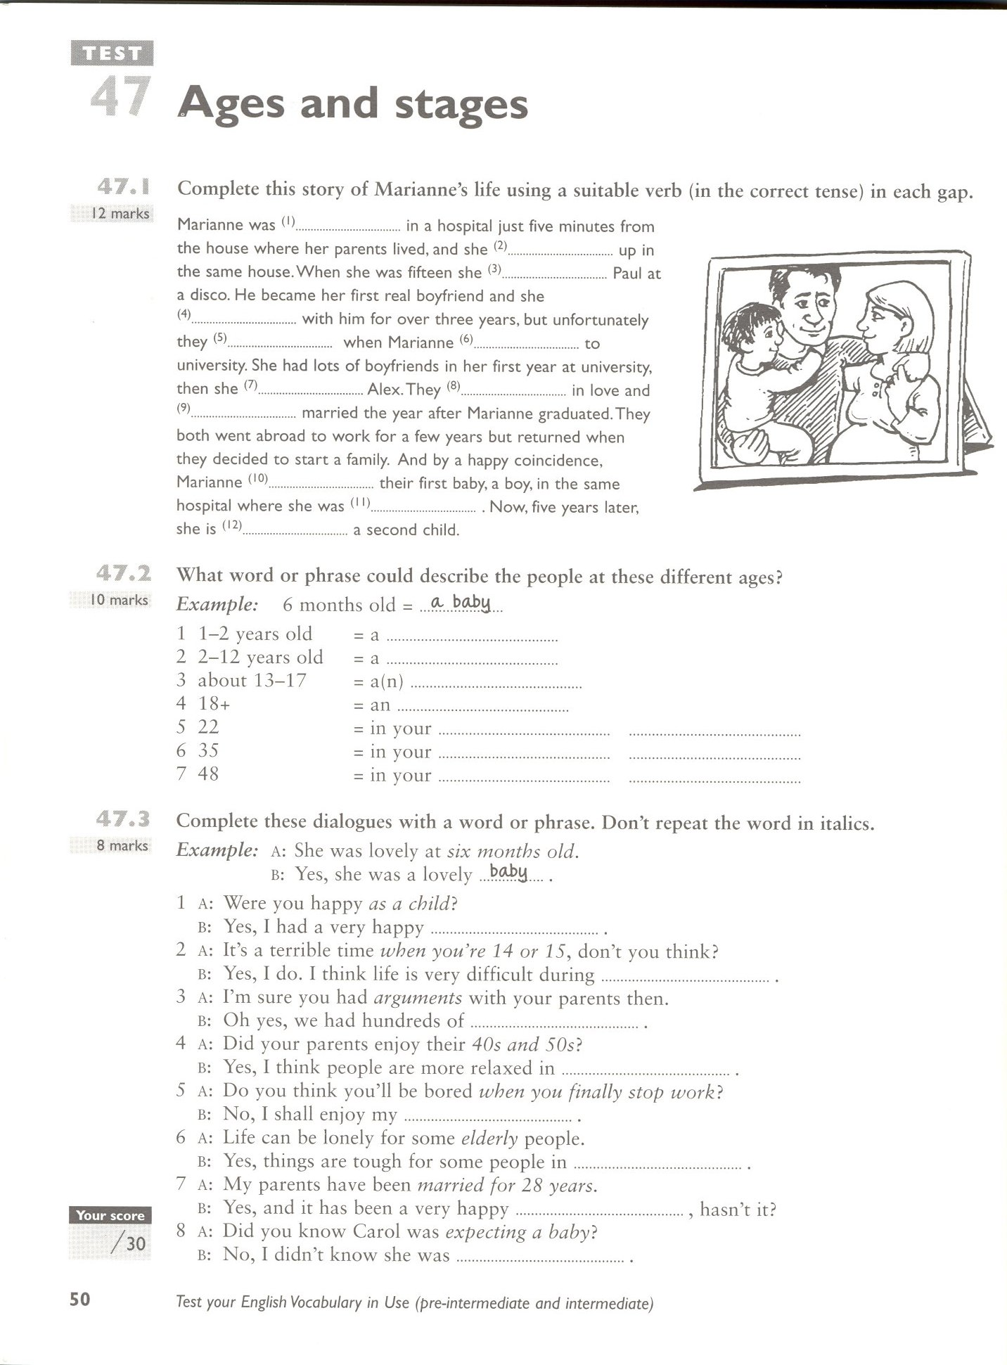

Taken from:
Gough,Chris. English Vocabulary Organiser. Hove:LTP, 2001, p. 10

