

Topic 2
The transcript of the lecture given by Ms.Katz

Taken from:
Espeseth,Miriam. Academic Encounters Listening, Note Taking and Discussion. Cambridge:CUP, 1999

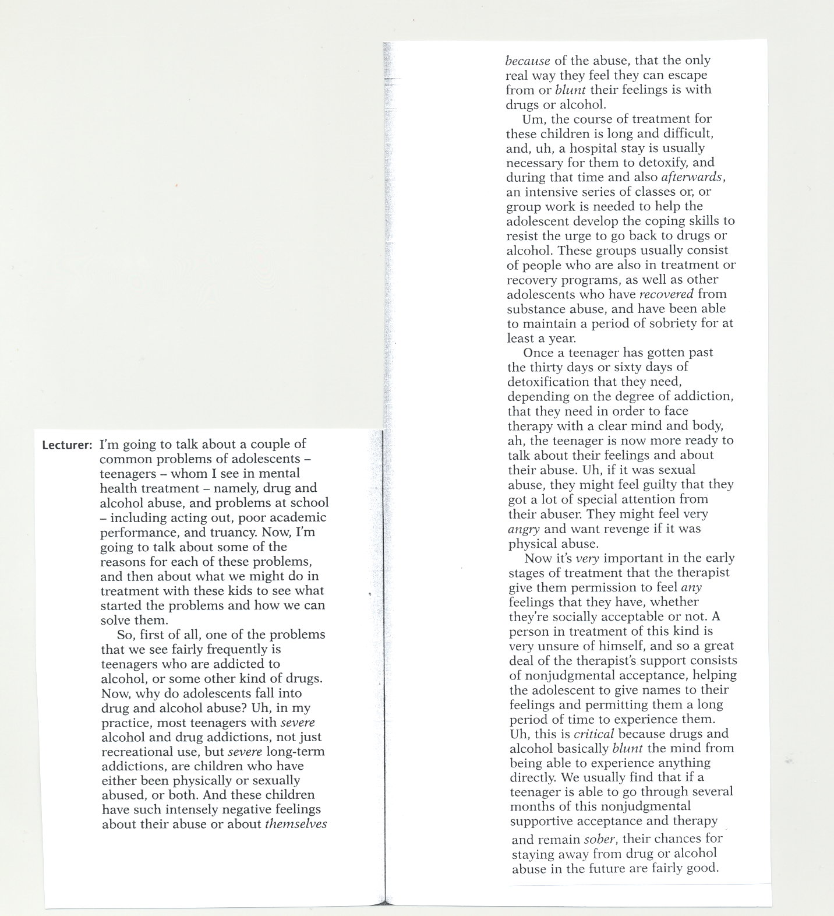

Answer key to exercises

Part 1/Text 1
Matching words and meanings
1d; 2f; 3b; 4h; 5c; 6j; 7i; 8a; 9g; 10e
True/false/doesn’t say
1T; 2T; 3T; 4F; 5F; 6DS; 7DS
Scan … and answer the questions
1 A restricted environment can delay the motor development of the child.
2 In terms of anticipated rewards and punishment.
3 In terms of one’s ethical principles.
4 It is the tendency to view certain activities as appropriate for one sex.
5 With adults who are warm, nurturing, and powerful, and whom they view as similar to themselves in some way.
Stages
A baby; a toddler; a child; a teenager; an adult; in your twenties ( 24 – 26 = mid twenties); in your thirties 38 = late thirties); middle – aged, in middle age; retirement (people stop work, they are retired); old age (elderly)

Part 2
A Fill each gap …..
dramatic, observe, important, challenging, opinions, own, to, they, still, of
B Jumbled paragraphs
The correct order of paragraphs: C, A, D, B
The best single-sentence summary: 1.
Paragraph organization
1a Sentences one and two
1b sentences three and four
1c Sentences five, six, and seven
2a Or
2b Additionally
3a When adolescence is viewed in biological terms
3b When adolescence is viewed from a psychological perspective
3c Looking at adolescence as a social stage

Part 3
A Match the terms …
1g; 2m; 3f; 4e; 5a; 6j; 7b; 8n; 9c; 10k; 11d; 12l; 13i; 14h
B Answer the questions
1 alcohol and drug abuse b) poor school performance
2 Most teenagers with severe alcohol and drug addictions are children who have either been physically or sexually abused, or both.
C Complete the notes
Drug, alcohol, out, academic, truancy, addictions, abused, themselves, escape, necessary, coping, feelings, permission, socially, unsure, consists

Vocabulary Practice – Key

Ages and Stages
1 1 born; 2 grew/was brought; 3 met/saw; 4 went out; 5 split up/broke up; 6 went; 7 met; 8 fell; 9 got;
10 had; 11 born; 12 expecting
2 1 toddler; 2 child; 3 a teenager/an adolescent; 4 adult; 5 early twenties; 6 mid thirties; 7 late forties
3 1 childhood; 2 adolescence/your teens; 3 rows; 4 middle age; 5 retirement; 6 old age; 7 marriage; 8 pregnant

Stages of Life
1 1 birth; 2 childhood; 3 puberty; 4 adolescence; 5 marriage; 6 middle age; 7 retirement; 8 old age
2 a teens, childhood, twenties; b child; teenager, student, kid; c growing up, at university, young,
single, at school
1 spent; 2 brought up; 3 grew up; 4 had

3 1c; 2d; 3b; 4e; 5a
4 1e; 2d; 3b; 4c; 5f; 6a
7 leave school; 8 get divorced; 9 change school; 10 losing his wife; 11 leave home; 12 moving
house

