People, personal information.

At the reception

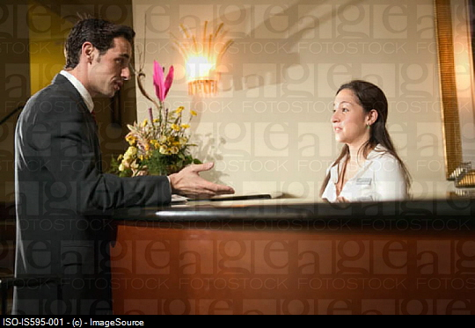

You are on a business trip in the UK and you have just come to the hotel.
The receptionist needs some information about you.

Receptionist You
What’s your family name? ……………
And your first name? ……………
Could I have your address? ……………
And the postcode? ……………

You are the first guest from the CR in the hotel and the receptionist is asking for more details.

Where do you come from? ……………
(Where are you from?)
Whereabouts in the Czech Republic? ……………
(Where in the CR exactly?)
What do you do in the CR? ……………
(What’s your job?)
Are you married or single? ……………
Have you got any children? ……………
How old are they? ……………

Practise the dialogue with your partner. Swap your roles.

Correct one mistake in each sentence.

1 My brother has eighteen years old.
2 I born in 1984.
3 My sister is younger that me.
4 His parents are divorce.
5 There are five child in our family.
6 Helen is more old than her brother.
7 We spend together a lot of time.
8 Where do come from you?

Meeting people – personal information.

Read about Jozef.
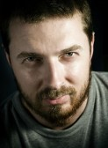
Complete the gaps.

My name is Jozef and I’m from Slovakia. I was 1 __________ in Košice and I’ve lived there all my life. I’m
2 __________ , but we haven’t got any children
We 3 __________ with my parents. Luckily their flat is very big, so there’s room for all of us. They are both retired, and they 4 __________ all the housework, which is great because Anna, my wife, and I both work.
I’m 5 __________ accountant. I studied Economics 6 __________ university and then I got a 7 __________ with a computer company. Anna is a secretary for the same company – in fact that’s how we 8 __________ .
I’m learning English because we do a lot of 9 __________ with Ireland. I need English 10 __________ write, to speak on the phone, and sometimes to go out 11 __________ a meal with Irish people. Next summer I’m going to do a business course in Ireland, so I hope my English will be 12 __________ enough!

Write questions.

1 _________________________ ? Molnár.
2 _________________________ ? In Košice.
3 _________________________ ? All his life.
4 _________________________ ? Yes, but he hasn’t got any children.
5 _________________________ ? His wife and his parents.
6 _________________________ ? He’s an accountant.
7 _________________________ ? Economics.
8 _________________________ ? They work for the same company.
9 _________________________ ? Because it’s important for his job.
10 _________________________ ? A course in Ireland.

