Revision of present tenses

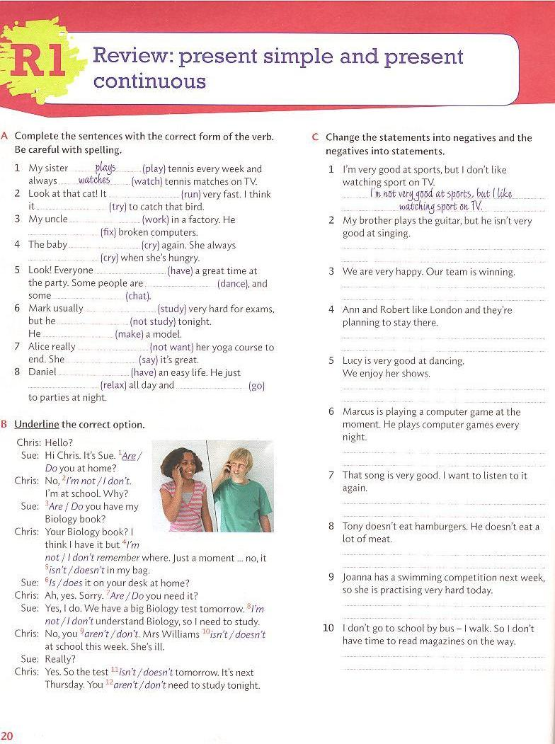

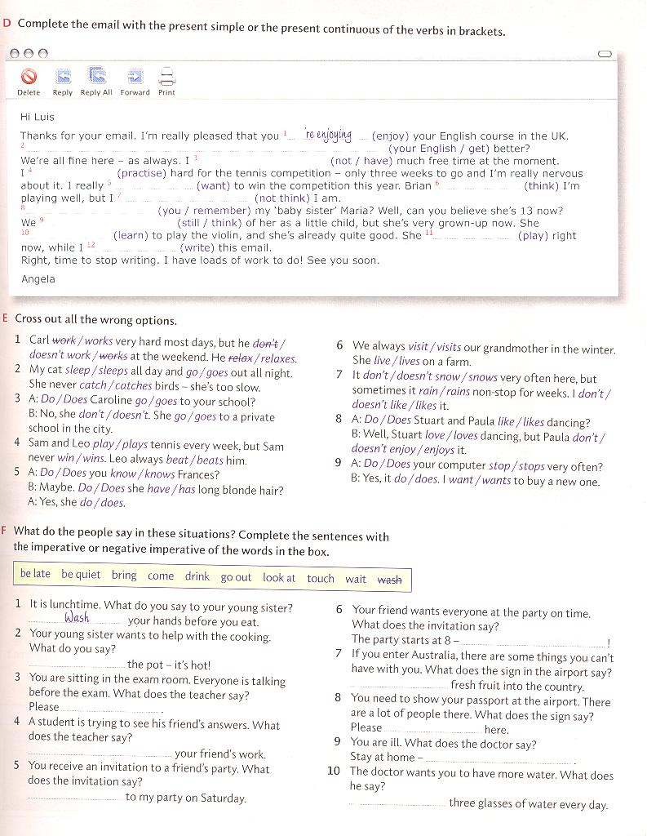

Taken from:
Davis,Fiona. Rimmer, Wayne. Active Grammar with answers. Level 1. Cambridge:CUP, 2011 ISBN 978-0-521-73251-2

