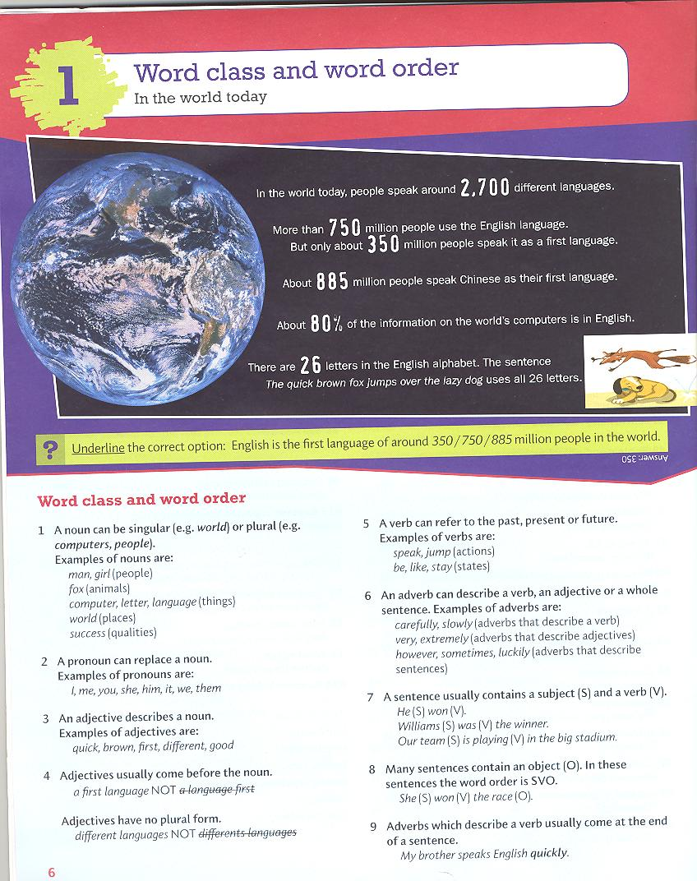

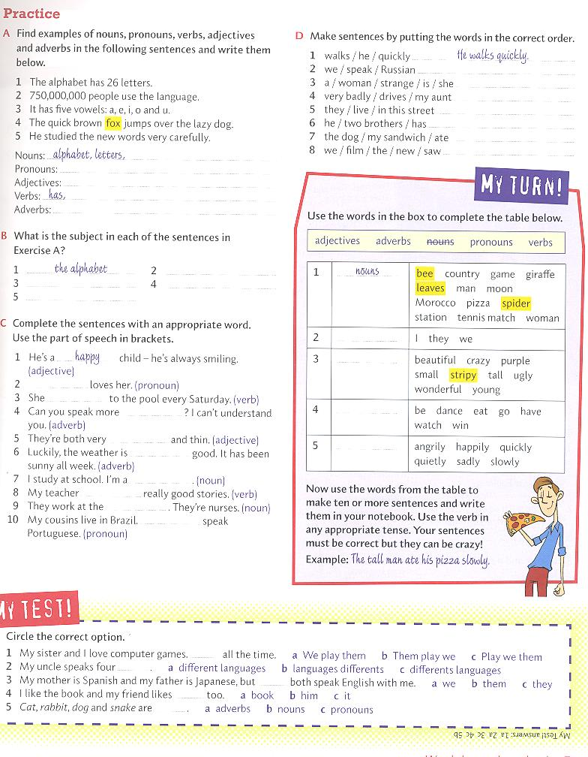

Answer key

Practice

A Nouns: people, language, vowels, fox, dog, words
Pronouns: it, he
Adjectives: quick, brown, lazy, new
Verbs: use, has, jumps, studied
Adverbs: very carefully

B 2 750,000,000 people, 3 It, 4 The quick brown fox, 5 He

C Possible answers

2 He, 3 goes / comes, 4 slowly, 5 tall, 6 very, 7 student, 8 tells, 9 hospital, 10 They

D 2 We speak Russian.
3 She is (‘s) a strange woman.
4 My aunt drives very badly.
5 They live in this street.
6 He has two brothers.
7 The dog ate my sandwich.
8 We saw the new film.

My Turn!

2 pronouns, 3 adjectives, 4 verbs, 5 adverbs

Possible answers

The ugly giraffe danced happily.
The beautiful woman watched the purple moon sadly.
The stripy spider went to Morocco slowly.
We won a crazy tennis match quickly.

