Non-verbal communication

Pre-reading

Thinking about the topic
1. Think of some examples of non-verbal communication. How can people communicate without using words?
2. Can you explain the difference between conscious and unconscious body language?
3. In what professions is non-verbal communication inevitable either to use or understand?

Reading

Body language
Humans use language to communicate, but we also communicate nonverbally with our bodies. The way in which we stand or sit, how we use our eyes, what we do with our hands, as well as what we wear - all of these convey powerful messages to other people. In fact, anthropologists claim that only a small percentage of what we communicate is verbal (about 7%); most of it is nonverbal (about 58%).
Some of our body language is conscious, such as the "thumbs up" gesture used in many cultures to signal "OK". But much of what we communicate with our bodies is unconscious. Even in one's own culture, unconscious body language can be difficult to read. Imagine, then, how much more incomprehensible the body language of someone from a different culture would be!

After reading

Answer the following questions:
1 With what parts of our bodies do we convey nonverbal messages?
2 What is conscious body language? Give an example.
3 What is unconscious body language? Think of an example.

Adapted from:
Espeseth, Miriam. Academic Encounters. Listening, Note Taking, and Discussion. Cambridge: CUP, 1999, pp. 86 – 87

Look at the diagram and find out how much of our communication non-verbal communication is. People trust more our body language than what we say.

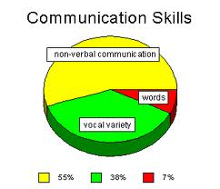

When Demosthenes was asked what was the first part of oratory he answered, "'action"; and which was the second, he replied, "action"; and which was third he still answered, "action."
See: http://ancienthistory.about.com/od/greekmenandwomen/p/Demosthenes.htm

People tend to believe actions more than words!
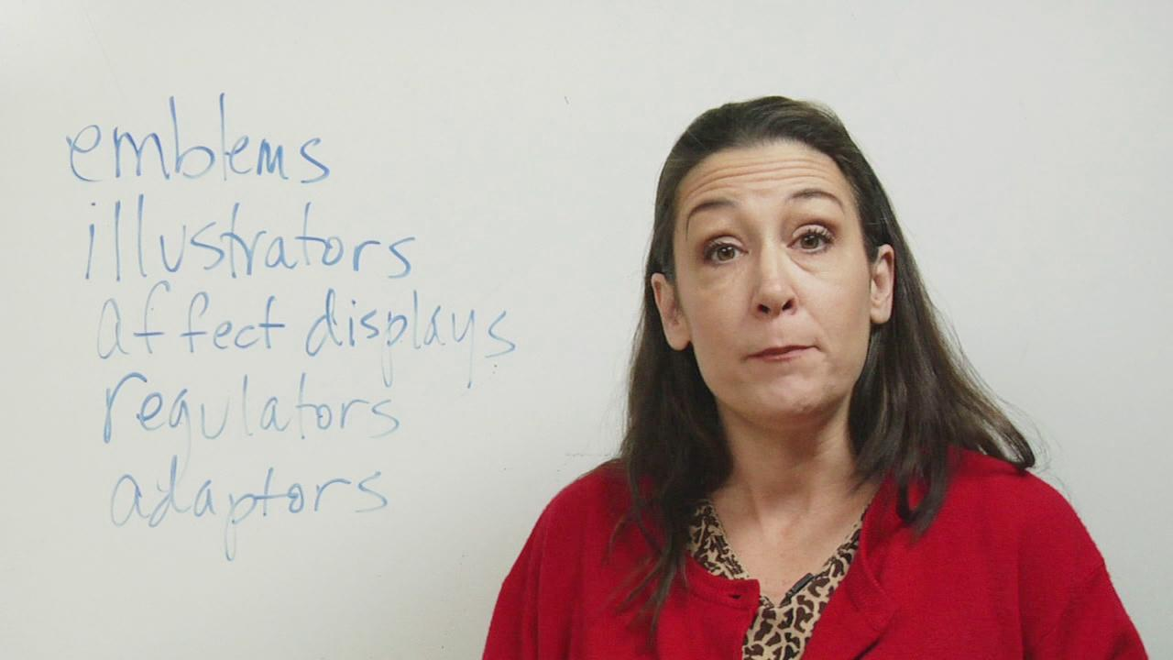
Today, many researchers are concerned with the information sent by communication that is independent of and different from verbal information; namely, the non-verbal communication. Verbal communication is organized by language; non-verbal communication is not.

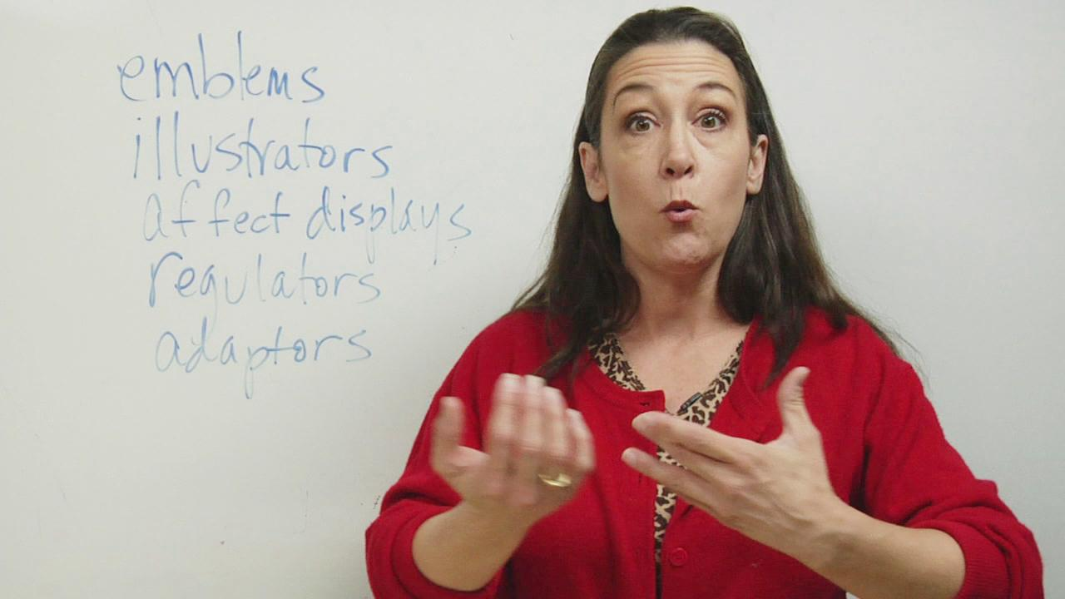
Communication is the transfer of information from one person to another. Most of us spend about 75 percent of our waking hours communicating our knowledge, thoughts, and ideas to others. However, most of us fail to realize that a great deal of our communication is of a non-verbal form as opposed to the oral and written forms. Non-verbal communication includes facial expressions, eye contact, tone of voice, body posture and motions, and positioning within groups. It may also include the way we wear our clothes or the silence we keep.
Facial expressions
A smile, frown, raised eyebrow, yawn, and sneer all convey information. Facial expressions continually change during interaction and are monitored constantly by the recipient. There is evidence that the meaning of these expressions may be similar across cultures.
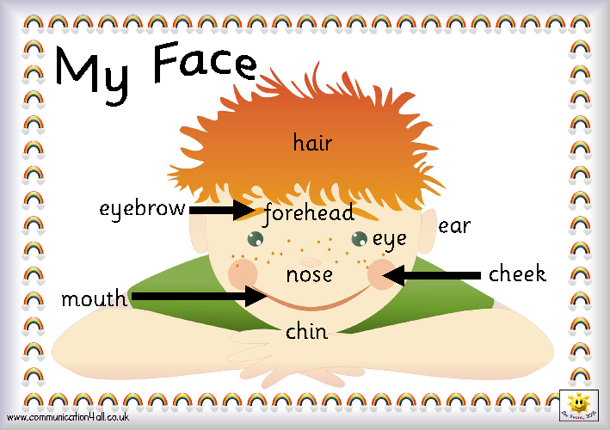
In the picture you can see a brief description of a face. Try to find the other parts:
eyelid, lips, nostrils
1 Watch the video about facial expressions. Before you start check if you understand the key words:

automatic reaction, be aware of, bewilderment, manipulate

http://www.ehow.com/video_4939833_nonverbal-communication-facial-expressions.html

What are the two things that your face communicates?

1

2

2 Watch the video and remember 3 techniques which are important not only for presentations.
They are a good example of effective body language.

http://www.bnet.com/videos/how-to-use-body-language-to-improve-your-presentation/162643

Write down the three techniques and take some more notes about each of them.
1.
2.
3.

