|  |  |
| --- | --- |
|  | **2014** |
|  | **University of Primorska, Faculty of Education Koper, Slovenia**    Nataša Dolenc Orbanić, Ph.D.  Petra Furlan |

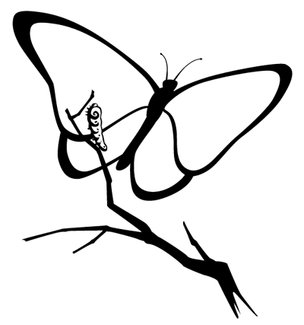

|  |
| --- |
| ***EXPLORING INSECTS*** |
|  |

***Engagement – What do you know about insects?***

Write a list of insects you have already known.

What do you think, how many different species of insects exist?

What do you think, which are common features of insects?

Where can we find insects?

Which are the body parts of insects?

How do insects developed?

What is the role of insects in the nature?

What do you want to know about insects?

***Exploring insects***

Find the common features of animals which you have in front of you and describe them. Discuss with your group colleagues.

***Exploring insects – body parts of grain beetle***

Precisely observe the grain beetle (use the magnifier). Fill in the boxes appropriate body parts: **the head** (eyes, antennae, mouth parts), **the thorax** (legs) and **the abdomen**.

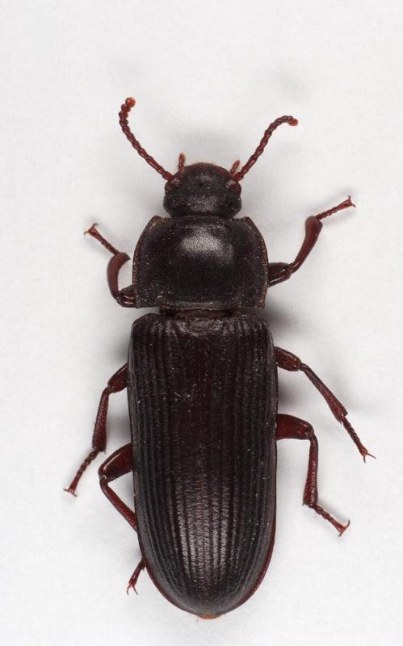 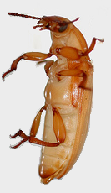

***Exploring insects – metamorphosis of grain beetle***

Observe, name and draw the various stages of life cycle. Describe them as precisely as possible.

Development stage: EGGS

Description:

Eggs are white and very small (1-1,5 mm). The eggs should hatch within 1-2 weeks.

Development stage: ___________________

Description:

Development stage: ___________________

Description:

Development stage: ___________________

Description:

***Exploring insects – metamorphosis of grain beetle***

Complete the scheme which represent the life cycle of grain beetle.

***Exploring insects – body parts of stick insect***

Precisely observe the stick insect (use the magnifier). Fill in the boxes appropriate body parts: **the head** (eyes, antennae, mouth parts), **the thorax** (legs) and **the abdomen**.

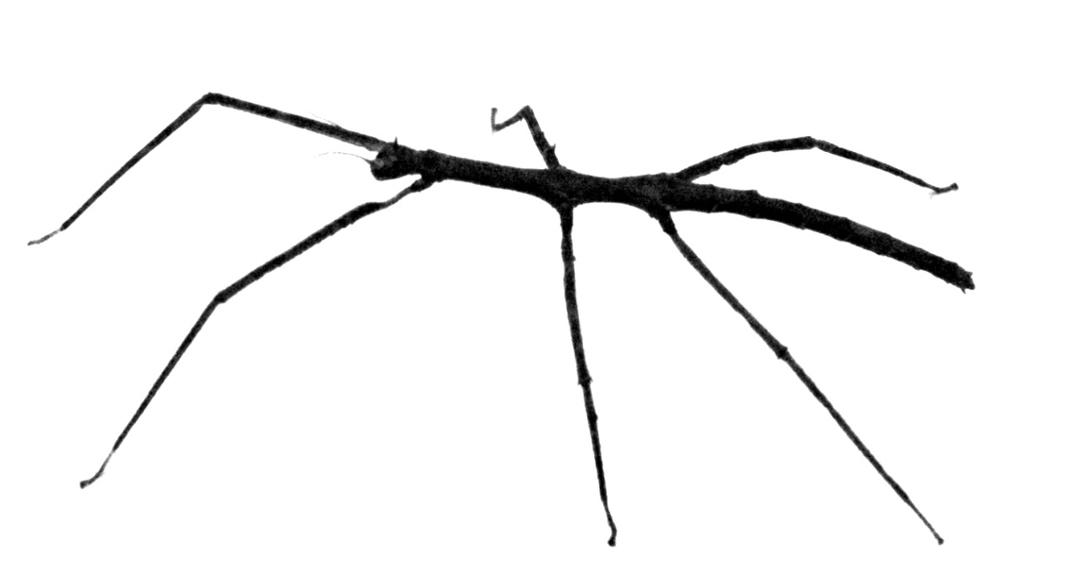

***Exploring insects – metamorphosis of stick insect***

Observe, name and draw the various stages of life cycle. Describe them as precisely as possible.

Development stage: EGGS

Description:

Eggs are small (5 mm). The eggs should hatch within 3 - 4 weeks.

Development stage: ___________________

Description:

Development stage: ___________________

Description:

***Exploring insects – metamorphosis of stick insect***

Complete the scheme which represent the life cycle of stick insect.

***Elaboration – Are they insects or not?***

Go to the meadow and catch some animals. Pay attention to allergies, animal bites and stings! Place the animals in the container and observe them with the magnifier.

Which of them are insects? Discuss your decision with your group colleague. Draw the animals in the appropriate box.

INSECTS: NOT INSECTS:

***Evaluation*** ***– What was the most interesting thing have you learned about insects?***