Current problems in the world

1. Look at the pictures and try to identify the current problems being presented:

A B
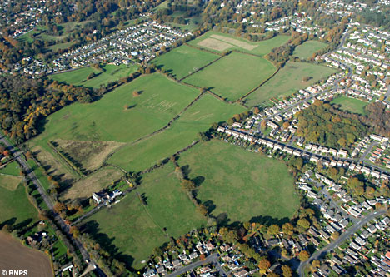

C D
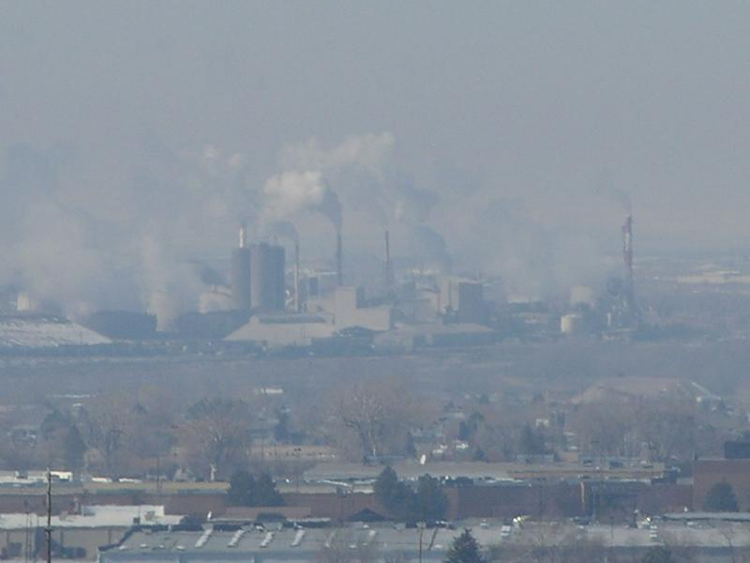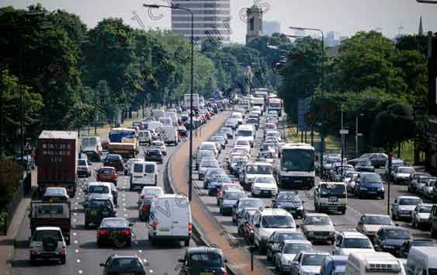
E F

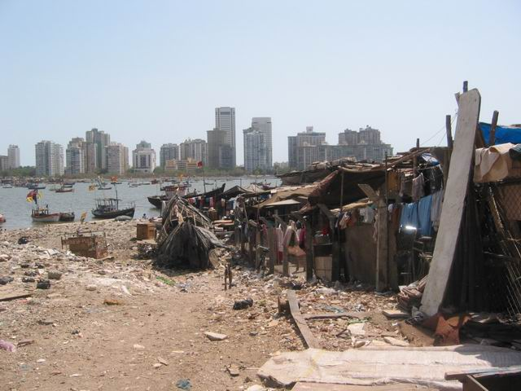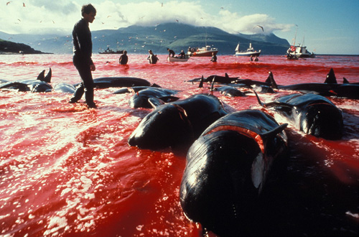

2. Match the following sentences with the pictures.

1) Poverty is a problem in all parts of the world.
2) Air pollution has reached extremely high levels in some countries.
3) Unemployment is hitting some industrialized countries badly.
4) Wildlife is under threat from human activity.
5) Green belt areas are being destroyed at an alarming rate.
6) Cars are bringing the big cities of the world to a standstill.

3. Discussion

1) Can you think of any other serious 21st century problems which were not mentioned?
2) Which of the issues seem to be the most alarming to you? Why?
3) Imagine that you have the power to change anything in the world. What 6 things would you do to make the world a better place for living? Write your ideas down.
1)
2)

4)
3)

6)
5)

4. Vocabulary Practice

A) Complete each sentence with a word from the list.

conservation disaster earthquake famine
floods invasion rubbish slums

1 Food rations are sent to regions in Africa suffering from _______________ .
2 Many Australian Aborigines live in overcrowded ______________ on the edge of the city.
3 Thousands of buildings collapsed down during a severe _________________ .
4 The ___________ of Timor (Indonesia) was condemned by the United Nations in 1999.
5 The eruption of the volcano was a terrible _________________ .
6 Hundreds of people drowned during the ________________ in China.
7 Large cities face the problem of household ________________ disposal.
8 The act of protecting animals or parts of the environment is called _______005F_______ .

B) Match the following expressions with their definitions:

immigrant brain drain asylum seeker bribery

refugee homeless xenophobia volunteer

...................................... – someone who leaves their native country and goes to live to another country, expecting improvement of the quality of their lives
..................................... - fear and hatred of strangers or foreigners or of anything that is strange or foreign
..................................... – someone who is outside his country of nationality and has fear of persecution because of his race, religion, nationality, membership in a particular social group or political opinion
.................................... – the act of giving some benefits (e.g. money) in order to influence the judgment or action of a person in a position of power
.................................... – someone who has made a claim that he is a refugee and is awaiting the determination (rozhodnutí, stanovení) of his status
............................................. - the act of emigration of a large number of a country's highly skilled and educated people to countries where they can find better economic and social opportunities
.......................................... – someone who lacks permanent place of residence
........................................ – someone who is willing to help other people and doesn’t expect any reward or payment for his help

