Topic 2 – Vocabulary Practice

Print out the following material and fill in the missing expressions:

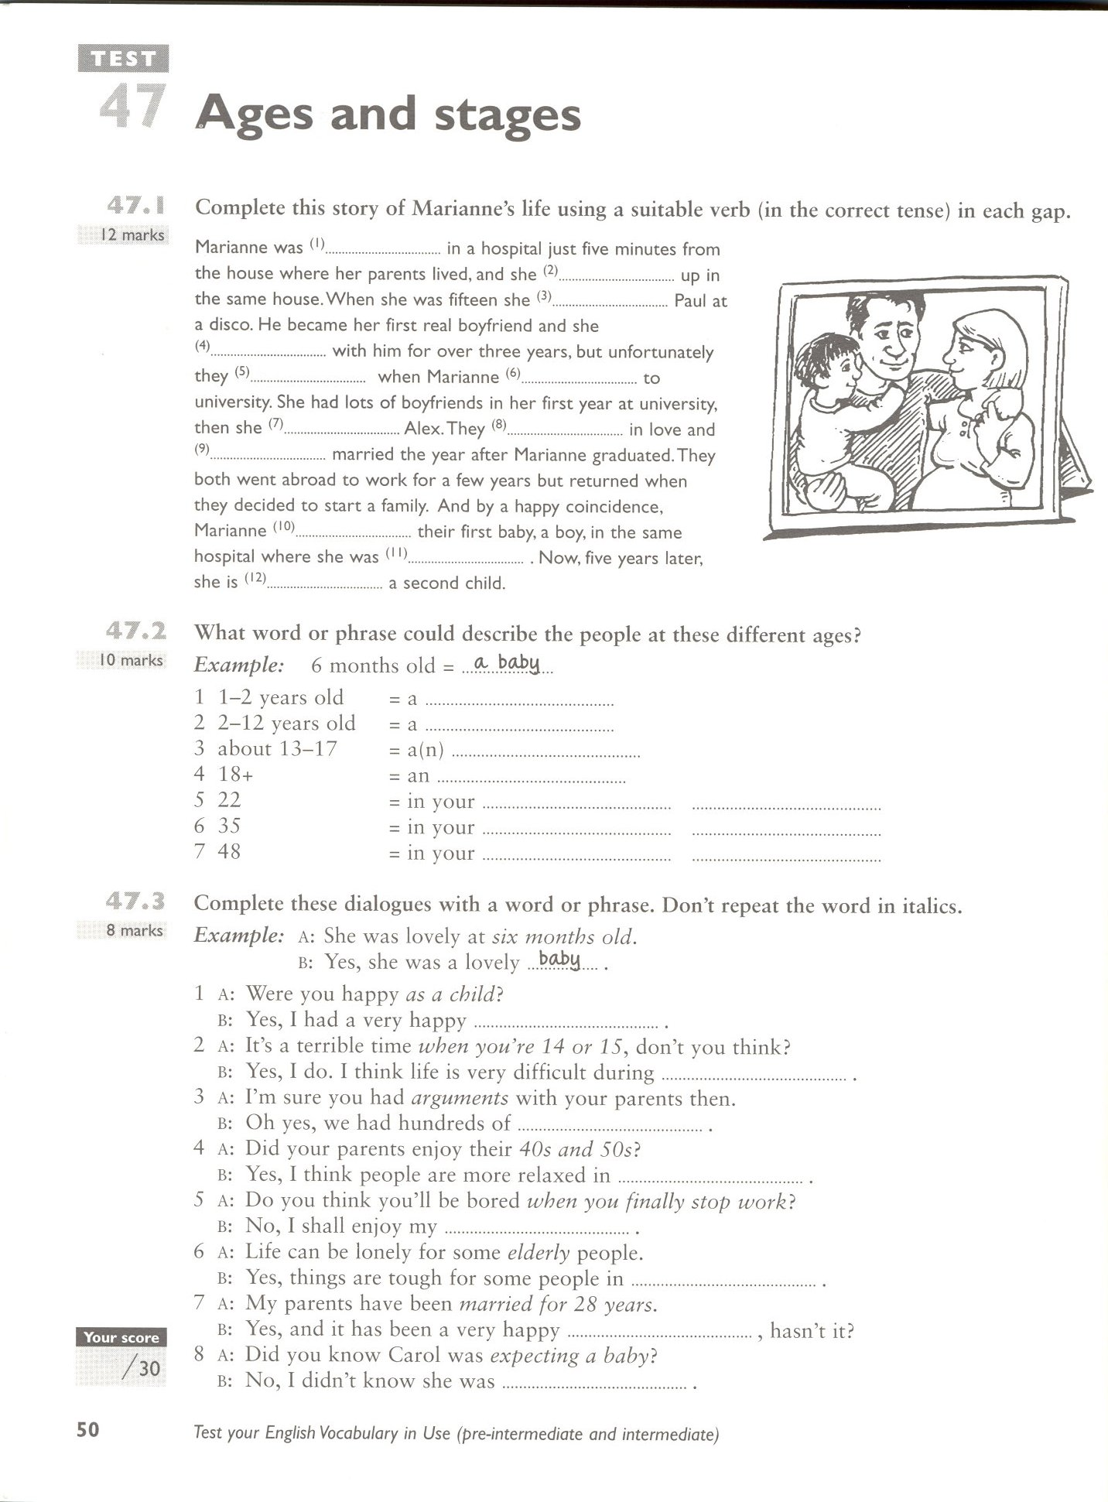

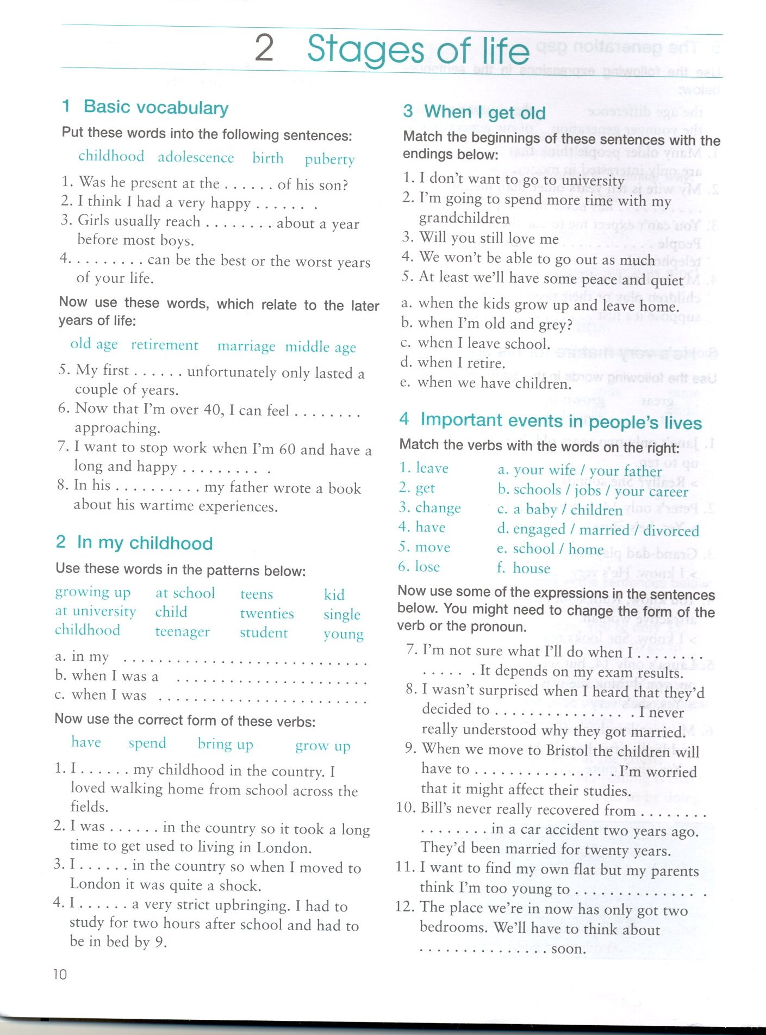

Taken from:
Gough,Chris. English Vocabulary Organiser. Hove:LTP, 2001

