Topic 2 - Interpersonal Relationships

Study the following vocabulary and make sure that you understand all of them before attending consultation 2:
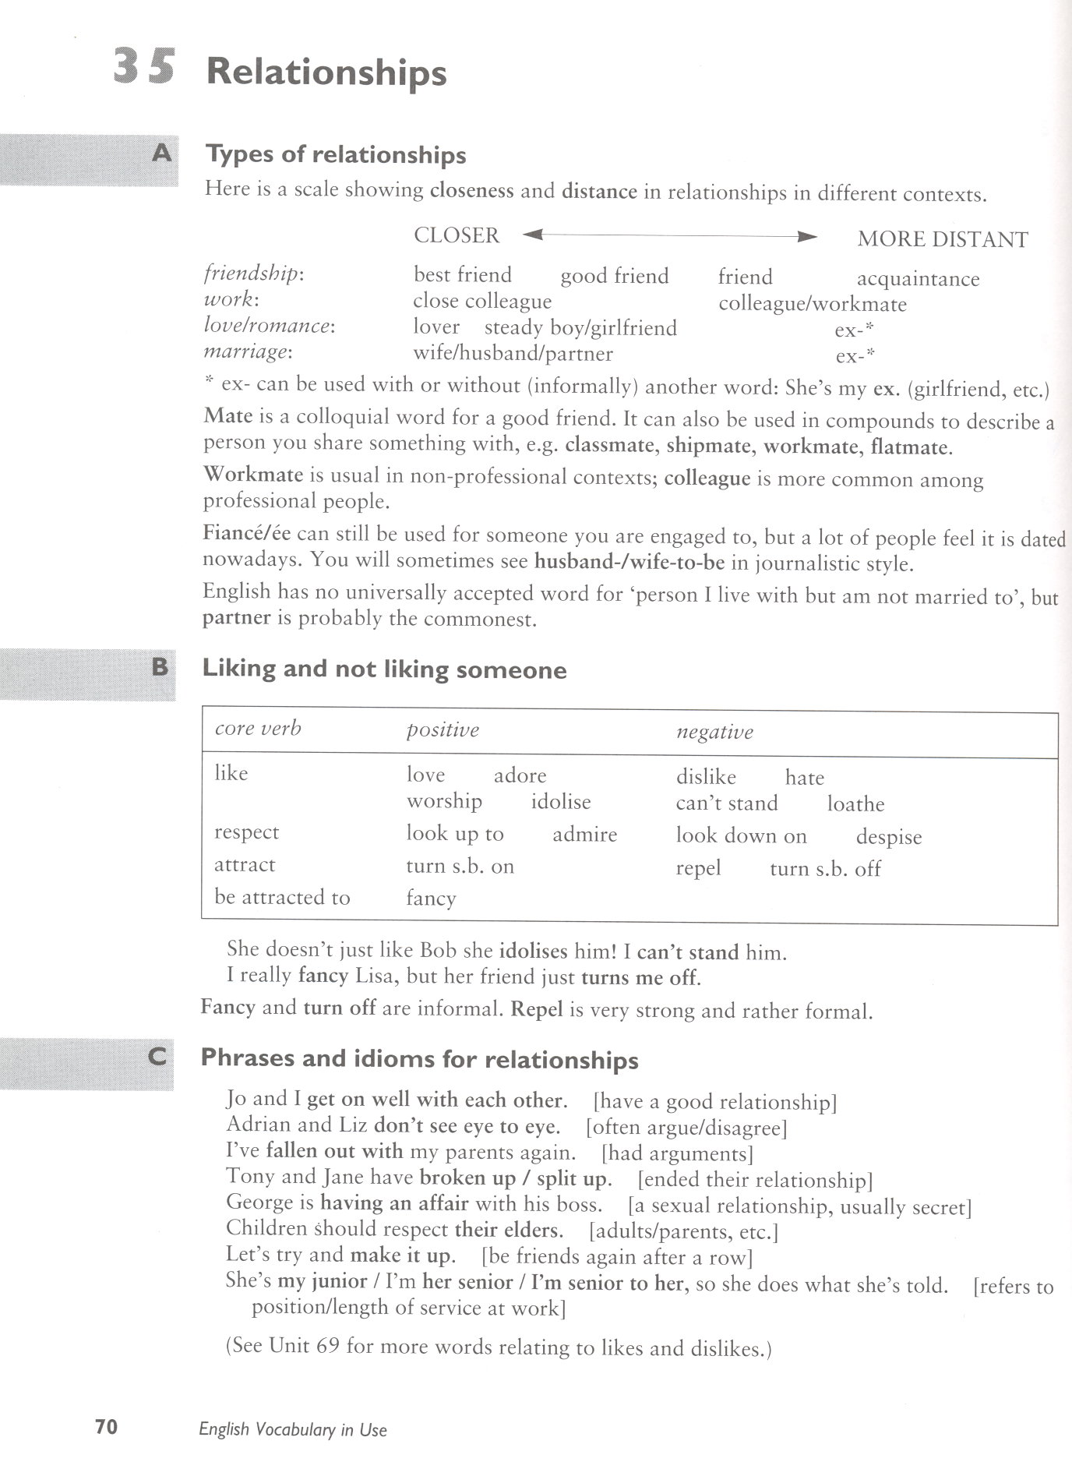

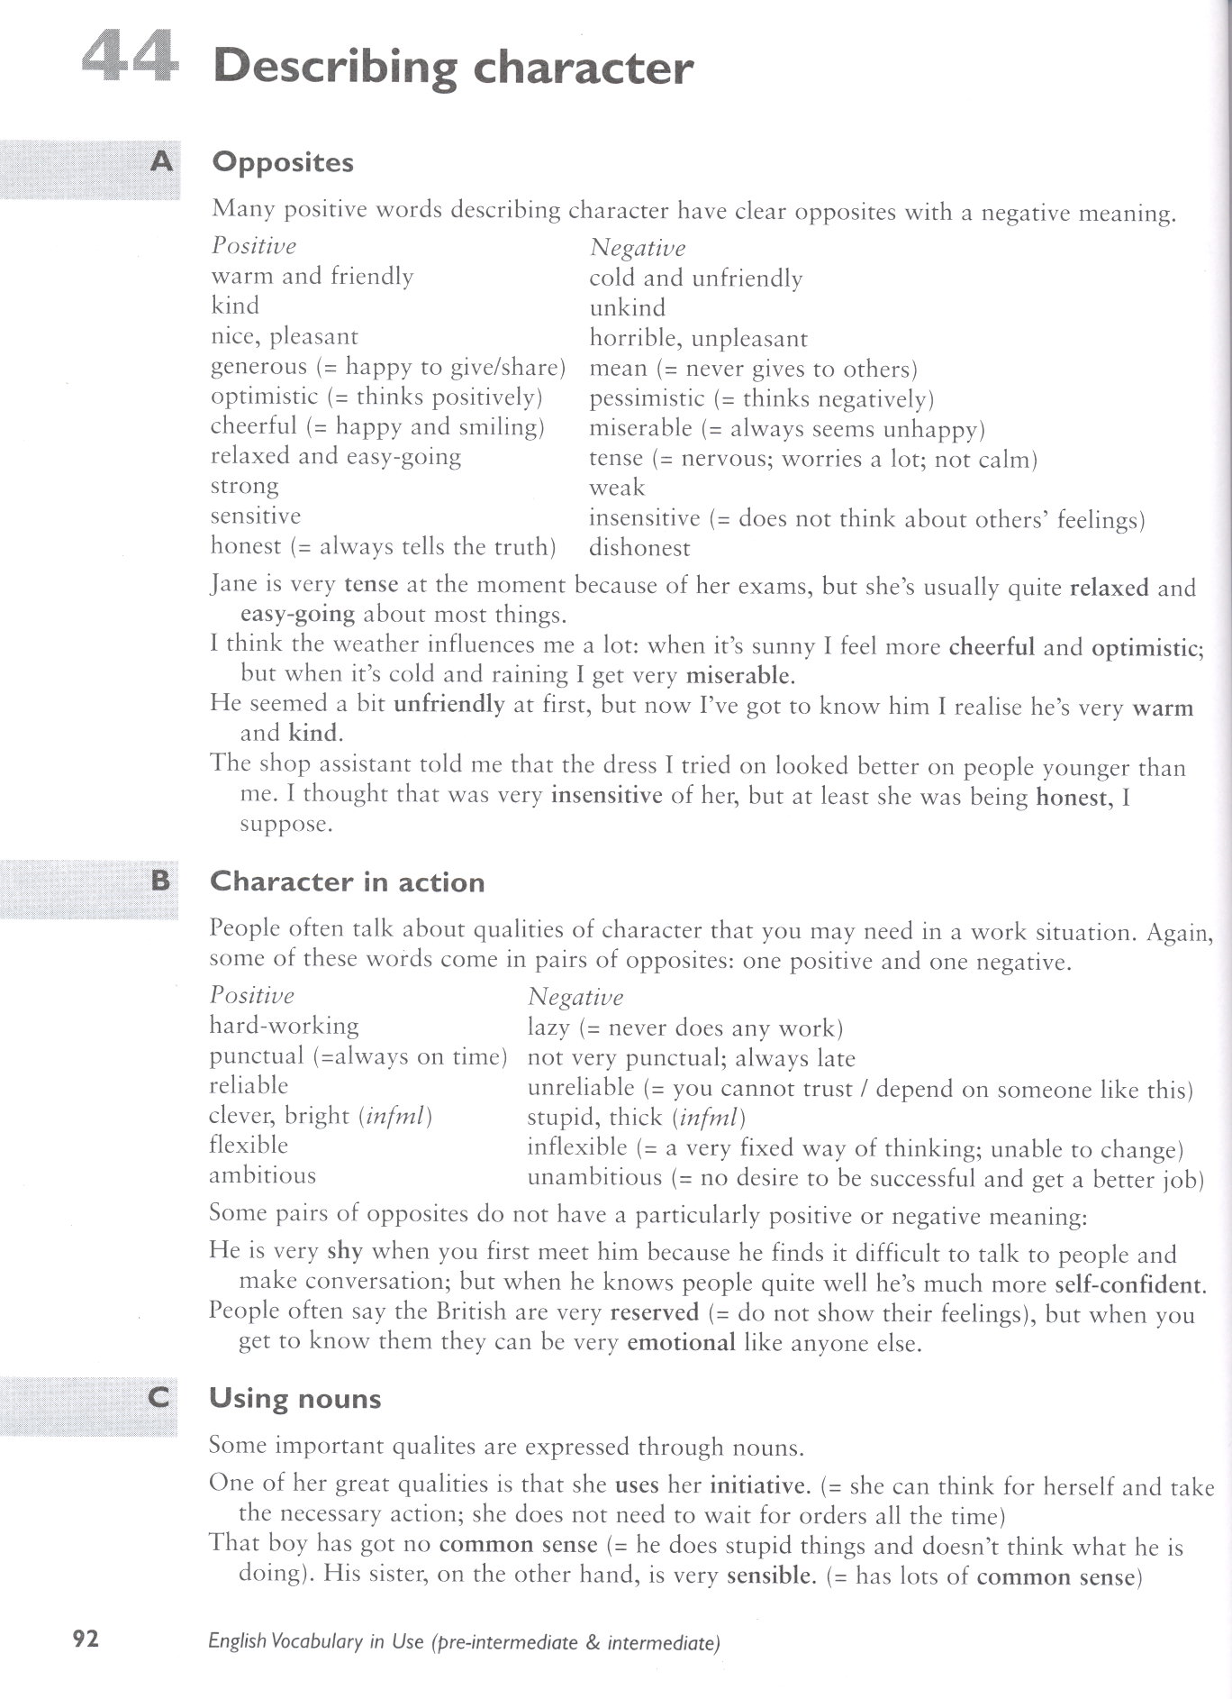

Taken from: Redman, S. English Vocabulary in Use (pre-intermediate+intermediate). Cambridge: CUP, 2000

