Reading techniques

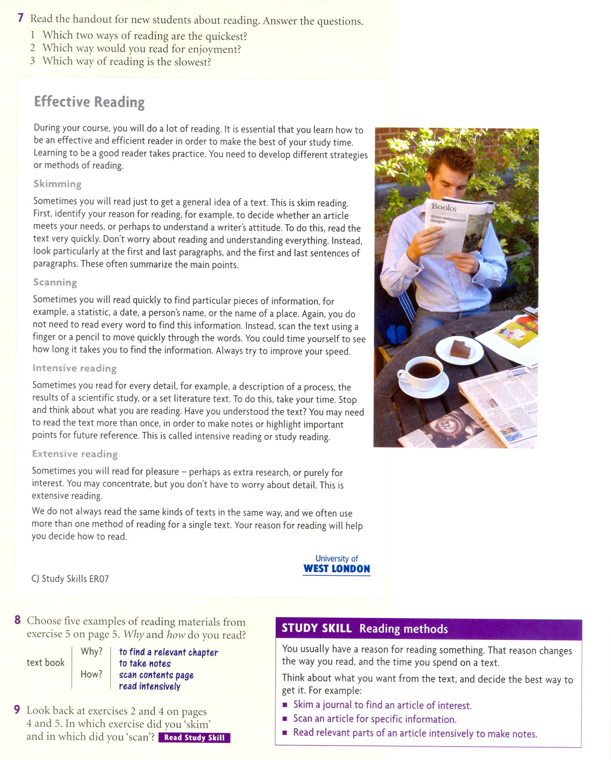

Taken and adapted from:
Philpot,Sarah. Academic Skills. Level 2. Oxford: OUP, 2006. ISBN 978-0-19-471567-6

