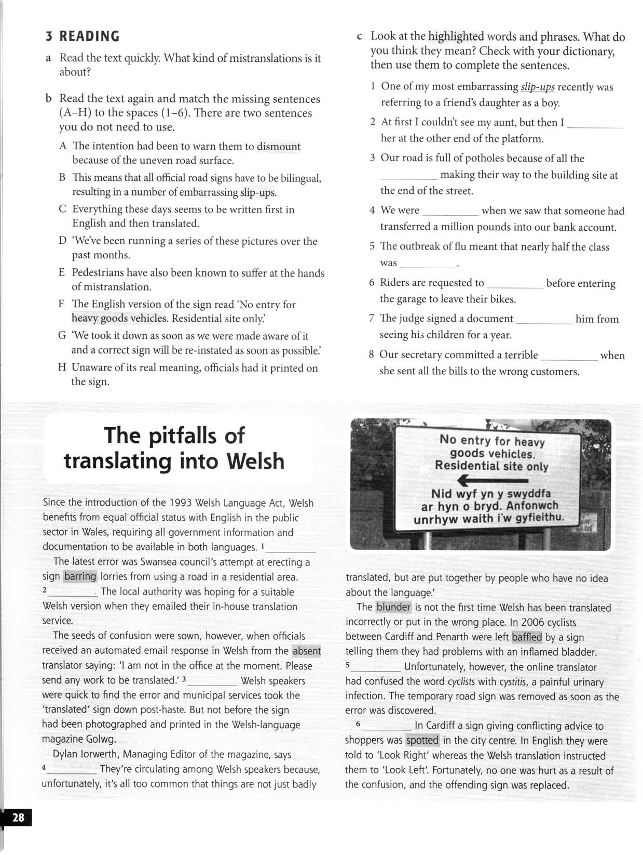
KEY: 1B, 2F, 3H, 4D, 5A, 6E || 2 spotted, 3 heavy goods vehicles, 4 baffled, 5 absent, 6 dismount, 7 barring, 8 blunder

