R. Queneau (1903-1976), a French writer: novels, poems, stories, essays; fascinated by language and its structure, and maths; “Exercices de style” (1981) = 99 chapters, presenting one and the same motif in various styles and genres.

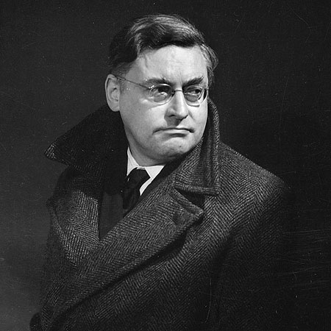

Lexical support: Exercises in Style by Raymond Queneau
Surprises | fop= floutek | sarˈtorial = krejčovský
Dream | nacreous / ˈneɪkrɪəs/=perleťový | multiˈfarious= četný | apparition= zjevení
Hesitation | / tʃ/charnel-house= márnice | adiˈposity= tučnost | adˈversaries= protivníci
The subjective side | aˈttire= oděv | lapels= klopy | headgear= cokoli na hlavě| ˌhoi ˈpolloi=spodina, plebs
Another subj. | dogs= nohy
Blurb | brio= zápal, žár | sarˈtorial = krejčovský | etch= dosl. vyrýt
Exclamations | yammer= reptat
You know | rave= zuřit
Asides | viˈtuperate= spílat

The following are suggestions for the use of tones:

subjective side: narrative; depends on the feelings of the speaker
blurb: narrative, mostly ↘, positive feeling
logical analysis: all facts, ↘

surprise: a lot of ! → high pitch, a lot of ↘
exclamations: all ! “ “ “

dream: narrative; slow, pauses, hesitation
hesitation: lots of ? → ↗ (this means “uncertainty”)
ignorance: emotional; a range of ↘, ↗, \/
you know: typical \/
asides: parantheses (thoughts to oneself); change of pitch & loudness, often \/

