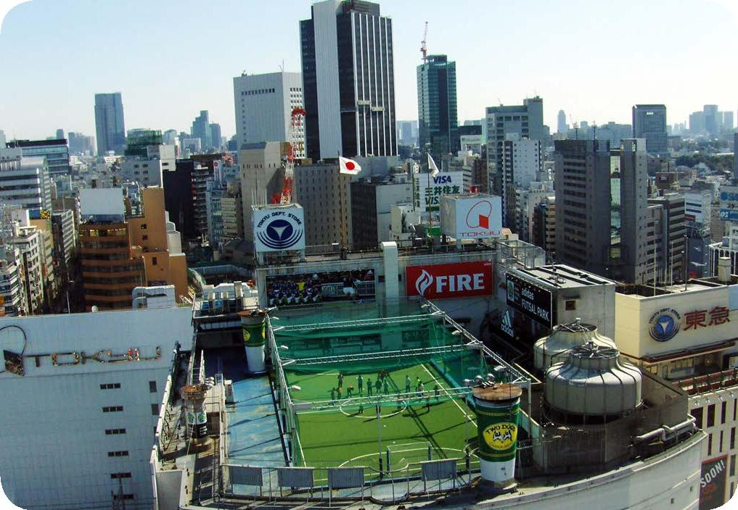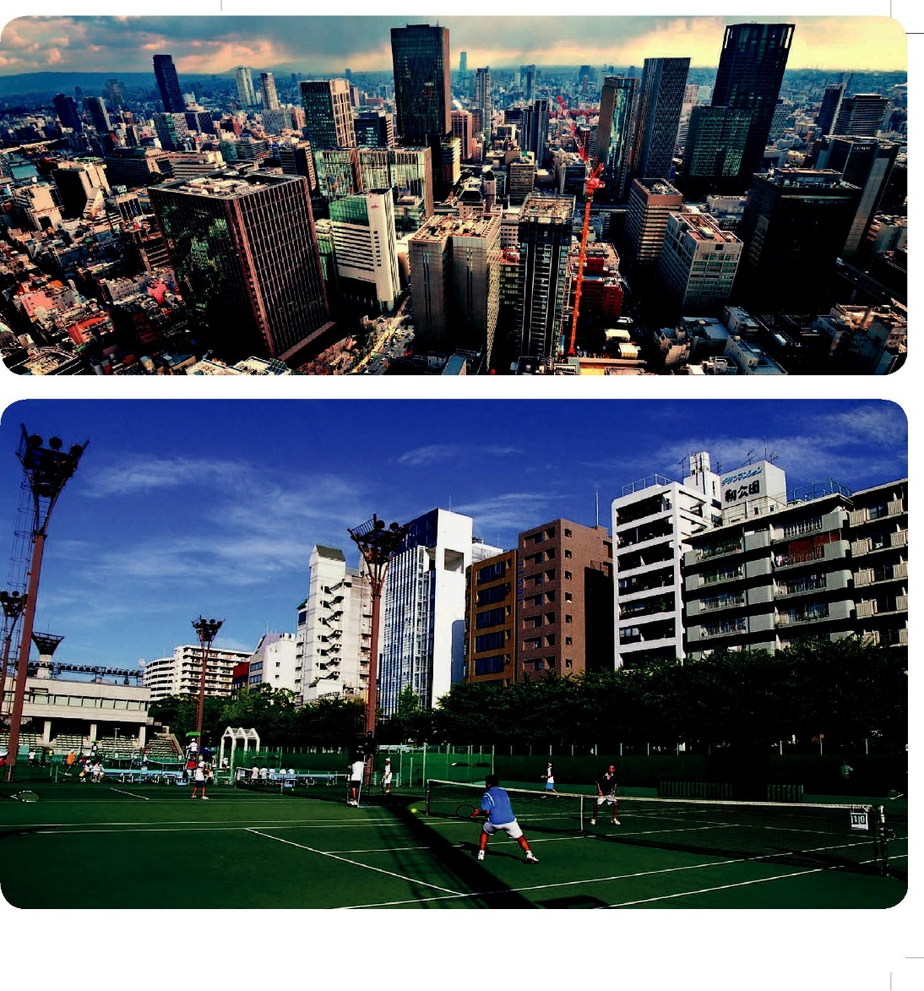Obr. 1 Obr. 2

Obr. 3 Obr. 4

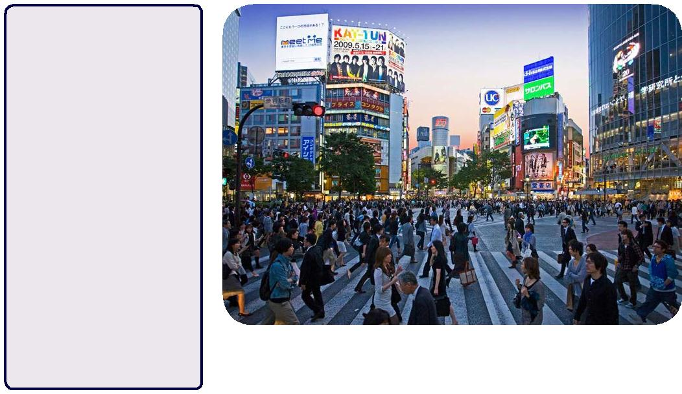

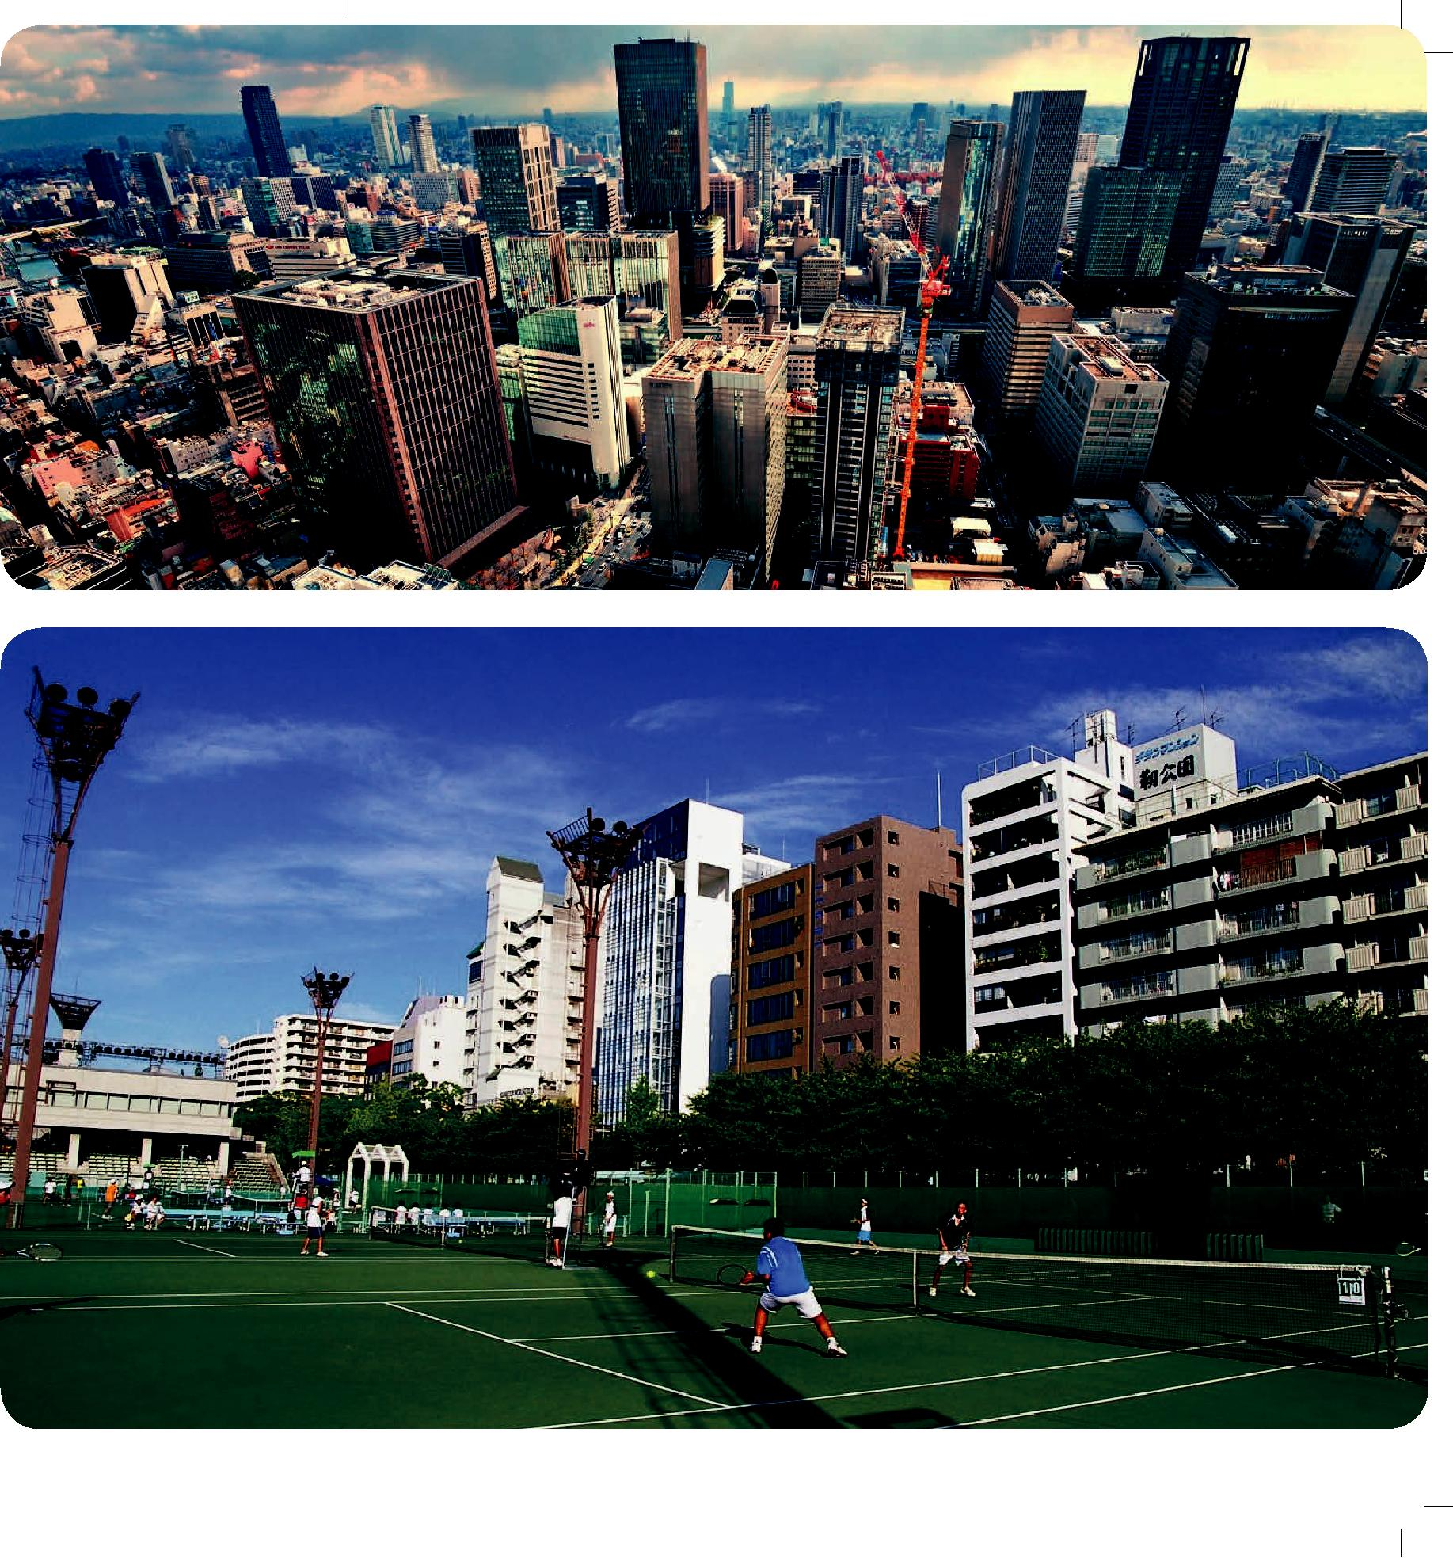

Obr. 5 Obr. 6

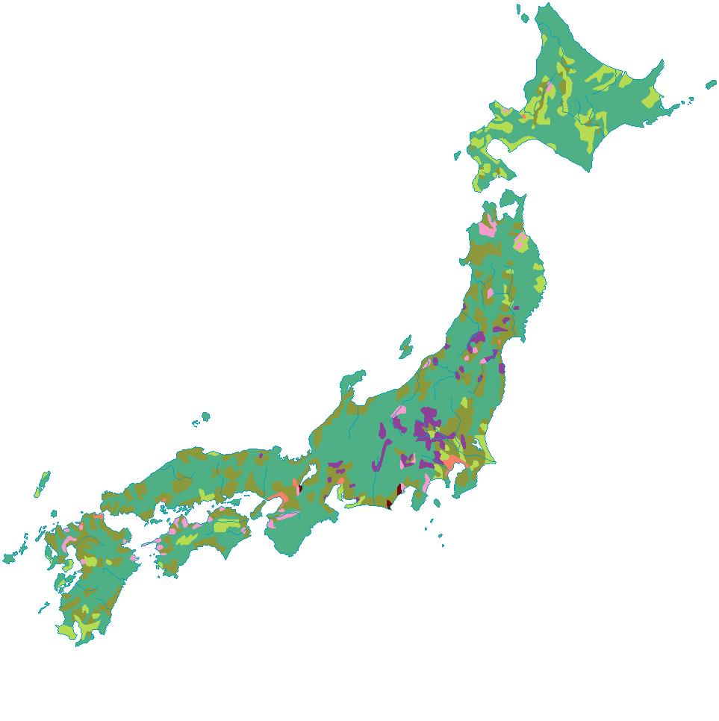

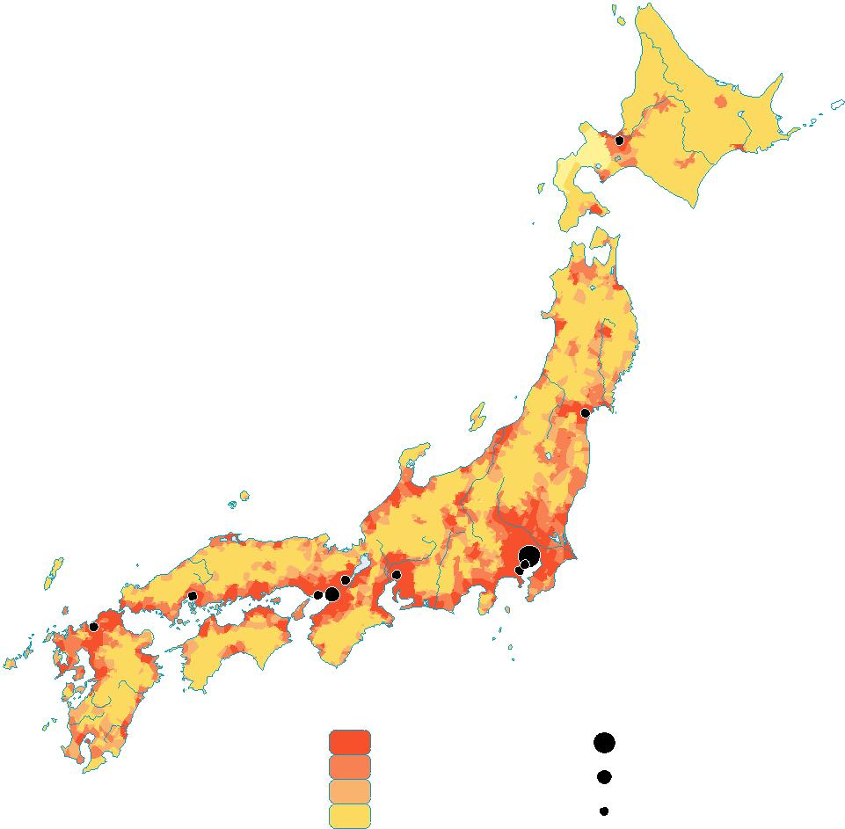

**Hustota obyvatelstva**

**Využití krajiny**

 Rýže  Lesy

 Čaj  Zástavba

 Moruše  Horské oblasti

 Sady

|  |  |  |  |  |
| --- | --- | --- | --- | --- |
|  |  |  | Sendai |  |
|  |  | **Tßkyß** |  |  |
| Kyßto | | Nagoya |  |  |
| Hiroshima |  | Yokohama | Kawasaki |  |
| Kßbe | **ªsaka** | |  |  |
| Fukuoka |  |  |
|  |  |  |  |
|  | **Počet osob na km2** | | Města |  |
|  |  | vice než 250 | over 25 000 000 |  |
|  |  | 100 – 250 | 10 000 000 – 25 000 000 |  |
|  |  | 10 – 100 |  |
|  |  | 1 000 000 – 10 000 000 |  |
|  |  | 0 – 10 |  |

Obr. 7 Obr. 8 Obr. 9

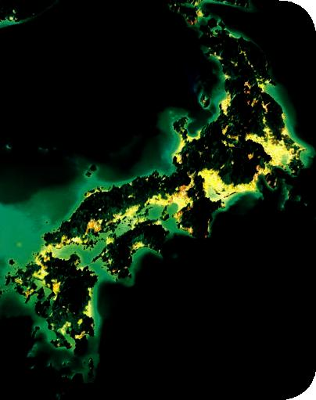 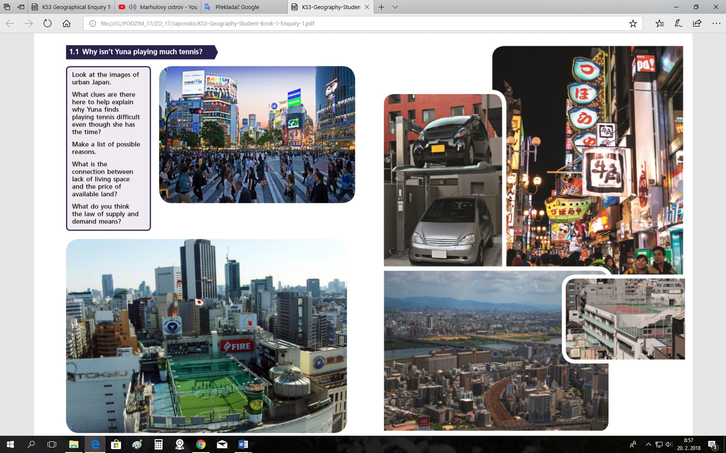 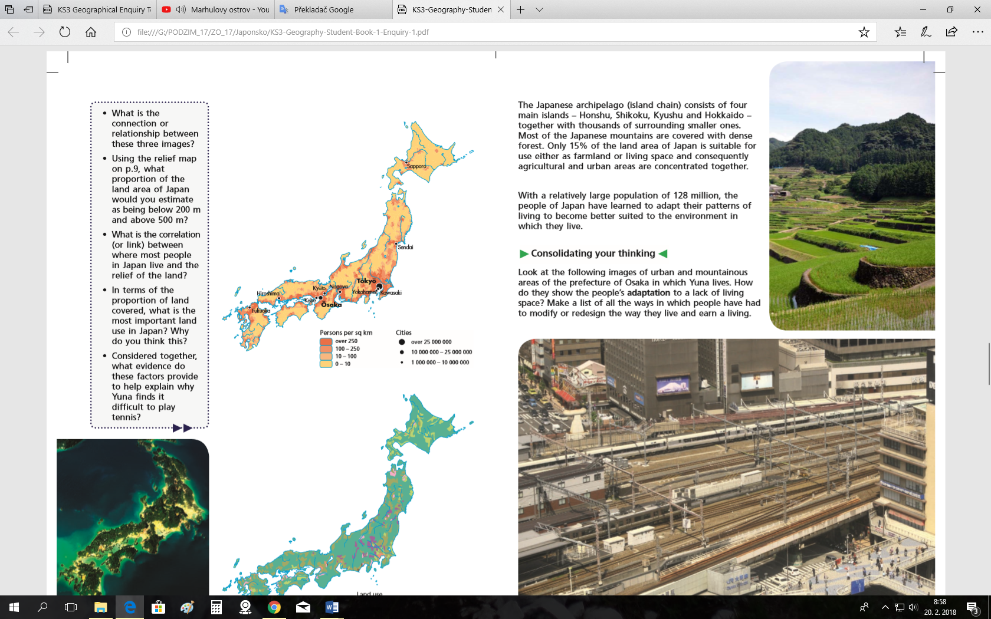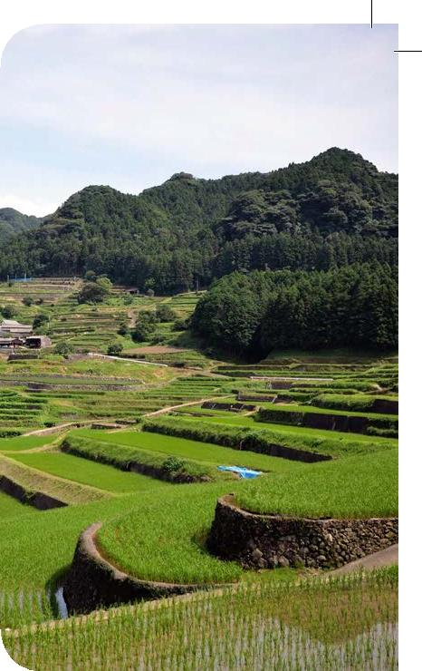

Obr. 10



Obr. 11 Obr. 12

|  |  |
| --- | --- |
| https://img.ihned.cz/attachment.php/460/37390460/iou38CEF7GJLN6PQchpqrxyz01Uw29Vn/1000x635x10e4/TOK104_JAPAN-TSUNAMI-_0307_11A.jpg | https://img.ihned.cz/attachment.php/560/37390560/aostu348BF7GHKMjl6Wcehpx0SUw29AR/1000x696x9bbd/TOK110_JAPAN-TSUNAMI-_0307_11A.jpg |