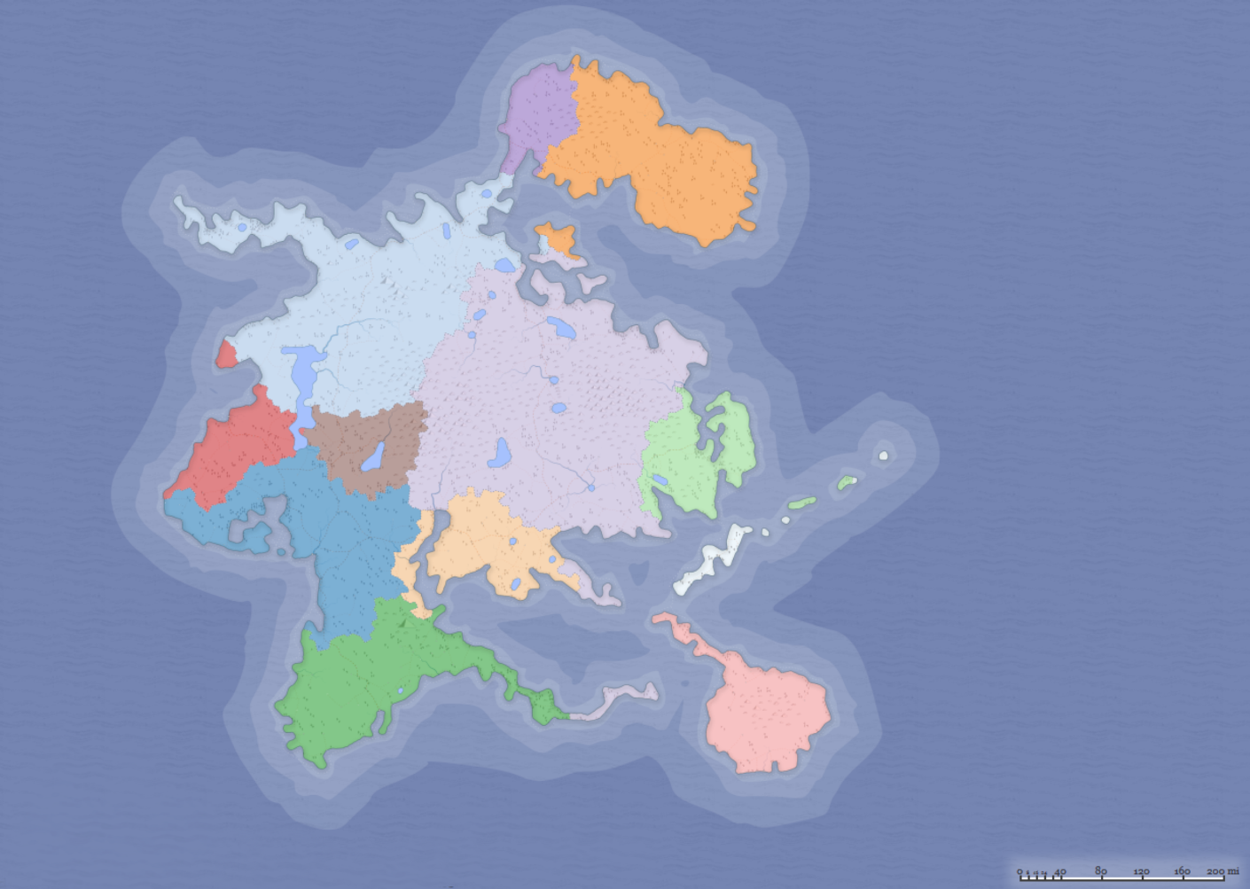**Our country is called:**

This is our flag:

The country was founded in by

The country is known for

is/are exported from the country.

is/are imported in the country.

**CURRENT situation of our country:**

|  |  |  |  |
| --- | --- | --- | --- |
| Silhouette, Nuclear Power Plant, Power PlantUranium is now mined  in your country | Anvil, Blacksmith, Iron, Metalwork, Ironwork, ForgeIRON ORE is now mined  in your country | Rice, Chopsticks, Bowl, Food, Chinese, Dish, AsianRICE is now GROWN  in your country | Rice, Chopsticks, Bowl, Food, Chinese, Dish, AsianRICE is now GROWN  in your country |
| Fruit, Fruit Bowl, Fruits, Shell, Healthy, Bananamany types of fruit are now GROWN  in your country | Cogwheel, Gear, Gearwheel, Cog, Options, SettingsVarious machines and devices are now made in your country | Www, Internet, Computer, Business, Communication Advanced technology is now developed in your country | Www, Internet, Computer, Business, Communication Advanced technology is now developed in your country |
| Silhouette, Nuclear Power Plant, Power PlantUranium is now mined  in your country | Anvil, Blacksmith, Iron, Metalwork, Ironwork, ForgeIRON ORE is now mined  in your country | Rice, Chopsticks, Bowl, Food, Chinese, Dish, AsianRICE is now GROWN  in your country | Silhouette, Nuclear Power Plant, Power PlantUranium is now mined  in your country |
| Fruit, Fruit Bowl, Fruits, Shell, Healthy, Bananamany types of fruit are now GROWN  in your country | Cogwheel, Gear, Gearwheel, Cog, Options, SettingsVarious machines and devices are now made in your country | Www, Internet, Computer, Business, Communication Advanced technology is now developed in your country | Fruit, Fruit Bowl, Fruits, Shell, Healthy, Bananamany types of fruit are now GROWN  in your country |
| Silhouette, Nuclear Power Plant, Power PlantUranium is now mined  in your country | Anvil, Blacksmith, Iron, Metalwork, Ironwork, ForgeIRON ORE is now mined  in your country | Rice, Chopsticks, Bowl, Food, Chinese, Dish, AsianRICE is now GROWN  in your country | Anvil, Blacksmith, Iron, Metalwork, Ironwork, ForgeIRON ORE is now mined  in your country |
| Fruit, Fruit Bowl, Fruits, Shell, Healthy, Bananamany types of fruit are now GROWN  in your country | Cogwheel, Gear, Gearwheel, Cog, Options, SettingsVarious machines and devices are now made in your country | Www, Internet, Computer, Business, Communication Advanced technology is now developed in your country | Cogwheel, Gear, Gearwheel, Cog, Options, SettingsVarious machines and devices are now made in your country |

|  |  |  |  |  |
| --- | --- | --- | --- | --- |
| Silhouette, Nuclear Power Plant, Power Plant | Cogwheel, Gear, Gearwheel, Cog, Options, Settings | Www, Internet, Computer, Business, Communication | Cogwheel, Gear, Gearwheel, Cog, Options, Settings | Anvil, Blacksmith, Iron, Metalwork, Ironwork, Forge |
| Rice, Chopsticks, Bowl, Food, Chinese, Dish, Asian | Rice, Chopsticks, Bowl, Food, Chinese, Dish, Asian | Fruit, Fruit Bowl, Fruits, Shell, Healthy, Banana | Anvil, Blacksmith, Iron, Metalwork, Ironwork, Forge | Fruit, Fruit Bowl, Fruits, Shell, Healthy, Banana |
| Silhouette, Nuclear Power Plant, Power Plant | Cogwheel, Gear, Gearwheel, Cog, Options, Settings | Www, Internet, Computer, Business, Communication | Cogwheel, Gear, Gearwheel, Cog, Options, Settings | Anvil, Blacksmith, Iron, Metalwork, Ironwork, Forge |
| Rice, Chopsticks, Bowl, Food, Chinese, Dish, Asian | Rice, Chopsticks, Bowl, Food, Chinese, Dish, Asian | Fruit, Fruit Bowl, Fruits, Shell, Healthy, Banana | Anvil, Blacksmith, Iron, Metalwork, Ironwork, Forge | Fruit, Fruit Bowl, Fruits, Shell, Healthy, Banana |
| Silhouette, Nuclear Power Plant, Power Plant | Cogwheel, Gear, Gearwheel, Cog, Options, Settings | Www, Internet, Computer, Business, Communication | Cogwheel, Gear, Gearwheel, Cog, Options, Settings | Anvil, Blacksmith, Iron, Metalwork, Ironwork, Forge |
| Rice, Chopsticks, Bowl, Food, Chinese, Dish, Asian | Rice, Chopsticks, Bowl, Food, Chinese, Dish, Asian | Fruit, Fruit Bowl, Fruits, Shell, Healthy, Banana | Anvil, Blacksmith, Iron, Metalwork, Ironwork, Forge | Fruit, Fruit Bowl, Fruits, Shell, Healthy, Banana |
| Silhouette, Nuclear Power Plant, Power Plant | Cogwheel, Gear, Gearwheel, Cog, Options, Settings | Www, Internet, Computer, Business, Communication | Cogwheel, Gear, Gearwheel, Cog, Options, Settings | Anvil, Blacksmith, Iron, Metalwork, Ironwork, Forge |
| Rice, Chopsticks, Bowl, Food, Chinese, Dish, Asian | Rice, Chopsticks, Bowl, Food, Chinese, Dish, Asian | Fruit, Fruit Bowl, Fruits, Shell, Healthy, Banana | Anvil, Blacksmith, Iron, Metalwork, Ironwork, Forge | Fruit, Fruit Bowl, Fruits, Shell, Healthy, Banana |

|  |  |  |  |
| --- | --- | --- | --- |
| Artillery Tank Gun Military Vehicle War MiArmy token | Artillery Tank Gun Military Vehicle War MiArmy token | Artillery Tank Gun Military Vehicle War MiArmy token | Artillery Tank Gun Military Vehicle War MiArmy token |
| Artillery Tank Gun Military Vehicle War MiArmy token | Artillery Tank Gun Military Vehicle War MiArmy token | Artillery Tank Gun Military Vehicle War MiArmy token | Artillery Tank Gun Military Vehicle War MiArmy token |
| Artillery Tank Gun Military Vehicle War MiArmy token | Artillery Tank Gun Military Vehicle War MiArmy token | Artillery Tank Gun Military Vehicle War MiArmy token | Artillery Tank Gun Military Vehicle War MiArmy token |
| Artillery Tank Gun Military Vehicle War MiArmy token | Artillery Tank Gun Military Vehicle War MiArmy token | Artillery Tank Gun Military Vehicle War MiArmy token | Artillery Tank Gun Military Vehicle War MiArmy token |
| Artillery Tank Gun Military Vehicle War MiArmy token | Artillery Tank Gun Military Vehicle War MiArmy token | Artillery Tank Gun Military Vehicle War MiArmy token | Artillery Tank Gun Military Vehicle War MiArmy token |
| Artillery Tank Gun Military Vehicle War MiArmy token | Artillery Tank Gun Military Vehicle War MiArmy token | Artillery Tank Gun Military Vehicle War MiArmy token | Artillery Tank Gun Military Vehicle War MiArmy token |

**Common Projects   
(You can invest in the same project more than once)**

|  |
| --- |
| Silhouette, Nuclear Power Plant, Power PlantOpen new uranium mines  COST: -2 machines, -1 iron, -1 Food (rice or fruit)  EFFECT: +1 Uranium is mined in your country |
| Anvil, Blacksmith, Iron, Metalwork, Ironwork, ForgeOpen new iron mines  COST: -1 machine, -2 Food (rice or fruit)  EFFECT: +1 IRON ORE is mined in your country |
| Cogwheel, Gear, Gearwheel, Cog, Options, Settingsbuild a new factory  COST: -2 iron, -2 Food (rice or fruit)  EFFECT: +1 machines and devices are made in your country |
| Www, Internet, Computer, Business, Communicationfound a new IT company  COST: -2 machines, -1 rice, -1 fruit  EFFECT: +1 Advanced technology is developed in your country |
| Fruit, Fruit Bowl, Fruits, Shell, Healthy, BananaPLANT more fruit trees  COST: -1 IRON, -1 machine  EFFECT: +1 fruit is grown in your country |
| Rice, Chopsticks, Bowl, Food, Chinese, Dish, Asiancreate more rice paddies  COST: -2 IRON  EFFECT: +1 rice is grown in your country |
| Artillery Tank Gun Military Vehicle War Mirecruit more soldiers  COST: -2 IRON, -2 machines, -2 Food (rice or fruit)  EFFECT: +1 army token |

**When You pay for one of these projects, you will get   
1 factory, MINE, Company, FIELD, orchard. Put it in your poster so everybody knows it!**

**You can also get some army tokens (do not show it to your enemies)!**

**Special Projects   
(You cannot invest in the same project twice)**

|  |
| --- |
| Robot Mechanical Futuristic Technology MetINVEST IN ROBOTICS  *robots will do work for your people!*  COST: -2 machines, -4 TECHNOLOGY  EFFECT: double production in one AREA  Olympics, Award, Caesar, Crown, Greek, Laurel, Olive(E.G. RICE OR MACHINES, you cannot change it in the future) |
| Atomic Bomb Cloud Explosion Nuclear Bomb BCreate an atomic bomb  *You have an atomic bomb now, others will fear you!*  COST: -6 uranium, -2 TECHNOLOGY, -3 machines, -1 iron  Olympics, Award, Caesar, Crown, Greek, Laurel, OliveOlympics, Award, Caesar, Crown, Greek, Laurel, OliveEFFECT: if your country is attacked, the attacking army will be defeated. YOU always win (only when you defend your country)! |
| Owl, Bird, Book, Wise, Nature, Character, Wild, Wisdomfound a famous university  *your people are educated and many great things were invented!*  COST: -2 rice, -2 FRUIT, -2 TECHNOLOGY, -2 machines, -1 iron  Olympics, Award, Caesar, Crown, Greek, Laurel, OliveOlympics, Award, Caesar, Crown, Greek, Laurel, OliveOlympics, Award, Caesar, Crown, Greek, Laurel, OliveEFFECT: the cost of all the projects is always cheaper for you (you do not have to pay 1 resource you choose) |
| Atom, Electron, Neutron, Nuclear Power, Atomic Nucleusbuild a nuclear power plant  *you will have a cheap and reliable source of energy!*  COST: -4 uranium, -2 TECHNOLOGY, -2 iron  Olympics, Award, Caesar, Crown, Greek, Laurel, OliveOlympics, Award, Caesar, Crown, Greek, Laurel, OliveEFFECT: your production of Iron and machines is increased by 2. you must have at least 1 iron mine and 1 factory for this bonus! |
| Fireworks New Year'S Eve Sparkler New Yearmake a huge celebration  *people love parties. throw a huge party for your people!*  COST: -3 rice, -5 fruit  EFFECT: it is cool! 😊  Olympics, Award, Caesar, Crown, Greek, Laurel, OliveOlympics, Award, Caesar, Crown, Greek, Laurel, Olive |

|  |
| --- |
| Guns Arms Ak-47 Kalashnikov Automatic Defeimprove your army  *You will train your soldiers and buy new weapons!*  COST: -3 machines, -2 IRON, -1 URANIUM, -2 FOOD (rice or fruit)  EFFECT: your army’s strength is now doubled  Olympics, Award, Caesar, Crown, Greek, Laurel, Olive(e.g.: if you have 2 army tokens, your strength is 4) |
| Paper Contract License Signature Seal Docusign a trade deal  *it will Be great for business!*  COST: -2 technology, -3 fruit, -3 rice  Olympics, Award, Caesar, Crown, Greek, Laurel, OliveOlympics, Award, Caesar, Crown, Greek, Laurel, OliveEFFECT: you get 1 Resource you choose for free at the beginning of each turn |
| Barrage Dam Landscape Mountain Weir Dam DaBuild a dam  *you will have enough water for your farms and orchards!*  COST: -1 technology, -3 iron, -1 machines, -2 food  Olympics, Award, Caesar, Crown, Greek, Laurel, OliveOlympics, Award, Caesar, Crown, Greek, Laurel, OliveEFFECT: your production of rice and fruit is increased  by 2. you must have at least 1 rice paddy and 1 orchard (some fruit trees) for this bonus! |
| Recycle Green Earth Environment Ecology EnRecycle your waste  *You will Save your resources and help the environment!*  COST: -3 technology, -2 machines  Olympics, Award, Caesar, Crown, Greek, Laurel, OliveOlympics, Award, Caesar, Crown, Greek, Laurel, OliveEFFECT: you get 1 IRON, RICE OR FRUIT for free at the beginning of each turn (you choose which one you want). |

**Rules:**

There are 6 basic resources in the game:

Rice, fruit, iron, machines, technology and uranium.

You can also build an army (army tokens).

you need to have the most victory points After the last turn.

**1 TURN looks like this:**

1. Get your resources from fields, mines, factories and other projects and facilities.
2. Trade with other countries and diplomats, discuss alliances, you can even trade army tokens.
3. Pay for projects you have chosen, build army.
4. Attack other countries if you want / defend yourself.
   1. Write down who you want to attack and how many soldiers (army tokens you send to attack enemies).
   2. Write down how many soldiers you left at home (army tokens you leave home).
   3. If your attack is stronger than the defence you can steal UP TO 2 resources (you choose) from that country.
   4. If your attack is weaker than the defence, you lose all your army tokens.
   5. If it is a tie, nothing happens.
5. End of turn.

**Secrets:**

You have to show everybody what is produced in your country. how many mines, factories, companies, fields... you have.

You don’t have to show anybody the projects you have finished, your army or your resources.

**Useful language**

Simple English

More!

*Víc!*

Less!

*Méně!*

I agree.

*Souhlasím.*

I disagree.

*Nesouhlasím.*

OK

*OK* 😊

Let’s trade!

*Pojďme obchodovat.*

We need this.

*Potřebujeme tohle.*

We offer this.

*Nabízíme tohle.*

Do you want this?

*Chcete tohle?*

What do you offer?

*Co nabízíte?*

Leave me be!

*Nech mě být!*

I have no time.

*Nemám čas.*

Working IN your team

I think, we should pick this project.

*Myslím, že bychom si měli vybrat tento projekt.*

We do not have enough iron for this project.

*Nemáme dost železa na tento projekt.*

We will trade our rice for uranium with somebody.

*S někým vyměníme naši rýži za uran.*

A lot of iron is mined in their country, let’s trade with them.

*U nich se těží hodně železa, pojďme s nimi obchodovat.*

Go and get some machines! Here, use these resources.

*Jdi a sežeň nějak stroje. Na, použij tyhle zdroje.*

Well, I do not agree, I have a better idea…

*No, s tím nesouhlasím, mám lepší nápad…*

That’s a great idea. Let’s do it.

*To je skvělý nápad. Pojďme do toho.*

We must have a bigger army.

*Musíme mít větší armádu.*

Let’s attack them with 3 army tokens.

*Pojďme na ně zaútočit se 3 žetony armády.*

We don’t have much time. Hurry up!

*Nemáme moc času. Pospěšte!*

Negotiating with others

What can I do for you?

*Co pro Vás můžeme udělat?*

We need 2 pieces of uranium? What do you want in return?

*Potřebujeme 2 kusy uranu, co za to chcete?*

If you give us 1 one more token of rice, than it is OK.

*Když nám dáte ještě jeden žeton rýže, tak to bude OK.*

We will give you 2 tokens of technology the very next turn. I promise.

*Dáme Vám 2 žetony technologie hned to další kolo. Slibuji.*

Will you accept this offer?

*Přijmete tuhle nabídku?*

It is a deal! My pleasure!

*Dohodnuto. Bylo mi potěšením!*

No way!

*V žádném případě!*

Let’s not attack each other, ok?!

*Nebudeme na sebe útočit, jo?!*

Accept it or we will attack!

*Přijměte to nebo na Vás zaútočíme!*