Role-playing activity – At the Market

Banknotes: https://en.wikipedia.org/wiki/United_States_dollar#/media/File:USDnotesNew.png
You can print them out BUT check the appropriate law, it says what is OK and what is not (size, one-sided)

Dialogues + phrases (p. 2) – Scaffolding
Some food (p. 3) – I have the majority of the items I use in the game from a leaflet – I am sorry, they are not in this document
Blank cards (p. 4) – When you need to create some of your own items to sell
Shopping lists (p. 5) – Change them as you like it

Dialogues
Hello!
Good morning!
Do you have any cheese?
I am sorry, we don’t have any cheese.
Do you have any ham?
Yes, have this delicious ham.
OK, I will take 200 grams of the ham.
I need some apples too.
Do you sell apples?
Yes, we do.
How many apples do you want?
Hmmm, I want 5 apples, please.

I would like to buy some sugar.
We have some sugar of course.
How much sugar do you want?
I want 1 kilo of sugar, please.
That’s 5 dollars.
Can I do anything else for you?
No, that is all. Thank you.
You are welcome.
Goodbye.
Bye.

Vocabulary
I would like to buy some (cheese, sugar)…
Rád bych koupil nějaký sýr, cukr…
Do you have any flour?
Máte (nějakou) mouku?
I need some apples.
Potřebuji nějaká jablka.
How much rice do you want?
Kolik rýže chcete?
How many bananas do you want to buy?
Kolik banánů si chcete koupit?
I want 300 grams of ham.
Chci 300 gramů šunky.
Can I do anything else for you?
Mohu pro Vás udělat ještě něco jiného?
I will take 3 bars of chocolate.
Vezmu si 3 tabulky čokolády.
That is all.
To je vše.
That is 10 dollars.
Dělá to celkem 10 dolarů.
Thank you.
Děkuji Vám.
You are welcome.
Rádo se stalo (prosím).

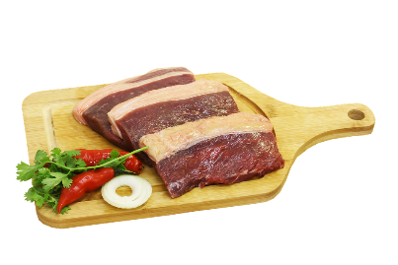 |  | 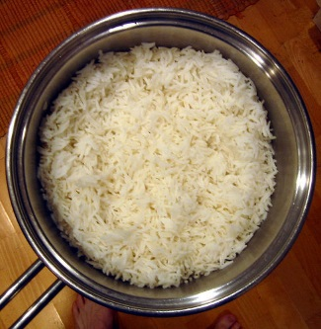
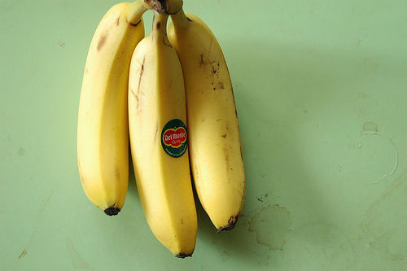 | 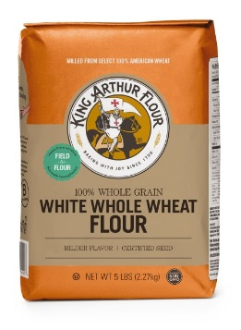 |  | 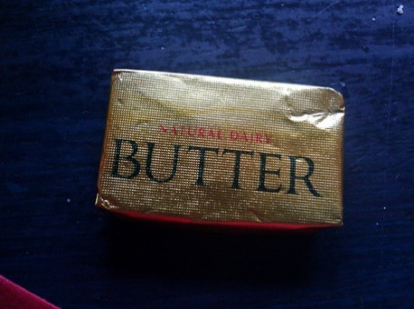
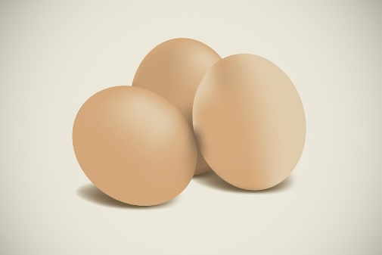
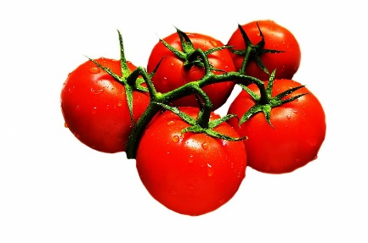 |  | 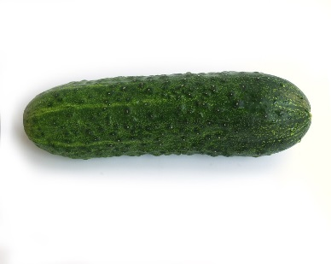
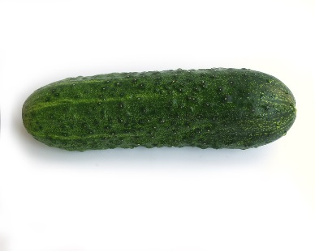 | 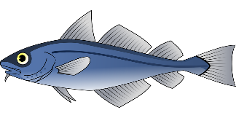

SHOPPING LIST
Some cheese
1 kg of tomatoes
3 bananas
1 packet of cookies
1 package of butter
1 cucumber
6 eggs
1 packet of flour

SHOPPING LIST
1 bottle of milk
1 kg of peaches
2 watermelons
1 kg of apples
Some meat
Fish
3 eggs
1 packet of flour

SHOPPING LIST
1 bottle of milk
1 kg of peaches
3 eggs
1 kg of apples
1 pot of cream
1 package of butter
1 packet of rice
1 packet of flour

SHOPPING LIST
2 bottles of juice
Some meat
Some rice
1 kg of apples
Fish
1 pot of yoghurt
Some tea
Some cheese

SHOPPING LIST
2 bottles of juice
6 bananas
Fish
1 cucumber
Some tea
1 pot of yoghurt
3 eggs
1 packet of chocolate cookies

SHOPPING LIST
Some meat
2 cucumbers
1 kg of tomatoes
1 packet of flour
1 bottle of water
1 loaf of bread
Some peaches
Some butter

SHOPPING LIST
Some meat
1 cucumber
1 kg of tomatoes
1 packet of flour
1 bottle of water
1 loaf of bread
Fish
Some apples

SHOPPING LIST
6 eggs
Some meat
1 kg of tomatoes
Some rice
2 bottles of juice
1 package of tea
Some cheese
1 pot of cream

