**THE PAST SIMPLE TENSE**

is mostly formed by adding **–ED** (play/played, want/wanted, call/called ...),

or **–D** (live/lived; smile/ smiled; like/liked; ...)

but there are a lot of irregular verbs (speak/spoke, write/wrote, eat/ate, buy/bought, ...) that must be learned by heart. See a [list of 50 **irregular verbs**](http://www.perfect-english-grammar.com/support-files/50_common_irregular_verbs_list.pdf)

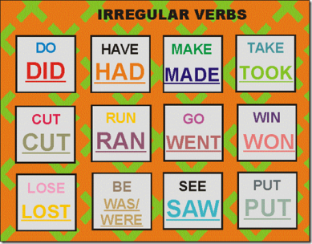

The past simple tense in English is used to talk about **completed events in the past:**

*She* ***worked*** *at McDonald’s last summer.*

*We* ***bought*** *a new flat last week.*

*They* ***went*** *to the Alps in December.*

We use **DIDN’T (did not) to make negatives** with the past simple:

*She didn’t watch TV yesterday.*

*She didn’t buy anything for dinner.*

*She didn’t do her homework on Sunday.*

|  |  |  |
| --- | --- | --- |
| Positive | Negative | Question |
| **verb+ed** | **didn't + verb** | **Did + (he) + verb** |
| *He washed his car.* | *He didn't wash his car.* | *Did he wash his car?* |

We use **DID to make questions** with the past simple:

*Did Jágr play in yesterday’s match?*

*Did she arrive on time last Sunday?*

*Did you eat spinach when you were young?*

Remember: We **often** start the **questions** in the past **with WHEN, WHERE, WHAT, WHY**

*When did they start the match?*

*Where did they meet?*

*What did she buy on holiday?*

*Why did you call them last night?*



**1. Complete the verbs in the correct past simple form.**

1. They (want) ............. to catch the last train, but they (fail) ...................... .
2. A man (call) ............... an ambulance and they (arrive) ....................... in 15 minutes.
3. Shakespeare (write) ..................... 39 plays.
4. We (have) .......................... a steak for dinner.
5. Last night he (go) ........................... to bed at midnight.
6. She (buy) .................... a new handbag yesterday.
7. They (do) ..................... homework on Saturday.
8. He (know) ………............ that writing a love letter to her last night (be) ……………........ a silly thing.
9. They (be) ……............. in a difficult situation, but they (manage) ………….......... to work it out.

**2. Write-up Sticky Moments - from notes to full sentences - in two paragraphs, the first explaining some of the questions you need to ask for more information, the second your order of priority with a brief justification.**