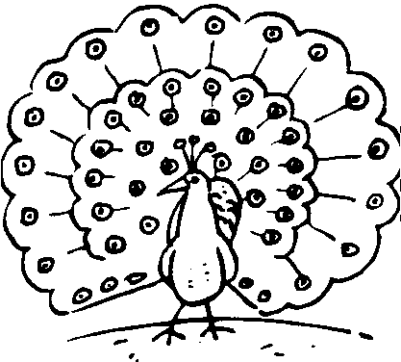

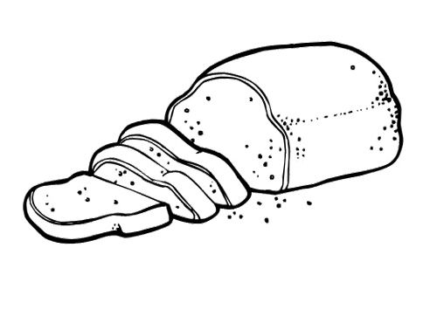[](http://www.google.cz/url?sa=i&rct=j&q=&esrc=s&source=images&cd=&cad=rja&uact=8&ved=0ahUKEwjmtcO2iZzTAhUMNxQKHT5lDPsQjRwIBw&url=http://critique-of-pure-reason.com/notes-on-moores-proof-of-an-external-world/&bvm=bv.152180690,d.ZGg&psig=AFQjCNHY2ySBjeD4xcKuRIxT5dcLh_39tw&ust=1491988766602562)la main l‘amant[](http://www.google.cz/url?sa=i&rct=j&q=&esrc=s&source=images&cd=&cad=rja&uact=8&ved=0ahUKEwjv08-lipzTAhVFthQKHfZQCJsQjRwIBw&url=http://retrovintage-vector.blogspot.com/2012/01/lover-retro-vector.html&bvm=bv.152180690,d.ZGg&psig=AFQjCNH3o9uIta_3Snn7x0Nm4tCAdDoDFw&ust=1491988966629125) pain paon

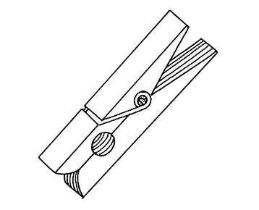enfant [](http://www.google.cz/url?sa=i&rct=j&q=&esrc=s&source=images&cd=&cad=rja&uact=8&ved=0ahUKEwiDsZPWi5zTAhXJXBQKHcljCXgQjRwIBw&url=http://www.snut.fr/dessin-de-bebe/&bvm=bv.152180690,d.ZGg&psig=AFQjCNEhU9jsCK5bgxAS0OuDM9PE39pBeQ&ust=1491989333942038) pince pense [](https://www.google.cz/url?sa=i&rct=j&q=&esrc=s&source=images&cd=&cad=rja&uact=8&ved=0ahUKEwj67t2OoZPTAhUFD5oKHVtJALsQjRwIBw&url=https://clipartfest.com/categories/view/e7acb27b7304bc003d88b3f0d7406caf47aa4f4a/think-clipart.html&bvm=bv.152180690,bs.2,d.d2s&psig=AFQjCNHeBvNUsatYXPl5e0YQvufYBh2DFw&ust=1491685886868937)

**enfin**

 faon [](https://www.google.cz/url?sa=i&rct=j&q=&esrc=s&source=images&cd=&cad=rja&uact=8&ved=0ahUKEwj46suRjJzTAhULVRQKHY0ICFwQjRwIBw&url=https://www.sansdepasser.com/coloriage/faon-418&bvm=bv.152180690,d.ZGg&psig=AFQjCNH4qY3ME3q9pgpnJ25s_vgzPQgSnQ&ust=1491989491211835) [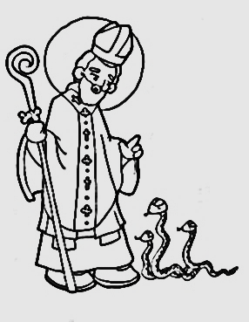](http://www.google.cz/url?sa=i&rct=j&q=&esrc=s&source=images&cd=&cad=rja&uact=8&ved=0ahUKEwiY3puAj5zTAhXHVBQKHeRwAD0QjRwIBw&url=http://xpgxi13.lorexddns.net/catholic-saint-coloring-pages.html&bvm=bv.152180690,d.ZGg&psig=AFQjCNFBuzow2R59gHx-ZPyVbdIHHoGRmw&ust=1491990165412100)saint sang 





**20**

vin vent vingt vent



**100**

**5**



cinq cent dessin descend

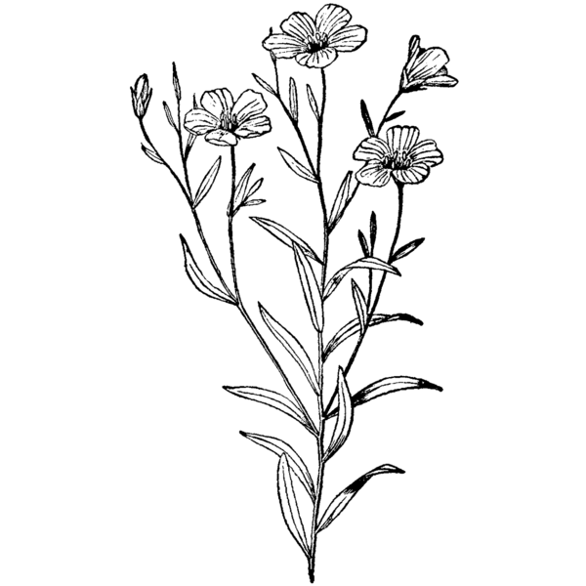

lin lent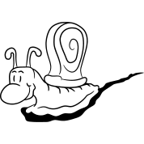 un an 

**1**

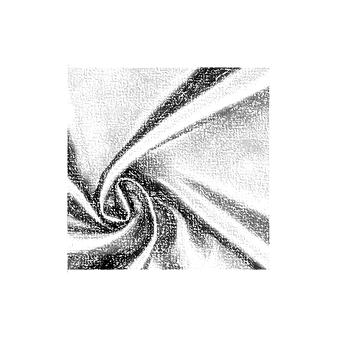faim faon [](https://www.google.cz/url?sa=i&rct=j&q=&esrc=s&source=images&cd=&cad=rja&uact=8&ved=0ahUKEwj46suRjJzTAhULVRQKHY0ICFwQjRwIBw&url=https://www.sansdepasser.com/coloriage/faon-418&bvm=bv.152180690,d.ZGg&psig=AFQjCNH4qY3ME3q9pgpnJ25s_vgzPQgSnQ&ust=1491989491211835) satin satan 

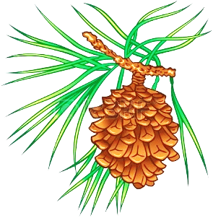pin paon  bain banc 