
Specific Learning Difficulties/Disabilities

- Imagine a life where you had to read extensive information or even whole books written like the passage below. How would you feel and behave?

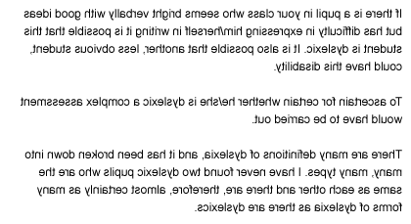
(Source: http://www.dyslexia-testing.com.au/what-is-dyslexia.html)
WRITTEN RESPONSE 1
Use the following structure: If I had to…, I would be/feel … (because)…
Example: If I had to read extensive information written like the above passage, I would probably feel frustrated and exhausted because I would have to concentrate very hard to decode the text.

Try to come up with at least three sentences and justifications and write them in the answer sheet.

Now make adjectives from the nouns on the left.
- embarrassment | 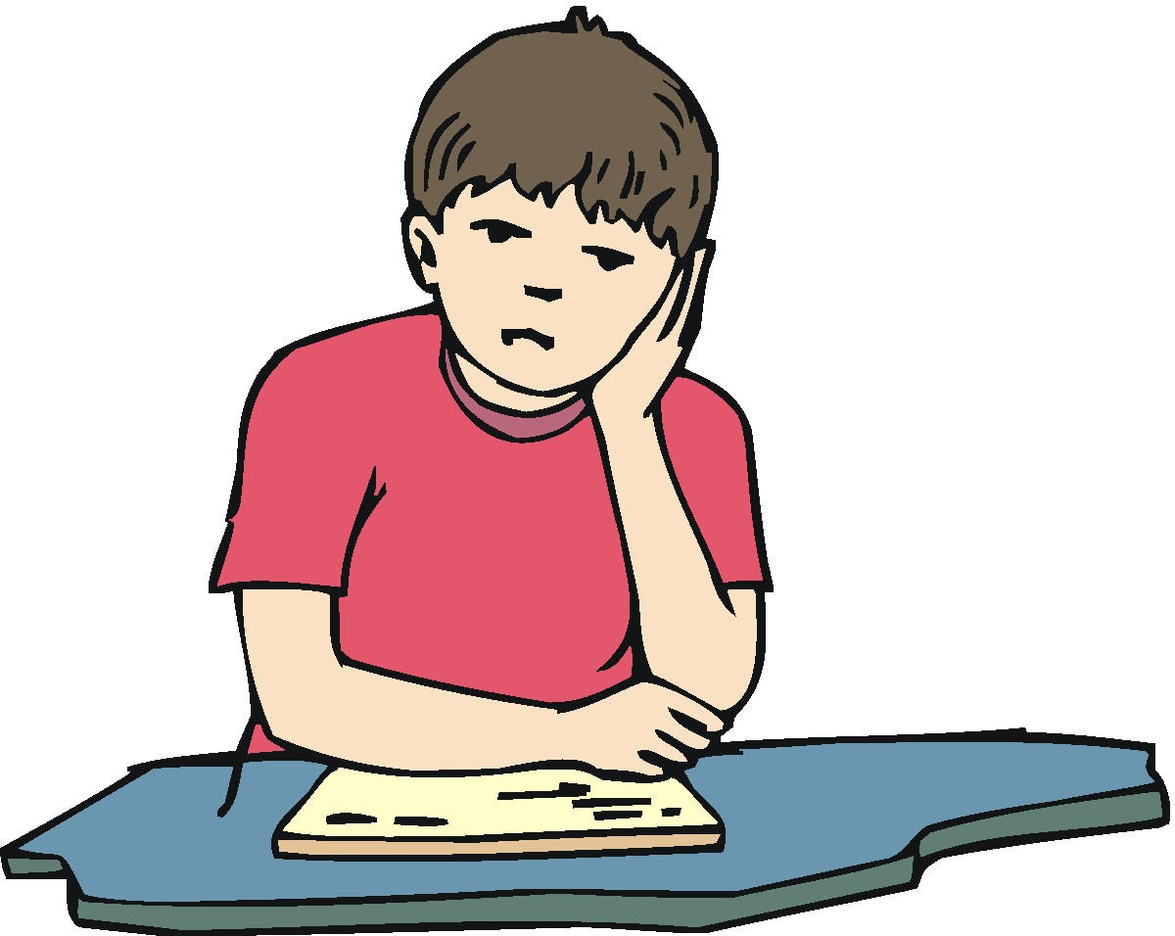  … I would feel …… | - embarrassed
- shame |  | - ashamed
- anxiety |  | - anxious
- fury |  | - furious
- irritability |  | - irritated (annoyed)/irritable (becoming annoyed easily)
- withdrawal |  | - withdrawn

LISTENING 1 (audio in the syllabus)
Task 1 (0:49 – 1:11)
Listen and complete the definition of specific learning disabilities (SLDs) below. You’ll hear the recording twice.
SLDs = unexpected underperformance by someone of average to above average intelligence in one or more key learning areas such as reading, spelling, writing or math, despite normal schooling and good teaching.

Task 2 (0:00 – 2:40)
You’ll now hear the entire talk where the speaker gives basic information about specific learning disabilities. As you listen, note down the most important points he makes, so that you can later report them to your teacher. Use for example https://www.rev.com/onlinevoicerecorder to record your answer and upload it in odevzdávárny in the syllabus (format: surname_SLD). Talk for about ONE MINUTE.
Notes:

TERMINOLOGY 1
- Add pronunciation and alternative expressions used in English to denote specific learning difficulties listed below:
- Dyslexia = /dɪˈslek.si.ə/ reading difficulty
- Dysgraphia = /dɪsˈɡrafɪə/ writing difficulty
- Dysorthographia = /dɪs,ɔːˈθɒɡ.rə.fɪə/ spelling difficulty
https://howjsay.com/search?word=dysorthographia&wid=&submit=Submit
- Dyscalculia = /ˌdɪs.kælˈkjuː.li.ə/ math difficulty
- Dyspraxia = /dɪsˈpræk.si.ə/ difficulty with physical movement and memory, affects fine and/or gross motor coordination
- What is the difference between “a general learning disability” and a “specific learning disability”?
--> record your answer with https://www.rev.com/onlinevoicerecorder and upload it in the syllabus (format of the file: surname_GLDxSLD). TALK FOR ONE MINUTE MAX.

READING and TERMINOLOGY 2
Read the information about dyslexia and dyspraxia below and fill in the gaps with suitable words.

short-term processing oral prior auditory
Dyslexia
Students who have dyslexia may have a difficulty with the use of both written and oral 1 language. This is due in part to processing 2 difficulties, including visual and auditory 3 perceptual skills, and is not necessarily related to prior 4 education. They may also find some learning tasks cause concern due to difficulties with short-term 5 memory, concentration and organisation.

hand-eye fine developmental whole
Dyspraxia
Dyspraxia is a developmental disorder that affects coordination. This can impact on movement, perception and thought, so may affect speech, fine motor movement, whole body movement and hand-eye coordination, sequencing and organisation. Dyspraxia can overlap with dyslexia, Asperger’s Syndrome and ADHD.

Now match the following signs to dysgraphia, dyscalculia or both.
dysgraphia
dyscalculia
Signs of OR ?

1) difficulty in dealing with the exchange of money (e.g. handling a bank account, dealing with change) DC
2) writing fatigue DG
3) poor communication of ideas in writing DG
4) getting disoriented easily, including left and right DG
5) difficulty in learning abstract concepts of time and direction DC
6) irregular letter sizes and shapes, a mixture of upper and lower case letters, or print and cursive letters DG
7) unfinished letters and letter inconsistencies DG
8) problems with mastering arithmetic facts by traditional methods and remembering specific facts and formulas for mathematical calculations DC
(Adapted from: http://www.open.ac.uk/inclusiveteaching/pages/understanding-and-awareness/what-are-specific-learning-difficulties.php)

READING (Test practice)
4 Read the text and match the headings with the paragraphs.

1 E
A child with a specific learning difficulty is as able as any other child, except in one or two areas of their learning. For instance, they may find it difficult to recognise letters, or to cope with numbers or reading.
2 D
There are many different types of specific learning difficulties, but the best known is probably dyslexia. In dyslexia, the child has difficulty with written symbols. Although these children are generally intelligent, they have difficulty with reading and spelling.
3 G
Other areas causing a great difficulty include arithmetic, understanding and following instructions, remembering what they have just been told, telling left from right, e.g. confusing '25' with '52', 'b' with 'd', or 'on' with 'no', coordination or clumsiness, e.g. in using a pencil, doing buttons, tying shoe-laces or in sports, their idea of time, e.g. confusing `yesterday', `today' and `tomorrow'.
4 F
It may be difficult for parents and teachers to realise that a child has this sort of problem, especially if their development has appeared quite normal in the early years. Often, the child will appear to understand, have good ideas, and join in storytelling and other activities as well as other children and better than some. Sometimes it can take years for adults to realise that a child has a specific difficulty.
5 C
Specific difficulties can make lessons hard for a child to understand. They will have a hard time keeping up with classmates, and may come to see themselves as stupid, or no good. They find it hard to concentrate on lessons and, because they cannot follow them properly, they find lessons 'boring'. The child will often search for other ways to pass the time and to succeed. They may try to avoid doing schoolwork because they find it impossible to do it well. If they don't get suitable help, the problems may get worse. Older children may drop out, fail exams or get into serious trouble - both at school and outside.
6 B
Doing badly in school can undermine children’s self-confidence. This can make it harder for the child to get along with other children and to keep friends. They may become the clown of the class because it is better than being `stupid'. Children with specific reading difficulties often become angry and frustrated, so behavioural problems are common.
7 H
The child's difficulties should be taken into account, which means that all education authorities should identify which children have special educational needs and make sure that they get the remedial help they require. Schools should adopt a new `Code of Practice' to help them to recognise and help children with this type of problem. Cooperation with the parents is also essential.
8 A
Children with learning difficulties should have their needs properly assessed by their school. The first step is to talk to the teacher. If problems continue, the child may need to be assessed by an educational psychologist. If the learning problem seems to be associated with hyperactivity, behavioural problems or problems with coordination, extra help may be needed. When necessary, you can refer to a local child and adolescent mental health service. This service includes child psychiatrists, psychologists, social workers, psychotherapists and specialist nurses who will be able to offer help and support.
(Adapted from: http://www.rcpsych.ac.uk/mentalhealthinformation/mentalhealthandgrowingup/11learningdifficulties.aspx

A Careful assessment B Effects of a low self-esteem
C Feeling “behind the others” D Problems with what’s written
E One or two weak points F Not easy to find out
G When easy tasks are a real challenge H Providing for an appropriate remedy

LISTENING 2: Teaching pupils with dyslexia at Ewelme primary school
PART 1
https://www.youtube.com/watch?v=vulIeXCN9So
A Before watching the video, discuss the following question and note down your answers:
- In which areas do you think children with dyslexia struggle at school?--> indicate your answer in the answer sheet (WRITTEN RESPONSE 2)
B Watch part 1 of the video and listen out for the answer(s) to the above question. Was your answer the same or different?

C Watch part 1 of the video again and complete the sentences below with a one-word expression according to what you hear.
1 Teachers should make pupils feel successful right from the onset.
3 Kate comes to Ewelme to work with dyslexic children a couple of sessions a week.
2 In terms of staff and what the children experience, Ewelme is a regular school.
4 Since the staff have become increasingly interested in children with dyslexia, the school foresees more formal training for the teachers.
5 However, teachers in Ewelme already employ teaching strategies that are more accessible to children with dyslexia.
6 One of the practices that is being used is writing on children’s back to help them memorise the letter shapes.
7 About 5 % of the children in a normal class have serious dyslexic problems and will need intensive help.
8 When looking out for characteristic signs of dyslexia, teachers focus on difficulties with organisation among others.
9 Some dyslexic children may be very disorientated when trying to find resources in the classroom.
10 One of the key characteristics of dyslexia that manifests itself through writing is the difficulty in retaining information.

D Vocab study: what’s the meaning of these phrases? Discuss with your partner (feel free to use online dictionaries):
- at first sight
- tell-tale signs
  - revealing, becoming known
- to be disorientated
  - confused as to where they are
- to retain (e.g. information)
  - to continue to have st.

  - You may think it appears a certain way, but later it is found to be different
- colour-tinted glasses
  - not transparent, but with colour added
- continuous cursive handwriting
  - rounded letters joined together
- to be on the lookout for something
  - you’re expecting st. to appear
E Complete the sentences below with the expressions from task D:
1 Dyslexic children may feel disorientated when they are looking for resources in the classroom.
2 Dyslexic children may find it difficult to retain the shapes and the size of letters.
3 The teachers are on the lookout for characteristic signs of dyslexia.
4 What may help some dyslexic children is wearing colour-tinted glasses while reading and writing.
5 At first sight, dyslexia may suggest a difficulty in visual processing, when in fact it means a difficulty in phonological processing.
6 How can dyslexia be recognised in a child? In other words, what are the tell-tell signs?
7 According to the British Dyslexia Association, continuous cursive handwriting helps dyslexic children improve writing speed and spelling.
PART 2
https://www.youtube.com/watch?v=jT35KppfFJk
A Before watching part 2, match the expressions with their meanings:
1 H reception year | A needing a lot of time and effort
3 D fuzzy board | B to make something more interesting
4 G to inform the teaching practice | C full of interest and energy
5 F to reinforce sbdy’s learning | D a type of teaching aid that uses the sense of touch to support the child’s learning
6 I multisensory approach | F to strengthen or support
7 A laborious business | G to influence st.
8 B to enliven | H part of school attendance that comes after nursery school (children between 4 – 5 years of age)
9 C animated | I through more senses

B Before watching the video, think about the following question and note down your answer:
- How do you think children with dyslexia should be taught?--> indicate you answer in the answer sheet (WRITTEN RESPONSE 3)
C Watch part 2 of the video and listen out for the answers to the above question. Was your answer the same or different?

D Watch part 2 of the video again and summarise answers to these questions.
1 What is multisensory teaching?
Approximate transcript: You’re trying to teach to all the channels of input into somebody’s brain. We learn from every experience from touch, feel, smell and listening.
Summary: As a teacher you should provide input to all receiving channels, e.g. hearing and touch.
2 Why is multisensory teaching beneficial?
You’re trying to put the information into as many parts of the brain as possible. If one part fails, another one will remember.
Summary: Since multisensory teaching engages more than one sense at the same time, children are more likely to retain information. If one input channel fails, they will remember through another one.
3 Why is it important to be lively and animated when teaching dyslexic children?
They tend to switch off, so you need to keep your lesson interesting even if you don’t feel like it.
4 Why is the teacher in the video teaching the alphabet to the reception children through singing and movement?
The movement and rhythm help them retain the alphabet better than just listening.
5 What is, according to one of the teachers, the best way to teach dyslexic children?
Varied input

Making questions
Make questions asking about the information in bold.

1 How many people with SLD are there in the worl? .
There are about 15-20% of people with SLD in the world.
2 When should a diagnosis of SLD be given?
A diagnosis of SLD should be given in the second or third grade.
3 What do children with SLD need to complete school tests? .
Children with SLD need more time to complete school tests.
4 What may be responsible for an SLD?
Heredity may be responsible for an SLD.
5 When was Barbara diagnosed with dyslexia?.
Barbara was diagnosed with dyslexia 5 years ago.
WRITING (Test practice)
Write a short argumentative essay on the following topic:
“Students with specific learning difficulties should not be educated in mainstream classes because their presence in the class hinders the intact students’ progress.”
Argue for or against this statement.
Write for an educated reader with specialist knowledge of the topic. Express your opinion in a formal way and structure your ideas logically – include a short introduction, body and conclusion.
Before you start writing study the handout “Exam_Sample_writing_task_and_tips” (see the syllabus). Use some of the linking expressions mentioned in this handout in your argumentative essay. Upload in the syllabus by 26 March (format: surname_essay_SLD)
You should write 160 words.

EXTRA LISTENING PRACTICE
  - If you need some more listening practice you may watch the following video called Learning Through Listening: http://www.youtube.com/watch?v=E8_pS25OtDg&feature=related

TERMINOLOGY

a specific learning difficulty/disability
a general learning difficulty/disability
an ability
the right hemisphere
the left hemisphere
to have (a) difficulty with st.
to have (a) difficulty (in) –ing st.
dyslexia / reading disability
a dyslectic student /a student with dyslexia / a dyslexic
reading abilities
a letter
to distinguish letters
to process information
to decode
dysgraphia / writing disability
writing abilities
spelling
handwriting
to confuse
to omit
to substitute
telling left from right
to type
typing
dysortographia / spelling disability
spelling rules
to distinguish sounds
dyspraxia / developmental coordination disorder
poor coordination
to be clumsy
clumsiness
dyscalculia / math disability
mathematical abilities
to assess
school assessment
to cope with
to overcome
a mainstream / regular class
a mainstream /regular school
a special class
a special school

