
Countable X Uncountable Nouns
Quantifiers (many / much; few / a few; little / a little…)

Countable nouns (e.g. a man, a school, a window)
Singular: a / the school Plural: schools / the schools

Uncountable nouns (milk, homework, information)
Singular: –/some/the homework NO plural form → verb always in singular!!!

List of common uncountables:

Substances: plastic, iron, wood, paper…
Liquids and gasses: water, oxygen…
Drinks: coffee, milk, tea, juice…
Food: chicken, yogurt, toast …
Abstract ideas: happiness, anger, love…
Mass nouns: equipment, furniture, luggage…

The nouns below are also UNCOUNTABLE:
- work/homework/housework…
- advice
- information
- knowledge
- news

a piece of, two pieces of…

PRACTICE
1 Choose the correct alternative.
1 Let me give you an/some advice.
2 Kate doesn’t like ---/a milk.
3 Could you pass me the/--- tea, please?
4 There’s some/a coffee left.
5 There is a/some woman waiting outside the cinema.
6 We must find a/some information/informations about the departure.
7 Money is/are very important to him.
8 None of the passengers had insured their baggage/baggages.

Quantifiers
Countables | Uncountables | Both: C/U
How many…? | How much? | - a lot of/lots of  - enough  - hardly any ( “hardly any” + positive form of verb)  - no
- many  - a few (několik)  - few (málo)  - several (několik)  - both (oba)  - a couple of (pár, “2-4”) | - much (ONLY in negative or question!!!)  - a little (trochu)  - little (málo)  - a bit of (informal; trochu)
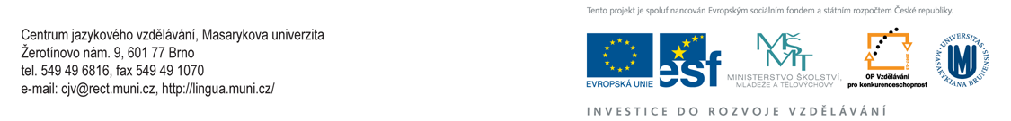

PRACTICE

2 Complete the questions with How much…? or How many…?

A _______________________homework do you usually get?

B _______________________people are there in your class?

C _______________________coffee do you drink a day?

D _______________________does a cup of coffee cost?

E _______________________languages do you speak?

F _______________________information has leaked out?

3 Complete these sentences with much, many, and a lot (of).

A It cost me ________________money to buy that present.

B We didn’t take ________________pictures when we were on holiday.

C He always puts ________________salt on his food.

D They don’t have ________________furniture in their flat. They’ve just moved in.

E Tom drinks ________________milk – at least one litre a day.

F We must hurry as we don’t have________________time.

G She is a very quiet person. She doesn’t say ________________.

4 Complete the sentences with appropriate quantifiers.

A Listen carefully. I’m going to give you __________________ (jednu radu) advice.

B Do you mind if I ask you ___________________ (několik otázek) questions?

C The cinema was almost empty. Very ________________ (málo lidí) people were there.

D The weather has been very dry recently. We’ve had _________________ (málo deště) rain.

E I don’t think Jill would be a good teacher. She’s got _________________ (málo trpělivosti) patience.

F ‘Would you like milk in your coffee?’ ‘Yes, please. ____________________ (trochu) ’.

G Can you lend me ___________________ (několik) dollars?

