Current problems in schools

Group discussion:

1. What are the most common problems in schools nowadays?

2. In groups of 3 or 4 try to agree on

a) 4 most common problems in Czech schools nowadays,

b) 4 most serious problems in Czech schools nowadays, choosing from the ones listed below:

lack of students´ motivation

bullying

lack of parents’ involvement

truancy

lack of discipline

low teachers’ salaries

too many students in the class

lack of experienced and well-educated teachers

teenage drinking and smoking

secondary students’ drug abuse

using old-fashioned and ineffective methods of teaching

|  |  |
| --- | --- |
| Most common | Most serious |
| 1. | 1. |
| 2. | 2. |
| 3. | 3. |
| 4. | 4. |

3. Work in pairs. Try to explain the expressions below. Use a monolingual dictionary if needed.

*cyber bullying bullying victim of bullying*

*name-calling social exclusion physical bullying*

*bully psychological bullying turning a blind eye on sth.*

4. Look at the pictures and describe them with your partner.

A B

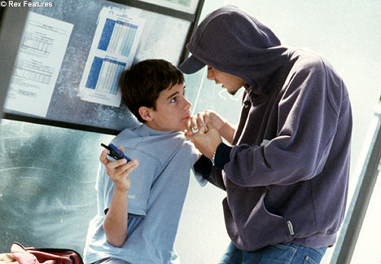 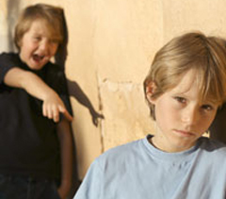

C D

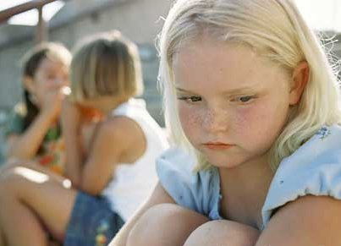 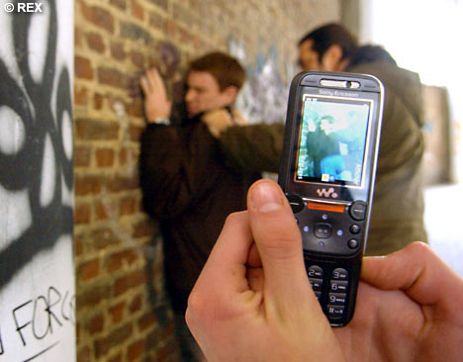

5. Role-play

Student A: Imagine that you are a parent of a 12-year old boy who suffers from physical bullying at school by his two classmates. He suffers from hair-pulling, kicking and sometimes even punching. He has to carry their schoolbags and give them his snacks. What exactly would you do to help your child and solve this serious problem? Prepare some suggestions and then go to school to discuss it with your son’s class teacher.

Student B: Imagine that you are a teacher of a class where one of the boys is bullied.

He experiences physical bullying at school by his two classmates. He suffers from hair-pulling, kicking and sometimes even punching. He has to carry their schoolbags and give them his snacks. What exactly would you do to help the boy and solve this serious problem in your class? Prepare some suggestions and then meet the boy’s parents to discuss it with them