**Learning English**

**1. Which things do you find easy in English? Which things do you find more difficult?**

**Put a X in the table below and give at least one example.**

|  |  |  |  |  |  |
| --- | --- | --- | --- | --- | --- |
|  | **very easy** | **easy** | **difficult** | **very difficult** | **example(s)** |
| Reading |  |  |  |  |  |
| Listening |  |  |  |  |  |
| Speaking |  |  |  |  |  |
| Writing |  |  |  |  |  |
| Grammar |  |  |  |  |  |
| Vocabulary |  |  |  |  |  |
| Pronunciation |  |  |  |  |  |

**2. Look again at the table in exercise 1. Choose one thing you find difficult and write a learning target for yourself. For example:**

*I would like to be able to write a formal email in English.*

**Write your learning target and today's date in the table below. (When you have achieved your target, complete the other two boxes and write a new target.)**

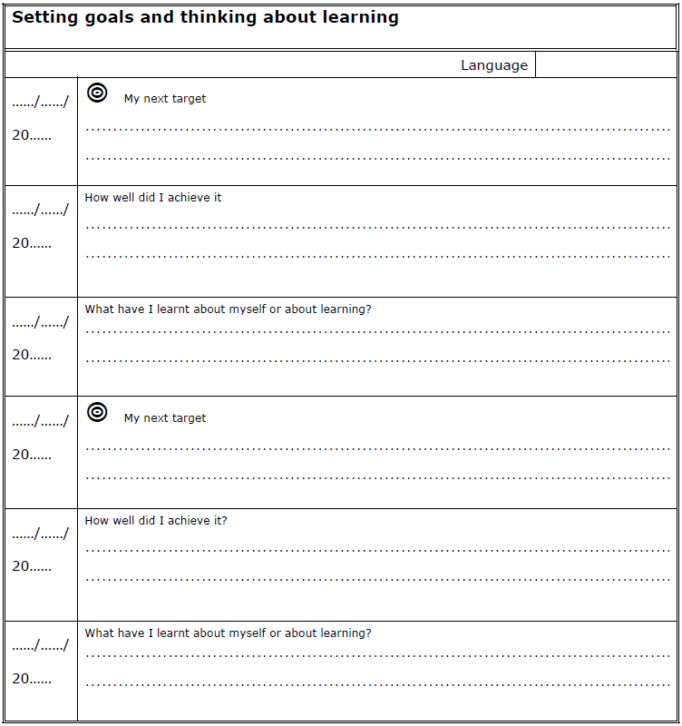

Adapted from *Goal setting and learning how to learn,* Council of Europe, 2011