Introduction to terminology

**Student A**

1. Use a monolingual learner’s dictionary to look up the definitions of the following terms:

|  |  |
| --- | --- |
| **special education** |  |
| **Down syndrome** |  |
| **a student with special needs** |  |
| **stammering** |  |
| **a special educator** |  |
| **glaucoma** |  |
| **a hearing impairment** |  |
| **a visual impairment** |  |
| **damage to the auditory nerve** |  |
| **an intellectual disability** |  |
| **long-sightedness** |  |
| **a severe disability** |  |

Can you think of the Czech equivalents? Write them down.

2. Read your definitions to Student B and check if he/she can give you the right expression.

3. Swap roles. Student B is going to read some definitions for you. Look at the expressions below and choose the one which matches the definition.

**impaired communication ability**

**specific learning difficulties**

**cerebral palsy**

**a physical impairment**

**behavioural disorders**

**damage to hearing cells**

**a mild disability**

**dyslalia**

**a student with multiple disabilities**

**developmental delay**

**a moderate disability**

**short-sightedness**

**Student B**

1. Use a monolingual learner’s dictionary to look up the definitions of the following expressions:

|  |  |
| --- | --- |
| **impaired communication ability** |  |
| **a student with multiple disabilities** |  |
| **specific learning difficulties** |  |
| **behavioural disorders** |  |
| **a mild disability** |  |
| **a moderate disability** |  |
| **dyslalia** |  |
| **developmental delay** |  |
| **damage to hearing cells** |  |
| **cerebral palsy** |  |
| **near-sightedness** |  |
| **a physical impairment** |  |

Can you think of the Czech equivalents? Write them down.

2. Student A is going to read some definitions for you. Look at the expressions below and choose the one which matches the definition.

**a severe disability**

**special education**

**a visual impairment**

**Down syndrome**

**an intellectual disability**

**damage to the auditory nerve**

**a student with special needs**

**a special educator**

**glaucoma**

**a hearing impairment**

**stammering**

**far-sightedness**

3. Swap roles. Read your definitions to Student A and check if he/she can give you the right expression.

4. Look at the pictures below. Which aids help these people to overcome their disability? Match the aids with the pictures.

a white cane C crutches F a guide dog A sign language H

the Braille system G tactile maps D a wheelchair lift E a cochlear implant B

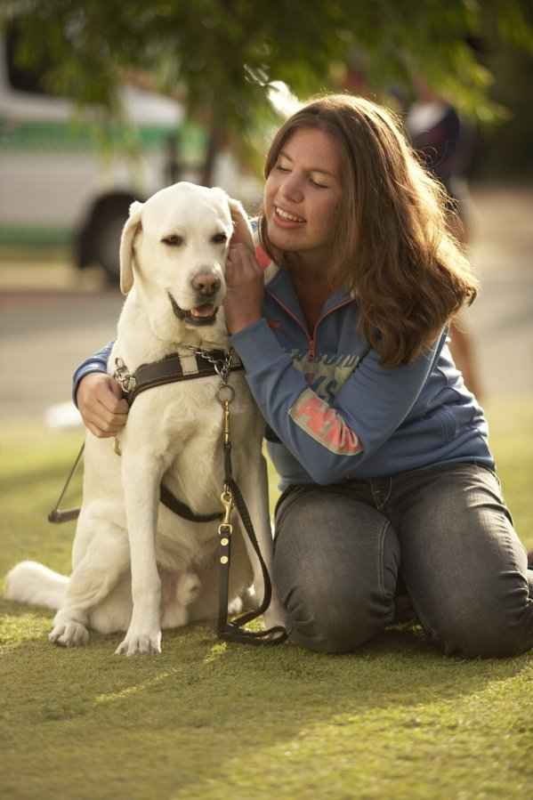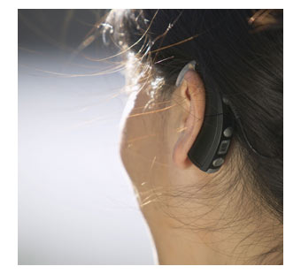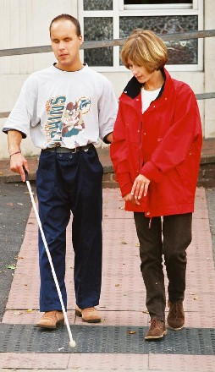

A B C D

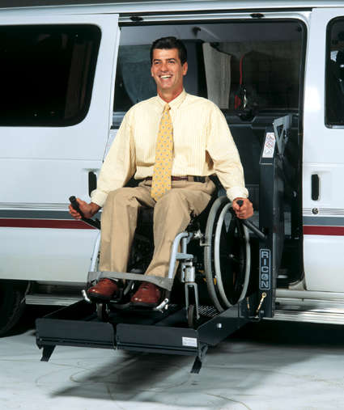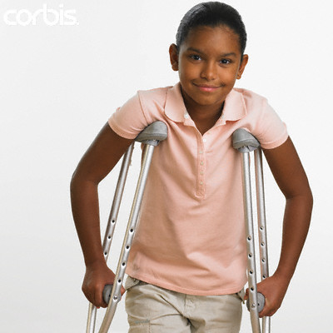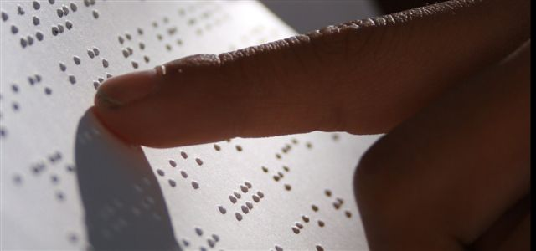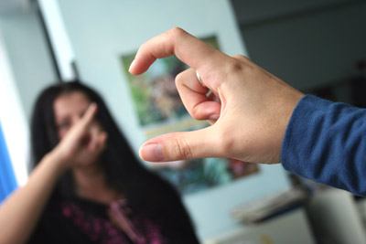

E F G H

5. Look at the expressions from the previous activities. Try to sort them into the following categories:

HEARING IMPAIRMENT VISUAL IMPAIRMENT PHYSICAL IMPAIRMENT

a cochlear implant a white cane crutches

sign language a guide dog a wheelchair lift

damage to the auditory nerve the Braille system cerebral palsy

damage to hearing cells tactile maps

glaucoma

long-sightedness

near-sightedness

INTELLECTUAL DISABILITY SPEECH IMPAIRMENT

Down syndrome stammering

impaired communication ability

dyslalia

6. Group discussion:

* Do you have any personal experience of meeting and helping someone with an impairment or disability?
* What do you think would be the most difficult situations to deal with for a person with a) a visual impairment b) a hearing impairment c) a physical impairment?
* What is your opinion on the relationship of people with disabilities and people without disabilities in the Czech Republic (e.g. in the area of education, free-time activities, working opportunities, the overall quality of their life)?