Sensory impairments

Do you have any experience with helping people with sensory impairments?

What is the general attitude to people with sensory impairments?

1. Brainstorming

**What are some of the difficult things people with sensory impairments have to face in nowadays society?**

Come up with as many ideas as you can. Every idea counts and no idea should be judged.

VISUAL IMPAIRMENT – physical obstacles on the road (signs, pavements…), crossing the road, dealing with money (notes and coins), obtaining information, cooking …

HEARING IMPAIRMENT – face-to-face conversation, implants – price, uncomfortable, noisy places, isolation, alarms …

2. Expressing your viewpoint

**Which type of impairment is more difficult to live with?**

Compare the brainstormed ideas. Express your opinion and justify your view.

**Useful language**

**Asking for an opinion:**

What do you think?

How do you feel about that?

**Giving an opinion:**

I think that …

I don´t think that … because…

In my opinion …

In my point of view …

3. Terminology

**What compensatory aids for people with sensory impairments do you know?**

The white cane, a guide dog, a hearing aid, a cochlear implant …

Match the terms with the pictures and the definitions below.

TERMS:

a) **the Braille (system)** b) **a magnifying glass** c) **an identification cane**

d) **a watch for the blind** e) **a guide dog** f) **a cochlear implant**

1.

[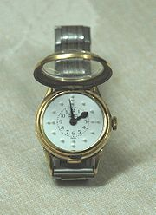](http://en.wikipedia.org/wiki/File:Watch_for_the_blind2.jpg) Name.: _____d_________ Definition No.___2____

2.

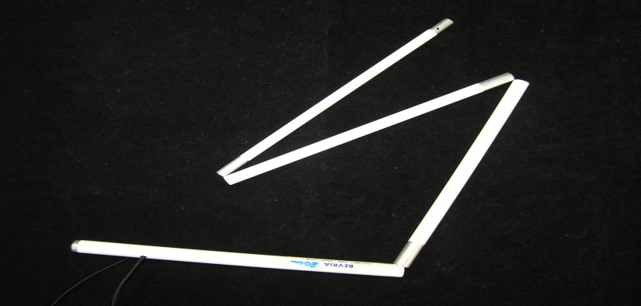

Name: __________c_________

Definition No.: ____5___

3.

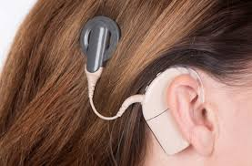 Name.: ______f________ Definition No.____3___

4.

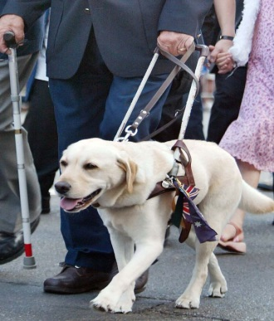

Name.: _____e_________ Definition No.____4___

5.

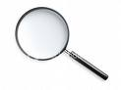 Name.: ______b________ Definition No.___1____

6.

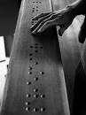 Name.: ________a______ Definition No.____6___

DEFINITIONS:

1) This tool consists of a convex lens which is used to produce a magnified image of an object. The lens is usually mounted in a frame with a handle.

2) This is a portable timepiece used by the visually impaired to tell time. It is used by touching the dial and noticing the embossments (both analog and digital versions are available).

3)  This is a small electronic device that electrically stimulates the **cochlear** nerve (nerve for hearing). The **implant** has external and internal parts. The external part sits behind the ear. It picks up sounds with a microphone. It then processes the sound and transmits it to the internal part of the **implant**.

4) They are assistance dogs trained to lead blind or visually impaired people around obstacles.

Although the dogs can be trained to navigate various obstacles, they are partially (red-green) color blind and are not capable of interpreting street signs. The human half of the guide dog team does the directing, based upon skills acquired through previous mobility training.

5) This type of white cane is a mobility tool used to detect objects in the path of a user It is used to extend the user's range of touch sensation. Some visually impaired people prefer this type of cane to a long cane because it is lighter.This cane (also called a "Symbol Cane" in British English) is used primarily to alert others that this particular persons has visual impairment.

6) This is a method that is widely used by blind people to read and write. Each of the signs is made up of six dot positions, arranged in a rectangle containing two columns of three dots each.

4. Talking about advantages and disadvantages

**What advantages and disadvantages are there when you are deaf and you are a part of the deaf community?**

|  |  |
| --- | --- |
| *Pros* | *Cons* |
| People with similar problems | Isolation from the world outside |
| encouragement | Limited number of friends |
| security | Limited number of opportunities |
| Special education | No training to function outside the community |
| Easier communication | Difficult to cope in new situations |
|  |  |
|  |  |

**Is it better for people with severe hearing impairment to be a part of the deaf community?**