Sensory impairments

Do you have any experience helping people with sensory impairments?

What is the general attitude to people with sensory impairments?

1. Brainstorming

**What are some of the challenges people with sensory impairments have to face?**

Think of as many ideas as you can.

2. Expressing your viewpoint

Which of the challenges you brainstormed would bet he greatest/most difficult to face?

Compare the ideas. Express your opinion and justify your view.

Useful language

**Asking for an opinion:**

What do you think?

How do you feel about that?

**Giving an opinion:**

I think that …

I don´t think that … because…

In my opinion, …

From my point of view, …

3. Terminology

**What compensatory aids for people with sensory impairments do you know?**

Match the terms with the pictures and the definitions below.

TERMS:

a) the Braille system b) a magnifying glass c) an identification cane

d) a tactile watch e) a guide dog f) a cochlear implant

1.

[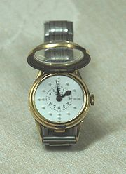](http://en.wikipedia.org/wiki/File:Watch_for_the_blind2.jpg) Name.: ______________ Definition No._______

2. 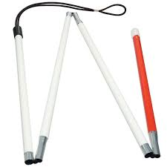 Name: ___________________Definition No.: _______

3. 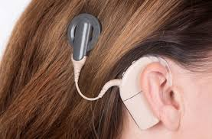 Name.: ______________ Definition No._______

4.

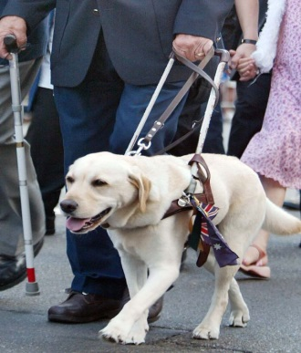

Name.: ______________ Definition No._______

5.

 Name.: ______________ Definition No._______

6.

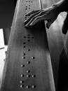 Name.: ______________ Definition No._______

DEFINITIONS:

1) This tool consists of a convex lens which is used to produce a magnified image of an object. The lens is usually mounted in a frame with a handle.

2) This is a portable timepiece used by the visually impaired to tell the time. It is used by touching the dial and noticing the embossments (both analogue and digital versions are available).

3) This is a small electronic device that electrically stimulates the cochlear nerve (nerve for hearing). The implant has external and internal parts. The external part sits behind the ear. It picks up sounds with a microphone. It then processes the sound and transmits it to the internal part of the implant.

4) They are assistance dogs trained to lead blind or visually impaired people around obstacles.

Although the dogs can be trained to navigate various obstacles, they are partially (red-green) colour blind and are not capable of interpreting street signs. The human half of the guide dog team does the directing, based upon skills acquired through previous mobility training.

5) This type of white cane is a mobility tool used to detect objects in the path of a user. It is used to extend the user's range of touch sensation. Some visually impaired people prefer this type of cane to a long cane because it is lighter.This cane (also called a ‘symbol cane’ in British English) is used primarily to alert others that this particular person has a visual impairment.

6) This is a method that is widely used by blind people to read and write. Each of the signs is made up of six dot positions, arranged in a rectangle containing two columns of three dots each.

4. Talking about advantages and disadvantages

**What advantages and disadvantages are there of being a part of the deaf community?**

|  |  |
| --- | --- |
| *Advantages* | *Disadvantages* |
|  |  |
|  |  |
|  |  |
|  |  |
|  |  |

**Is it better for people with a severe hearing impairment to be a part of the deaf community?**